## **CS 623 Summer I**

## **Exercise on GitHub and Git**

In this project, we will be using GitHub for assignment submissions and code versioning.

The goal of this exercise is to get you started with Git and GitHub. Even if you are using Git and GitHub regularly you need to do this exercise and submit it. If you already did it, you need to create the required repository and fill out the required documents.

Please follow the instructions completely. Work that does not follow the instructions (including naming conventions) will NOT be accepted and will result in a grade of 0.

**Part 1:** Create a GitHub account (if you do not have one)

<https://github.com/evelyn-k>

**Part 2:** Install Git bash <http://git-scm.com/downloads> and browse the documentation.

**Part 3:** Answer the following questions.

What is GitHub?

GitHub provide a web-based graphical interface of Git. Git is a repository hosting service that a command line tool. This is a place where developers can collaborate on projects using wikis and other management tools.

When was it created? Why? By who?

GitHub was created by Chris Wanstrath, P.J. Hyett, Tom Preston-Werner, and Scott Chacon in 2007, however, the service was only released in early 2008. Git version control system was difficult to use which arose the need for a creation of GitHub, a graphical web-based interface.

What similar platforms exist? Why would you use such a platform? (Answer between 2 and 3 lines)

* GitLabm – an open source software that can be installed on your own server
* BitBucket – is a version-controlled repository and would be best for use by big enterprise because of its integration with tools like Jira, HipChat, and Confluence
* SourceForge – popular among open source projects since it provides all the necessary tools. (Linux distributions and projects are provided through it)

Answer these questions in a Word file called *LastnameFirstnameGitTutorial-mm-dd-yyyy.docx*. Please respect the naming conventions!

**Part 4:**

Go through the Git tutorial here: <https://try.github.io> (Git It). While doing the tutorial, save your work the *LastnameFirstnameGitTutorial-mm-dd-yyyy.docx* file.

While there is a GUI to use Git and GitHub, developers use the command line!

<https://github.com/evelyn-k/hello-world>

<https://github.com/evelyn-k/patchwork>

<https://github.com/jlord/patchwork/blob/gh-pages/CONTRIBUTORS/add-evelyn-k.txt>

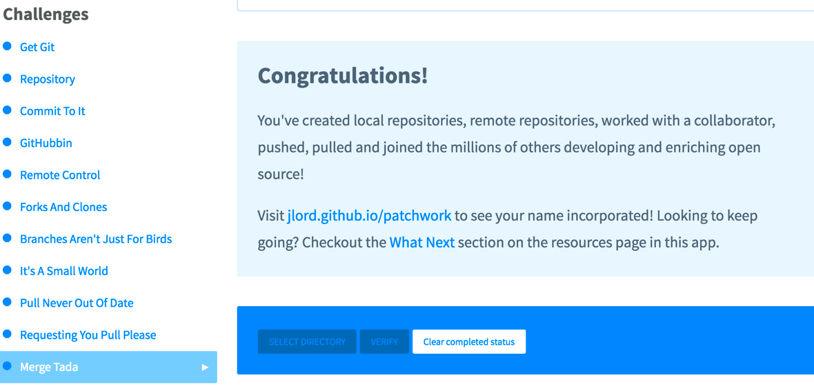

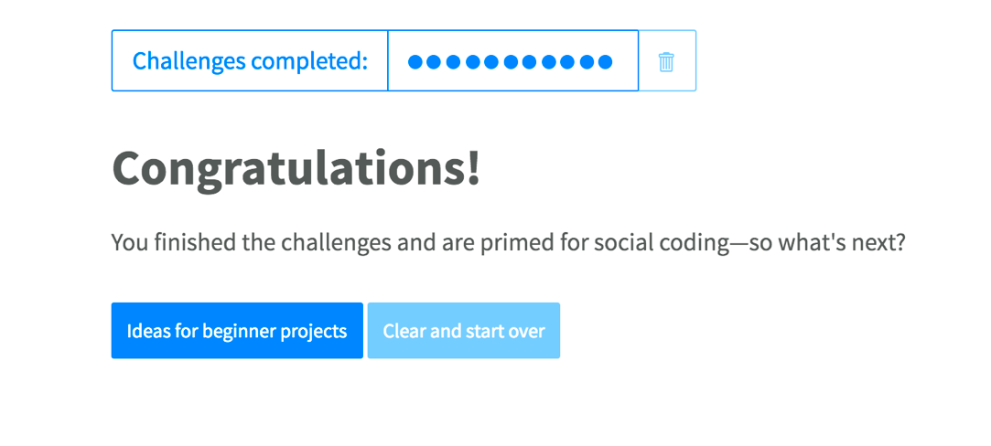

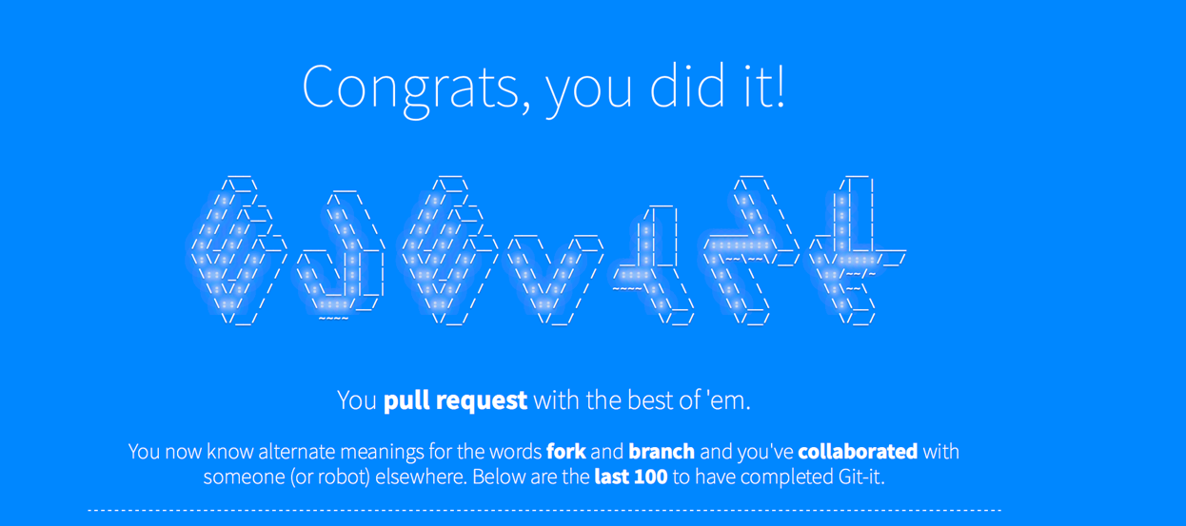

**Part 5:**

Become familiar with the following terms:

* Repository – the most basic element of GidHub that contains all the project files and their revision history
* Commit – also called revision is a change to a file or files
* Push – is used to send changed to a committed repository
* Branch – a parallel version of the repository. It is contained within the master branch but does not affect it. This is very useful when working on changes
* Fork – a personal copy of another user’s repository. Any changed made don’t affect the original repository.
* Merge – merging happens when changes in one brand are applied to another. This can be done automatically and often happens through a pull request
* Clone – is a copy of a repository on the computer instead of a web server
* Pull – refers to fetching in changes and merging them
* Pull request – are the proposed changes to the repository submitted by other users. They are accepted/rejected by repository’s collaborators

**Part 6:**

Push the Word file in **YOUR** GitHub account in a repository called ***CS6232019***. Please respect the naming conventions! You will use this repository for the project. Your repository will be accessible at: <https://github.com/yourpseudo/CS6232019>.

<https://github.com/evelyn-k/CS6232019>

**Part 7:**

Add an issue with title “GitHub training” in your repository called CS6232019. Issues are used for tasks and bug reports.

<https://github.com/evelyn-k/CS6232019/issues/1>

**Part 8:**

Edit the main page of the wiki in your repository called CS6232019. Add the title “CS 623 2019” to the page (if you decide to do so).

You can also override Readme.md to document your work.

<https://github.com/evelyn-k/CS6232019/wiki/CS-623-2019>