# SQL - product, depot, stock

## References from Week 4

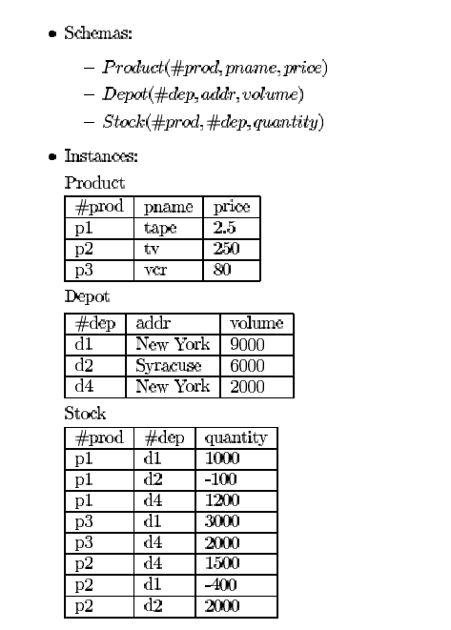

* The primary key of product is #prod. The primary key of depot is #dep. The (composite) primary key of stock is #prod, #dep.
* #prod in stock is a foreign key referring the primary key #prod in product.
* #dep in stock is a foreign key referring the primary key #dep in depot.

## Write the following queries in SQL.

1. What are the #prods whose name begins with a ’p’ and are less than

$300.00?

**SELECT prod_id**

**FROM product**

**WHERE pname LIKE 'p%' AND price < 300;**

1. Names of the products stocked in ”d2”.
   1. without in/not in

**SELECT p.pname**

**FROM product p**

**WHERE p.prod_id IN (SELECT prod_id FROM stock WHERE dep_id = 'd2');**

* 1. with in/not in

**SELECT p.pname**

**FROM product p**

**WHERE p.prod_id IN (SELECT prod_id FROM stock WHERE dep_id = 'd2');**

1. #prod and names of the products that are out of stock.
   1. without in/not in

**SELECT p.prod_id, p.pname**

**FROM product p, stock s**

**WHERE p.prod_id = s.prod_id AND s.quantity < 1;**

* 1. with in/not in

**SELECT prod_id, pname**

**FROM product**

**WHERE prod_id IN (SELECT prod_id FROM stock WHERE quantity < 1);**

1. Addresses of the depots where the product ”p1” is stocked.
   1. without exists/not exists and without in/not in

**SELECT d.addr**

**FROM depot d**

**WHERE d.dep_id=s.dep_id AND s.prod_id = ‘p1’ AND s.quantity > 0;**

* 1. with in/not in

**SELECT addr**

**FROM depot**

**WHERE dep_id IN (SELECT dep_id FROM stock WHERE prod_id = 'p1' AND quantity > 0);**

* 1. with exists/not exists

**SELECT addr**

**FROM depot**

**WHERE EXISTS (SELECT dep_id FROM stock WHERE prod_id = ‘p1’ AND quantity > 0);**

1. #prods whose price is between $250.00 and $400.00.
   1. using intersect.

**SELECT prod_id**

**FROM product**

**WHERE price >= 250.0**

**INTERSECT**

**SELECT prod_id**

**FROM product**

**WHERE price < 400.0;**

Note: there is a syntax error here, unfortunately couldn’t figure it out. Will work on it after submission.

* 1. without intersect.

**SELECT prod_id**

**FROM product**

**WHERE price BETWEEN 250.0 AND 400.0;**

1. How many products are out of stock?

**SELECT count(*)**

**FROM stock**

**GROUP BY prod_id, dep_id**

**HAVING quantity < 1;**

1. Average of the prices of the products stocked in the ”d2” depot.

**SELECT p.prod_id, AVG(p.price)**

**FROM product p JOIN stock s ON p.prod_id = s.prod_id AND s.dep_id = 'd2' AND s.quantity > 0;**

1. #deps of the depot(s) with the largest capacity (volume).

**SELECT dep_id**

**FROM depot**

**WHERE volume = (SELECT max(volume) FROM depot);**

1. Sum of the stocked quantity of each product.

**SELECT prod_id, SUM(quantity)**

**FROM stock**

**GROUP BY prod_id;**

1. Products names stocked in at least 3 depots.
   1. using count

**SELECT pname**

**FROM product**

**WHERE prod_id IN (SELECT prod_id FROM stock GROUP BY prod_id HAVING count(prod_id) >= 3);**

* 1. without using count

1. #prod stocked in all depots.
   1. using count

**SELECT COUNT(dep_id), prod_id**

**FROM stock**

**GROUP BY prod_id HAVING COUNT (dep_id) = 3;**

* 1. using exists/not exists

**SELECT EXISTS (**

**SELECT dep_id**

**FROM stock**

**WHERE dep_id = “d1’, ‘d2’, ‘d3”);**

???