Polls, rating, and comparison, adding products.
Fronted - Evelyn Martinez
Backend - Ryan McCann
Database Design- Magnus Gertonson

Node server on a cloud or vps.

Communication canvas or group 5 in canvas.

Wireframes:
Main page:

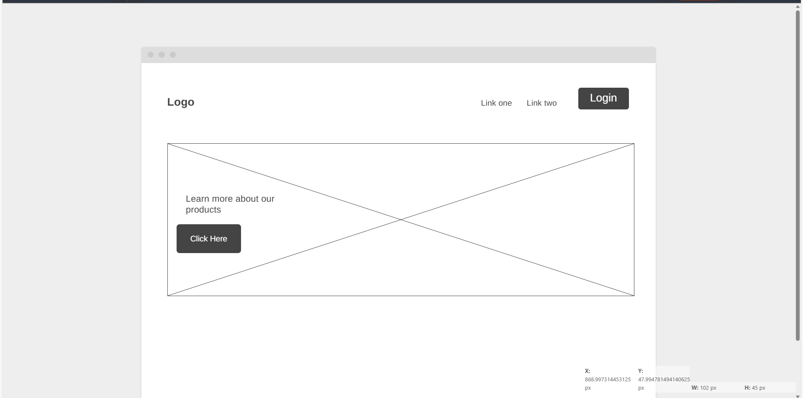
Second page:
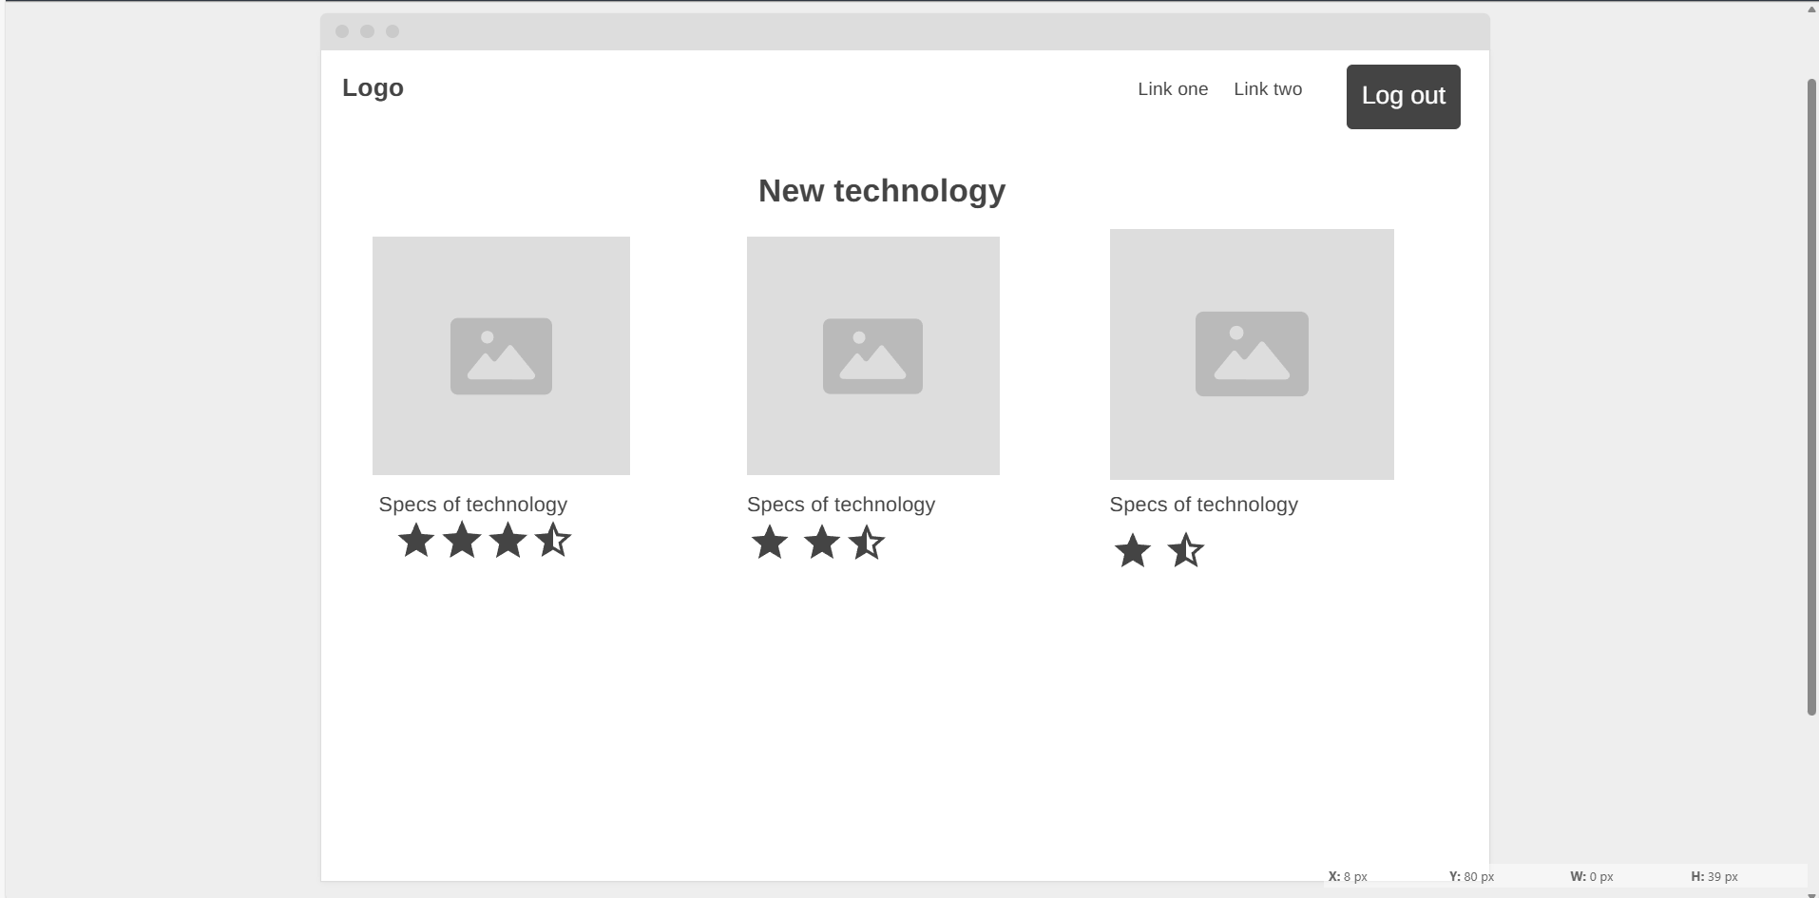
Third page:
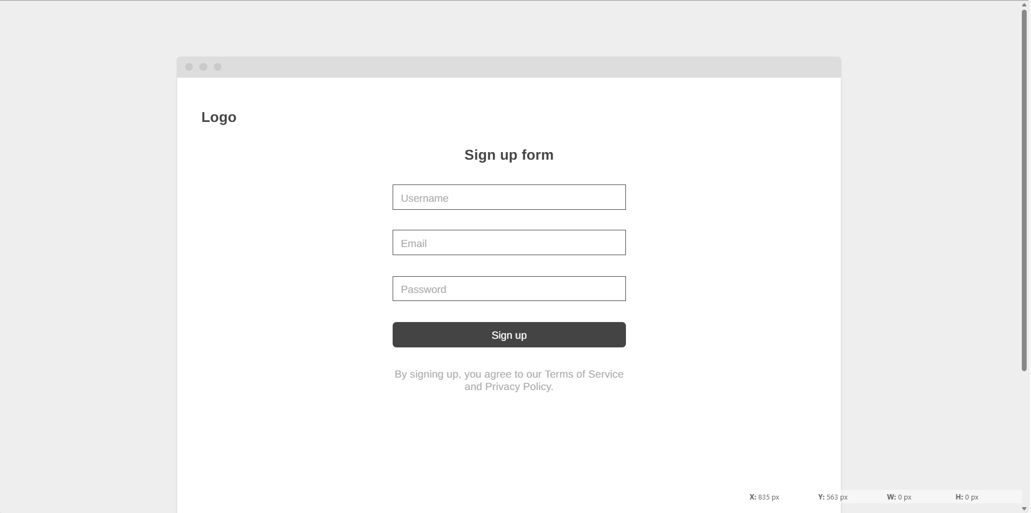

Fourth page:

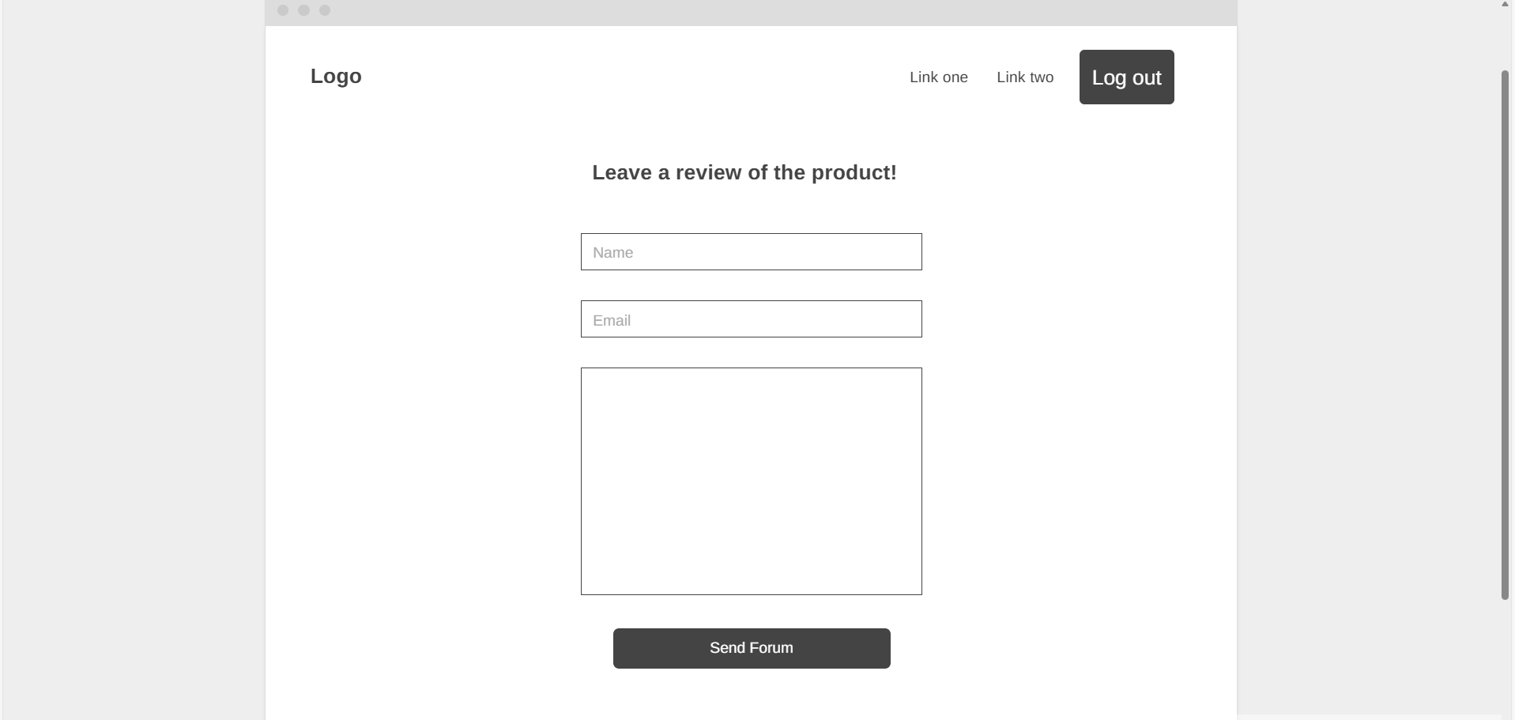

Pseudocode:
load credentials
connect to database
# Main page-level routes
IF route = "/" THEN
load "index.html"
ELSE IF route = "/products" THEN
load "products.html"
ELSE IF route = "/new-tech" THEN
load "new.html"
ELSE IF route = "/login" THEN
load "login.html"
ELSE IF route = "/register" THEN
load "register.html"
ELSE IF route = "/review" THEN
load "review.html"
# Database-access routes
ELSE IF route = "/createuser" THEN
IF username, email, password are set THEN
IF username not in table "UAccount" THEN
hashedPassword = hash password
createdAt = updatedAt = now
create row user (username, hashedPassword, email, createdAt, updatedAt)
redirect to /login
ELSE
send message "Username is already taken."
ENDIF
ELSE
send message "Please fill in all forms."
END IF
ELSE IF route = "/submitlogin" THEN
IF username and password are set THEN
IF username in table "UAccount" THEN
hashedPassword = hash password
IF username, hashedPassword in row for "username" THEN
set session logged in
set login cookie
redirect to previous page
ELSE
send message "Invalid password."
ENDIF
ELSE
send message "Username does not exist."
ENDIF
ELSE
send message "Please fill in all forms."
END IF
ELSE IF route = "/createreview" THEN
IF name, email, review are set THEN
create row in review table with name, email, review
ELSE
send message "Please fill in all forms."
ENDIF
ELSE IF route = "/createpoll" THEN
IF user is logged in THEN
IF question is set THEN
IF options is set THEN
create row in Poll with question, userid and set pollid
FOR option in options
create row in PollOption with option.text and pollid
ELSE
send message "At least one option must be added to the poll"
ENDIF
ELSE
send message "Please fill out all fields."
ENDIF
ELSE
send message "You must be logged in to create a poll."
ENDIF
ELSE IF route = "/rateproduct" THEN
IF user is logged in THEN
IF ratingValue is set THEN
insert row in Rating with ratingValue
ELSE
send message "Please select a value."
ENDIF
ELSE
send message "You must be logged in to rate products."
ENDIF
ELSE IF route = "/loadnewproducts" THEN
sort table "Products" by date ascending and get 3 rows as products
get associated rows from "Rating" as ratings
return products, ratings
# Load index if route not known/invalid
ELSE
load "index.html"
ENDIF

Erd+ ER Diagram+Relational Schema:

