Game Design Document

Fill up the following document

1. Write the title of your project.

🡪 COVID Warrior

1. What is the goal of the game?

🡪 Corona is a very dangerous virus. To stop spreading it is our duty.

But How?

By staying at house sanitizing,going out only if needed by wearing masks and spreading awareness through newspapers,media,internet. But not all children maybe familiar with social media’s or internet, due to their young age or being in an remote area.

So is there any other way to make them aware of it ?

What about a game?

That is what my game intends to do. A game which entertaines as well as advices the players would be perfect.

My game help’s everyone by giving the information in fun ways.

So, the goal is to make all age people that includes all children to know about corona through a fun game, quizzes and informations to take precautions in a fun ways.

The game’s aim is to tell everyone the imporatnce of wearing mask, applying santizer and get vaccinated if whenever possible or available. And being a brave covid warrior by protecting themselves and family and helping as they can.

1. Write a brief story of your game.

🡪 A boy/girl is trying to get vaccinated but has to keep using

sanatizers,wearing masks to escape corona while reaching the

destianation. After taking vaccination as the player is a covid warrior he will be asked to supply vaccines to the near by remote area.Which gives them more chances to gain points, The player also has to earn scores by doing quizzes.

1. Which are the playing characters of this game?

* Playing characters are the ones who respond to the user based on the input from the user.
* Cars, monkeys, dinos, wizards, etc., are the playing characters in the game.

|  |  |  |
| --- | --- | --- |
| Number | Character Name | What can this character do? |
| 1 | Girl | She can run and jump up to rescue herself from corona and wear mask,earn points. |
| 2 | Boy | He can run and jump up to rescue himself from corona and wear mask,earn points. |
| 3 |  |  |
| 4 |  |  |
| 5 |  |  |
| 6 |  |  |
| 7 |  |  |

5. Which are the Non-Playing Characters of this game?

* Non-Playing characters are the ones that don't have an action or behavior when the user interacts with the game.
* Hurdles, stones, bananas, coins, etc., are non-playing characters in the game.

|  |  |  |
| --- | --- | --- |
| Number | Character Name | What can this character do? |
| 1 | Corona | They can weaken the player. |
| 2 | Mask | They can strengthen the player. |
| 3 | Sanitizer | They can strengthen the player. |
| 4 |  |  |
| 5 |  |  |
| 6 |  |  |
| 7 |  |  |
| 8 |  |  |

6. Draw your imagination of this game. What does this game look like?

* Draw the game either on your computer or on paper.
* Add images of the game scenes to show each of the playing and non-playing characters at least once.

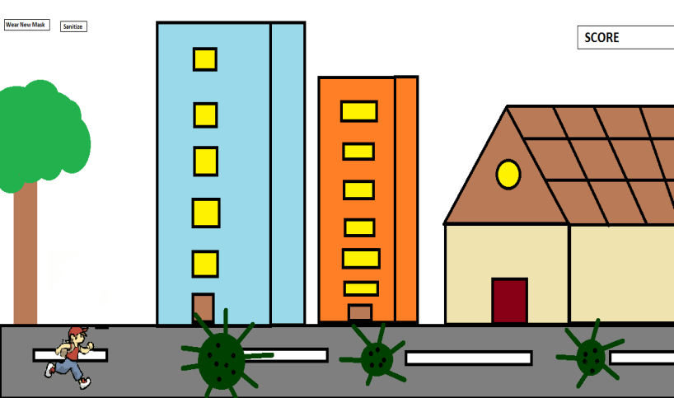

AN IMAGINARY ANIMATED PICTURE ABOVE

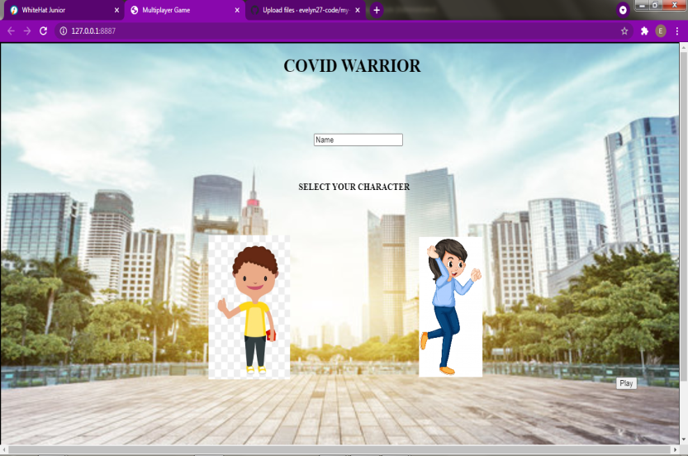

IMAGES OF GAME IN PROGRESS [ABOVE & BELOW]

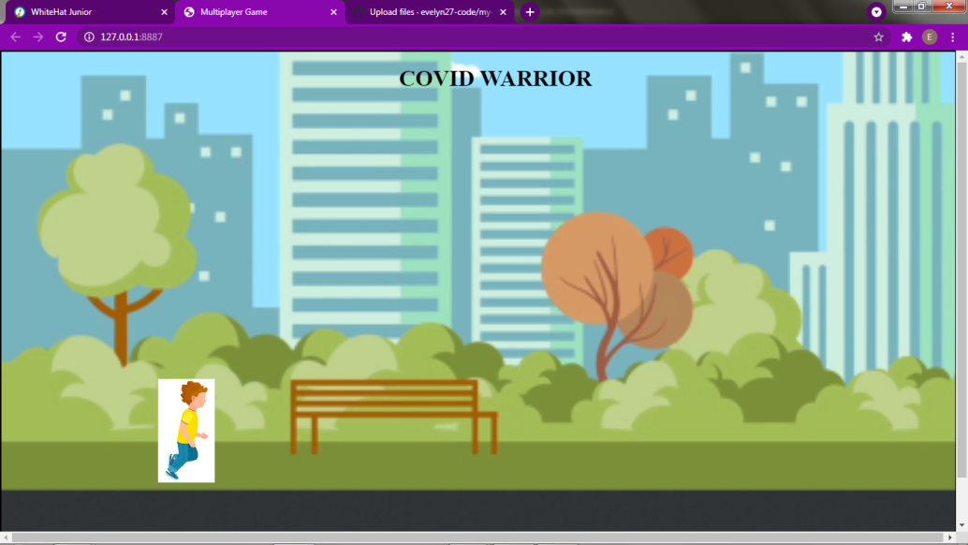

7. How do you plan to make your game engaging?

🡪By allowing player to select their desired player.

🡪 Adding entertaining sounds

🡪 Adding an interseting goal.[GET VACCINATED]

🡪And also being a covid warrior by supplying vaccination to the remote village areas.

🡪 Quizzes for them to answer between and after game.

🡪Giving them badges after a particuar number of score

🡪Giving fun facts and precaution how to avoid corona.