**SCHOOL INFORMATION MANAGEMENT SYSTEM**

**TEACHER INFORMATION MANAGEMENT SYSTEM AND AUTOMATIC GENERATED TIMETABLE**

**THESIS**

**SYSTEM DEVELOPMENT**

*by*

*Evelyn Kharisma 1701320825*



**BINUS INTERNATIONAL**

**BINUS UNIVERSITY**

**JAKARTA**

**(2017)**

**SCHOOL INFORMATION MANAGEMENT SYSTEM**

**TEACHER INFORMATION MANAGEMENT SYSTEM AND AUTOMATIC GENERATED TIMETABLE**

**THESIS**

**Proposed as a requirement for obtaining**

**Sarjana degree at**

**Program Computer Science**

**General Computer Science**

**Education Level Strata-1 (Sarjana / Bachelor)**

*by*

*Evelyn Kharisma 1701320825*



**BINUS INTERNATIONAL**

**BINUS UNIVERSITY**

**JAKARTA**

**(2017) SCHOOL INFORMATION MANAGEMENT SYSTEM**

**TEACHER INFORMATION MANAGEMENT SYSTEM AND AUTOMATIC GENERATED TIMETABLE**

**THESIS**

**Prepared by :**

***Evelyn Kharisma***

***1701320825***

**Approved by :**

**Supervisor**

**Satrio Pradono, S.Kom., M.T.I**

**Lecture Code : D4106**

**BINUS UNIVERSITY**

**Jakarta**

**(2017)**

Table of Contents

Cover Page i

Approval Form ii

Table of Contents iii

Table of Figures v

CHAPTER 1 1

1.1 Background 1

1.2 Scope 2

1.3 Aims and Benefits 3

1.4 Structures 4

CHAPTER 2 5

2.1 Management Information System 5

2.1.1 Web Application 5

2.2 Development Technologies 5

2.2.1 HTML 5

2.2.2 CSS 6

2.2.3 PHP 6

2.2.4 CodeIgniter 7

2.2.5 MySQL 8

2.2.6 Javascript 8

2.2.7 jQuery 8

2.2.8 SQL Injection 8

2.2.9 Encryption and Decryption 9

2.2.10 Hashing 10

2.3 Architecture 10

2.3.1 MVC (Model View Controller) Architecture 10

2.4 Methodology 11

2.4.1 Research Methodology 11

2.4.2 Agile Software Development 12

CHAPTER 3 15

3.1 Existing Problem 15

3.1.1 Paper Based Record Keeping System 15

3.1.2 Survey Result 15

3.2 Existing Solution 16

3.2.1 ManageBac 16

3.2.2 FeKara 17

3.2.3 Fedena 18

3.2.4 aSc TimeTables 20

3.3 Proposed Solution 20

Bibliography 23

**Table of Figures**

Figure 2.1 – PHP market position in terms of popularity and traffic 7

Figure 2.2 Symmetric Key Encription 9

Figure 2.3 Public Key Encryption 10

Figure 2.4 MVC Architecture Diagram [11] 11

Figure 2.5 Waterfall software development [14] 12

Figure 2.6 Agile software development [15] 13

Figure 2.7 Scrum Process 14

Figure 3.1 ManageBac 16

Figure 3.2 ManageBac annual subscription fee 17

Figure 3.3 FeKara – school management software 18

Figure 3.4 Fedena free version modules 18

Figure 3.5 Fedena PRO version modules 19

Figure 3.6 Fedena PRO PLUS version modules 19

Figure 3.7 Fedena Enterprise version modules 19

Figure 3.8 aSc TimeTables pricing 20

# CHAPTER 1

**INTRODUCTION**

## 1.1 Background

Education is a foundation of everyone life as it is said to be a vital human right [1]. It encourages individual freedom and authorization and yields essential development benefits. Education is an influential tool by which economically and socially marginalized individuals can lift themselves out of poverty and fully participate in society [2]. Every child should have the right to an elementary education so that they can have more opportunity to participate actively in society, including employment chances, better health and also to take part in the political procedure.

Parents are the primary educators as they start caring for the baby from the birth day. Children perceive their parent, learn to talk, walk, and interact with people. They observe, discover and experience things around them and develop physically and mentally. Once they are done with primary education, school plays the important part as the institution for the secondary education. School teaches children about knowledge and how to interact with friends and society. Indonesia education system is categorized into, 2 years of kindergarten, 6 years of elementary, 3 years of junior high and 3 years of high school. As a lot of their times are spent in the school, children growth will eventually affected by their school environment. Parents who want the best for their children will evaluate the school quality before entrusting their children to the school.

In order to be more attractive and gain more profits, schools are competing in offering the best education and facilities. School that provides better education, activities and facilities seems more convincing to the parent, and as the result they will take interest to enroll their children in that school. With the increase of the number of students, school should prepare more teachers, school staff, and facilities to improve their quality of education. Managing all of the academic information related to the educational material, resources, activities and studies along with the

non-academic information related to the school administration, operation, financial and library will require extra time and thoroughness.

In this ever-growing IT era, many human life activities have been integrated with technology. Through technology which is reliable, tasks can be completed effectively and efficiently. The XYZ International School, as one of the business established to provide education, intended to implement a better information management system for their school. The school requested for the system to be able to accomplish these main functionality, such as, manage and keep all of the school information securely; provide means for sharing data and education materials as the alternative to the conventional method, file copying using flash disk which can be easily affected by virus; provide means to build trust between school and parent by giving parent a media to monitor their children’s progress; and offers better payment system for school and parent.

## 1.2 Scope

The scope of this project is to develop a working web application which includes several features that may help teachers in the academic and non-academic aspect of school system. This thesis is a collaboration project and the author will handle the teacher and timetable aspect of this project. The features are as listed below:

* Academic
  + Create lesson plan
  + Create Implementation document
  + Sending notification through email as reminder for homework and quizzes
  + Upload materials such as slides, quizzes, homework and references
  + Create, view and edit student report
  + Create full end of year pupil reports for parents
  + Automatic generated timetable for classes schedule
  + Automatic generated timetable for exam along with the seating arrangement and invigilators
* Non-Academic
  + Take daily attendance by homeroom teacher
  + View directory of staffs, students and parents
  + View outstanding payment
  + View book borrowed status by each students
  + Change password
  + Forget password

## 1.3 Aims and Benefits

The expected result of this project is to develop a web application to manage the school information based on the requirements provided by the client. The application will help the school members in managing their academic and non-academic needs efficiently.

The benefits of this project are aimed at the school members, which include school’s staffs, teachers, students, and parents. The benefits are:

* Data management – the main focus is to provide the most efficient and effective way to manage all of the information in the school for the purpose of saving times and eliminating unwanted errors, giving school more chances to increase the education quality.
* Automatic generated timetable – using the data provided, the system will automatically create timetable for all classes in the school without clashes in the teacher’s schedule.
* Better payment process
* Build trust between parent towards the school – the school information management web application provides transparency of school education system for the parent, so that parent can monitor over their children progress and have a better understanding of the school teaching materials and methods. This transparency is to build trust towards the school hence parents can be relieved entrusting their children.

## 1.4 Structures

Chapter 1 Introduction

This chapter explains the background of the thesis project, describing the scope, aims, benefits and the structure of the thesis.

Chapter 2 Theoretical Foundation

This chapter explains the terminologies related to the thesis, including the frameworks, technologies, and also the methodology which will be used to support the solution of the problem.

Chapter 3 Problem Analysis

This chapter analyzes the problem, the existing solution and also the proposed solution in solving the problem.

Chapter 4 Solution Design

This chapter describes the system design of the proposed solution through visual representation of diagrams.

Chapter 5 Implementation and Testing

This chapter discusses the implementation of the solution and the testing of the product.

Chapter 6 Discussion

This chapter evaluated the solution, describes the constraints and problems the author has experiences in developing the web application.

Chapter 7 Conclusion and Recommendation

This chapter concludes the thesis and discusses the possible recommendations for the possible further development.

# CHAPTER 2

**THEORETICAL FOUNDATION**

## 2.1 Management Information System

According to the Microsoft Computer Dictionary 5th edition, management information system is “a computer-based system for processing and organizing information so as to provide various levels of management within an organization with accurate and timely information needed for supervising activities, tracking progress, making decisions, and isolating and solving problems” [3]. It can be simply explained as a computer-based system that helps the management process of information within an organization for the purpose of providing effective and efficient result.

### 2.1.1 Web Application

Web application can be found everywhere over the internet. Most of the website that people commonly see while browsing are web applications. Web application is a website that can be accessed through a Web browser over a network which purpose is to provide solution to a problem with cooperation between clients and server [3].

## 2.2 Development Technologies

### 2.2.1 HTML

HTML (Hypertext Markup Language) is a tag-based notation language used to format documents on the World Wide Web that can be interpreted and rendered by an Internet browser. The HTML tags are used to represent how the Web browser should display the page to the user [3]. HTML usually paired with CSS to provide a better User interface.

### 2.2.2 CSS

CSS (Cascading Style Sheet) is a standard created by the World Wide Web Consortium which include typographical information that usually integrated with HTML with the intention of improving the appearance of a website [3]. This programming language is used to improve User experience by providing better user interactivity using easily understandable interface. In other words, HTML is used for structuring the content of a web page, where else CSS is used for formatting the appearance of the structured content of the web page.

There are three ways to embed CSS style into a web page, such as inline style, internal style sheet and external style sheet. Inline style is specified directly using style attribute inside the related tag elements of the HTML web page. Internal style sheet is embedded inside the head tag of the HTML web page in the style tag. External style sheet is written on a separate file and the link to this file is specified in the web page inside the head tag.

One of the benefit of using external style sheet is the structure of the web page is separated with the style representation. This means that using single style sheet; web designer can apply the style to many web pages. This also applies vice versa, where a web page can have different display using multiple style sheets.

### 2.2.3 PHP

PHP was originally an acronym of Personal Home Page with the later versions standing for Hypertext Preprocessor. It is an open source scripting language created for web development purpose which is integrated with HTML documents to execute server-side interactive functions and generate a dynamic web page [3]. It runs on all major operating systems and is primarily used with Linux, UNIX and Windows Web servers. PHP may be embedded in Web page and used to access and present database information. The diagram below shows that in term of popularity, PHP is a server-side programming language which is used by many sites in the network [4]. Some popular website like Facebook, Twitter, Wikipedia and Baidu are also using PHP.

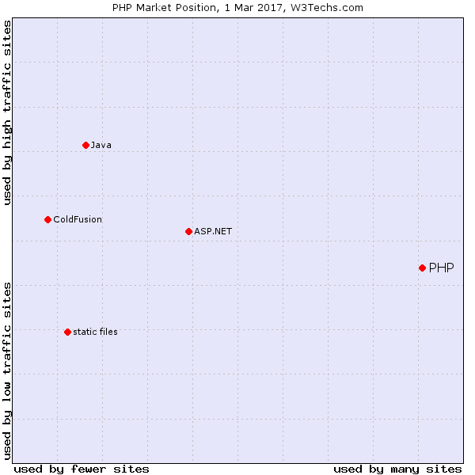

Figure 2.1 – PHP market position in terms of popularity and traffic

.

### 2.2.4 CodeIgniter

According to Codeigniter official website, Codeigniter is “a powerful PHP framework with a very small footprint, built for developers who need a simple and elegant toolkit to create full-featured web applications” [5]. Codeigniter uses the MVC (Model View Controller) as its architecture. It also provides functions and libraries which are ready to use so the development process of the web application become easier.

### 2.2.5 MySQL

MySQL is a widely used open source Relational Database Management System (RDBMS), developed by Oracle Corporation. It has compatibility with a wide number of platforms and often used in web application to store and organize data [6]. It uses Structured Query Language (SQL) queries that include Data Definition Language (DDL), Data Manipulation Language (DML), and Data Control Language (DCL) which allows developer to create, insert, update, drop and modifies access privileges of the database.

### 2.2.6 Javascript

Javascript is a language that is loosely related to Java that is well-suited to object-oriented programming which is added to Web page to provide basic online application and functions [3]. Javascript is important programming language in almost all dynamic web pages as it helps adding interactivity to the HTML web page and is supported by major Internet browser such as Mozilla Firefox, Internet Explorer and Google Chrome.

### 2.2.7 jQuery

jQuery is a fast, small, and feature-rich library for JavaScript created to minimize the works of developer by simplifying the amount of code needed to be written [7]. Developer can achieve the intended functionalities using single line of jQuery code instead of multiple lines of JavaScript. jQuery also include several simplified function that makes things like HTML document traversal and manipulation, animation, event handling, AJAX request, etc.

### 2.2.8 SQL Injection

Direct SQL Command Injection is a technique to disclose hidden data, or to override valuable information, or even to execute critical system level commands on the database host by creating or altering existing SQL commands [8]. This is accomplished by building an SQL query through combining the static parameters with user input in the system.

There are some ways to avoid SQL Injection:

* Create customized users with very limited privileges for the database connection.
* Use predefined statements with constrained variables, which are maintained by PDO, MySQLi and other libraries.
* Check the data type of the given input.
* Verify the numerical input using ctype_digit(), change the numeric input type using settype(), and use the input numeric representation by sprintf().
* Use database specific string escape function to quote each non numeric user input value, which is to be passed into database.
* Do not print out any database specific information.
* Do not let users directly access tables or views.

### 2.2.9 Encryption and Decryption

Encryption is the technique of encoding data for the purpose of preventing unauthorized access, specifically during transmission. It is usually based keys, or codes, that are necessary for decoding or reconstruct the data to readable form. Decryption is the technique of restoring the initial form from the encrypted data [3].

There are two types of encryption as defined below [9]:

* Symmetric Key Encryption, which the encoding and decoding of cipher text uses the same cryptographic keys.

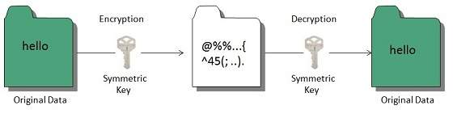

Figure 2.2 Symmetric Key Encription

* Public Key Encryption, which uses two keys that are mathematically linked with each other, one is a secret key and one is the public key.

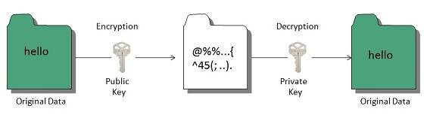

Figure 2.3 Public Key Encryption

### 2.2.10 Hashing

In term of security, hashing is a process used to encrypt data and produce unreadable hash values. The hash function is the method that generates the hash code, which helps in protecting data from unauthorized users during transmission process [9]. Hashing algorithm equipped with a technique to validate that the input expected is the same as the input sent. It can receive a plain text as input and then generate a value based on that.

## 2.3 Architecture

### 2.3.1 MVC (Model View Controller) Architecture

The Model-View-Controller (MVC) pattern separates the modeling of the domain, the presentation, and the actions based on user input into three separate classes [10]:

* Model – The business layer
  + The Model handles the data of the application. Commonly includes storing the states of the data or manipulating and retrieving the data.
* View – The display layer
  + The View provides the data representation to the user.
* Controller – The input control
  + The Controller responsible for managing the communication between Model and View along with user interaction.

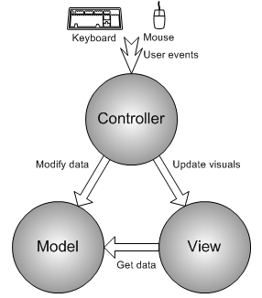

Figure 2.4 MVC Architecture Diagram [11]

As MVC isolates between each layer, it gives convenience for developers to make changes in one layer without affecting the other two layers.

Using MVC pattern in project development gives following benefits:

* Supports multiple views – because there is no direct dependency between Model and View, the user interface can display numerous views of the same data synchronously.
* Accommodates change – user interface change rapidly compared to business model. As the Model and View are independent components, changing the View does not affect the model.

## 2.4 Methodology

### 2.4.1 Research Methodology

The research methodology of this project will be done based on the following steps:

1. Define the problem.
2. Gather information through observation and research from various sources.
3. Conduct a survey to gather further information. The survey will be spread through online methods and the target audience for the survey will be focused on people related to school environment, such as school staffs, teachers, students and parents.
4. Design the solution to the problem.
5. Development and implementation.
6. Testing the solution.
7. Evaluate the solution.

### 2.4.2 Agile Software Development

Agile software development is an iterative project management methodology mainly used for software development. It is an alternative to the traditional waterfall method. The waterfall method is a linear and sequential approach to project management where each development phase needs to be completed before moving to the next phase and developers are not allowed to revisit the previous phases once it is completed [12]. Unlike the waterfall method, agile gives the opportunity for developers to revisit the steps, allowing more flexibility and changes to fit the requirements of the clients [13].

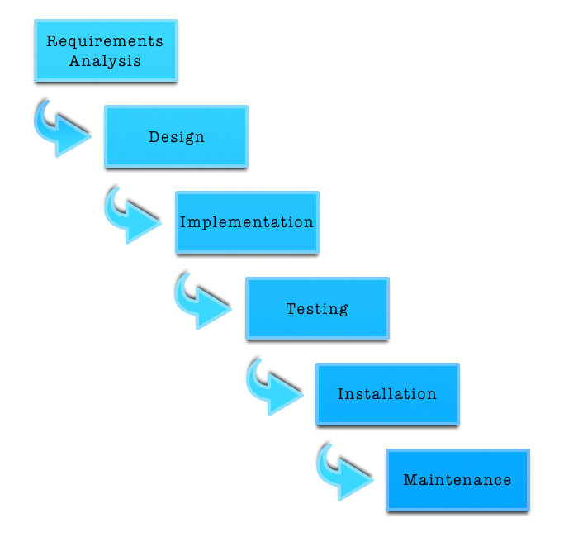

Figure 2.5 Waterfall software development [14]

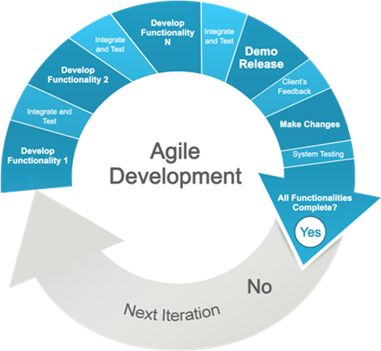

Figure 2.6 Agile software development [15]

The author decides to implement the agile software development as it allows developer to constantly revisit the completed phase to accommodate with client feedbacks, continuously re-evaluate and adapt the solution to optimize the final product. This method is utilized by developing the functionalities for the web application in cycles, where each of the function is being developed, integrated, tested and revised iteratively.

#### 2.4.2.1 Scrum

Scrum is one of the agile software development methods, which has a lightweight framework and most widely-used. It focuses on how to manage project within a team-based development environment [16]. In Scrum, the entire project is timed boxed into several parts called *Sprints*, which defines the incremental and iterative work processes needed to fulfill the requirement defined in the backlog which must be finished in 1 to 4 weeks. *Backlog* is list of priority requirements and features defined by the client and can be changed anytime. Scrum is best suited for this project as it needs to get constant feedback from the clients.

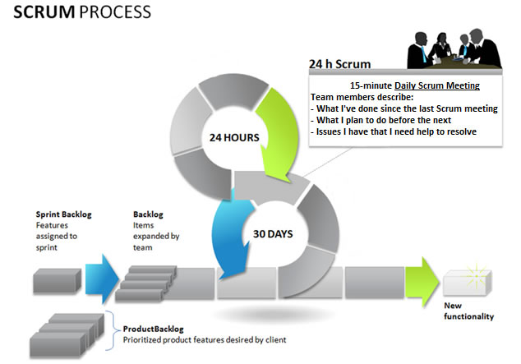

Figure 2.7 Scrum Process

# CHAPTER 3

**PROBLEM ANALYSIS**

## 3.1 Existing Problem

School is an institute which purpose is to deliver education for children. To provide knowledge and skill, school should be equipped with teachers, facilities and staffs. Managing a school, building trust between all its members and organizing all the data related to school are a difficult challenge for school management.

### 3.1.1 Paper Based Record Keeping System

This system is the manual record keeping system, in which all administration procedure, data management, planning, and decision making are done manually and recorded on papers. There are some fallbacks using paper-based record keeping systems:

* Need a lot of paper to write all of the related records
* Need a lot of space to store all of the documents
* Need a lot of time to search for specific data when needed
* Need a lot of time to produce each reports and documents
* There may exist duplication of data entry
* No data backup data and records in case of fire or theft

### 3.1.2 Survey Result

To gain more information, the author has conducted a survey and has received responses from a total of numbers people. The survey is focused on people related to the educational field, such as teachers, students, parents, and schools’ staffs. Below are the summary of the survey results:

## 3.2 Existing Solution

### 3.2.1 ManageBac

ManageBac is an online learning platform focus on IB world schools which purposes are to save time and eliminate paperwork which enables efficient curriculum planning, assessment and reporting [17]. It also strives to enhance communication between school, students and parents. ManageBac is a service provided by Faria Systems Inc. founded in 2006 and has been in business for eight years by serving IB school community as their core customers. According to ManageBac official website, “ManageBac is the trusted choice of over 2,000 leading IB schools and 4 in 5 IB Diploma students globally” [17]. In 2013 ManageBac launched their iOS version which is available on the app store.

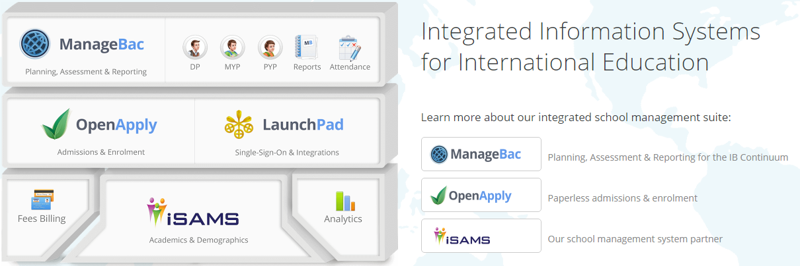

Figure 3.1 ManageBac

ManageBac provide a free 60-day trial for user to have a better understanding of how the web application works before purchasing their annual subscription service which cost varies with the total number of students. It also offer great service through their fast e-mail replies and 24/7 accessibility along with free of charge online training and extensive step-by-step tutorials documented with annotated screenshots.

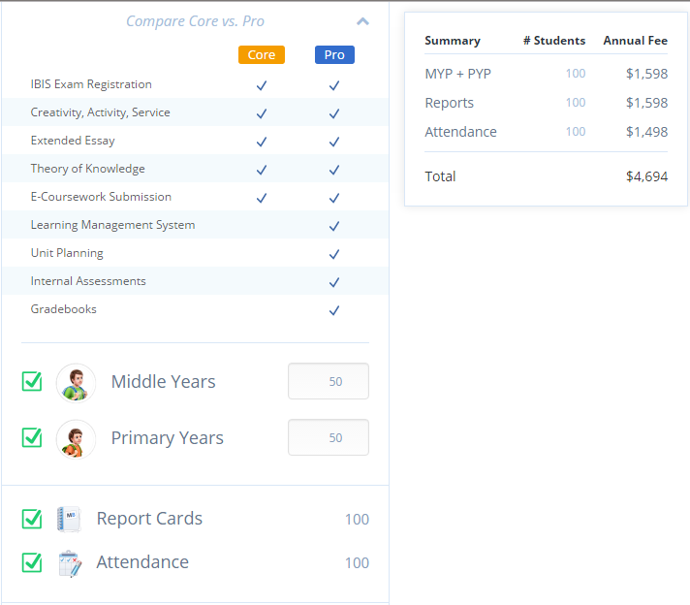

Figure 3.2 ManageBac annual subscription fee

### 3.2.2 FeKara

FeKara is school management software for learning, administration and management activities of educational institutions include schools, universities, and tuition center [18]. FeKara provide software for PC, mobile and tablet to give convenience in accessing information everywhere. It is free to use for up to 50 students and 5 teachers with limited amount of bandwidth and storage. For better service, FeKara offer two types of upgrade version which charged $0.20 per student monthly with unlimited teachers and one-time charge of $350 for unlimited students and teachers. FeKara also allows user to create timetable using drag and drop method which give better visualization in making timetable.

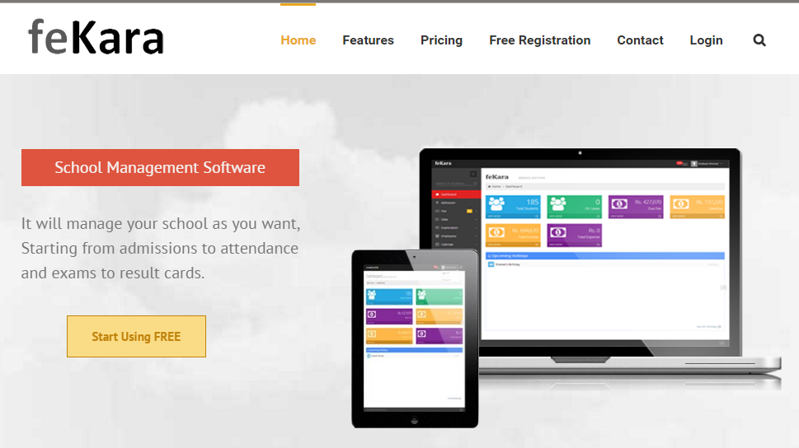

Figure 3.3 FeKara – school management software

### 3.2.3 Fedena

Fedena is all-in-one college and school management software which greatly focuses on handling records [19]. Fedena is used in over 40,000 schools and colleges by over 20 million students and teachers. It provides a large number of features that can help the administration and management of the school. The feature include creating timetable through drag and drop method. Fedena offers 3 types of pricing upgrade with different modules bargain. The PRO version charged $600 annually, the PRO PLUS charged $1000 annually and the Enterprise.

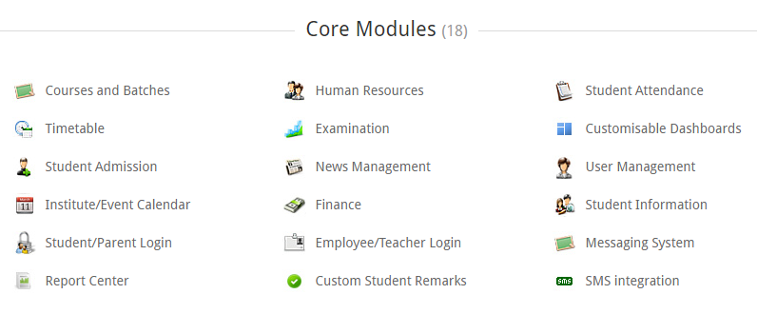

Figure 3.4 Fedena free version modules

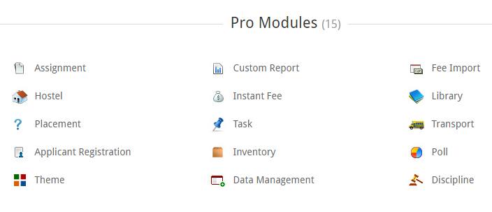

Figure 3.5 Fedena PRO version modules

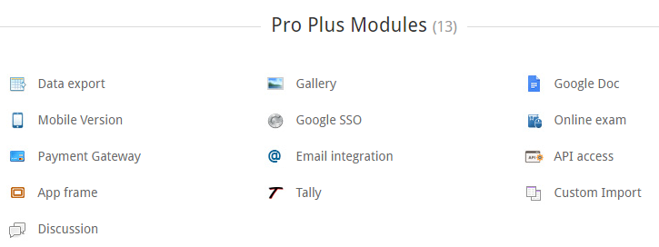

Figure 3.6 Fedena PRO PLUS version modules

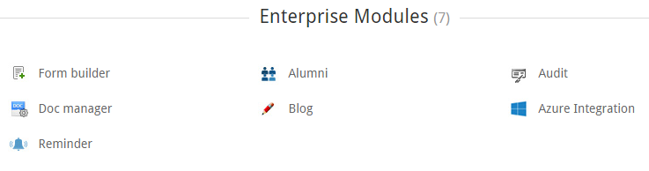

Figure 3.7 Fedena Enterprise version modules

Because of the different modules offered by each version, users may have to purchase the most expensive package if some of the modules that they required are in the highest level version even though they do not need all of the features in that package. This shows that Fedena is low in flexibility for its features customization.

### 3.2.4 aSc TimeTables

aSc TimeTables is quick and easy timetable scheduling software that automatically generate over 5,000,000 possibilities of a beautifully-balanced schedule [20]. This software allows manual adjustment to the schedule and quickly checks for conflicts. It enables user to publish the schedule and make it available for students and teachers on their mobile. It also support electronic form data import and export final schedule into pdf or Excel. aSc TimeTables offers 4 types of pricing as shown in the picture below.

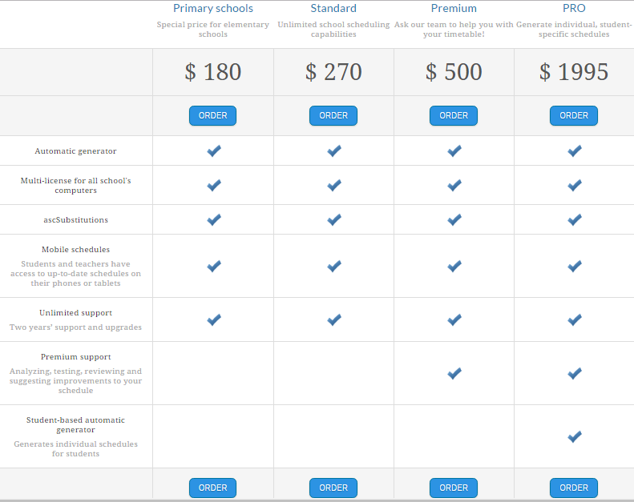

Figure 3.8 aSc TimeTables pricing

## 3.3 Proposed Solution

After thoroughly evaluating the problem and existing solution, the author agree with the existing solution which shows that changing the school system with technology based tool to support the academic and non-academic procedure will make it easy to solve these problems. However, those existing solutions are not suitable enough to satisfy the client’s requirements. As a solution to the problem, the author is assigned to develop a school management information system which sufficient to adapt with the needs of the client.

These are the essential features that school management information system needs to provide for the teacher and timetabling aspect according to the client’s request:

* The system should be exclusively for the XYZ International School
* The system should be online-based
* The facility for users to login into their accounts based on their role in the school
* The ability for users to view and edit their own account information, this include changing password and the forgot password feature
* Provide appropriate views and functionalities based on the login role
* The ability to limit specific features based on each privilege assign to the users.
* The ability for homeroom teacher to take attendance, create homeroom report, and generate mid-term and final-term report for each student
* The ability to view, create, edit, and delete course details such as course overview and lesson plan
* The ability to view and create lesson implementation
* The ability to share slides, assignments, quizzes, and references to students
* The ability to notify student about assignment and quiz deadline
* The ability to download and assign score to students assignment and quiz
* The ability to keep record and create the mid-term and final-term report of student performance of each course
* The ability to keep track on teaching schedule and exam schedule
* The ability to add new teacher to the school system
* The ability to view the students, parents, staffs, and libraries directories
* The ability to view payment details
* The ability to automatically generate timetable of all classes without clash between teacher schedule
* The ability to generate exam schedule and its invigilators for each class

The author intends to satisfy all of the requirements demanded by the client by properly implementing all of the essential features into the web application. The author also aims to provide a good user experience for the school members as the main users of this school management information system. The user experience will be delivered by creating a useful and usable final product.

# Bibliography

[1] United Nations. (1948, December 10). *Universal Declaration of Human Rights.* Retrieved March 3, 2017, from United Nations: http://www.un.org/en/universal-declaration-human-rights/

[2] UNESCO. (2016). *The Right to Education*. Retrieved March 3, 2017, from United Nations Educational, Scientific and Cultural Organization: http://www.unesco.org/new/en/right2education

[3] Microsoft. (2002). *Microsoft Computer Dictionary Fifth Edition.* Washington: Microsoft Press.

[4] W3Techs. (2017, March). *Usage Statistics and Market Share of PHP for Websites*. Retrieved March 3, 2017, from W3Techs: https://w3techs.com/technologies/details/pl-php/all/all

[5] Codeigniter. (2017). *Codeigniter Web Framework*. Retrieved March 1, 2017, from Codeigniter: https://codeigniter.com/

[6] MySQL. (2017). *MySQL 5.7 Reference Manual*. Retrieved March 1, 2017, from MySQL: https://dev.mysql.com/doc/refman/5.7/en/

[7] jQuery. (2017). *jQuery*. Retrieved March 3, 2017, from jQuery: https://jquery.com/

[8] PHP. (2017). *SQL Injection*. Retrieved 3 20, 2017, from PHP: http://php.net/manual/en/security.database.sql-injection.php

[9] TutorialsPoint. (2017). *Data Encryption*. Retrieved 3 20, 2017, from TutorialsPoint: https://www.tutorialspoint.com/internet_technologies/data_encryption.htm

[10] Burbeck, S. (1992, January). *Application Programming in Smalltalk-80: How to use Model-View-Controller (MVC).* Retrieved March 1, 2017, from ResearchGate: https://www.researchgate.net/publication/238719652_Applications_programming_in_smalltalk-80_how_to_use_model-view-controller_mvc

[11] Ahn, S. H. (2016). *OpenGL Windows GUI Application*. Retrieved March 1, 2017, from http://www.songho.ca/opengl/gl_mvc.html

[12] Steven, P. M. (2013). *Parallel Worlds: Agile and Waterfall Differences and Similarities.*

[13] Lotz, M. (2016). *Waterfall vs. Agile: Which is the Right Development Methodology for Your Project?* Retrieved March 1, 2017, from SegueTech: http://www.seguetech.com/waterfall-vs-agile-methodology/

[14] Haughey, D. (2010, December 23). *WATERFALL V AGILE: HOW SHOULD I APPROACH MY SOFTWARE DEVELOPMENT PROJECT?* Retrieved March 1, 2017, from Project Smart: https://www.projectsmart.co.uk/waterfall-v-agile-how-should-i-approach-my-software-development-project.php

[15] Sybite. (2017). *Our Approach*. Retrieved March 1, 2017, from Sybite: http://www.sybite.com/approach.html

[16] Pawar, R. P. (2015). A Comparative study of Agile Software Development. *IOSR Journal of Computer Engineering (IOSR-JCE)*, 01-08.

[17] ManageBac. (2017). *An Introduction to ManageBac*. Retrieved March 2, 2017, from ManageBac: http://managebac.com/faq

[18] feKara. (2014). *feKara*. Retrieved March 2, 2017, from feKara: https://fekara.com/

[19] Fedena. (2017). *Fedena*. Retrieved March 2, 2017, from Fedena: http://www.fedena.com/

[20] aSc, A. S. (2017). *aSc TimeTables*. Retrieved March 2, 2017, from aSc TimeTables: http://www.asctimetables.com

[21] Cheng, Y. &. (2000). Implementation of School-Based Management: A Multi-Perspective Analysis of the Case of Hong Kong. *International Review of Education*, 205-232.

[22] De Grauwe, A. (2005). Improving the Quality of Education through School-Based Management: Learning from International Experiences. *International Review of Education*, 269-28.

[23] Deslandes, R. &. (2005). Motivation of Parent Involvement in Secondary-Level Schooling. *The Journal of Educational Research*, 164-175.

[24] Halsey, P. (2005). Parent Involvement in Junior High Schools: A Failure to Communicate. *American Secondary Education*, 57-69.

[25] Park, H. (2008). The Varied Educational Effects of Parent‐Child Communication: A Comparative Study of Fourteen Countries. *Comparative Education Review*, 219-243.

[26] Shah, M. (2014). Impact of management information systems (MIS) on school administration: What the literature says. *Procedia*, 2799-2804.

[27] Shelly. (2015). Comparative Analysis of Different Agile Methodologies. *International Journal of Computer Science and Information Technology Research*, 199-203.