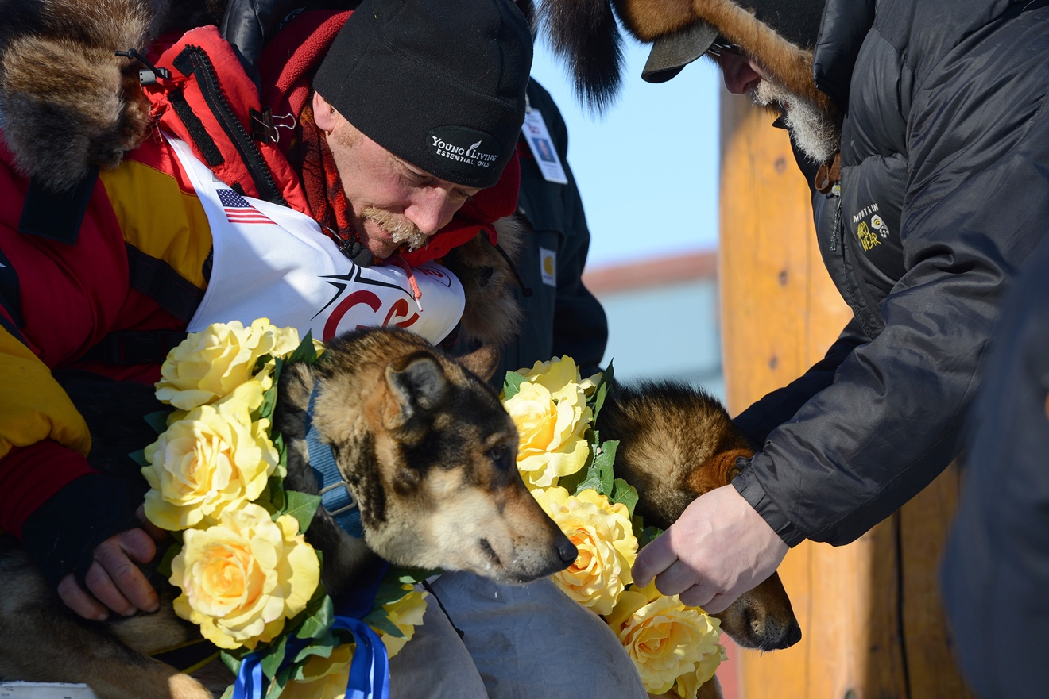

Mitch Seavey's lead dogs receive flower garlands for being the first-place winners of the 2017 Iditarod. https://www.jber.jb.mil/News/Photos/igphoto/2001717809/

**Interesting Info about the Iditarod 2017**

**The Last Great Race on Earth®**

Evelyn Zayas | Applied Data Science Capstone | 1/8/19

# Introduction

# Mushers spend an entire year getting ready and raising the money needed to participate in the Iditarod, a 1,000 mile race from the interior of Alaska to the Bering Sea coastal town of Nome. Some prepare while holding down a full-time job. In addition to planning the equipment and feeding needs for themselves and their 16-dog teams for up to three weeks on the trail, hundreds of hours and hundreds of miles of training have to be put on each dog team. For this project, some important facts and figures about the 2017 Iditarod Race will be presented.

# Data

# The main dataset for this analysis was retrieved from Kaggle at https://www.kaggle.com/iditarod/iditarod-race It includes the musher's name, number and country, checkpoint name and location, distance in miles from the last checkpoint, time from departure at the last checkpoint, date and time of arrival and departure, layover time at the checkpoint, and the number of dogs at arrival and departure at each checkpoint.

# Foursquare location data was used to discover points of interest in the town of Nome, the endpoint of the race.

# Methodology

After loading the main dataset, inferential statistics such as number of dog teams, the origin and count of what country the teams were from, and the geographic location of the 17 checkpoints along the path of the race.

A folium map was created that shows the 17 checkpoints ranging over 979 miles between Fairbanks, the official start of the race, to the westernmost endpoint of Nome.

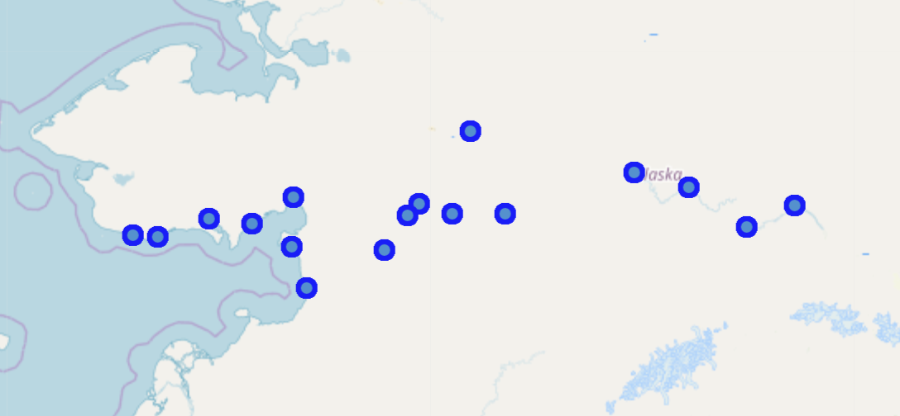

Next, the number of dog teams that made it to each checkpoint and their status (55 veteran vs. 26 rookie teams) was determined:

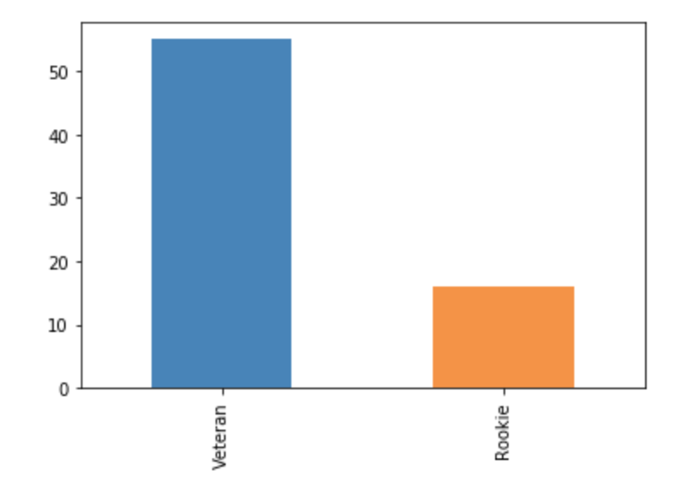

Statistical information about the 64 teams that completed the race (made it to Nome) was uncovered.

K-means clustering was used to look at the relationships between the time, speed, and number of dogs.

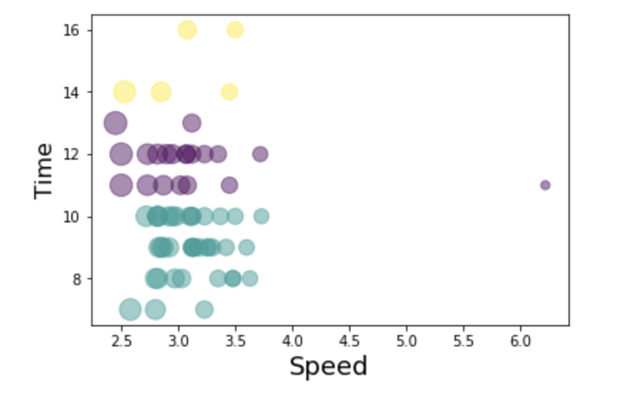

Lastly, the FourSquare API to obtain restaurant info for Nome.

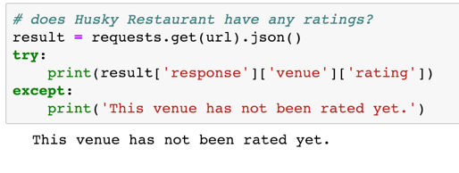

# Results

Statistical information about the 64 teams that completed the race (made it to Nome) uncovered an interesting observation about the difference in how many dogs were in each team at the end of the race. The top five finishers ended with very differing dog teams:

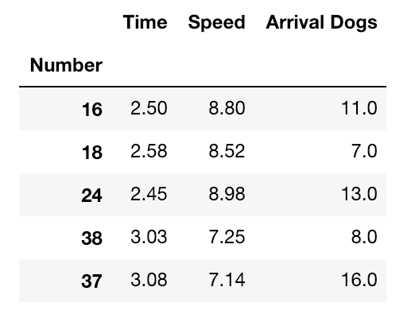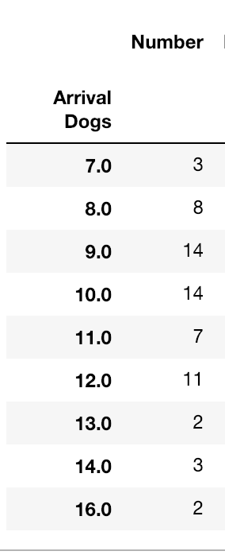

# Discussion

# There were just as many teams that finished the race with less than half the dogs they started out with than those who finished the race with more than half. 55 veterans and 16 rookies started the race, and 50 veterans and 14 rookies finished the race. All of the top 10 finishers were veteran teams.

From this analysis, the number of dogs on a dog team does not appear to be a significant factor.

# Conclusion

2017 Iditarod race with a starting point of Fairbanks, Alaska, to the tiny town of Nome on the Bering Sea was reviewed. From Fairbanks, 72 dog sled teams set out, and 64 teams made it through treacherous conditions to make it to Nome.