Evelyn Du
- Publications
- Social Actitivies
- About
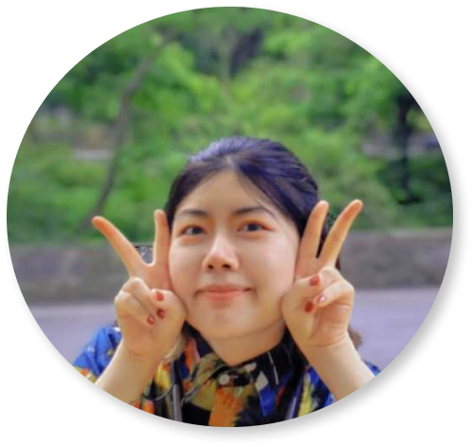

Evelyn Du

Social Activities
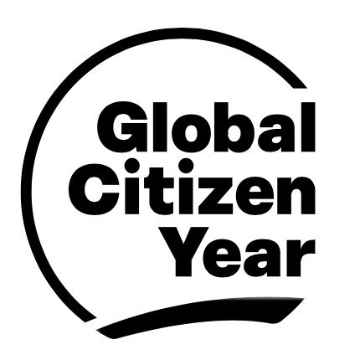
As my gap year project,Global Citizen Year is an international education non-profit organization focused on youth empowerment, aiming to connect world innovation and change leaders through first-class academic and practical projects, and cultivate a new generation of world youth leaders to jointly address global challenges including climate change, disease prevention, improved education, and poverty eradication.
Under the guidance of Global Citizen Year, I held large local workshops and participated in designing like:
- Carbon Cycle
- Zero-Carbon Challenge
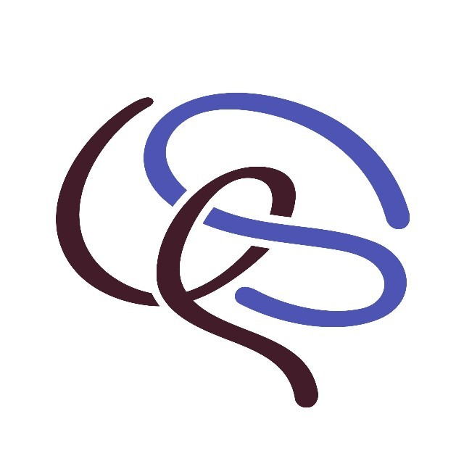
As the founder of VIRA, which is one social enterprise, I believe in the strength of Metaverse for EDUCATIONAL EQUATLITY and SUSTATINABILITY through our social innovation toolkits and EdTech software.Registered in China, committed to build open-source virtual STEAM communities under the “Edu+” ecosystem. We also have the mission as follows:
• Plan marketing, creative writing, and graphic design for WeChat and Instagram.
• Design social innovation tools for Better workshops in partnership with B Corps CN.
• Conduct Project-based Learning sessions and assist Product R&D Department in curriculum design.

📌 Memorabilia
Time | Event
Feb 2021 | Be invited to be the guest speaker in Youth Movers Programme to share our social impact
Feb 2022 | Hold the International Meeting
Apr. 2021 | Play the role of media and marketing partner of the 12th Harvard China Education Symposium
Dec. 2021 | Join the UN Global Compact as a corporate member
Mar. 2021 | Become the official partner of the China Regional Alliance of Invention Convention Worldwide
Jul. 2022 | Be rewarded more than 100K USD by our sponsors
Dec. 2022 | Be selected and accelerated in Watson Institution, one of the top communities for next-gen entrepreneurs
2023 | Stories continued...

🧩 Extention Projects
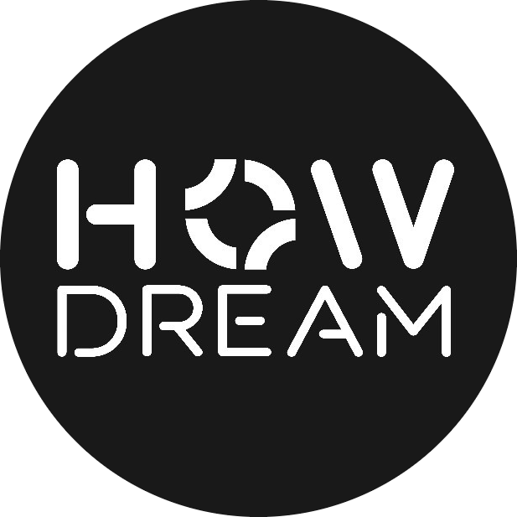
The principle of me to start Howdream is similar to VIRA. As the ex-business manager, I focused more on art therapy.We started from the Watson Institution 2021 Shanghai Workshop.
We are committed to assisting Chinese youth—both locally and abroad—in exploring personal development, family and campus relationships, cultural integration, and educational equity through creative products, multimedia content, and workshops.
- Cooperated with EdwithU
- Set up channels like handcraft and mailbox
- Supported youngsters in dealing with mental pressure
- Advocated for women's power
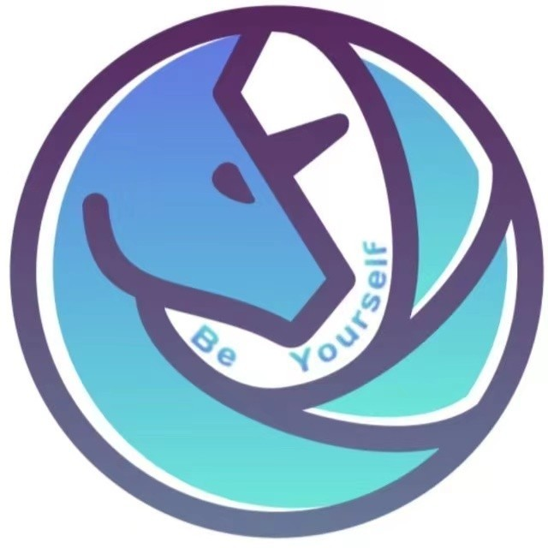
Under the concept of Education Equality, I've supported as a core member in the iDreamer initiative.
- Everything here is for University Students in China.
- This project pays more attention to Life Planning and Mental Health Platform.
- This project has also been selected and accelerated by i-Lab Harvard Accelerator.

📌 Memorabilia
Time | Event
Nov. 2021 | Be Selected for Youth Venture Capital Joint Action
Mar. 2022 | Be Selected into the U35 Lise
Jun. 2022 | Be Selected into the Global Citizen Year
Feb. 2023 | Develop the Canadian Branch
In general,as the first generation college student born in one small town of the southwestern China,I consistently show interest to public-goods,especiall for the education equality and youngster therapy in SDGs. Under the principle of expressing better education to more people,I’ve started the country-round tutoring and speech jobs since the start of undergruate study

©2019 - 2025 by Evelyn Du
Powered by Hexo & Academia Theme

