Pocket Chang'An / 口袋长安

> 世间已无长安城

# 1. Intro / 游戏简介

"Pocket Chang'An" is a 64 cards Deck building game which focused on Chang'An City in Tang Dynasty.

「口袋长安」是以开元天宝年间的长安城为背景的，使用64张卡牌进行游玩的桌面游戏。

# 2. Rules / 游戏规则

## 2.1 No of Players / 游戏人数

"Pocket Chang'An" supports 1 - 4 players.

游戏人数：1 - 4

## 2.2 Setup / 初始设置

There're 4 types of cards: Military(Icon: Sword), Religion(Icon: Pagoda), Economy(Icon: Copper Coins) and Culture(Icon: Book), Each type has 16 cards, with number 2 - A(like Poker) and 3 wild cards(with Star) on them.

游戏中有四种类型的卡牌：军事（图标：宝剑）、宗教（图标：浮屠）、经济（图标：铜钱）和文化（图标：书简），每种类型的卡牌均有16张，其中十三张数字牌从2到A（类似扑克），和三张特殊牌（印有星星）标志

Shuffle all cards then deal 6 to each player. flip 8 cards face up and separate them into 4 columns, one type each. Sorted the columns by number of cards in ascending order, we called those cards in 'Royal Area'. Remain cards form 'Draw Deck'.

洗混所有卡牌并发给每名玩家六张，然后翻出八张牌，按照卡牌类型排成四列，每列都按照卡牌数字顺序从小到大排列，称之为「公共区域」【。公共区域的卡牌排序仅为整洁，对游戏过程没有影响】；然后将剩余卡牌放置一边形成「牌堆」。

## 2.3 Player Turn / 玩家回合

Eldest player become the start player, then play clockwise. In each player's turn, he/she can perform 2 actions, each choose from those 3 listed below:

1. Play:

- Play a card in front of him/herself, following the rules below:

- If there haven't a column matched this card's type(Military, ...), form a new one,

- If there have one already, the card's number __MUST BE BIG__ than the last one in this column, and some additional conditions(described on the card) __MUST BE MET__.

- A is the biggest number while 2 is the smallest, like Poker game.

- When a card is successful played, Trigger the event or perform the action(if have) on the card.

- We called the cards played in front of a player his/her 'Urban Area'

2. Buy:

- Discard a card to gain a card from 'Public Area' and put it in your hand, or directly play it on the table if conditions were met.

- If the card discarded is the same type of the one gain, number of it __MUST BIGGER_THAN_OR_EQUAL_TO__ the one which you gain. If not, number __MUST EXACTLY SAME__ with the one gain.

- Wild cards could be considered as any number.

3. Draw: Simply draw the top card of 'draw deck' to your hands.

Then player's turn came into 'Refill hands' phase:

1. If any cards in player's 'Urban Area' provide ability which let him/her drawing cards, draw as card described.

2. If hands' size is more than 6 cards, discard to 6.

Whenever a card in 'Royal Area' was bought:

1. Flip a new cards from 'draw deck' to refill.

Notice:

1. Whenever the 'draw deck' is empty, shuffle the cards in discard pile to form the new 'draw deck'.

最年长的玩家成为初始玩家，游戏以顺时针方式轮流进行；在每个玩家的「行动阶段」，他/她可以执行两个动作，每个均从如下三个动作中选择一个：

1. 打出卡牌，须遵守如下规则：

- 如果玩家面前的「城市区域」（坊）没有对应类型的卡牌，则形成新的一列；

- 如果已有对应类型的卡牌，则新出卡牌必须放置于该列的末尾，且卡牌上的数字需大于等于该列末尾之前卡牌的数字；如果新出卡牌有其他前提，也必须满足该前提；

- 数字大小为从2到A，2最小，A最大；

- 当一张卡牌有「打出效果」（详见卡牌描述）且被成功打出时，执行该效果；

- 特殊牌可视为任意数字【，但一经打出，即被视为其打出之前该列末尾卡牌的数字，若形成新的一列，则视为2】

2. 购买卡牌，须遵守如下规则：

- 弃掉一张手牌，从「公共区域」获得一张卡牌，获得的卡牌可进入手牌或直接打出（如果满足条件）；

- 如果弃掉的手牌和获得的为同一类型，则弃掉卡牌的数字必须 大于等于 获得卡牌的数字；如果为不同类型，两者数字必须 相同

- 特殊牌可视为任意数字【，且特殊牌参与购买时被视为的数字可以与它被打出时被视为的数字不同】

3. 抓牌，获得牌堆顶最上面一张牌。

然后进入「弃牌/补牌阶段」：

1. 如果玩家「城市区域」的卡牌提供了补牌能力，按照上面的说明执行；

2. 如果玩家手牌数量超过了六张，弃到六张为止。

任何一张「公共区域」的卡牌被买走/弃掉时：

1. 从牌堆补充一张到「公共区域」，依然按照类型和数字大小排列。

如果任何时候牌堆被抓光，洗弃牌堆形成新的牌堆。

## 2.4 Game End / 游戏结束

There're several ways to end game:

1. Some 'End Game Events' come to play, which means were played into some player's 'Urban Area'.

2. Both 'draw deck' and discard pile are empty.

3. Some reasons not mentioned, such as some player(s) surrender.

From the player who triggered 'Game End', each player perform the last turn until all players played same number of turns then come to SCORE.

游戏在满足如下条件之一时结束：

1. 某些标注有「结束游戏事件」的卡牌进入玩家的城市区域；

2. 牌堆和弃牌堆均为空；

3. 其他条件，例如有人掀桌

从触发游戏结束的玩家开始，每人执行一个回合（对触发游戏结束的玩家即为完成其回合）直到所有玩家执行过的回合数相同，然后进入游戏计分

## 2.5 SCORE / 游戏记分

Each Player's basic score equals to the amount of cards in his shortest column multiplied by sum of the amount of remain 3 types, sum up with 'Special Score' provided by cards in his 'Urban Area'.

每名玩家的得分等于他面前四种类型的列最短一列卡牌的数量，乘以其他几列卡牌数量之和；然后加上「城市区域」中标注有「额外计分」的卡牌提供的分数。

Score Example / 记分示例：

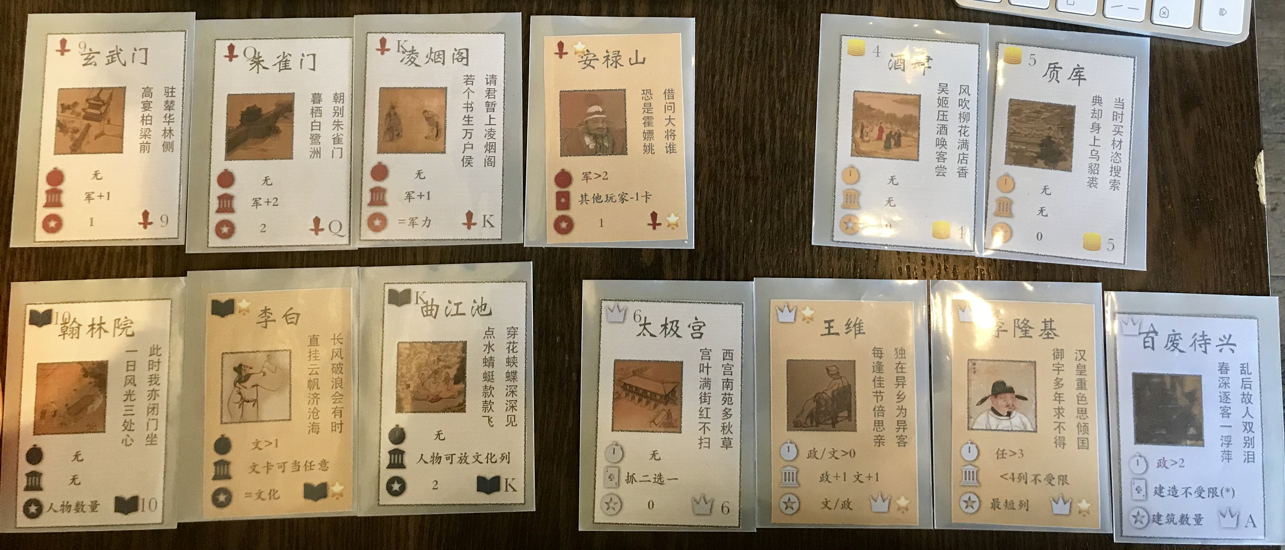

 As above, calculate your base points first:

1. Economy points = 2

2. Culture points = 3 (amount of cards) + 1 (Wang Wei) = 4

3. Politics points = 4 + 1(Wang Wei) = 5

4. Military points = 4 + 1(Xuan Wu Men) + 2(Zhu Que Men) + 1(Ling Yan Ge) = 8

So base score = 2(minimum of four types) * (4+5+8) = 34

Let’s continue to bonus points:

Bonus score = 1(Xuan Wu Men) + 2(Zhu Que Men) + 8(Ling Yan Ge, equals to military points) + 1(An Lu Shan) + 4(Han Lin Yuan, where you have 4 heroes in your urban area: LiBai, Wang Wei, An Lu Shan and Li Long Ji) + 4(Li Bai, equals to culture points) + 2 (Qu Jiang Chi) + 5(Wang Wei, either politics points(5) or culture points (4) ) + 2 (Li Long Ji, equals to minimum of four types) + 8(Bai Fei Dai Xing, equals to amount of your buildings) = 37

So your total score = 34 + 37 = 71

按照上图示意计算得分如下：

1. 经济点数 = 2 （卡牌张数，无其他加成）

2. 文化点数 = 3 + 1（王维加成） = 4

3. 政治点数 = 4 + 1（王维加成） = 5

4. 军事点数 = 4 + 1（玄武门）+2（朱雀门）+1（凌烟阁）= 8

因此玩家基本分 = 2（四项点数最小值）*（4+5+8）= 34分

卡牌加分计算如下：

加分 = 1（玄武门）+2（朱雀门）+8（凌烟阁，军事点数）+1（安禄山）+4（翰林院，人物数量：4）+4（李白，文化点数）+2（曲江池）+5（王维，政治点数（5）或文化点数（4））+2（李隆基，四项点数最小的一项）+8（百废待兴，建筑数量）= 37

因此玩家总得分 = 34 + 37 = 71分

# 3. Card Sample / 卡牌示例

The ‘building’Icon means skills while this card is in your ‘Urban Area’

and the ‘card’ icon mean effects while played into table.

卡牌上的建筑图标表示「在场效果」，卡片图标表示「打出效果」

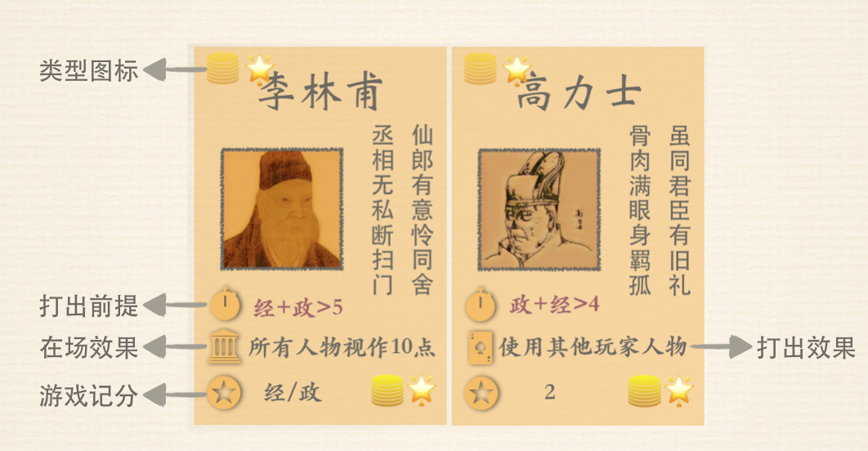

# 4. Cards’ Effects / 卡牌能力说明

1. Culture Wild Card (Li Bai): Can use ‘Culture Cards’ as other type, still have to follow the rules of card number when playing,
2. Culture Wild Card (Du Fu): Only use once per game, choose one type in your ‘Urban Area’ and made this type ‘descend’,
3. Culture Wild Card (Yan Zhen Qing): Do not affect the ability of ‘Li Long Ji’,
4. Culture Q (Guo Zi Jian): Can use cards which types are not ‘Culture’ as ‘Culture Cards’, still have to follow the rules of card number when playing, can make combos with the ability of ‘Li Bai”
5. Economics Wild Card (Li Lin Fu): Wild cards are count as 10, even on buying cards,
6. Economics Wild Card (Gao Li Shi): Copy the ‘play effect’ while played,
7. Economics J (Kai Yuan Sheng Shi): Effect last until the end of your next turn,
8. Economics 10 (Ping Kang Li): After a player finished his/her two actions and before he/she use ‘drawing abilities’ , if there’s wild cards in ‘Royal Area’, pick one to your hands,
9. Economics 9 (Xin Feng Shi): While number of a card in ‘Royal Area’ is even, you can discard any card to buy it,
10. Economics 7 (Da Yi Hang): Draw a card after you ‘Buy’a card,
11. Politics Wild Card (Li Long Ji): If number of types of your cards which in your ‘Urban Area’ is less than 4, you do not need to follow the rule of ‘play cards’, but still have to follow the rule of ‘buy cards’,
12. Politics Wild Card (Yang Yu Huan): Discard cards after you draw(If needed),
13. Politics A (Bai Fei Dai Xing): All players do not need to follow the rule of ‘play cards’ until the end of your next turn,
14. Politics J (Wan Guo Lai Chao): Pick cards from the player who played this card, clockwise,
15. Military Wild Card (An Lu Shan): Only discard cards in players’ ‘Urban Area’, can not discard players’ hands,
16. Military Wild Card (Guo Zi Yi): All actions which could affect player’s hand and cards on‘Urban Area’ are ‘Attack’,
17. Military Wild Card (Ge Shun Han): While the military points are equal, Choose cards from the player who player ‘Ge Shun Han’ then clockwise,
18. Military J (An Shi Zhi Luan): Only discard cards in “Urban Area’,
19. Military 7 (Wong Cheng): Any action which affect players’ ’hands’ does not consider as ‘discard’.
20. 李白（文化*）：可以将类型为「文化」的卡当作其他类型卡使用，但仍然要满足点数限制
21. 杜甫（文化*）：可在游戏的任何时刻选择将某一列变为降序，整局游戏只能使用一次【，降序重新排列之后，后续仍需满足升序条件】
22. 颜真卿（文化*）：在记分和判断是否满足「打出前提」时提供军力和文化，不影响「李隆基」的能力
23. 国子监（文化Q）：可将任何类型的卡当作「文化」卡使用，但仍然要满足点数限制，可和「李白」的能力配合使用；
24. 【贵妃醉酒（文化J）：均分时，如果有多余，则从触发事件的玩家开始，顺时针分配多余的卡牌；】
25. 李林甫（经济*）：买牌时「人物」也视作10点【，无论买还是被买，打出时也视作10点】；
26. 高力士（经济*）：「打出」时复制一名其他玩家人物的「打出效果」；
27. 【姚崇（经济*）：复制一名己方已出现人物的能力；】
28. 开元盛世（经济J）：效果持续到触发事件的玩家的下一个回合结束；
29. 平康里（经济10）：玩家结束动作后补充手牌前，若「公共区域」有人物卡，玩家可选择一张人物卡入手；
30. 新丰市（经济9）：当「公共区域」时的卡牌点数为偶数时，玩家可弃掉任意一张手牌购买之【，JQKA分别视为11，12，13，14】；
31. 大衣行（经济7）：玩家执行完「买牌」动作后，可额外抓一张牌；
32. 李隆基（政治*）：当玩家面前的卡牌类型<4时，无需遵守「打牌」动作的规则，但仍需遵守「购买」规则；
33. 杨玉环（政治*）：在「补牌弃牌」阶段抓牌，注意永远先补牌再弃牌；
34. 百废待兴（政治A）：效果持续到触发事件的玩家的下一个回合结束【，即本回合和下回合，该玩家打出卡牌均不受数字和打出条件的限制】；
35. 【大明宫（政治K）：人物卡放置其上，不需要满足打出条件，在场效果和打出效果均有效，但不得计入基本分点数】
36. 万国来朝（政治J）：挑选时从触发事件玩家开始，按顺时针方向轮流挑选；
37. 【小雁塔（政治10）：抓牌时总是抓取两张，然后弃掉一张到弃牌堆】
38. 安禄山（军事*）：只能弃「城市区域」牌，不影响手牌【，由触发事件的玩家选择】；
39. 郭子仪（军事*）：所有影响玩家手牌和「城市区域」的卡牌的动作均可视为「攻击」；
40. 哥舒翰（军事*）：军力相等时，从打出哥舒翰的玩家开始按顺时针顺序挑选；
41. 【六军驻马（军事A）：从触发事件玩家下家开始按顺时针顺序执行，只能弃「城市区域」牌，由触发事件的玩家选择；】
42. 安史之乱（军事J）：从触发事件玩家下家开始按顺时针顺序执行，只能弃「城市区域」牌【，由触发事件的玩家选择】；
43. 瓮城（军事7）：影响手牌的所有动作均不算作「弃牌」【，可用该牌顶替任何被其它玩家选中要求弃掉的牌】。