WORD Template for IEEE Sponsored Conference Proceedings

First Author Name
Hee Jung Nam/Aiffel, Modulab
email hjnam@modulab.net.com
Second Author Name
Hee Jung Nam/Aiffel, Modulab
email hjnam@modulab.net.com
Third Author Name
Dept. Affiliation, School/Corp.
City, State, Country
email address@net.com

Abstract
In this paper, we describe the test result of BERT project of Aiffel in Modulab .
Keywords
Keywords are BERT, Encoder.

1. Introduction
Although I take Overleaf to practice writing an article, it was not successful because it is maintenance day of the company and it could affect to access to template file according to their posting. Since I was not able to access what I have done so far, I notify it to 나융 퍼실님 and try to what I can do using word format template which is provide by iEEE. It’s hard to accept I lost what I’ve done and have to do again from the beginning but I will do my best to fill this new format as much as possible.

2. Data preprocessing
First step of all the test is to preprocess the given dataset. The detail process is below:

2.1 Adding special characters

2.2 Producing NPS pair

2.3Proucing Masks

2.4 Proucing Masks

2.5 Tokenization

3. Buidling BERT Model
Firstly define three different For body text, please use a 10-point Times Roman font, or other Roman font with serifs, as close as possible in appearance to Times Roman in which these guidelines have been set. The goal is to have a 10-point text, as you see here. Please use sans-serif or non-proportional fonts only for special purposes, such as distinguishing source code text. If Times New Roman is not available, try the font named Computer Modern Roman. On a Macintosh, use the font named Times. Right margins should be justified, not ragged.
The following is an example of what a bulleted list should look like:
- All bullets should start at the same point.
- Spacing between the bullets can vary to produce good column and page breaks.
- The use of hanging indent is recommended.
- Numbered lists should follow similar layout

3.1. Title and Authors
The title (Times New Roman 14-point bold), authors’ names (Times New Roman 12-point) and affiliations (Times New Roman 12-point italics) run across the full width of the page. We also recommend e-mail addresses for all authors. See the top of this page for three addresses. If only one address is needed, center all address text. For two addresses, use two centered columns, and so on. If more than three authors, you may have to improvise.

3.2. Subsequent Pages
For pages other than the first page, start at the top of the page, and continue in double-column format. The two columns on the last page should be as close to equal length as possible.
Table 1. Table captions should be placed above the table
Graphics | Top | In-between | Bottom
Figures | Good | Body text for the tables should be Times Roman 10 pt.
Text | Graphs

3.3. References and Citations
Footnotes should be Times New Roman 8-point, and ragged right. Ragged right was decided because of many web addresses being used.
A numbered list at the end of the article, ordered alphabetically by first author, and referenced by numbers in brackets [1]. See the examples of citations at the end of this document. Within this template file, use the style named references for the text of your citation. The body text of the citation/references section should be 10 pt. Times New Roman.
References should be published materials accessible to the public. Internal technical reports may be cited only if they are easily accessible (i.e., give the address to obtain the report within your citation) and may be obtained by any reader. Private communications can be acknowledged, not referenced (e.g., “[Robertson, personal communication]”). Proprietary information may not be cited.

3.4. Page Numbering, Headers and Footers
Do not include headers, footers or page numbers in your submission. These will be added when the publications are assembled.

4. Pre-training the model
Place tables/figures/images in text as close to the reference as possible (see Figure 1). Figures may extend across both columns to a maximum width of 17.78 cm (7”).
Captions should be Helvetica bold 10-point. They should be numbered (e.g., “Table 1” or “Figure 2”). Please note that the words “Table” and “Figure” are spelled out. Figure captions should be centered beneath the image or picture, and table captions should be centered above the table body.

4.1. Hyper Parameters

4.2. Total paramters and ploting

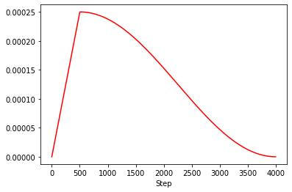
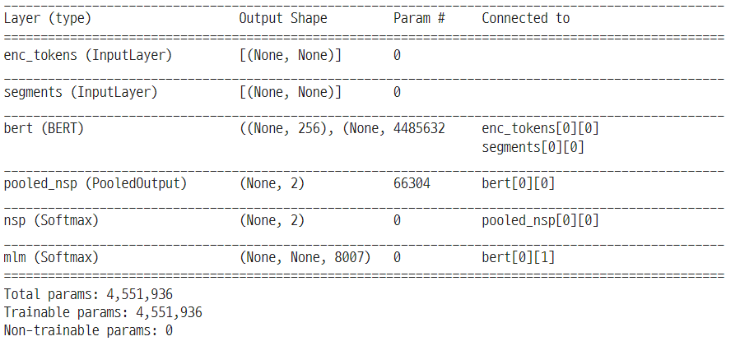

5. Performance Evaluation
The heading of a section should be in Times New Roman Bold 12-point bold, flush left with an additional 6 points of white space above the section head. Sections and subsequent subsections should flush left.
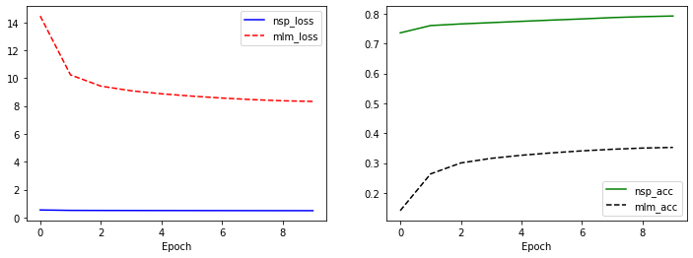

5.1. Subsections
The heading of subsections should be in Times New Roman 11-point bold with only the initial letters capitalized. For subsections and subsubsections, a word like the or a is not capitalized unless it is the first word of the header.

5.1.1. Subsubsections
The heading for subsubsections should be in Times New Roman 10-point italic with initial letters capitalized and 6 points of white space above the subsubsection head.

Acknowledgments
Your appreciation to employers, co-workers, department heads, and/or institutions that issued you a grant can be acknowledged in this section.

References
- Gennari, J., et al., Templates for IEEE Proceedings, available at
<http://www.sheridanprinting.com/ieee/ieee.htm>
- Panther, J. G., Digital Communications, 3rd ed., Addison-Wesley, San Francisco, CA (1999).
- Schneider, M., “Guidelines for Bias-Free Writing,” PhD Thesis, Indiana University, Bloomington, IN (1995).

If Helvetica is not available on your machine, Arial may be used as a substitute.
If necessary, you may place some address information in a footnote, or in a named section at the end of your paper. Please make footnotes Times New Roman 8 pt., this will match the ACM copyright statement when put in place.

