ASSIGNMENTS
과제 3

과 목 : 웹프로그래밍[8]
담당교수 : 교수 김인희
학 과 : 빅데이터트랙
학 번 : 2371209
이 름 : 김주혁
일 자 : 2026년 10월 1일 목요일
실습 1
<!DOCTYPE html>
<html lang="en">

<head>
<meta charset="UTF-8">
<meta name="viewport" content="width=device-width, initial-scale=1.0">
<title>실습 1</title>
</head>

<body>
<p id="clockLine">현재시간: <span id="time">00:00:00</span></p>
<h1><span id="status"></span></h1>

<script>
function getTimes() {
var dt = new Date();
var h = dt.getHours();
var hours = String(h).padStart(2, "0");
var minutes = String(dt.getMinutes()).padStart(2, "0");
var seconds = String(dt.getSeconds()).padStart(2, "0");
var time = document.getElementById("time");
time.innerHTML = hours + ":" + minutes + ":" + seconds;

var clockLine = document.getElementById("clockLine");
var statusE1 = document.getElementById("status");

if (h >= 9 && h < 21) {
statusE1.innerHTML = "영 업 중";
clockLine.style.color = "black";
statusE1.style.color = "black";
document.body.style.backgroundColor = "white";
} else {
statusE1.innerHTML = "영 업 종 료";
clockLine.style.color = "white";
statusE1.style.color = "white";
document.body.style.backgroundColor = "black";
}
}
getTimes();
setInterval(getTimes, 1000);
</script>
</body>

</html>
결과
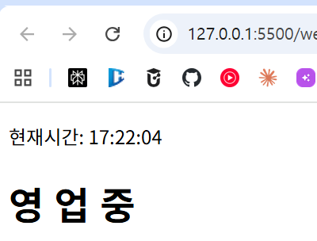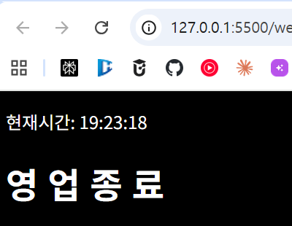
실습 2-1
<!DOCTYPE html>
<html lang="en">

<head>
<meta charset="UTF-8">
<meta name="viewport" content="width=device-width, initial-scale=1.0">
<title>실습 2-1</title>
</head>

<body>
<h1>식물 키우기</h1>

<button onclick = "green.giveLight(15)">빛 공급</button> :
<span id = "light">0</span>
&nbsp;
<button onclick = "green.giveWater(10)">수분 공급</button> :
<span id = "water">0</span>
<br>
<br>
<h3>성장 크기 : <span id = "treeSize">0</span></h3>
<img src = "pot.png" height="30" id="myTree">
</body>

</html>
결과
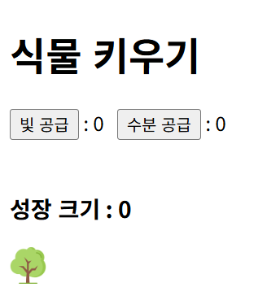
실습 2-2
<!DOCTYPE html>
<html lang="en">

<head>
<meta charset="UTF-8">
<meta name="viewport" content="width=device-width, initial-scale=1.0">
<title>실습 2-2</title>
</head>

<body>
<h1>식물 키우기</h1>

<button onclick = "green.giveLight(15)">빛 공급</button> :
<span id = "light">0</span>
&nbsp;
<button onclick = "green.giveWater(10)">수분 공급</button> :
<span id = "water">0</span>
<br>
<br>
<h3>성장 크기 : <span id = "treeSize">0</span></h3>
<img src = "pot.png" height="30" id="myTree">

<script>
function tree() {
this.light = 0;
this.water = 0;

this.giveLight = function (light) {
this.light += light; // light량 증가
document.getElementById("light").innerHTML = this.light; // 화면 표시
};

this.giveWater = function (water) {
this.water += water; // water량 증가
document.getElementById("water").innerHTML = this.water; // 화면 표시
};
}

let green = new tree();
</script>

</body>

</html>
결과
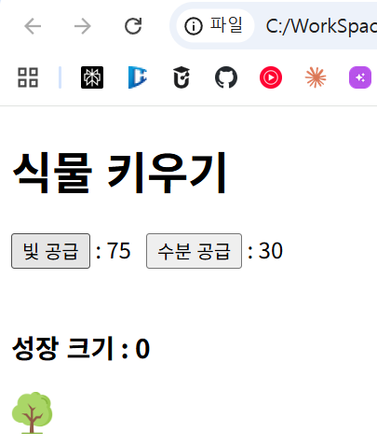
실습 2-3
<!DOCTYPE html>
<html lang="en">

<head>
<meta charset="UTF-8">
<meta name="viewport" content="width=device-width, initial-scale=1.0">
<title>실습 2-3</title>
</head>

<body>
<h1>식물 키우기</h1>

<button onclick = "green.giveLight(15)">빛 공급</button> :
<span id = "light">0</span>
&nbsp;
<button onclick = "green.giveWater(10)">수분 공급</button> :
<span id = "water">0</span>
<br>
<br>
<h3>성장 크기 : <span id = "treeSize">0</span></h3>
<img src = "pot.png" height="30" id="myTree">

<script>
function tree() {
this.light = 0;
this.water = 0;
this.size = 0; // 성장 크기 추가

this.giveLight = function (light) {
this.light += light;
document.getElementById("light").innerHTML = this.light;
this.growth(); // 성장 판단 호출
};

this.giveWater = function (water) {
this.water += water;
document.getElementById("water").innerHTML = this.water;
this.growth(); // 성장 판단 호출
};

this.growth = function () { // tree() 안으로 이동
if (this.light > 0 && this.water > 0) {
this.size++; // 빛, 물 모두 있으면 성장
} else {
this.size--; // 그렇지 않으면 감소
}
document.getElementById("treeSize").innerHTML = this.size;
};
}

let green = new tree();
</script>

</body>

</html>
결과
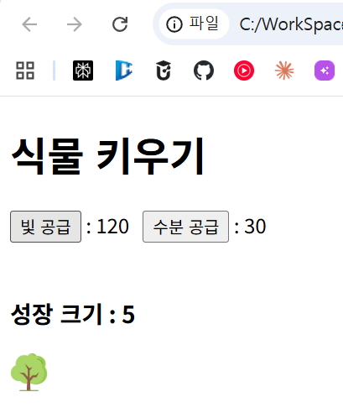
실습 2-4
<!DOCTYPE html>
<html lang="en">

<head>
<meta charset="UTF-8">
<meta name="viewport" content="width=device-width, initial-scale=1.0">
<title>실습 2-4</title>
</head>

<body>
<h1>식물 키우기</h1>

<button onclick = "green.giveLight(15)">빛 공급</button> :
<span id = "light">0</span>
&nbsp;
<button onclick = "green.giveWater(10)">수분 공급</button> :
<span id = "water">0</span>
&nbsp;
<button onclick = "green.giveTemp(5)">온도</button> :
<span id = "temp">0</span>
&nbsp;
<button onclick = "green.giveNutrient(1)">영양분</button> :
<span id = "nutrient">0</span>
<br>
<br>
<h3>성장 크기 : <span id = "treeSize">0</span></h3>
<img src = "pot.png" height="30" id="myTree">

<script>
function tree() {
this.light = 0;
this.water = 0;
this.temp = 0; // 온도 추가
this.nutrient = 0; // 영양분 추가
this.size = 0;

this.giveLight = function (light) {
this.light += light;
document.getElementById("light").innerHTML = this.light;
this.growth();
};

this.giveWater = function (water) {
this.water += water;
document.getElementById("water").innerHTML = this.water;
this.growth();
};

this.giveTemp = function (temp) { // [온도] 버튼: 클릭마다 5도 상승
this.temp += temp;
document.getElementById("temp").innerHTML = this.temp;
this.growth();
};

this.giveNutrient = function (nutrient) { // [영양분] 버튼
this.nutrient += nutrient;
document.getElementById("nutrient").innerHTML = this.nutrient;
this.growth();
};

this.growth = function () {
// 빛, 물이 있고 온도가 15~40도일 때만 성장
if (this.light > 0 && this.water > 0 && this.temp >= 15 && this.temp <= 40) {
if (this.nutrient > 0) {
this.size += 2; // 영양분 있으면 2배 성장
} else {
this.size++;
}
} else {
this.size--; // 그렇지 않으면 감소
}
document.getElementById("treeSize").innerHTML = this.size;
};
}

let green = new tree();
</script>

</body>

</html>
결과
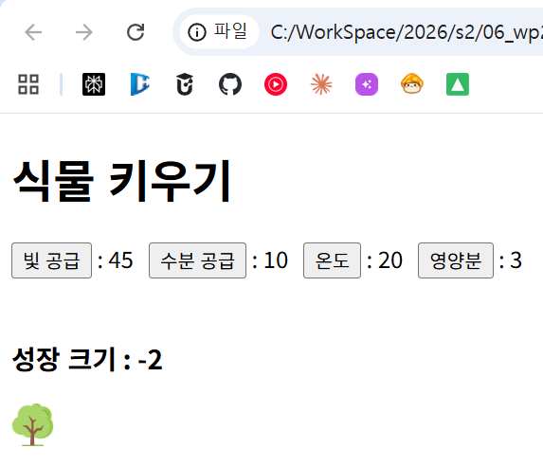
실습 2-5
<!DOCTYPE html>
<html lang="en">

<head>
<meta charset="UTF-8">
<meta name="viewport" content="width=device-width, initial-scale=1.0">
<title>실습 2-5</title>
</head>

<body>
<h1>식물 키우기</h1>

<button onclick = "green.giveLight(15)">빛 공급</button> :
<span id = "light">0</span>
&nbsp;
<button onclick = "green.giveWater(10)">수분 공급</button> :
<span id = "water">0</span>
&nbsp;
<button onclick = "green.giveTemp(5)">온도</button> :
<span id = "temp">0</span>
&nbsp;
<button onclick = "green.giveNutrient(1)">영양분</button> :
<span id = "nutrient">0</span>
<br>
<br>
<h3>성장 크기 : <span id = "treeSize">0</span></h3>
<img src = "pot.png" height="30" id="myTree">

<script>
function tree() {
this.light = 0;
this.water = 0;
this.temp = 0; // 온도 추가
this.nutrient = 0; // 영양분 추가
this.size = 0;

this.giveLight = function (light) {
this.light += light;
document.getElementById("light").innerHTML = this.light;
this.growth();
};

this.giveWater = function (water) {
this.water += water;
document.getElementById("water").innerHTML = this.water;
this.growth();
};

this.giveTemp = function (temp) { // [온도] 버튼: 클릭마다 5도 상승
this.temp += temp;
document.getElementById("temp").innerHTML = this.temp;
this.growth();
};

this.giveNutrient = function (nutrient) { // [영양분] 버튼
this.nutrient += nutrient;
document.getElementById("nutrient").innerHTML = this.nutrient;
this.growth();
};

this.growth = function () {
// 빛, 물이 있고 온도가 15~40도일 때만 성장
if (this.light > 0 && this.water > 0 && this.temp >= 15 && this.temp <= 40) {
if (this.nutrient > 0) {
this.size += 2; // 영양분 있으면 2배 성장
} else {
this.size++;
}
} else {
this.size--; // 그렇지 않으면 감소
}
document.getElementById("treeSize").innerHTML = this.size;
this.resize(); // 이미지 크기 조절 호출
};

this.resize = function () { // 성장 크기에 따라 이미지 크기 조절
let h = 30 + this.size * 5; // 기본 30px + 성장 크기 * 5
h = Math.max(10, Math.min(300, h)); // 최소 10px ~ 최대 300px
document.getElementById("myTree").height = h;
};
}

let green = new tree();
</script>

</body>

</html>
결과
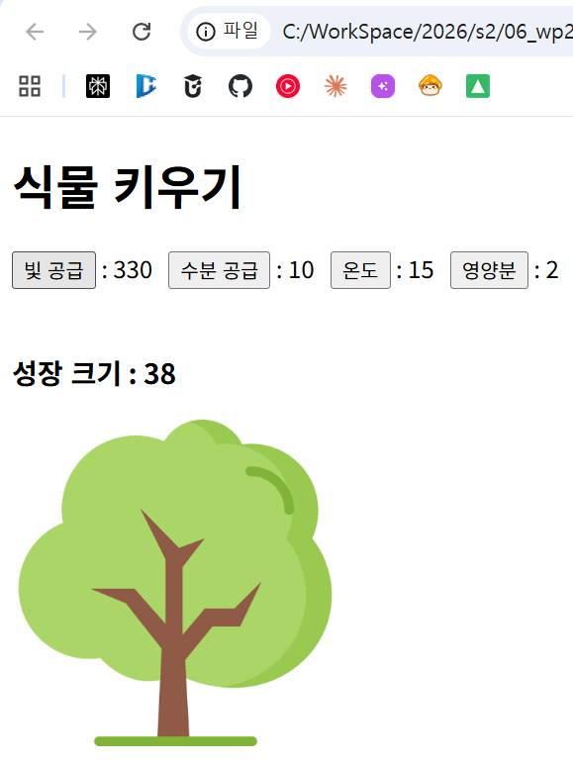
실습 3
<!DOCTYPE html>
<html lang="en">

<head>
<meta charset="UTF-8">
<meta name="viewport" content="width=device-width, initial-scale=1.0">
<title>실습 3</title>
</head>

<body>
<h1>식물 키우기</h1>

<button onclick = "green.giveLight(15)">빛 공급</button> :
<span id = "light">0</span>
&nbsp;
<button onclick = "green.giveWater(10)">수분 공급</button> :
<span id = "water">0</span>
&nbsp;
<button onclick = "green.giveTemp(5)">온도</button> :
<span id = "temp">0</span>
&nbsp;
<button onclick = "green.giveNutrient(1)">영양분</button> :
<span id = "nutrient">0</span>
<br>
<br>
<h3>성장 크기 : <span id = "treeSize">0</span></h3>
<img src = "pot.png" height="30" id="myTree">

<script>
// 리터럴 표기법: 중괄호 { } 안에 프로퍼티와 메서드를 작성 (콤마로 구분)
let green = {
light: 0,
water: 0,
temp: 0,
nutrient: 0,
size: 0,

giveLight: function (light) {
this.light += light;
document.getElementById("light").innerHTML = this.light;
this.growth();
},

giveWater: function (water) {
this.water += water;
document.getElementById("water").innerHTML = this.water;
this.growth();
},

giveTemp: function (temp) { // [온도] 버튼: 클릭마다 5도 상승
this.temp += temp;
document.getElementById("temp").innerHTML = this.temp;
this.growth();
},

giveNutrient: function (nutrient) { // [영양분] 버튼
this.nutrient += nutrient;
document.getElementById("nutrient").innerHTML = this.nutrient;
this.growth();
},

growth: function () {
// 빛, 물이 있고 온도가 15~40도일 때만 성장
if (this.light > 0 && this.water > 0 && this.temp >= 15 && this.temp <= 40) {
if (this.nutrient > 0) {
this.size += 2; // 영양분 있으면 2배 성장
} else {
this.size++;
}
} else {
this.size--; // 그렇지 않으면 감소
}
document.getElementById("treeSize").innerHTML = this.size;
this.resize(); // 이미지 크기 조절 호출
},

resize: function () { // 성장 크기에 따라 이미지 크기 조절
let h = 30 + this.size * 5;
h = Math.max(10, Math.min(300, h)); // 최소 10px ~ 최대 300px
document.getElementById("myTree").height = h;
}
};
</script>

</body>

</html>

