ASSIGNMENTS

과제2


과 목 : 웹프로그래밍
담당교수 : 교수 김인희
학 과 : 빅데이터트랙 학 번 : 2371209
이 름 : 김주혁
일 자 : 2026년 9월 17일 목요일

실습 1
결과

<form>
<div id="number">0</div>
<input type="button" value="count" onclick="tClick()">
<input type="button" value="reset" onclick="tReset()">
</form>

<script>

let count = 0;

function tClick() {
count++;
document.getElementById("number").textContent = count;
}

function tReset() {
count = 0;
document.getElementById("number").textContent = count;
}

</script>

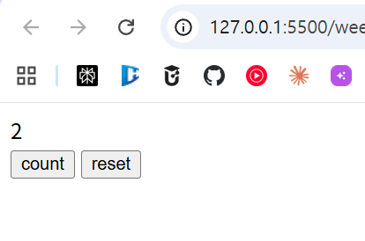

실습 2
<form>
<div id="number">0</div>
<input type="button" value="count" onclick="tClick()">
<input type="button" value="reset" onclick="tReset()">
</form>

<script>

let count = 0;

function tClick() {
count++;
document.getElementById("number").textContent = count;
checkColor();
}

function tReset() {
count = 0;
document.getElementById("number").textContent = count;
checkColor();
}

function checkColor() {
if (count === 0) {
document.bgColor = "white";
} else if (count % 2 === 0) {
document.bgColor = "lightgreen";
} else {
document.bgColor = "yellow";
}
}

</script>

결과
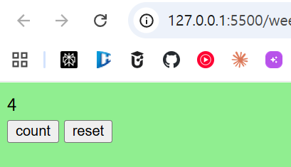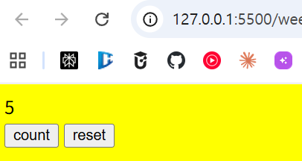

실습 3
<body>
<script>
function pr(a, b) {
for (let i = 1; i <= b; i++) {
for (let j = 0; j < i; j++) {
document.writeln(a);
}
document.writeln("<br>");
}
}
</script>
<script>
pr("♡", 5);
</script>
</body>

결과
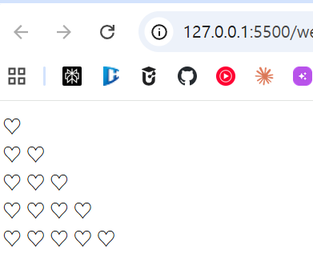

실습 4-1
<!DOCTYPE html>
<html lang="en">
<head>
<meta charset="UTF-8">
<meta name="viewport" content="width=device-width, initial-scale=1.0">
<title>Document</title>
</head>
<body>

<h2>1단계 계산</h2>
<form>
<input type="text" id="txt1" size="5" />
+
<input type="text" id="txt2" size="5" />
<input type="button" value="계산" onclick="add1()" />
<h2>결과 : <span id="total">0</span></h2>
</form>

<script>
function add1() {
let a = document.getElementById("txt1").value;
let b = document.getElementById("txt2").value;
let result = Number(a) + Number(b);
document.getElementById("total").innerHTML = result;
}
</script>

</body>
</html>

결과
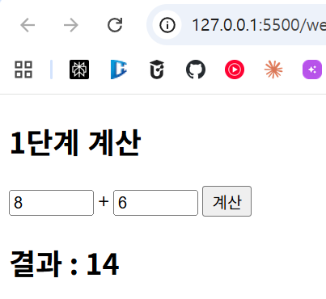

실습 4-2

결과
<!DOCTYPE html>
<html lang="en">
<head>
<meta charset="UTF-8">
<meta name="viewport" content="width=device-width, initial-scale=1.0">
<title>Document</title>
</head>
<body>

<h2>1단계 계산</h2>
<form>
<input type="text" id="txt1" size="5" />
+
<input type="text" id="txt2" size="5" />
<input type="button" value="계산" onclick="add2()" />
<h2>결과 : <span id="total">0</span></h2>
</form>

<script>
function add2() {
let a = document.getElementById("txt1").value;
let b = document.getElementById("txt2").value;
let result = Number(a) + Number(b);
document.getElementById("total").innerHTML = a + "+" + b + "=" + result;
document.getElementById("txt1").value = "";
document.getElementById("txt2").value = "";
}
</script>

</body>
</html>

