Software Architecture and Design Specification
Project: Event Management System
Version: 1.0
Authors: Team 7
Date: 01-10-2026
Status: Draft

Revision History
Version | Date | Author | Change Summary

Approvals
Role | Name | Signature/Date

1. Introduction
1.1 Purpose
This document specifies the architecture and design of the Event Management System.

1.3 Audience
Developers, QA engineers, security auditors, instructors, and maintenance teams.
1.4 Definitions
Event Management System, PIN, ADR, PCI-DSS, TLS.

2. Document Overview
2.1 How to use this document
Provides architectural deliverables including UML diagrams, ADRs, threat models, and API design.
2.2 Related Documents
SRS, STP, RTM.

3. Architecture
3.1 Goals & Constraints
Architecture Goals
The architecture of the Event Management System is designed to provide a simple, maintainable and reliable web-based platform for event management and attendee registration.
1. Allow organizers to create, edit and delete events that they own.
2. Allow attendees to browse upcoming events and view event details.
3. Allow attendees to register for events using their name and email address.
4. Prevent duplicate registrations for the same event using the same email address.
5. Enforce access control so that an organizer can manage only events created by that organizer.
6. Maintain the integrity of event, organizer and registration data.
7. Provide responsive system performance, with the event list loading within 2 seconds and registration confirmation within 3 seconds under normal conditions.
Architecture Constraints
1. The frontend shall be implemented using React.js.
2. The backend shall use Node.js and Python Django as specified in the SRS.
3. Communication between the frontend and backend shall use HTTP/HTTPS with JSON-formatted REST API requests and responses.
4. The system shall use a relational database for storing organizer, event and registration information.
5. The project must remain within the available course-project development timeline.
6. Deployment and infrastructure choices may be constrained by the free tiers of hosting and database services.
3.2 Stakeholders & Concerns
Stakeholder — Main Concerns
Organizer — Creating, editing and deleting events; viewing registered attendees; ensuring only the event owner can manage the event.
Attendee — Finding upcoming events, viewing complete event details, and completing registration quickly and easily.
Development Team — Maintainability, clear separation of components, reliable data handling and ease of future enhancement.
Course Instructor / Evaluator — Correct implementation of the requirements, traceability between requirements and design, and completeness of project documentation.

3.3 Component (UML) Diagram
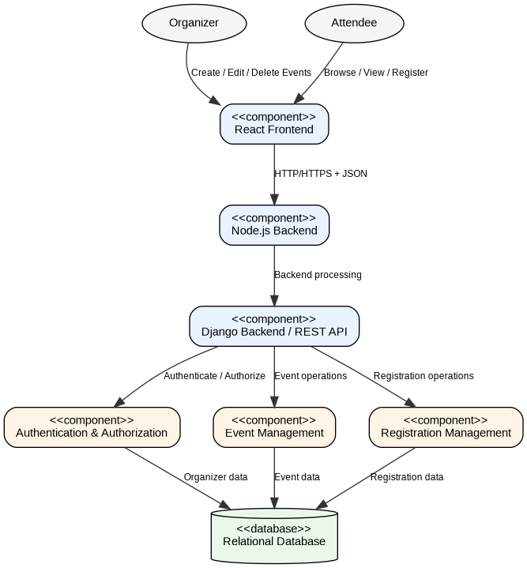
Figure 1: UML Component Diagram – Event Management System

3.4 Component Descriptions
React Frontend: Provides the browser-based user interface for organizers and attendees. Organizers use it to create, edit and delete events, while attendees use it to browse upcoming events, view event details and submit registration forms.
Node.js Backend: Forms part of the backend environment specified in the SRS and supports communication between the frontend and backend services.
Django Backend / REST API: Provides the REST endpoints consumed by the React frontend. It processes requests related to event and registration data and communicates with the relevant backend components.
Authentication & Authorization: Handles organizer authentication and access control. It ensures that organizers must be authenticated before creating, editing or deleting events and that an organizer can manage only events that they created.
Event Management: Handles event creation, modification, deletion and retrieval. It supports REQ-1, REQ-2 and the event-viewing part of REQ-3.
Registration Management: Handles attendee registration for events. It validates registration information and prevents duplicate registration using the same email address for the same event. It supports REQ-4.
Relational Database: Provides persistent storage for organizer, event and registration information.

3.5 Chosen Architecture Pattern and Rationale
3.5 Chosen Architecture Pattern and Rationale
The proposed architecture follows a layered architecture approach. The system is separated into presentation, backend/service, business-logic and data-storage responsibilities.
• Presentation Layer: React.js frontend used by organizers and attendees.
• Backend/API Layer: Node.js and Python Django components responsible for backend processing and REST API communication.
• Business Logic Layer: Event Management and Registration Management components that implement event and registration rules.
• Data Layer: Relational database used to persist organizer, event and registration information.
This separation supports maintainability, clear responsibility boundaries and easier testing. It also allows changes to the user interface or database layer with limited impact on other parts of the system.
A microservices architecture is not selected because the current course-project scope does not require multiple independently deployed services and would add unnecessary operational complexity.

3.6 Technology Stack & Data Stores
3.6 Technology Stack & Data Stores
| Area | Technology / Approach |
|---|---|
| Frontend | React.js |
| Backend | Node.js and Python Django |
| API communication | REST API over HTTP/HTTPS |
| Data format | JSON |
| Database | Relational database |
| Client | Web browser |
| Development / documentation | GitHub and UML modelling tools |
The SRS specifies React.js for the frontend, Node.js and Python Django for the backend, REST-based communication using HTTP/HTTPS with JSON, and a relational database for persistent storage.
The specific relational database management system is not fixed in the current SRS and should be finalized by the development team before implementation.

3.7 Risks & Mitigations
3.7 Risks & Mitigations
| Risk | Impact | Mitigation |
|---|---|---|
| Unauthorized organizer actions | An organizer may modify an event that they do not own | Enforce authentication and authorization checks before create, edit and delete operations |
| Duplicate event registration | Multiple registrations may be created for the same attendee and event | Validate the event ID and attendee email before creating a registration and enforce the duplicate-registration rule |
| Database failure or data loss | Event and registration information may become unavailable | Use database backup/recovery procedures and validate database operations |
| Slow event listing | Users may experience delays when browsing events | Optimize database queries and keep the event-list response within the required performance target |
| Slow registration response | Attendees may not receive timely confirmation | Optimize registration processing and database operations to meet the registration response target |
| Backend integration ambiguity | Node.js and Django responsibilities may overlap | Define the exact responsibility of each backend technology before implementation |
| Limited project infrastructure | Free-tier hosting or database limits may affect deployment | Select lightweight deployment options and monitor resource usage during development |

3.8 Traceability to Requirements
3.8 Traceability to Requirements
| SRS Requirement | Architectural Component(s) | Architectural Responsibility |
|---|---|---|
| REQ-1: Organizer creates an event | React Frontend, Event Management, Database | Accept event details, validate the request, create the event and persist event data |
| REQ-2: Organizer edits/deletes an event | Authentication & Authorization, React Frontend, Event Management, Database | Verify organizer access and perform update/delete operations on the organizer's event |
| REQ-3: Attendee views upcoming events/details | React Frontend, Event Management, Database | Retrieve event information and present upcoming events and details to attendees |
| REQ-4: Attendee registers for an event and duplicate registration is rejected | React Frontend, Registration Management, Database | Validate registration data, check for an existing registration and store a valid registration |
The architecture therefore provides a direct mapping between the functional requirements defined in the SRS and the components responsible for implementing them.

3.9 Security Architecture
3.9 Security Architecture
The security architecture is based on authentication, authorization, input validation and protection of application and registration data.
1. Authentication
Organizer-only operations shall require authentication before event creation, editing or deletion.
2. Authorization
The system shall verify that the authenticated organizer is authorized to modify or delete the requested event. An organizer shall only manage events created by that organizer.
3. Input Validation
Event and registration inputs shall be validated before processing to reduce invalid or malicious requests.
4. Registration Protection
The Registration Management component shall check for duplicate registrations before storing a new registration.
5. Secure Communication
Communication between the frontend and backend shall use HTTP/HTTPS as specified by the SRS. HTTPS should be used for deployed environments to protect data in transit.
6. Data Protection
Organizer, event and registration information shall be stored in the relational database and access to the data shall be controlled through the backend application.
7. Error and Logging Security
Error responses should provide useful information to users without exposing internal implementation details. Logs should not contain sensitive authentication information.
The exact authentication mechanism, authorization implementation and database security configuration are implementation decisions that should be finalized before deployment.

4. Design

4.1 Design Overview
4.1 Design Overview
The design of the Event Management System follows the architecture defined in Section 3. The React frontend provides the user interface, while the backend exposes REST API endpoints for event and registration operations. Business rules are handled by the Event Management and Registration Management components, and persistent information is stored in a relational database.
The design focuses on the four functional requirements: event creation, event editing/deletion, event browsing, and attendee registration with duplicate-registration prevention. The design also considers the performance targets specified in the SRS: the event list should load within 2 seconds under normal conditions and registration confirmation should be provided within 3 seconds.

4.2 UML Sequence Diagrams
The following two sequence diagrams cover project-specific flows required by the SRS:
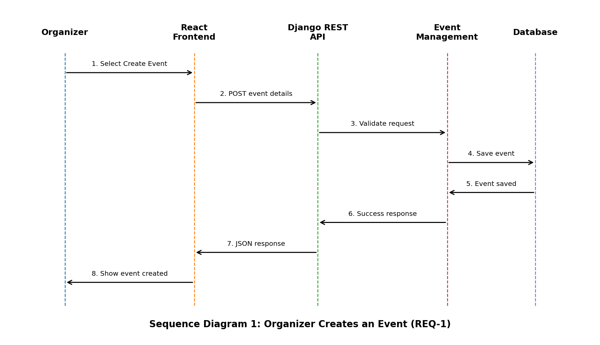
Figure 2: Sequence Diagram – Organizer Creates an Event
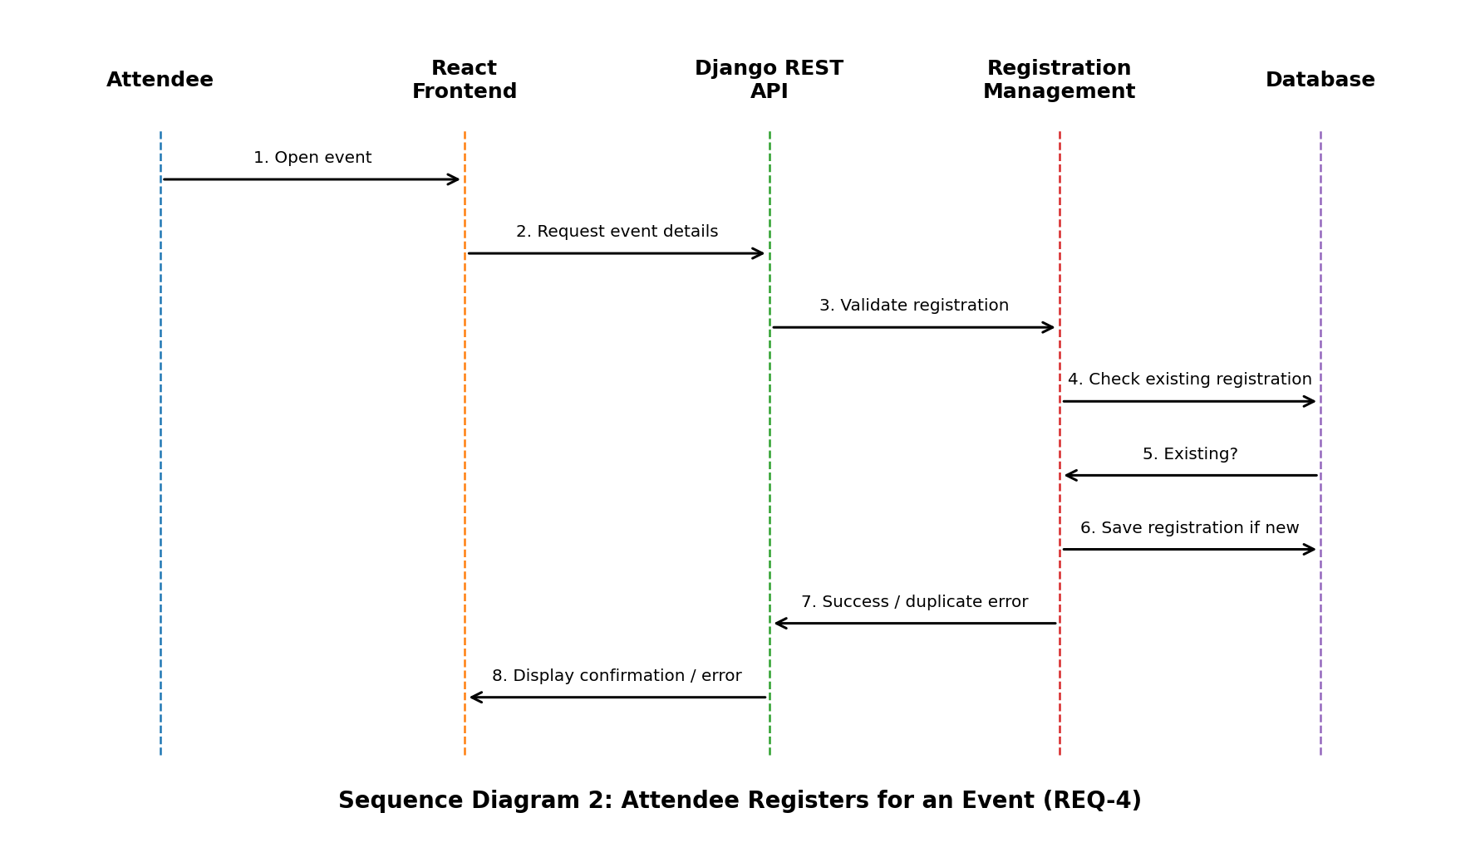
Figure 3: Sequence Diagram – Attendee Registers for an Event

4.3 API Design
4.3 API Design
The SRS specifies REST API communication using HTTP/HTTPS and JSON, but it does not define final endpoint names. The following endpoints are therefore proposed design interfaces and should be confirmed by the development team before implementation.
| Method | Proposed Endpoint | Purpose | Related Requirement |
|---|---|---|---|
| POST | /api/events | Create a new event | REQ-1 |
| PUT | /api/events/{eventId} | Edit an event owned by the organizer | REQ-2 |
| DELETE | /api/events/{eventId} | Delete an event owned by the organizer | REQ-2 |
| GET | /api/events | Retrieve upcoming events | REQ-3 |
| GET | /api/events/{eventId} | Retrieve selected event details | REQ-3 |
| POST | /api/events/{eventId}/registrations | Register an attendee for an event | REQ-4 |
Example request for event creation:
{
"name": "Tech Fest",
"description": "Annual technical event",
"date": "2026-09-20",
"time": "10:00",
"location": "PES University"
}
Example registration request:
{
"name": "Student Name",
"email": "student@example.com"
}
Responses shall use JSON. Successful operations should return an appropriate success status and data/message. Invalid input, unauthorized access, missing resources and duplicate registration should return standardized error responses.

4.4 Error Handling, Logging & Monitoring
4.4 Error Handling, Logging & Monitoring
The system shall use consistent error handling across the REST API.
| Condition | Suggested HTTP Status | Example Meaning |
|---|---:|---|
| Invalid or missing input | 400 | Required event or registration data is invalid |
| Authentication required | 401 | Organizer is not authenticated |
| Access denied | 403 | Organizer attempts to manage another organizer's event |
| Resource not found | 404 | Requested event does not exist |
| Duplicate registration | 409 | Same email is already registered for the same event |
| Unexpected server/database failure | 500 | Internal processing failure |
Error responses should contain a clear message suitable for the client without exposing internal implementation details.
Logging should record important application events and failures such as failed requests, authorization failures, event operations and registration failures. Sensitive information such as passwords or authentication secrets must not be written to logs.
Monitoring should focus on backend availability, API failures, database failures, event-list response time and registration response time. These measures support the SRS performance targets.

4.5 UX Design
4.5 UX Design
The attendee-facing interface shall prioritize usability because the SRS identifies usability as a priority for attendees.
The main attendee flow is:
1. Open the upcoming events page.
2. Browse the list of events.
3. Select an event to view its details.
4. Enter name and email address.
5. Submit the registration form.
6. Receive a confirmation message or a clear error message.
The organizer interface shall provide a dashboard for creating and managing events and a page for viewing registered attendees.
The interface should use a consistent navigation bar, clearly labelled buttons such as Create, Edit, Delete and Register, and clear validation/error messages for invalid or incomplete input. These choices follow the user-interface requirements in the SRS.

4.6 Open Issues & Next Steps
4.6 Open Issues & Next Steps
1. Confirm the exact responsibility of Node.js and Python Django in the backend because the SRS specifies both technologies but does not define a detailed division of responsibility.
2. Confirm the relational database management system to be used for implementation.
3. Finalize the exact REST API endpoint names and request/response schemas before coding.
4. Finalize authentication and session/token handling for organizer login.
5. Implement and verify the duplicate-registration rule at the backend/database level.
6. Validate the performance targets of under 2 seconds for event listing and under 3 seconds for registration confirmation during testing.
7. Update the SAD and Test Plan if the implementation architecture changes.

5. Appendices
5.1 Glossary: Event Management System, PIN, PCI-DSS, TLS, ADR.
5.2 References: IEEE 42010, OWASP, NIST SP 800-160.
5.3 Tools: PlantUML, draw.io, Swagger.

