第三次統計作業解答
每一小題5分，合計27題，滿分100。

30. a. 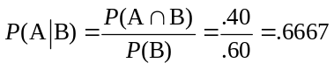

b. 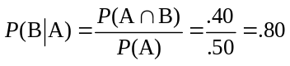

c. No because P(A | B) ≠ P(A)

32. a. Row and column sums are shown.

 | Car | Light Truck | Total
U.S. | 87.4 | 193.1 | 280.5
Non U.S. | 228.5 | 148.0 | 376.5
Total | 315.9 | 341.1 | 657.0

A total of 657.0 thousand vehicles were sold.

Dividing each entry in the table by 657.0 provides the following joint probability table.
 | Car | Light Truck | Total
U.S. | .1330 | .2939 | .4269
Non U.S. | .3478 | .2253 | .5731
Total | .4808 | .5192 | 1.0000

b. Let U = U. S. manufacturer
N = Non U.S. manufacturer
C = Car
L = Light Truck

Marginal probabilities: P(U) = .4269 P(B) = .5731
There is a higher probability that the vehicle was not manufactured by a U. S. auto maker. In terms of market share, non U.S. auto makers lead with a 57.3% share of vehicle sales.

Marginal probabilities: P(C) = .4808 P(L) = .5192
The light truck category which includes pickup, minivans, SUVs and crossover models has a slightly higher probability. But the types of vehicles are fairly even split.

c. 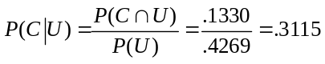 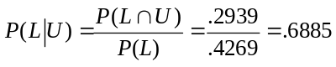

If a vehicle was manufactured by one of the U.S. auto makers, there is a higher probability it will be in the light truck category.

d. 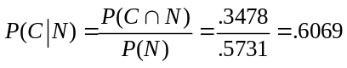 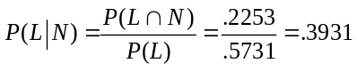

If a vehicle was not manufactured by one of the U.S. auto makers, there is a higher probability it will be a car.

e. 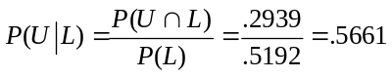

If a vehicle was a light truck, there is better than a 50-50 chance that it was manufactured by one of the U.S. auto makers.

f. There is a higher probability, and thus a larger market share for non U.S. auto makers. However, the U. S. auto makers are leaders in sales for the light truck category.

33. a.
 | Reason for Applying
 | Quality | Cost/Convenience | Other | Total
Full Time | .218 | .204 | .039 | .461
Part Time | .208 | .307 | .024 | .539
 | .426 | .511 | .063 | 1.000

b. It is most likely a student will cite cost or convenience as the first reason - probability = .511. School quality is the first reason cited by the second largest number of students - probability = .426.

c. P(Quality | full time) = .218/.461 = .473

d. P(Quality | part time) = .208/.539 = .386

e. For independence, we must have P(A)P(B) = P(A ∩ B).

From the table, P(A ∩ B) = .218, P(A) = .461, P(B) = .426

P(A)P(B) = (.461)(.426) = .196

Because P(A)P(B) ≠ P(A ∩ B), the events are not independent.

35. a. The total sample size is 200. Dividing each entry by 200 provides the following joint probability table.

 |  | Pay Rent
 |  | Yes |  | No
 | Yes | .28 |  | .26 | .54
Buy a Car
 | No | .07 |  | .39 | .46
 |  | .35 |  | .65

b. Let C = the event of financial assistance to buy a car
R = the event of financial assistance to pay rent

Using the marginal probabilities, P(C) = .54 and P(R) = .35. Parents are more likely to provide their adult children with financial assistance to buy a car. The probability of financial assistance to buy a car is .54 and the probability of financial assistance to pay rent is .35.

c. 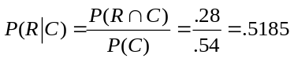

d. 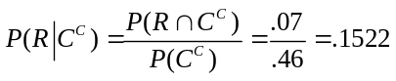

e. Financial assistance to buy a car is not independent of financial assistance to pay rent, 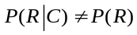.

If there is financial assistance to buy a car, the probability of financial assistance to pay rent increases from .35 to .5185. However, if there is no financial assistance to buy a car, the probability of financial assistance to pay rent decreases from .35 to .1522.

f.

41. S₁ = successful, S₂ = not successful and B = request received for additional information.

a. P(S₁) = .50

b. P(B | S₁) = .75

c. 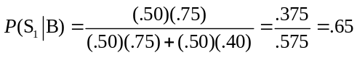

43. a. Let M = event that a putt is made

P(M) = 983,764/1,613,234 = .610

Note: The probability that a putt is missed is 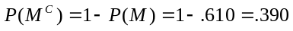

b. Let A= event that a PGA Tour player has a par putt

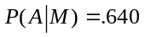

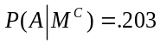

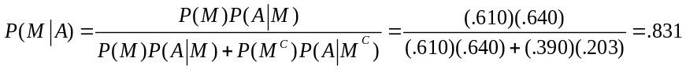

c. Let B = event that a PGA Tour player has a birdie putt

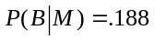

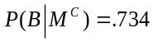

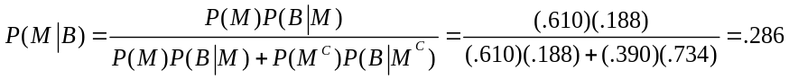

d. These probabilities indicate that there is a much higher probability of making a par put than a birdie putt. The authors of the article referenced in this exercise state that “even the best players … show evidence of loss aversion.” In other words, PGA Tour players tend to view missing a par putt as a loss and making a birdie putt as a gain. With regard to putting, their behavior indicates that they prefer avoiding losses to making gains. “On average this bias costs the best golfers over $1.2 million in tournament winnings per year.”

