# Using the Syrius SCXML drawing tool in Rodin

## Set up Rodin (or Eclipse) for Sirius.

To set up your Rodin configuration for using the Sirius SCXML drawing tool you need to install Sirius. The easiest way to do this is to first install the Eclipse Marketplace Client from the Neon update site. Then select Marketplace from the Help menu. When the window appears, type Sirius in the search bar and then click ‘install’ next to Sirius 5.0. On the ‘Confirm Selected Features’ window, I added ‘Sirius Properties Views – Runtime Support’ to the default selection. Then click confirm.

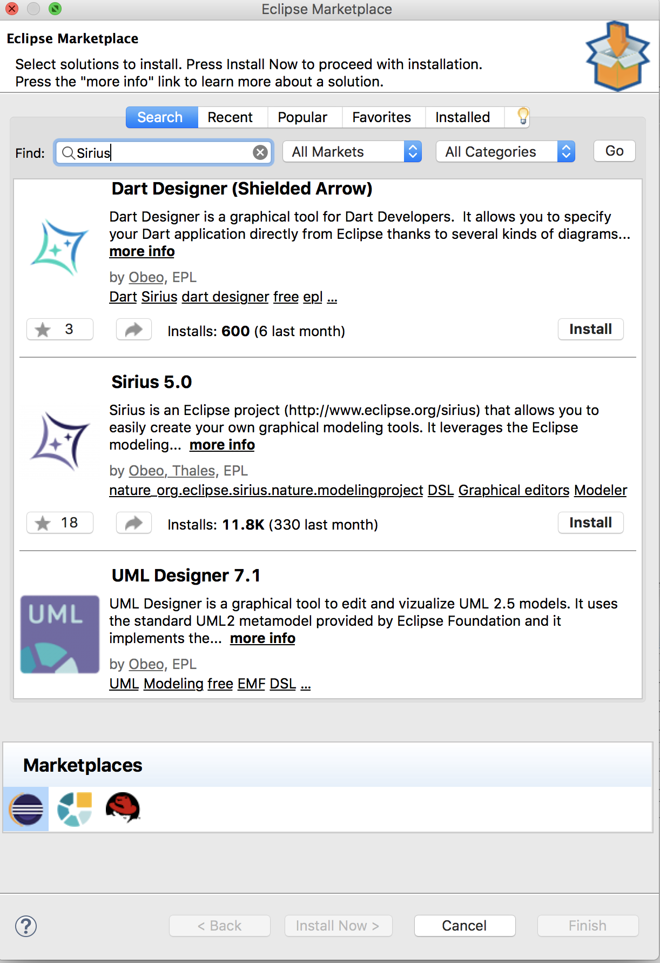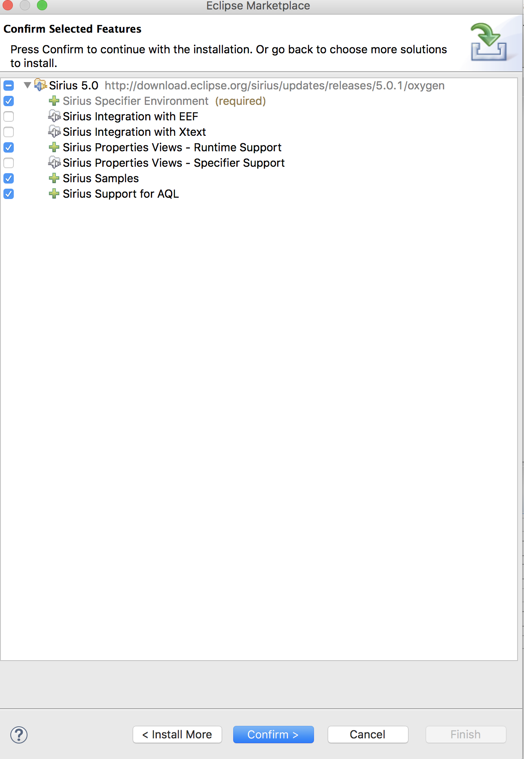

Alternatively, if you only want to draw SCXML diagrams, you could just install a ready to use package here: http://www.eclipse.org/sirius/download.html

Make sure you have installed the Soton/Sandia specialised Sirius SCXML plugin that provides support for Sirius SCXML diagrams with extensions for guards, actions, invariants etc.

## To create a new ‘SCXML to iUML-B’ project from scratch:

1. First create an Event-B Rodin project as usual in the Event-B perspective. (You only need to start with a Rodin project if you want to generate Event-B - if you only want to draw SCXML models you can start with an ordinary eclipse project).
2. Switch to the Sirius perspective: (look for this icon )
3. Convert the Event-B project into a modelling project (it will also remain as a Rodin project) by right clicking on the project in the Model Explorer and selecting Configure-Convert to Modelling Project.

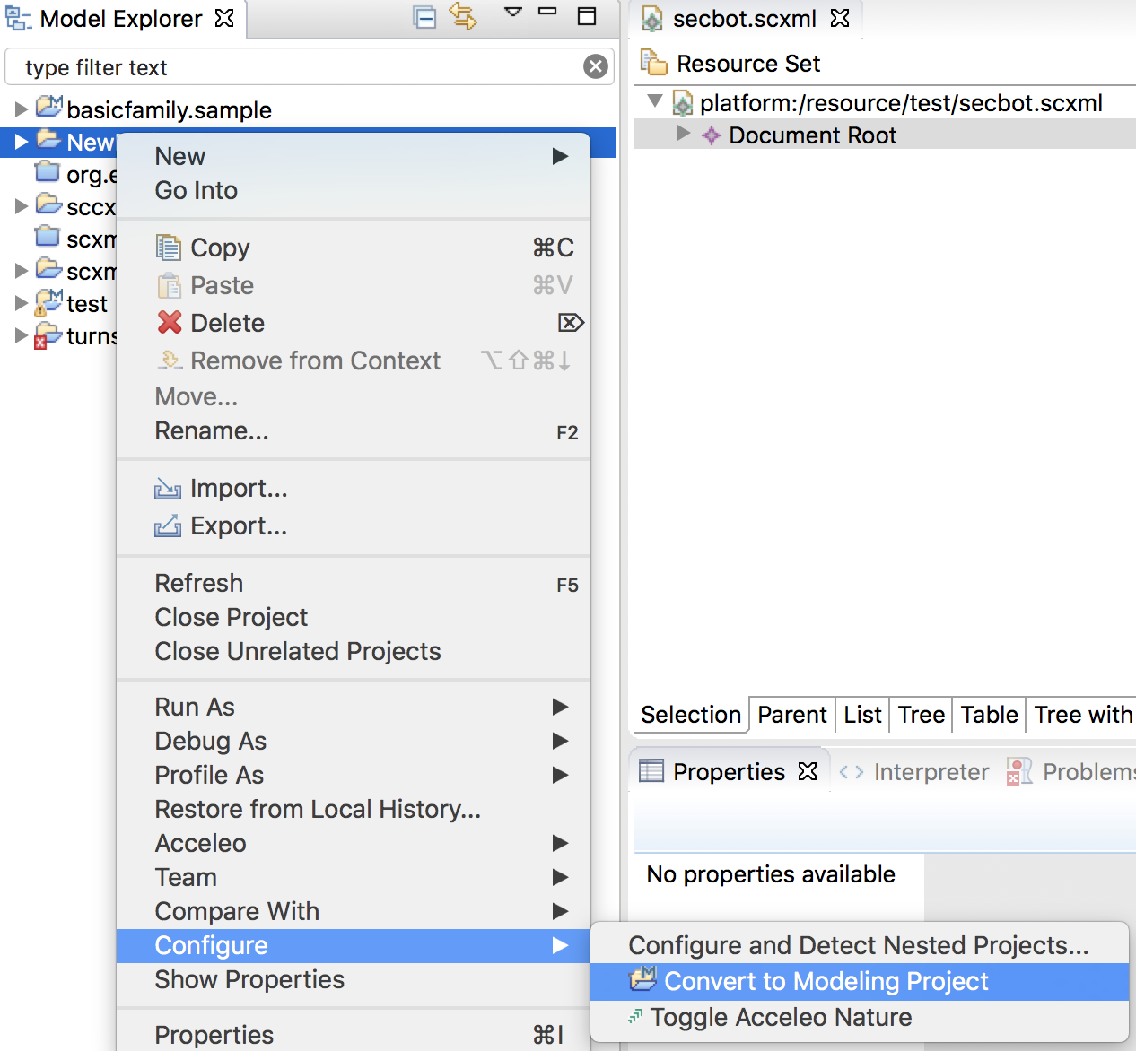

1. Create a new SCXML model in the project by using the usual ‘New-other’ wizard and selecting ‘Scxml Model’ in the folder ‘Example EMF Model Creation Wizards’. (In the wizard, for ‘Model Object’ select ‘scxml’). Alternatively, you could import an existing scxml model as long as it is in the format of the scxml EMF metamodel.
2. Add the SCXML viewpoint to the project by right clicking on the project and choosing ‘Viewpoints Selection’. Then check the tick box next to ‘SCXML Diagram’ and press ok.

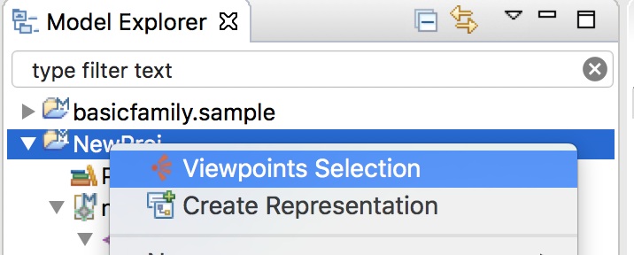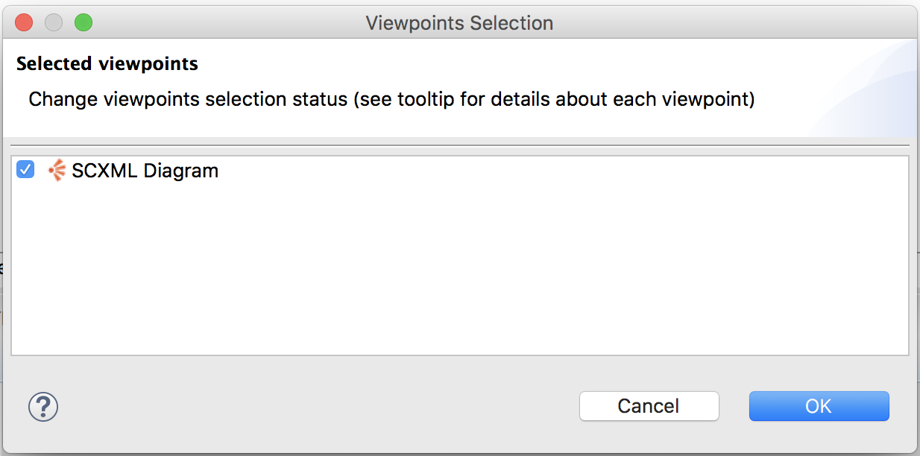

1. Now you can create a new ‘representation’ (diagram) by right-clicking on the project and selecting ‘Create Representation’, and then select ‘Diagram’ under ‘SCXML Diagram’. Select ‘Scxml Type’ as the semantic element and click finish.

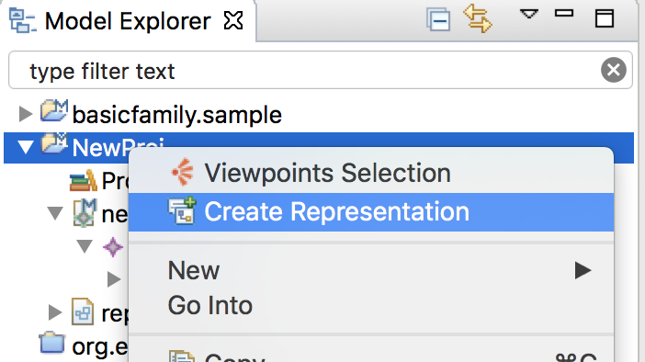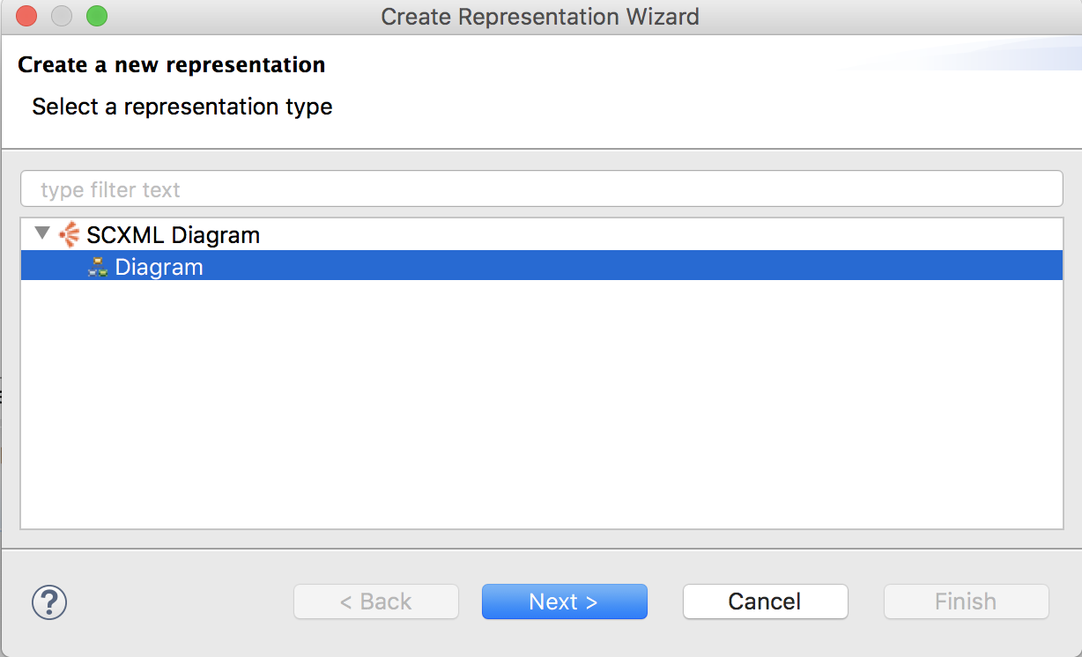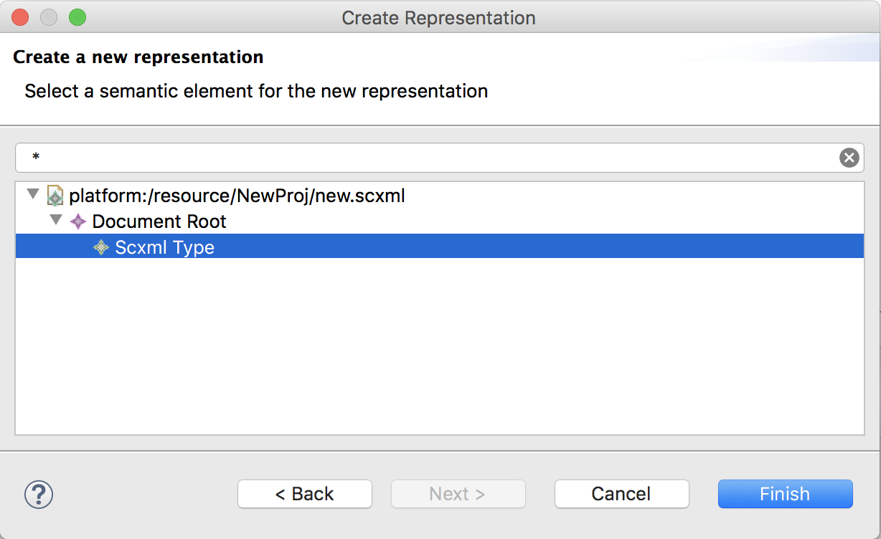

1. After naming the diagram, this should result in the diagram editor being opened so that you can start adding states etc. Note that not all attributes are supported in the Main properties view. For example, you need to go to the ‘Semantic’ properties view to enter the name of the initial state. Also, not all elements are supported in the diagram tool. For example, there appears to be no way to display or add ‘Initial state’ or ‘Raise’ elements at the moment.
2. Saving the diagram updates the scxml model (i.e. you should be able to see the diagram changes reflected in the *.scxml model if you open it with a text or emf editor). However, you may have to close and re-open the *.scxml file for the changes to be updated.

Issues:

1. Initial state elements are not supported. The initial attribute is supported and can be set from the context menu of the targeted state.
2. Raise elements are not supported
3. Transition ‘type’ (internal/external) is supported but the iUML-B translator does not use this attribute (perhaps it should).
4. SCXML Extensions (e.g. guards, actions, invariants, refinement levels) are ignored (not a surprise). We will need a way to view/edit them. Probably most can be handled by properties view.
5. We would like invariants to appear in the States like they do in iUML-B.
6. Investigate whether the Sirius team have improved this SCXML example.