**CISCO TALENT OUTREACH PROGRAM 2019**

**DELHI PUBLIC SCHOOL BANGALORE EAST**



**PROPOSAL:**

A state of the art event communicator for school events involving a link between students and teachers to iron out wrinkles in the selection process. This includes, but is not limited to, explanation of events, requirements for participation, custom application forms and the reason why teachers went another way. It further maintains a record of students past achievements and participation to create an even playing field thus allowing equal consideration to all.

**APPLICATION**:

* Students can access the various events and register for the events, based on whether their interests align with the event requirements.
* Teachers can use this simple and interactive backend to view the applications and make well-thought-out and fair decisions.
* Teachers will also have the opportunity to explain their reasons to reject a student for an event. An entity very much required and lacking.
* The students will also have their past participations shown to the teachers, in order to ensure fair opportunity for all interested.

**DESIGN**:

**Front End Preview**:

* **Main Page Preview**:

The software consists of an interactive GUI that makes it easy-to-use for students and teachers.

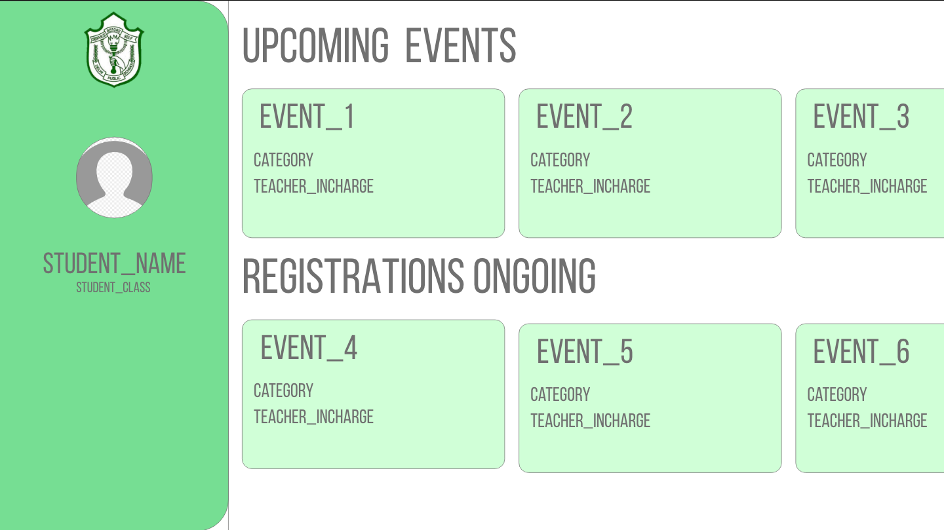

* **Sub-Events Screen Preview**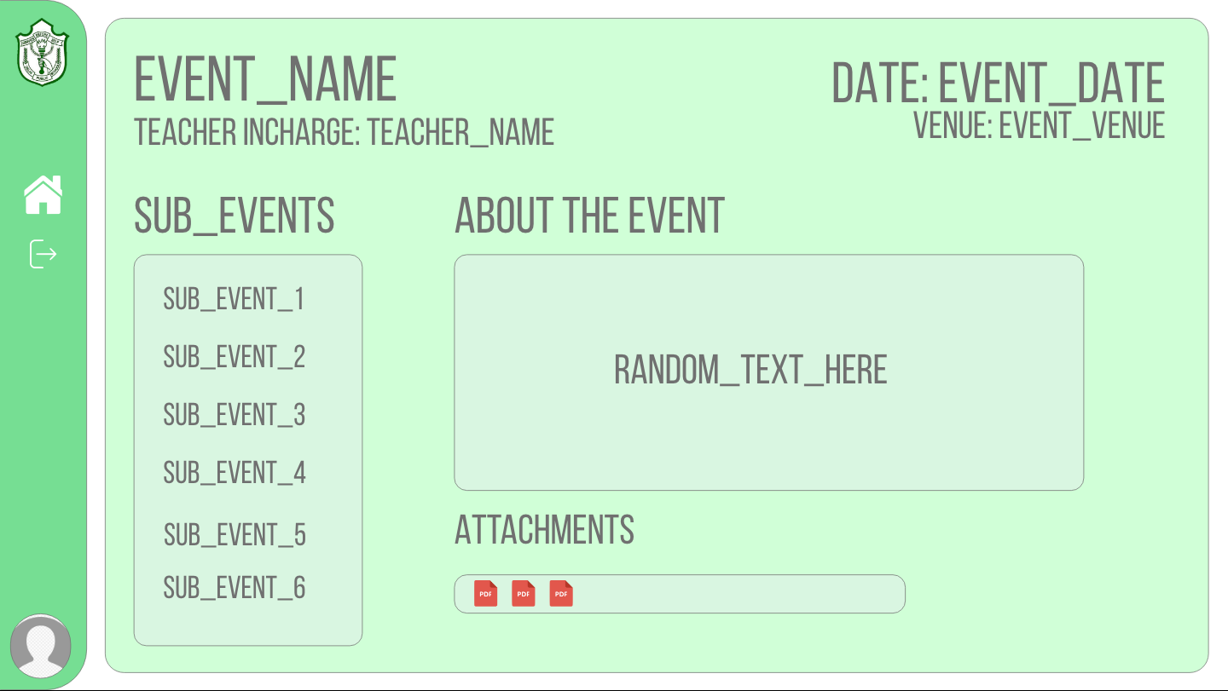
* **Individual Sub-Event Screen Preview**

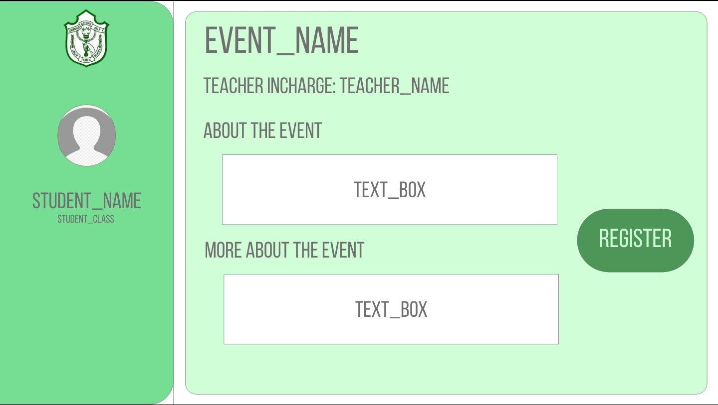

**Back End Preview:**

* **Main Page Preview:**

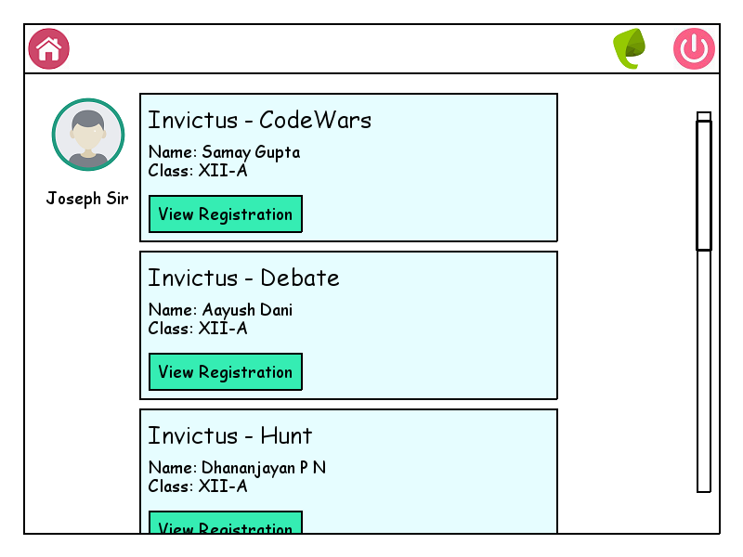

* **Event Teacher Preview:**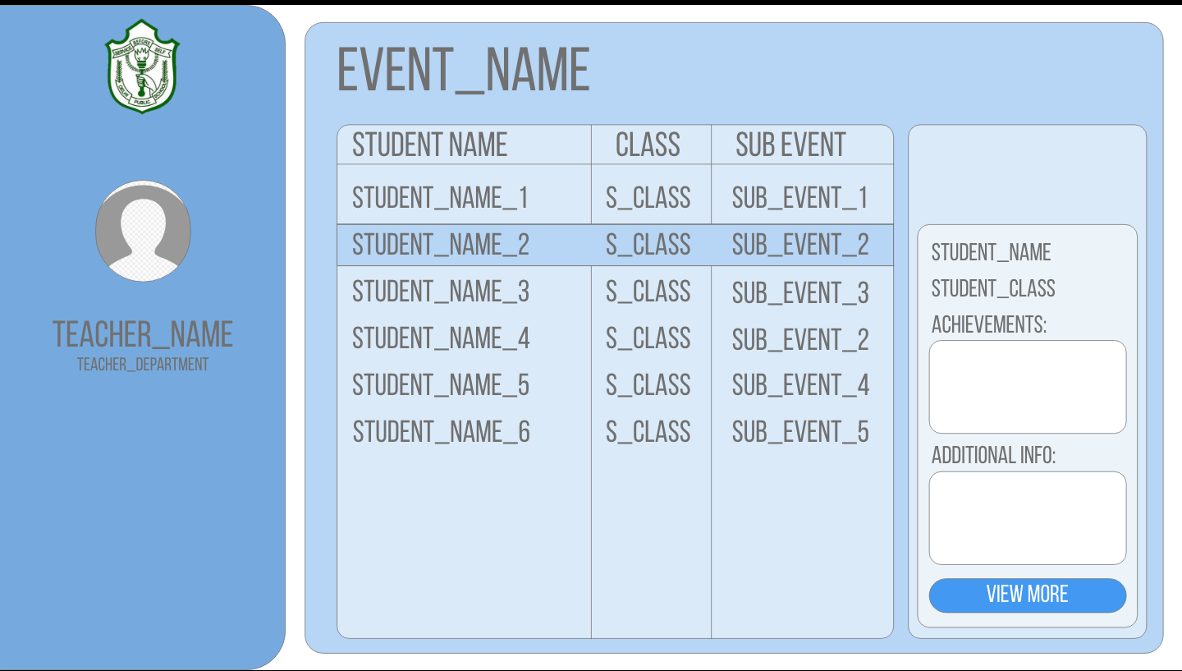
* **View Registration Page Preview**

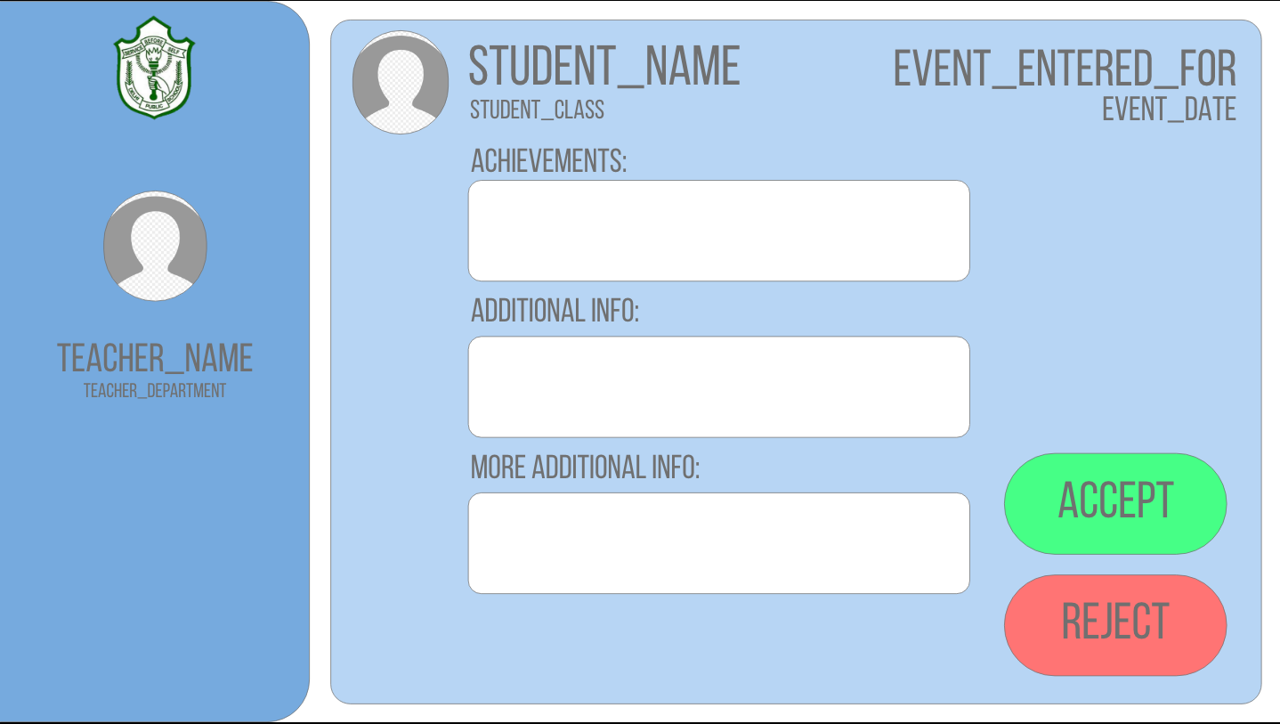

1. **Flows:**
2. Sequential Flow
3. Data Flow
4. **Technical:**
   * Front End - HTML, CSS, BOOTSTRAP
   * Back End - Python, Django (Python)
   * Database - SQLite (dev), MySQL
5. **Roles:**
   * Samay Gupta -
   * Dhananjayan PN -
   * Arham M -
   * Shreyas S -
   * Aayush Dani -
   * Rida Javed -
6. **Sequential Flow**:
   * For Students:
     + Entrar LogIn Page
     + Entrar Home Page
     + Navbar Link takes them to Portal
     + Portal Homepage
       - A Fest: Takes you to Particular’s Fests Page
         * Particular Event:

Register Button takes them to Registration Form

Back to Homepage after form is submitted.

* + - * An Event:
        + Registration Form

Homepage

* + For Teachers:-
    - Entrar Login
    - Entrar Homepage
    - Link to Portal
    - Portal Homepage (Backend-View)
      * Event In Charge Of:
        + Students Registered

See how many events they’ve gone for

Per Student Registration Details

* + - * + Add Event

Form

Homepage

1. **Data Flow:**