1. Rationale

1.1 Problem Description
Every rainy season, communities in Freetown such as Kroo Bay and Wellington suffer from floods. Warnings come late, are informal (word of mouth) and are not based on clear rules, so families lose lives, homes and property.
Who is affected: families in flood-prone communities, especially children, the elderly and people living near rivers and drains. Why it exists: heavy rainfall, blocked drains, rivers that overflow, and no simple system that turns local readings into a clear warning. How the solution helps: community volunteers enter simple readings and the system gives a risk level (LOW, MODERATE, HIGH or SEVERE) with advice on what to do.

1.2 Background
Sierra Leone has some of the heaviest rainfall in West Africa, and many communities are built on low ground near rivers. Floods in Freetown have caused many deaths and left thousands homeless. A simple logical design for early warning can be turned into a free tool that works on a basic phone or computer.

1.3 Community Impact
- Problem being solved: late and unclear flood warnings.
- Expected impact: faster warnings, safer evacuation, fewer deaths and less property loss.
- Beneficiaries: families, community leaders, volunteers and disaster management officers.
- Long-term sustainability: the system is free and simple, so local students and volunteers can keep using and improving it.

1.4 Proposed Solution
FloodWatch SL is a flood early-warning system. The user enters the community name, rainfall in the last 24 hours (mm), the river level (% of bank-full) and whether the drains are blocked. The system adds up points to make a risk score, classifies the risk level and shows advice. If evacuation is needed it says so.

1.5 Computational Thinking Process
Step | Application to this problem
Decomposition | Break the problem into: get readings, calculate score, classify risk, show alert.
Pattern recognition | Every community check follows the same steps and the same rules.
Abstraction | Keep only what matters: rainfall, river level and blocked drains. Ignore other details.
Algorithm design | Write clear steps with IF/ELSE rules and a loop to check many communities.

1.6 Algorithm Design
The algorithm uses a repetition structure to check many communities, decision structures to score and classify risk, and functions to keep the design organised.

1.7 SDG Alignment
SDG 13: Climate Action (helps communities adapt to climate-related disasters). SDG 11: Sustainable Cities and Communities (makes communities safer and more resilient). SDG 3: Good Health and Well-being (fewer injuries and deaths).

1.8 Open Source Justification
- Why Open Source: community groups and local councils have little money, so the software must be free to use, copy and improve.
- Benefits for Sierra Leone: no licence cost, local developers and students can learn from it, and it can be adapted for other districts.
- Potential community contributions: translation into Krio, adding new rules, building an SMS or mobile version, and fixing bugs.

1.9 Digital Public Goods Justification
The system could become a Digital Public Good by being released under an open licence (such as MIT or GPL) with open documentation and no private data in the code. It promotes accessibility because any community can use it for free on low-cost devices. It promotes openness because the design and code are public. It promotes public benefit because it protects lives and property instead of making profit.

2. Algorithm (Step by Step)
- Start.
- Set totalChecks = 0 and severeCount = 0.
- Input communityName, rainfall, riverPercent and drainBlocked (YES/NO).
- Call CalculateScore using rainfall, riverPercent and drainBlocked to get the score.
- Call ClassifyRisk using the score to get the riskLevel.
- Decide evacuate: YES if riskLevel is SEVERE, or riskLevel is HIGH and drains are blocked. Otherwise NO.
- Call DisplayAlert to show the community, score, risk level, advice and evacuation notice.
- Add 1 to totalChecks. If riskLevel is SEVERE, add 1 to severeCount.
- Ask "Check another community? (YES/NO)". If YES, go back to step 3.
- Display totalChecks and severeCount.
- End.

3. Pseudocode

3.1 Variables, Constants and Data Types
Name | Data type | Purpose
communityName | String | Name of the community
rainfall | Real number | Rain in last 24 hours (mm)
riverPercent | Real number | River level as % of bank-full
drainBlocked | Boolean | TRUE if drains are blocked
score | Integer | Total risk points
riskLevel | String | LOW, MODERATE, HIGH or SEVERE
evacuate | Boolean | TRUE if evacuation is needed
totalChecks, severeCount | Integer | Counters for the summary
answer | String | YES or NO
Constants | Integer | RAIN_LOW = 25, RAIN_MED = 50, RAIN_HIGH = 100

3.2 Main Program
START
SET totalChecks = 0
SET severeCount = 0
REPEAT
INPUT communityName, rainfall, riverPercent, drainBlocked
SET score = CalculateScore(rainfall, riverPercent, drainBlocked)
SET riskLevel = ClassifyRisk(score)
IF riskLevel = "SEVERE" OR (riskLevel = "HIGH" AND drainBlocked = TRUE) THEN
SET evacuate = TRUE
ELSE
SET evacuate = FALSE
END IF
CALL DisplayAlert(communityName, score, riskLevel, evacuate)
SET totalChecks = totalChecks + 1
IF riskLevel = "SEVERE" THEN
SET severeCount = severeCount + 1
END IF
INPUT answer (Check another community? YES/NO)
UNTIL answer = "NO"
OUTPUT totalChecks, severeCount
END

Flowchart
Flowchart

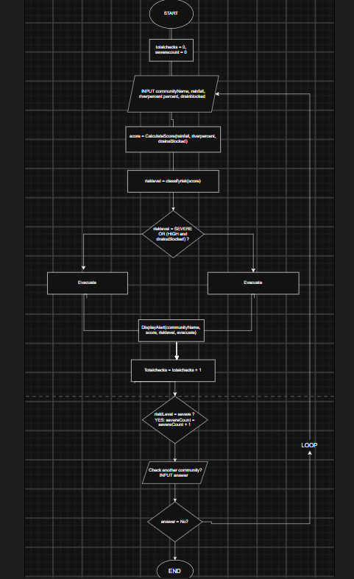

5. Functional Modules
Module / Function | Input | Output / Job
Main Program | User entries | Controls the loop and calls the functions
CalculateScore | rainfall, riverPercent, drainBlocked | Returns the risk score
ClassifyRisk | score | Returns LOW, MODERATE, HIGH or SEVERE
DisplayAlert | name, score, riskLevel, evacuate | Shows the alert, advice and evacuation notice
Example of one alert on screen (Kroo Bay):
Community : Kroo Bay
Risk score: 7
Risk level: SEVERE
Advice : Move to higher ground now
EVACUATION REQUIRED

7. GitHub Evidence
- Repository name: PROG101_Assignment1_StudentName_StudentID
- Repository URL: ______________________________
- Git commit history (screenshot): [insert]
- README.md (screenshot): [insert]
- Repository screenshot: [insert]

8. References
- United Nations (2015). Sustainable Development Goals. https://sdgs.un.org/goals
- Digital Public Goods Alliance. What is a Digital Public Good? https://digitalpublicgoods.net
- Open Source Initiative. The Open Source Definition. https://opensource.org/osd
- World Bank. Sierra Leone: Freetown flooding and landslide reports. https://www.worldbank.org/en/country/sierraleone

