|  |
| --- |
| Eventlab |
| VRUnited |
| - User Manual - |
|  |
|  |
| **1/26/2022** |

|  |
| --- |
|  |

Contents

Install 2

Execution 3

Controls 6

Appendix A: Installing an APK from your computer using SideQuest 7

Appendix B: Where is VRUnited installed? 9

Oculus Quest 9

Pico Neo 10

# Install

From the folder *Builds,* select the build that matches your system requirements.

* **Quest:** It contains a compatible .apk for *Oculus Quest* (1/2)*.* You must enable the developer mode on your *Quest* (see [here](https://developer.oculus.com/documentation/native/android/mobile-device-setup/)). Then you must sideload the .apk on your device using [SideQuest](https://sidequestvr.com/setup-howto) (recommended, see Appendix A) or by directly using the corresponding adb commands through the console.
* **Pico:** sideload the .apk on your device using [SideQuest](https://sidequestvr.com/setup-howto) (recommended, see Appendix A) or by directly using the corresponding adb commands through the console. No further action is required as *Pico* devices already have the developer mode enabled.
* **PC_Oculus:** This build works with the following devices: Oculus Rift family, Oculus Quest (1/2) + Link. You need to install the [Oculus software](https://www.oculus.com/setup/) on your computer.
* **PC_SteamVR:** This build works with any platform supporting SteamVR, which includes (but not limited to) HTC Vive (Pro), Valve Index as well as all the platforms in PC_Oculus. It is necessary to install [Steam](https://store.steampowered.com/?l=english) in your PC, as well as the [SteamVR](https://store.steampowered.com/app/250820/SteamVR/) application.

If you don’t have an HMD, you also can use the VRUnited application as a normal desktop application by using either the PC_Oculus or PC_SteamVR executables. In that case, **no additional software is required,** so simply start the executable.

Also take into consideration that, if you are running the application through the PC (with VR support or not), you need to make sure beforehand that your microphone is correctly detected as the default audio input device, that is properly working and that your applications are allowed to access to the microphone.

Finally, for future releases, probably the PC_Oculus build will be deprecated, as all the platforms supported by PC_Oculus are already supported by PC_SteamVR. So it is convenient you start installing the Steam and SteamVR if you want to keep using VRUnited on desktop with VR support.

# Execution

Execute the application that you have just installed. If you have problems finding it, see section Appendix B. Once the application starts, the *Character Selector* screen is presented. Here you will select your virtual avatar representation. By default, there is only one available avatar, representing a generic dummy character.

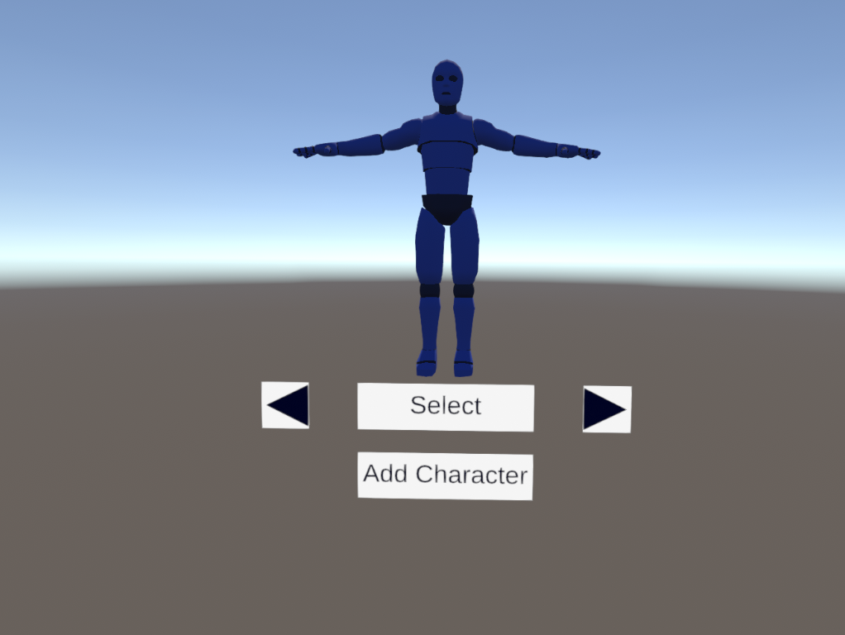

You can add new avatars for embodiment. To do so, click the button *Add Character* and introduce the character code:

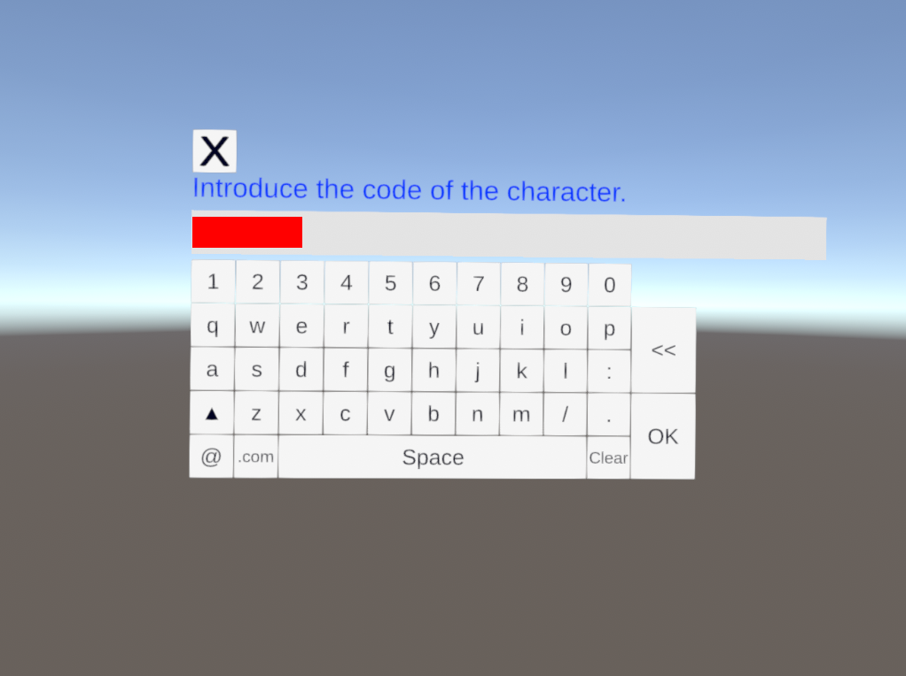

If the code is correct, the new avatar will be unlocked and you’ll be able to select it.

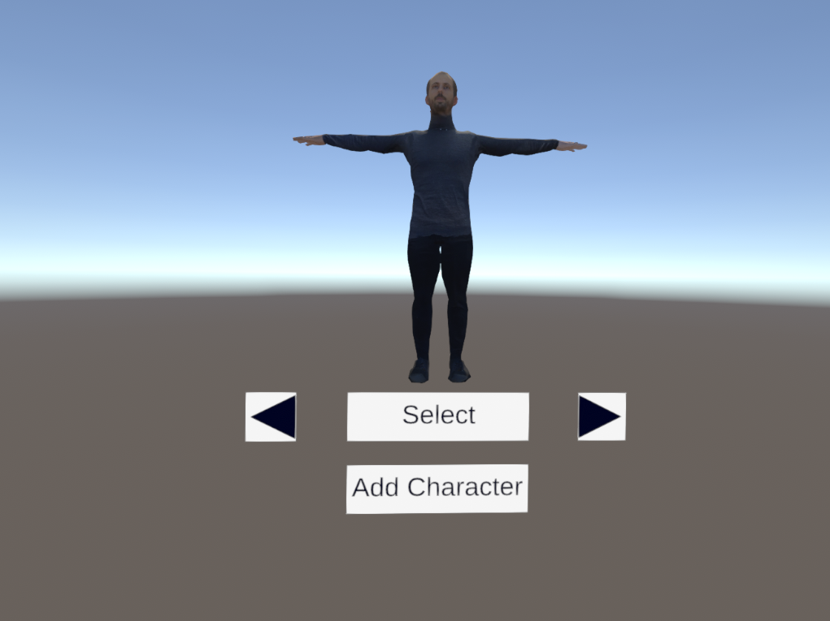

Click on the arrow like buttons in order to go through all the unlocked avatars, and when you are happy with your selection, click the button *Select.* The unlocked avatars as well as your avatar selection are stored, so the next time you execute the application, those avatars will be already unlocked and by default, the last used avatar will be selected.

Next you will go to the *Lobby* screen, which basically allows you to create a new room to host a new instance of the game, or joining to an existing room.

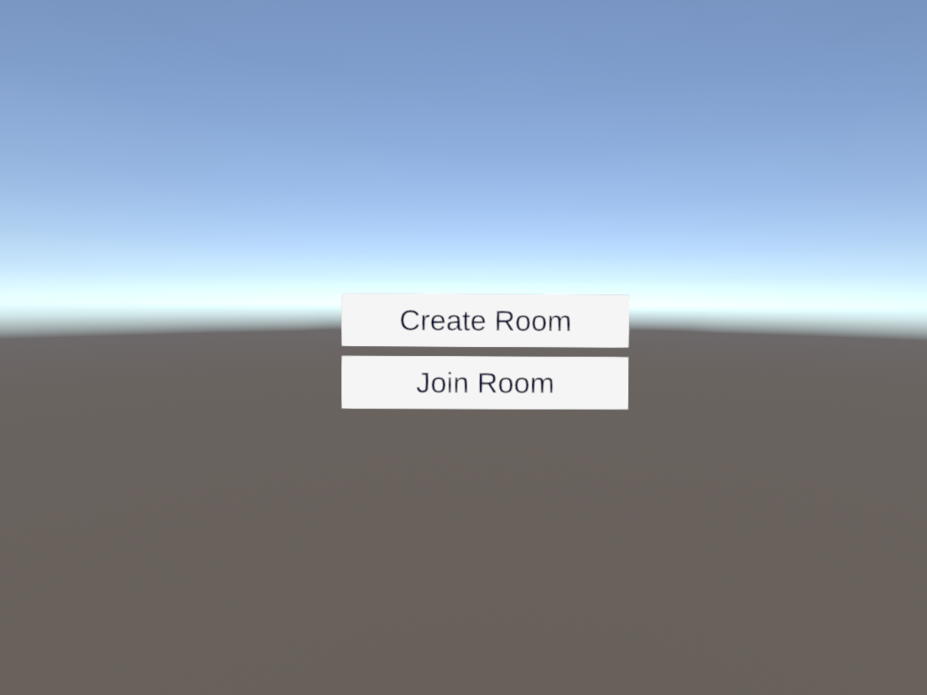

If you are going to host a new game session, select *Create Room.* Then you simply set the name for the new room and click on *OK.* You will create and join the room automatically.

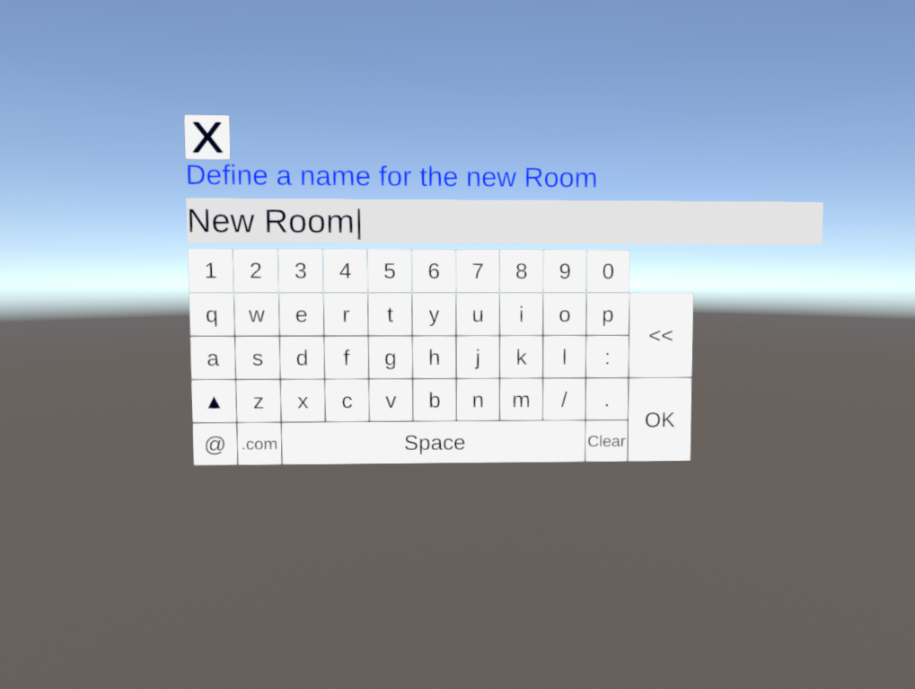

On the other hand, if you are going to join to an already created room, select Join Room. A dynamic list of the active rooms is shown. This list is updated as new rooms are created or existing ones are closed, so select the room you want to join from the list.

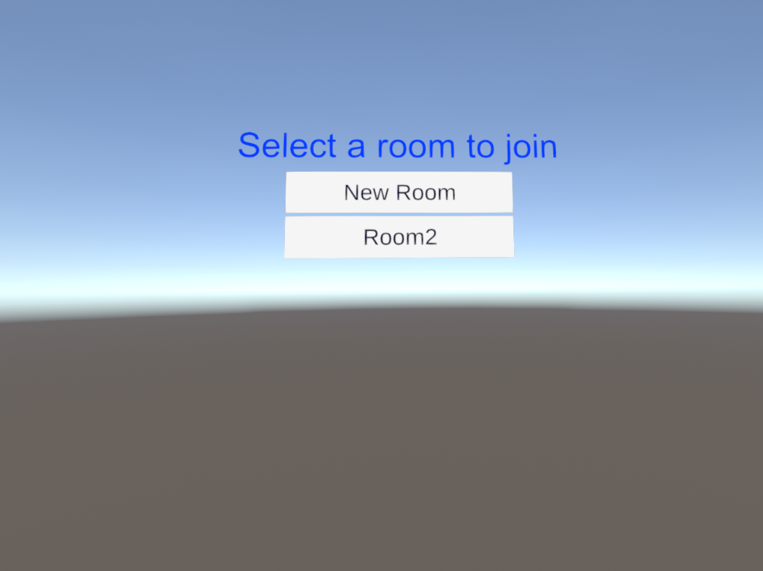

Remember that each room is like a different instance of the game. So if you want to meet with a specific group of people, you need to agree on which room you are going to meet. Communication between different rooms is not possible.

# Controls

* **Recalibrate:** If you physically move after the calibration process is done, there will be a mismatch between your physical body and your virtual counterpart representation. To fix this, simply look forward and press the *Y* button on your left controller.

# Appendix A: Installing an APK from your computer using SideQuest

[SideQuest](https://sidequestvr.com/) is a third-party application that makes sideloading content onto your Android VR Headset (tipycally Oculus Quest and Pico families) really easy. To start with, simply [download](https://sidequestvr.com/setup-howto) the version that matches your system.

Once it is installed on your system, open SideQuest. Connect your VR device to the computer using the USB-C cable that goes with it. If the device is properly connected, at the top left corner it should appear the type of the device that you have connected and some information like the local IP address and the battery level.



Next in the bar menu that is located at the top right corner of the screen, select the icon that looks like a box with an arrow pointing down.

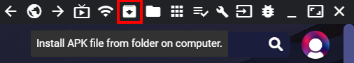

A file explorer window will appear. Look for the APK that you want to install in your device. Make sure to select the corresponding APK for your device, as APKs from Oculus Quest and Pico devices are different and one does not work on the other device.

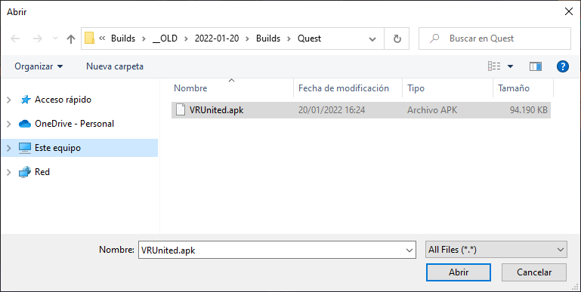

If the installation process succeeds, you will see the following message at the bottom of your screen:



You can also check the log of the application in the running tasks section.

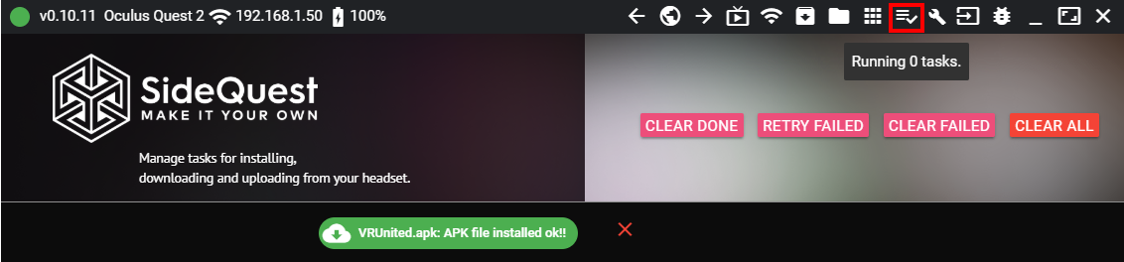

Now you can proceed to execute the application in your device.

# Appendix B: Where is VRUnited installed?

## Oculus Quest

Select the *Apps* menu on the main menu. On the *Apps* window, click on the dropdown menu located at the top right corner, and select *Unknown Sources.*

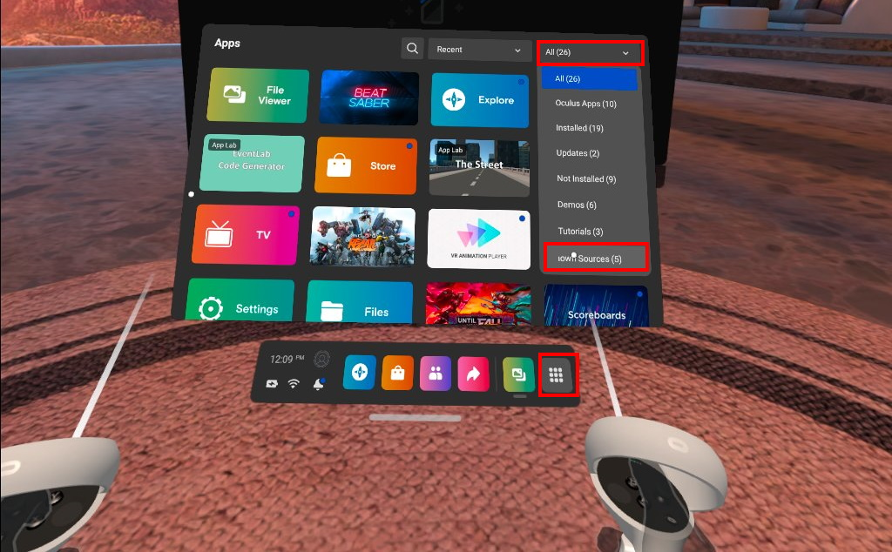

Select *VRUnited* from the apps list.

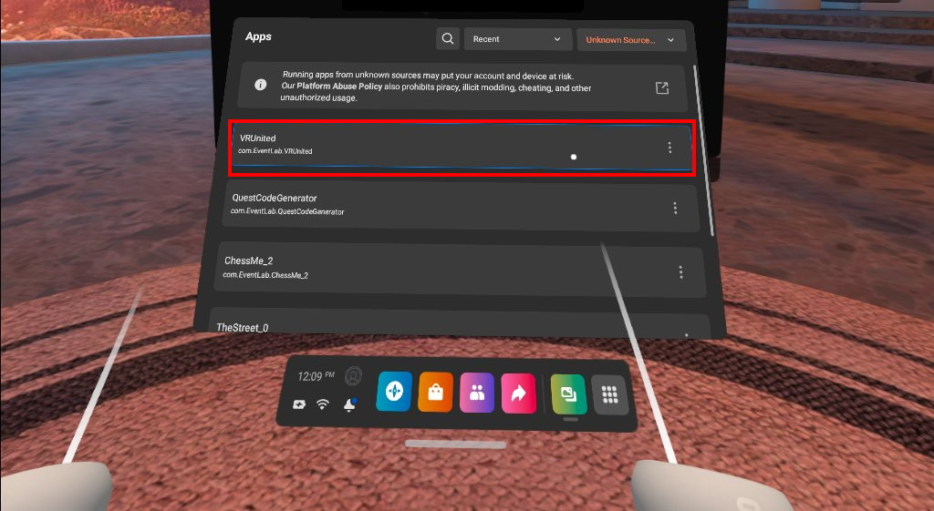

## Pico Neo

If you have a Pico Neo device, just select *App Library* on the main menu and select *VRUnited.*

