**Software Requirements**

**Specification**

**for**

**<씽쏭씽쏭>**

**<Hyeongil>**

**< June 14.2016>**

**Table of Contents**

**Table of Contents 1**

**1. Introduction 2**

1.1 Purpose 2

1.2 Intended Audience and Reading Suggestions 2

1.3 Product Scope 2

1.4 Sofware Context 2

**2. Overall Description**

2.1 System Environment

2.2 Functional Requirements Specification

**3. Functional Model and Description 7**

3.1 Functional Descriptions

3.1.1 Select Song 7

3.1.1.1 Choose a Player 7

3.1.1.2 Play or Stop Theme 7

3.1.2 Search Player 6

3.1.2.1 Player’s Profile and Theme 6

3.1.3 Map 7

3.1.3.1 Pop Up Window for Stadium 7

3.2 Software Interface Description

3.2.1 External Machine Interfaces 7

3.2.2 External System Interfaces 8

3.2.3 Human Interfaces 8

**4. Validation Criteria 8**

4.1 Tests

4.1.1 Invalid to show Search Result 8

4.2 Expected Software Response

4.1.1 Invalid to show Search Result 8

1. **Introduction**
   1. **Purpose**

The purpose of this document is to define the requirements for creating an Android application, which will be called 씽쏭씽쏭(SingSong). It will explain the purpose and feature of this software, the interfaces of the software and what the software do.

* 1. **Intended Audience and Reading Suggestions**

The intended audience for this document is classmates who attend The Mobile Programming II and the professor.

* 1. **Project Scope**

This software will be an Android mobile application for people who want to practice singing songs. This application is going to be designed to maximize the pro baseball fans’ convenience by reducing unnecessary buttons to find the players whom they are looking for instantaneously. This application also contains information such as lyrics, artists etc..

* 1. **Software Context**

Ultimately this software project is to give people a chance to sing their favorite songs not going karaoke or some plaeces by using this application. With that in mind we must make it a priority to minimize processes for finding songs what they would like to sing and update songs what many people would like to sing.

1. **Overall Description**
   1. **System Environment**

Mobile device

SingSong

Search a Song

Book a Song

A song will be searched

A song will booked and appeared on track list

Song wil be played

user

**Figure 1 - System Environment**

The SingSong application has 2 menus, which are ‘search song’ and ‘book song’. Users can access one of the 2 menus so that they can find songs which they want to sing and book songs they are going to sing in advance.

* 1. **Functional Requirements Specification**

This section explains the use cases for user. The user has 4 cases in this application, which are search a song book a song, play/stop a song and turn up/down volume.

* + 1. **User case**

Use case: **Search a Song**

title

title

apple

banana

cherry

durian

elderberry

fig

title

Contrary to popular belief, Lorem Ipsum is not simply random text. It has roots in a piece of classical Latin literature from 45 BC, making it over 2000 years old. Richard McClintock

**Diagram:**

User

**Brief Description**

The user accesses the search song page and chooses a song to be played.

**Description for each step**

1. The user enters title or artist.

2. The application shows results according to the input entered by user.

3. The user chooses one of the results.

4. The application provides song and lyric to the users.

Use case: **Book a Song**

**Diagram:**

User

1 2 3 play

4 5 6 pause

7 8 9 book

0

keypad

Search Song

|

Book Song

1000

title

1000

track list : 1000

keypad

1 2 3 play

4 5 6 pause

7 8 9 book

0 book cancle

play a booked song

1000

track list : 1000

title

Contrary to popular belief, Lorem Ipsum is not simply random text. It has roots in a piece of classical Latin literature from 45 BC, making it over 2000 years old. Richard McClintock

keypad

1 2 3 play

4 5 6 pause

7 8 9 book

0 book cancel

**Brief Description**

The user accesses the search song page and search a song by entering is tunique song number using keypad beside the device. If the user presses book button then a searched song will be uploaed on track list. At this time, the user can press play button and a song on the track list will be played in order.

**Description for each step**

1. The user enters song number into the search bar.

2. The application displays searching bar and shows title matches the number. Searching bar will support auto text completion function .

3. The user presess book button on the keypad and the song will be shown on track list. The user also can add some songs on the track list by booking more songs.

4. After the booking, the user presses play button and the song will be played.

Use case : **Play/Stop a Song**

**Diagram:**

Stop

title

Contrary to popular belief, Lorem Ipsum is not simply random text. It has roots in a piece of classical Latin literature from 45 BC, making it over 2000 years old. Richard McClintock

Proximity Sensor

Now playing

title

Contrary to popular belief, Lorem Ipsum is not simply random text. It has roots in a piece of classical Latin literature from 45 BC, making it over 2000 years old. Richard McClintock

Proximity Sensor

User



Now playing

title

Contrary to popular belief, Lorem Ipsum is not simply random text. It has roots in a piece of classical Latin literature from 45 BC, making it over 2000 years old. Richard McClintock

Proximity Sensor

Stop

title

Contrary to popular belief, Lorem Ipsum is not simply random text. It has roots in a piece of classical Latin literature from 45 BC, making it over 2000 years old. Richard McClintock

Proximity Sensor

User



**Brief Description**

The user accesses the search song page and search a song by entering is tunique song number using keypad beside the device. If the user presses book button then a searched song will be uploaed on track list. At this time, the user can press play button and a song on the track list will be played in order.

**Description for each step**

1. The user enters song number into the search bar.

2. The application displays searching bar and shows title matches the number. Searching bar will support auto text completion function .

3. The user presess book button on the keypad and the song will be shown on track list. The user also can add some songs on the track list by booking more songs.

4. After the booking, the user presses play button and the song will be played.

Use case : **Turn Up/Down Volume**

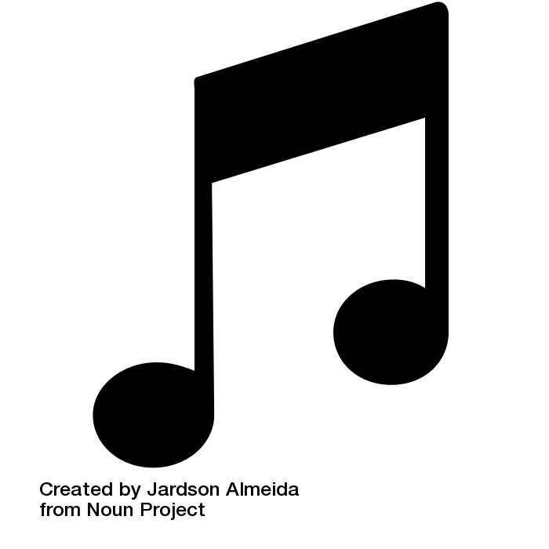**Diagram:**

User





User





**Brief Description**

The user accesses the search song page and search a song by entering is tunique song number using keypad beside the device. If the user presses book button then a searched song will be uploaed on track list. At this time, the user can press play button and a song on the track list will be played in order.

**Description for each step**

1. The user enters song number into the search bar.

2. The application displays searching bar and shows title matches the number. Searching bar will support auto text completion function .

3. The user presess book button on the keypad and the song will be shown on track list. The user also can add some songs on the track list by booking more songs.

4. After the booking, the user presses play button and the song will be played.

1. **Functional Model and Description**

The following section will describe the major functions which make up the SingSong. This section will also include interface and user interaction descriptions.

* 1. **Functional Description**

This section will discuss some functions within the SingSong

* + 1. **Play a Song**

When a user presses search bar, which contains all songs is the first button in the main menu page, the user will go to select team page and there will be 10 pro base ball teams, which will be aligned by 5x2. If the use pushes a back button, the user will go back to the main menu page.

* + - 1. **Choose A Player**

When a user selects one of 10 teams there will be 9 key players, which will be aligned by 3x3. If user pushes a back button, the user will go back to the select team page.

* + - 1. **Play or Stop theme**

Once a user pushes a button for each player, the theme for the player will be starting instantaneously. If a user pushes the button again, the theme will stop and if the user pushes another player’s button, the previous theme will stop and new theme will start playing. When the user pushes back button the theme which is playing will stop and the user go back to choose a player page.

* + 1. **Search Player**

When a user pushes search player button, which is the second button in the main menu page, the user will go to search player page and there will be a searching bar in the middle of the page and the searching bar will support both automated text completion function and English and Korean. Once the user enters a keyword for existing player, there will be right player’s name what the user want to find. If the user clicks the name, the user will go to page which offers player’s profile and theme. If the uses pushes a back button, the user will go back to the main menu page.

* + - 1. **Player’s Profile and Theme**

When a user is in the player’s profile and theme page, they can see the player’s profile, which will be including the player’s height, weight, position and characteristics. At the bottom of this page, there will be 3 buttons, which will be play, pause and stop button for users to control the player’s theme. If the user pushes a back button, the user will go back to the search player page.

* + 1. **Map**

When a user pushes a map button there will be 10 buttons for pro baseball teams on a Korean map. Each team will be on their right place (i.e. Kia Tigers-Gwanju, Hanhwa-Daejeon etc.). If user pushes one of the buttons, new pop up window will appear in the middle of the page. If the user pushes a back button, the user will go back to the main menu page.

* + - 1. **Pop Up Window for Stadium**

There will be a small diagram for each stadium and a URL which will link to Naver Map by using user’s web browser and it will give user geological information. If the user pushes outside of the pop up window or back button, the user will go back to the map page.

* 1. **Software Interface Description**

The PB.tunes will be run only on Android operating system devices and will have only one interface. Although this application will be run on Android operating system, we have only one device for testing, which is the Samsung Galaxy Note 8.0’ so it will be not easy to test on other Android devices.

* + 1. **External machine interfaces**

The SingSong will run on HBE SM5-4210

* + 1. **External machine interfaces**

The SingSong user will rely on the API 10: Android 2.3.3(GingerBread).

* + 1. **Human Interface**

The application will contain search bar, seek bar and several buttons, each of which will serve some primary functions. Each of these interfaces will differ only in different function with almost similar design themes so it will be easy to understand and will not require a tutorial for the user’s first use. There are 16 buttons, which care called keypad beside the device. They are used to book some songs and play them.

1. **Validation Criteria**

This section lists the various tests that will be conducted on the software. The tests are done to ensure the software is working properly, and how it will handle possible errors that may occur.

* 1. **Tests**
     1. **Invalid to Show Search Result**

This error occurs when the user inputs non-existing player’s name on the searching bar.

* 1. **Expected Software Response**
     1. **Invalid to Show Search Result**

If the uses enters non-existing player’s name, an error message will appear saying, “No result” and the user will be asked to enter a new keyword again.