Template / Instructions for Abstract of ^{11th}CNCCB

Application：1）Poster，2）Speaker，3）Invited Speaker.
[Please choose one selection，We will inform you the result considering your application]

Title [14pt, bold, middle]
A Blank line
Author(s) [10.5pt, middle]
[Family name (First capital letters), given name (initial mid-name, if any); separated by comma(s), 10.5pt, plain text, middle; superscript star (*) for corresponding author, superscript a, b, c, et al. for different affiliations]
Affiliation(s) [10.5pt, middle]
[Department, School, University, Address, postal code, 10.5pt, plain text, middle]
[Different affiliations begins with a new line]
A Blank line
Detailed abstract or brief article [free style, 12pt, plain text, 1.0Space]
Keywords: [no more than Keywords, 10.5pt, bold]
A Blank line

References [10.5pt bold]
List of no more than5 main references, [9pt].
Journal article: [authors (full list), journal (italic), year (bold), volume (italic), initial page.]
Book: [authors (full list, plain text), title of the chapter (bold, italic) in (plain text) Name of the book (bold, italic), Editors (full list), name of publisher, year of publication.
Patent: [inventors, Patent Number, Publication Number or Application Number (Italic), year (Bold).

Acknowledgement[10pt bold]: Project supported by:…… [10.5pt plain text]

All text in “Times New Roman”

Application：1）Poster
NMR Structural Basis for Higher-Order Human Telomeric G-quadruplex Complexes Induced by Platinum(II)-Based Tripod

Wenting Liu, Yi-Fang Zhong, Liu-Yi Liu, Liang-Nian Ji, Zong-Wan Mao*
MOE Key Laboratory of Bioinorganic and Synthetic Chemistry, School of Chemistry,
Sun Yat-Sen University, Guangzhou, 510275
*Email: liuwting@mail2.sysu.edu.cn

DNA guanine-rich sequences can form non-canonical secondary structures known as G-quadruplexes. It has been suggested that DNA G-quadruplexes are involved in several key biological processes and various cancer and human genetic diseases. Such DNA secondary structures have attracted great interest nowadays due to the increasing evidence of their significant biological role, and have been developed as novel targets for anticancer drug development. Moreover, G-quadruplexes have important applications in various fields such as nanotechnology and assembling chemistry.^{[1]} Here, we designed a platinum(II)-based tripod (Pt-tripod) and we found the Pt-tripod specifically binds the hybrid-1 human telomeric G-quadruplex and effectively inhibits telomerase activity. NMR studies were used to investigate the dynamic binding of the Pt-tripod and hybrid-1 human telomeric G-quadruplex. We demonstrated the Pt-tripod induces the formation of monomeric and higher-order Pt-tripod/G-quadruplex complex structures in solution. We solved the 1:1 and 4:2 Pt-tripod/G-quadruplex complex structures by NMR.^{[2]}
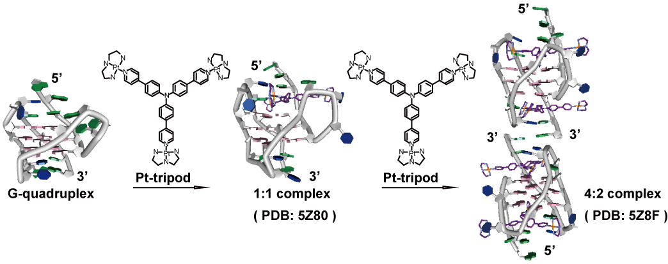
Figure 1. The dynamic binding of the Pt-tripod and the human telomeric G-quadruplex DNA.

Keywords: Platinum complex, NMR, G-quardruplex, dynamic binding

References
[1] Neidle, S. Nat. Rev. Chem. 2017, 1: 0041.
[2] Liu, W.; Zhong, Y. F.; Liu, L. Y.; Shen, C. T.; Zeng, W.; Wang, F.; Yang, D.; Mao, Z. W. Nat. Commun. 2018, 9: 3496.

Acknowledgement: This work was funded by the 973 program (Nos. 2014CB845604 and 2015CB856301), the National Science Foundation of China (Nos. 21231007 and 21572282), the Ministry of Education of China (IRT-17R111), Science and Technology Planning Project of Guangdong Province (Nos. 2013B051000047 and 207999), the Fundamental Research Funds for the Central Universities, and the US National Institutes of Health (R01CA177585 (DY), and P30CA023168 (Purdue Center for Cancer Research)).

