**Swimming in a Sea of Excess**

**Introduction: Traces, Data, Susan Sontag**

Three years ago, I came to know of Susan Sontag in my introductory English class, *Intellectuals and Their Publics*. I remember being in awe of her intelligence, ferocity, her fame as a public intellectual, and her grand, self-proclaimed devotion to, and appetite for culture. As an impressionable, undergraduate freshman, I aspired to be like her one day. Gung-ho, I set out to know as much as possible about her. In knowing more about her work and life, I believed that even if I could not be her, I could at least ‘know everything’ about her.

*11/25/48:*

*I must not think of the solar system—of innumerable galaxies spanned by countless light years—I must not look up at the sky for longer than a moment—I must not think of death, of forever—I must not do all those things so that I will not know these horrible moments when my mind seems a tangible thing—more than my mind—my whole spirit—all that animates me and is the original and responsive desire that constitutes my ‘self’—all this takes on a definite shape and size—far too large to be contained by the structure I call my body—All this pulls and pushes—yearns and strains (I feel it now) until I must clench my fists—I rise—who can keep still—every muscle is on a rack—striving to build itself into an immensity—I want to scream—my stomach feels compressed—my legs, feet, toes stretching until they hurt. I come closer and closer to bursting this poor shell—I know it now—contemplation of infinity—the straining of my mind drives me to dilute the horror by the opposite of abstraction’s simple sensuality.*

*-Susan Sontag,* Reborn: Journals and Notebooks, 1947-1963

*The fever, or the sickness of the archive is to do with its very establishment, which is at one and the same time, the establishment of state power and authority. And then there is the feverish desire—a kind of sickness unto death—that Derrida indicated, for the archive: the fever not so much to enter it and use it, as to have it, or just for it to be there, in the first place.*

*-*Carolyn Steedman*, Dust: The Archive and Cultural History*

For this class, I first introduced Susan Sontag through one of my generative text projects: I presented a poem that I made by taking a list of adjectives Sontag wrote in her journals and

inputting each word as the prompt string for a recurrent neural network algorithm I had trained to generate text. I intentionally trained the algorithm on her entire body of fiction writing. In doing this, I hoped that I could tease out more meaning surrounding those words in her list. In other words, I idealized that I could somehow make her elaborate from the dead. In other words, I desperately dreamed that the neural network would somehow represent part of Sontag’s mind—that the algorithm would be her literary ghost: a digital ghost that might tell me more about her various bizarre, decontextualized lists of words and statements.

My attachment to making her lists of words ‘speak’ (to be more than just one-off lists) comes from a wider body of research on Susan Sontag’s life, which I have been gathering for the last three years. In that time, I have been thinking about Susan Sontag’s relationship to death and life, overabundance and lack, meaning making, and conferring value on her life. These themes are the sieve through which I have come to apprehend her life. They are also themes which touch on the conditions of making meaning/meaningful things in a world where algorithms and statistics are also endowed with that power (not without human facilitation). In the context of my own research on Susan Sontag, I have always had this question at the back of my head: what does it mean and take to represent her life? Or really, any life?

*Just as history is not the past itself but a story about the past, biography is not a life, but a life story.*

*-*Benjamin Moser, *In the Sontag Archives*

I first confronted this question when I teamed up with a pair of professors from SFAI to be part of their research team for a Susan Sontag-themed season of public events around San Francisco. The question that was on all of our minds was: how do we begin to represent the life of such a prolific and multifaceted person? At the time, I had just started my own research on her life and work, and having read her diaries first, I was already wary of the difference between her public and private self; even more, I was concerned with the ethics of telling her ‘life story’ through the traces she left behind, but which, cannot actually speak for her.

*So there is a double nothingness in the writing of history and in the analysis of it: it is about something that never did happen in the way it comes to be represented (the happening exists in the telling or the text); and it is made out of materials that aren’t there, in an archive or anywhere*

*-*Carolyn Steedman*, Dust: The Archive and Cultural History*

For historians, the dynamic between myth and truth in historiography (the writing of history) means paying attention to, not only the information that then becomes sanctioned as history, but also the institutions of power that govern the process of recording, collecting and qualifying information as historically valuable (worthy of being remembered).

As someone with deeper background in history and cultural/literary studies, my approach to working with data and algorithms draws a lot from my understanding of how archives and history have failed to represent certain stories, lives, and bodies. So, my entry point into big data and its uses, is viewing it as an archive: to understand (certain) data as traces (parts) of real lives or events—to understand data as a process implicated in the ethics of representation. Another field of research that influences the way I work and think about data is digital humanities (DH). Specifically, the sub-field of DH that deals with computational and statistical textual corpus analysis.

Computational text analysis changes the flow of reading: instead of flipping serially from one page to the next, with the help of special programs, one can ‘read’ several texts at once whilst looking for broader patterns that link the texts in the corpus together (known to some practitioners as ‘distant reading’). Below is an example of this kind of methodology (taken from my corpus analysis of Susan Sontag’s obituaries):

*This project aims to find differences in rhetorical strategies within a single corpus of texts. DocuScope takes into account and identifies 24 cluster and 169 dimensions supported by 20,000+ language pattern classes and 100 million+ unique English patterns. The entire corpus of Sontag obituaries has been tagged according to the 25 cluster categories (top-level, less granular) that DocuScope identifies as being significantly present in each text. Through factor analysis, all these clusters are gathered together into super-clusters (or super-variables), which can be thought of as rhetorical strategies. This project seeks to find a single factor that can help describe two opposing rhetorical strategies that exist within this corpus.*

Under the paradigm of computational text analysis that I have engaged with, the results of computational analysis always need verification and substantiation by the human reader: it is undeniably a process thick with interpretive moves. In other words, tools like Docuscope and statistical models like factor analysis facilitate (not automate) our discovery of potentially interpretable textual phenomena. In this context of research and analysis, data is not seen as inherently meaningful, several interpretative frameworks converge to bring latent meaning into recognition.

For the purposes of this paper, I want trace how I have come to use Susan Sontag’s corpus to think about what it means and what it takes to make algorithmically, generative text out of her oeuvre. In doing so, I hope to illustrate the philosophical questions and ethics that have guided my research on Sontag, and my desire to develop a generator that ‘writes like her.’ In the following sections I will track a few projects that have led me towards working with Sontag’s writing as data, as well as how those projects have shaped the way I orient myself towards the data I am using.

**Vertigo: Susan Sontag’s Born Digital Archive**

*How much information is just too much information? What are we to do with this overmuchness, this “plenitude,” the “sheer crowdedness” that is Sontag’s digital life?*

- Jacquelyn Ardam & Jeremy Schmidt, *On Excess: Susan Sontag's Born-Digital*

*Archive*

Reflecting on Sontag’s urging for people “to see more, to hear more, to feel more,” Jacquelyn Ardam and Jeremy Schmidt note that “‘more’ was both Sontag’s problem and her proffered solution” (2014). With the 2014 unveiling of her digital life, now housed in and available through a laptop computer at the UCLA Library Special Collections, the issue of her excess, and the vertigo of sorting through what she has left behind is being tackled in the domain of archival practice. The convergence of her sensuous relationship to excess with the accommodating space of the digital platform of the computer has produced a born-digital archive that is in part organized by Sontag’s logic, or as she might prefer, erotics of accumulation, but also governed by and reflective of the digital era’s propensity for and accommodation of superabundance and redundancy. Indeed, Ardam and Schmidt propose that “Sontag is…an ideal subject for exploring the new horizon of the born digital archive, for the tension between preservation and flux that the electronic archive renders visible, is anticipated in Sontag’s own writing.”

Researching her born digital archive, I became aware of the precarity of digital traces. While everything that “happens leaves traces”(Trouillot, 29), traces in the digital space are far from being concrete like the “buildings, dead bodies, censuses, monuments, diaries, political boundaries” (29) that Trouillot identifies as being fundamental limitations to “the range and significance of any historical narrative” (29). Indeed, “the born digital archive asks us to interpret not smudges and cross-outs, but many, many copies of almost-the-same-thing” (Ardam, Schmidt, 2014).

It seems to me that a new form of “traces”—redundant information— has been introduced to historical production, and the limitations on, or their contributions to, the production of history must be explored—how do these traces, these redundant (and abundant) documents and facts, “limit the range and significance” (Trouillot, 29) of (historical) narratives created in this digital and virtual paradigm? In other words, how does redundancy effect the way we can make meaning out of an already overwhelming quantity of digital traces? These questions lead into another more general question: how do we decide how to sort through vast amount of information to make meaning? This question, while broad enough to be applicable to all research fields, is one that is particularly important for people working with sensitive data.

In the context of Susan Sontag’s own philosophy of life, her desire for ‘more’ was mediated by her proclivity for list making. In a characteristically self-reflexive entry from August 9, 1967, 34-year-old Sontag considers the allure of lists:

*I perceive value, I confer value, I create value, I even create — or guarantee — existence. Hence, my compulsion to make “lists.” The things (Beethoven’s music, movies, business firms) won’t exist unless I signify my interest in them by at least noting down their names.*

*Nothing exists unless I maintain it (by my interest, or my potential interest). This is an ultimate, mostly subliminal anxiety. Hence, I must remain always, both in principle + actively, interested in everything. Taking all of knowledge as my province.*

As we can see, for Sontag, list making was a way to manage her appetite for knowledge, to sustainably live a life where knowledge could actually be her province, her home—not a force that would break her ‘poor shell.’

In the context of her born digital archive, Ardam and Schmidt have discussed how the archive’s search function carries the primary burden of sorting through the excess of her archive, of helping us make meaning out of her dizzying, born digital life:

*Listing and searching both provide us with ways, however flawed, to cut through redundancy, to make meaning out of chaos, to, in Sontag’s vocabulary, confer and create “value,” even “existence.” This impulse to list, to search, or, in other words, to reduce — an impulse researchers necessarily share with Sontag herself — takes on a peculiar resonance in the context of the guarded writer’s archive: what does it mean that we can now search Susan Sontag’s entire digital life for “Annie”?* [Leibowitz, her lover at the end of her life]

What the search function and list making have in common is that they order information, so that we can maybe begin to grasp it as knowledge. That desire I shared earlier: to complete one of Susan Sontag’s lists, for one, came out of an impulse to bring order or consistency to my application of generative algorithms. However, it was also a poetic gesture, an homage to Sontag’s own need to filter the overabundance of information into a more discrete and digestible form.

**Towards Escaping Vertigo:**

*On what ‘table’, according to what grid of identities, similitudes, analogies, have we become accustomed to sort out so many different and similar things? What is this coherence – which, as is immediately apparent, is neither determined by an a priori and necessary concatenation, nor imposed on us by immediately perceptible contents?*

*-*Michel Foucault*,* *The Order of Things*, xxi

Finding, ordering, and synthesizing research is in a general sense about managing the abundance of information that the world has to offer. In many ways, I am writing this paper to articulate the various moments that have pivoted me towards digital and computational research practices. In this next section I will discuss a project that came out of a struggle to make something evocative and sensual out of Susan Sontag’s corpus—to make a textual project that was also imbued with the love and care that moved me to apprehend her life’s work.

Loving, Susan Sontag: Desire Oriented Research

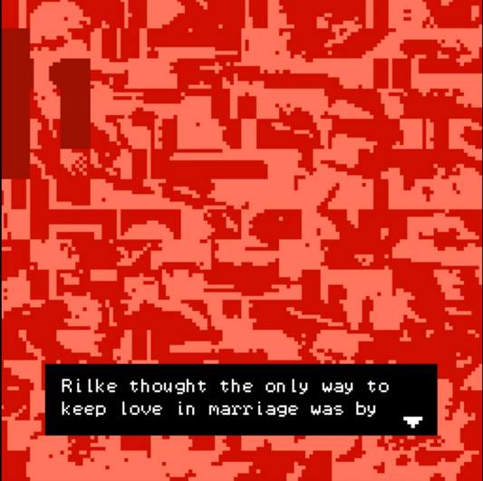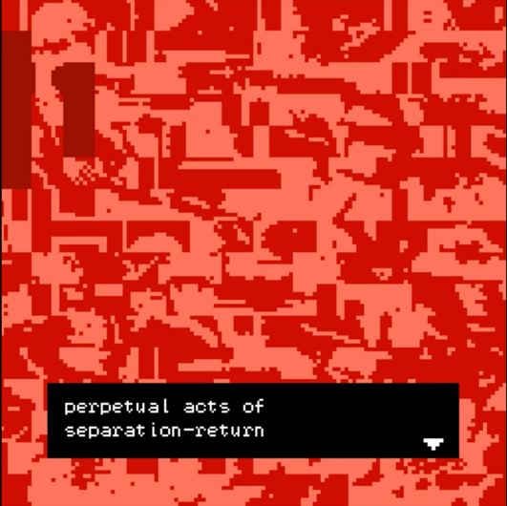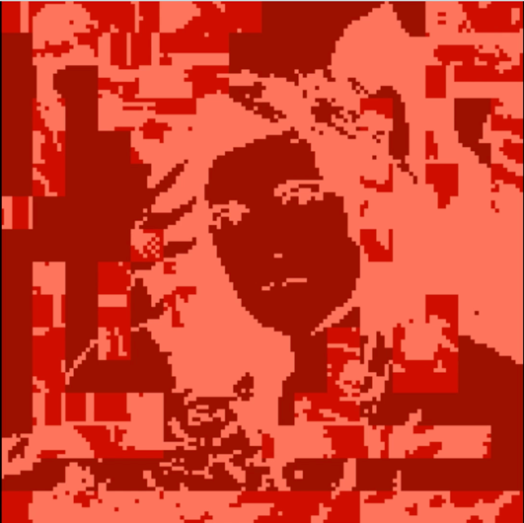

<https://vimeo.com/305430056> (video of game-play)

At the time that I made this project I had already compiled all of Susan Sontag’s writing into a corpus of .txt files ready for computational processing, but I did not yet know how I was going to use it as data. By that time, I only had experience treating textual data as my object of analysis not as an object to be synthesized: I knew that the two were not mutually exclusive, but I did not know how to translate my understanding of data from one mode of interpretation to the other. So, I took on this dilemma and made a Bitsy game that was about reading and writing, analysis and synthesis, quotation and generation all at once. In this game, reading also means writing a particular configuration of Sontag’s sentences about love. Conceived of as a kind of dynamic love letter from her to me and vice versa, the text in the game is about quotation (a kind of redundancy), and the generation of new meaning.

To do this project, I wrote a small python script that extracted all the sentences containing the word ‘love’ in Susan Sontag’s corpus. I then created tiles for the Bitsy game (from an image of Sontag), which were all covered by Bitsy items (which are then be picked up by the user’s avatar). The items were made of the scrambled tiles composing the background tiles. The intention for this ‘game’ is to uncover Susan Sontag’s face by picking up all the ‘items’—each of which contains a sentence with the word ‘love’ in it. I imagined this ‘game’ to be a shifting poem or letter about love—each player creates their own passage through the various sentences regarding ‘love’ that Sontag has written. I also tried to add music to the game to give the reading experience some rhythm; specifically, Scriabin’s 24 Preludes (Op.11). The music was chosen from one of Sontag’s journal entries from June 4th, 1949—Sontag was 16 years old at the time:

*6/4/49:*

*Shostakovich Piano Concerto*

***Scriabin Preludes***

*Franck D Minor Symphony*

*Prokofiev Symphony #5*

*[Bach’s] Mass in B Minor*

*Sex with music! So intellectual!!*

In making this piece, I wanted to mediate the way one reads Sontag’s published journals.

Journals are private documents of one’s life. The ethics of publishing and reading the most intimate thoughts of a person is, necessarily, a tricky experience, yet, it can also be joyous and illuminating. Indeed, for this project, I wanted to move away from prescribing a particular interpretation of Sontag’s relationship to love over time, and instead show how the theme of love in her journals can also be captured through various permutations of her sentences containing the word ‘love’. I still ask myself, however, if this intervention is legible enough? I still do not have an answer to that, but I am working towards it as I continue to work on what it means to read and write in this digitizing world.

**Conclusion? Chasing the Future of Writing**

Tracing this lineage of research, I find it endearingly appropriate for the conceptual and technical difficulties I am having with generating ‘interesting’ text out of Susan Sontag’s existing oeuvre. With the generative methodologies I have tried so far I am once again dealing with how the magnitude and accumulation of information can fail to account for a life or a lifetime’s worth of knowledge. In other words: feeding the recurrent neural network ‘more’ of Sontag doesn’t make it better at ‘becoming’ Sontag. So far, my solution to this dilemma follows Robin Sloan’s mode of using generative text methodologies: that is, using them as creative tools to collaborate with.

In the Fall semester of 2018, I was invited to take part in Robin Sloan’s workshop, Automatic Telling: A Cyborg Fiction-Writing Experiment, at the Studio for Creative Inquiry at Carnegie Mellon University. The workshop unfolded over the course of three days, during which the participants, coming from a wide range of disciplines—from game design to English literary studies— sat down together on a long, continuous table to co-author, with the computer (specifically, an artificial recurrent neural network trained on artists’ biographies and other corpora and developed by Sloan), a brief account of a fictional artistic movement of the late twentieth century: The Center for Midnight: A History in Fragments . In order to craft this fictional history, each workshopping day was carefully divided into cycles of collective writing, editing, and discussion; the whole process was undeniably a labor of love.

To make his writing collaborator, Robin Sloan trained a recurrent neural network (called torch-rnn-server) on 150MB of Galaxy and IF Magazine texts, derived from the Internet archive’s Pulp Magazine Archive . The server itself is an elaboration on Justin Johnson’s torch-rnn project, and it runs an artificial neural network that takes in excerpts of text and generates a new chunk of text in ‘response’ to or to ‘complete’ the inputted text. Sloan also created a package, rnn-writer, which runs on the code-editor, Atom, and ‘talks’ to the torch-rnn-server and present it to the user.

In the early stages of developing his new writing tool, Sloan considered several important questions regarding the data the neural network was trained on, how that data would change what could be written, and how his tool might impact contemporary writing practices and fit into the cut-throat information and data ecology that exists today:

*I am just so compelled by the notion of a text editor that possesses a deep, nuanced model of… what? Everything ever written by you? By your favorite authors? Your nemesis? All staff writers at the New Yorker, present and past? Everyone on the internet? It’s provocative any way you slice it. I should say clearly: I am absolutely 100% not talking about an editor that “writes for you,” whatever that means. The world doesn’t need any more dead-eyed robo-text.*

-Robin Sloan, 2016

Indeed, for Sloan, the potential of a text-editor merged with a generative text function lies not in its promise to reduce or increase the difficulty of writing—by outsourcing the labor of imagining and then actually writing something to the computer—rather, Sloan is interested in how this new function in a text editor might expand what can be written: “The goal is not to make the resulting text “better”; it’s to make it different — weirder, with effects maybe not available by other means” (Sloan, 2016).

The assumption that computer-generated methods of writing somehow reduce the agency of the human writer, or that they take the ‘soul’ out of writing, is simply a myopic and paranoid argument for the authenticity of human labor and its products. It is a myopic view of the history and practice of writing, taking no interest in the layers of intersecting labor—automated or not—required in the process of imagining, writing, composing, editing, publishing, and disseminating a textual artifact. As Matthew G. Kirschenbaum in, Track Changes: A Literary history of Word Processing, “an analysis that imagines a single technological artifact in a position of authority over something as complex and multifaceted as the production of a literary text is suspect in my view and reflects an impoverished understanding of the writer’s craft” (7). It is an excessively paranoid defense of the Empire of the Author, an anxious desire to reaffirm the authority and authenticity of the ‘person’ behind the text.

When the typewriter was introduced, people lamented the loss of the pencil or pen, with the advent of the word-processor, people wept for the click-clacking of the typewriter’s keys. What we see in these transitions is how much the materiality of these writing tools matters inasmuch these technologies become muses for our love of writing, shape our bodies and reorient our senses when we dedicate ourselves to inscribing our thoughts. In addition, they become philosophical tools through which we meditate on and experiment with our preconceived notions of the place of the writer and of writing in a rapidly changing society with increasingly diversified, accessible, and inclusive platforms for the production and circulation of media, textual or not. Now that we are in the thick of a so-called ‘information society,’ where finding truth in the visual and textual data we encounter almost every second, is at the very best, precarious (think: fake news), we must hold ourselves at a higher level of accountability not only for what we disseminate, but also for how we make the artifacts of our intellectual and emotional curiosity. We must become more explicit and transparent about the material processes and conceptual methodologies we employ in our making. Sloan’s generosity in detailing the making and use of his text-editor and his impulse to engage with it together with others (in a temporary but powerful community), demonstrates this new mode of creating— at least, on a small scale.

As I look forward to the next step in my digital and traditional research on Susan Sontag’s life and work, I want to carry what I have learned through all of these different moments of research into my next project. The next project I will be embarking on is first and foremost a storytelling project. I foreground storytelling to remind myself that even if I use generative text methodologies, they are primarily in service of creating a story that touches people. To foreground a generative text experiment as a storytelling experiment highlights the interpretive and imaginative labor (human and not) that it takes to move generative text into the domain of generative *literature*. As thus, in the next few months I will working on incorporating generative text into a comic adaptation of Susan Sontag’s short story, *The Dummy*. As I work on this project, I intend to carefully document the process of using algorithmically generated texts as creative prompts for both written and visual elaboration. At the end I will not only publish this comic with a detailed intro on the various collaborators involved, but I will also share the process of making this comic online. I want to disseminate this kind of research process, because, frankly, there is very little extant documentation on the ideas behind creative applications of generative text methodologies. There are plenty of tech reviews and technical reports on this subject matter, but I have yet to see humanities-oriented documentation and discussion of engaging with these methodologies.

**Works Cited:**

Ardam, Jacquelyn, and Jeremy Schmidt. "On Excess: Susan Sontag's Born-Digital Archive." Los Angeles Review of Books. N.p., 26 Oct. 2014. Web. 09 May 2017.

Barthes, Roland. Image-Music-Text: Roland Barthes. Translated by Stephen Heath, Collins,1977.

Kirschenbaum, Matthew G. *Track Changes: a Literary History of Word Processing*. The Belknap Press of Harvard University Press, 2016.

Michel-Rolph Trouillot. Silencing the Past: Power and the Production of History, (Boston: Beacon Press, 1995)

Sloan, Robin. “Writing with the Machine.” Robin Sloan, May 2016, [www.robinsloan.com/notes/writing-with-the-machine/](http://www.robinsloan.com/notes/writing-with-the-machine/).

Sontag, Susan, and David Rieff. Reborn: Journals and Notebooks, 1947-1963. Picador, 2009.

Steedman, Carolyn. Dust: the Archive and Cultural History. Rutgers University Press, 2011.