**Cursor Icon Archive**

**Reflection**

**Background:**

After reading Mimi Onuoha’s *On Missing Datasets*, I started thinking about information that I would like to have but don’t have access to. First, I thought about the information about myself that I have never and may never have access to: data about my birth family, and genetic heritage (perhaps this was on my mind since I have been writing a paper about China’s One Child Policy). Although I have submitted my DNA to 23andMe (yikes, I know, but I did it with my family when I was younger), there are several significant gaps in my reports, due to the fact that I don’t have any known biologically related family members, let alone any that sent their DNA to 23andMe (I do have 5th -8th cousins pop up in the “relatives” list, which is generated by comparing my data to other people on 23andMe). I am not too bothered by this absence of genetic data, it holds no more value and truth as evidence of myself than anything else does. But then I began to think about how platforms like 23andMe have been used by adoptees to find genetic relatives—I, for one, have been contacted several times by other users with blurbs about when and where they were adopted. Anyways, I then began to think about how there is almost no data about the children and families that were affected by the One Child Policy (i.e. no records on the circulation of china’s excess children (relinquished, domestic adoptions, international adoptions, killed) to name just name one subset of many bodies affected by the policy).

I thought I would try to make something serene with the absences in data related to my history—so, I requested my incomplete DNA data from 23andMe…BUT…I never got it.

Since this line of thought got cut off for the time being, I switched gears and began reflecting on the relationship between image databases for training neural networks, the abstraction and simplification of social/individual bodies in data, and the several connotations of the phrase, “still life.”

Still life, in painting, means the depiction of an arrangement of inanimate objects. The phrase can also be a kind of insistence that something is *still* (a) life, or it can sound like a command or plea: (be) still, life. I think this is phrase (and its various connotations) is a fruitful metaphor for the tug and pull of power, meaning and truth between people’s actual bodies, abstracted bodies in data, the systems that abstracted those bodies as data, and the people who get to collect other’s data. Thinking about this, I was compelled to collect images from *WetCanvas.com* from the “still life” sub-section of the reference image section. I would then write a small program that would re-output those images only with the rgb values in place of each of the image’s pixel, and titles with the name of the scraped file. Unfortunately, I was pressed on time this last week, and wasn’t able to learn how to code that quickly enough.

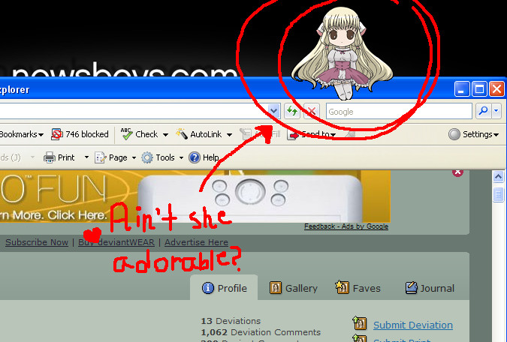I wanted to continue to think along the theme of still life, so I began to reflect on what things end up in (things that are “stilled” in) image databases for neural networks. For commercial purposes, machine learning algorithms are often oriented to predicting or generating things that populate the material human world. But what of all the digital artefacts we make? (not a new question, but a guiding one for sure) Encouraged by pippinbarr’s vr3 water project, I went around searching if anyone had made a computer cursor database—I went in this direction because I remembered a short period of time (middle school?) when my friends and I had used custom cursors and desktop mascots to “decorate” our PC interface. Here is an example of what a desktop mascot looks like:

And this is where my project emerged [although I definitely feel like it can be developed more]:

**Discussion of my Dataset:**

For this project I scraped (using the image scraper code we used in class) around 1,000 (983 to be exact) still images (not functional .ani or .gif files) of custom cursor designs (for Windows) from [www.rw-designer.com](http://www.rw-designer.com), specifically, from the self-proclaimed “Junkyard” section of the site. These cursors are collected under this category if the users were unable to upload enough icons to create a full “icon set.”

After collecting about 10 html pages of junkyard cursor icons, I began to browse them! To say the least, they were for the most part amazing (some sensitive/violent imagery was found as well, although because the images are only 50 pixels square or so, it’s sometimes hard to see). I found declarations of love for someone (like you would find carved into a tree or scribbled in a bathroom stall), selfies, family portraits, anime characters, pets, and more (see last page for portraits of people as cursor icons). The html structure for this website was kind of funky, and because I was pressed for time, I wasn’t able to collect the file names of these images or the usernames of the people who created them—however, I would love to keep working on this project, and revise my method of collection and implement a crediting system, based on the cursors I end up collecting for it.

I was particularly interested in the phenomena of full selfies or family portraits within this cursor-icon sharing site, and what would happen if people created an image database of people based on the people that show up as cursors.

Regarding the use of a database of cursor icon image, more generally, I thought it could be interesting to use this data to make generative cursors out of the “junkyard” icons available on this site!

