TỔNG LIÊN ĐOÀN LAO ĐỘNG VIỆT NAM

**TRƯỜNG ĐẠI HỌC TÔN ĐỨC THẮNG**

**KHOA CÔNG NGHỆ THÔNG TIN**

**BÀI TẬP LỚN/ĐỒ ÁN CUỐI KÌ MÔN CÔNG NGHỆ .NET**

**WEBSITE QUẢN LÝ BÁN HÀNG THỜI TRANG**

*Người hướng dẫn*: **GV NGUYỄN NGỌC PHIÊN**

*Người thực hiện*: **Nguyễn Văn Sơn - 521H0148**

Lớp : **21H50201**

Khoá : **25**

**THÀNH PHỐ HỒ CHÍ MINH, NĂM 2024**

TỔNG LIÊN ĐOÀN LAO ĐỘNG VIỆT NAM

**TRƯỜNG ĐẠI HỌC TÔN ĐỨC THẮNG**

**KHOA CÔNG NGHỆ THÔNG TIN**

**BÀI TẬP LỚN/ĐỒ ÁN CUỐI KÌ MÔN CÔNG NGHỆ .NET**

**WEBSITE QUẢN LÝ BÁN HÀNG THỜI TRANG**

Người hướng dẫn: **GV NGUYỄN NGỌC PHIÊN**

Người thực hiện: **Nguyễn Văn Sơn - 521H0148**

Lớp : **21H50201**

Khoá : **25**

**THÀNH PHỐ HỒ CHÍ MINH, NĂM 2024**

# LỜI CẢM ƠN

I am profoundly grateful for the unwavering support and guidance I have received throughout the journey of completing this report. My deepest appreciation goes to [names/titles] for their invaluable wisdom, insightful feedback, and constant encouragement. Your expertise and dedication have not only shaped this work but have also been a wellspring of inspiration, pushing me to reach new heights.

While I have poured my utmost effort into this report, I humbly acknowledge that there may be areas for improvement. I would be immensely grateful for any additional feedback from my esteemed teachers and mentors. Your continued guidance is invaluable to me, and I eagerly welcome your suggestions to further refine and elevate this work.

Words cannot fully express my gratitude for your unwavering support, patience, and the knowledge you have imparted. Your influence extends far beyond this report, shaping my academic journey and personal growth. I am truly honored to have had the opportunity to learn from such distinguished individuals.

Thank you, from the depths of my heart, for your tireless dedication and for believing in my potential. Your impact will resonate with me long after the completion of this project.

# ĐỒ ÁN ĐƯỢC HOÀN THÀNH

# TẠI TRƯỜNG ĐẠI HỌC TÔN ĐỨC THẮNG

I hereby declare that this is my/our own thesis, developed under the guidance of Dr. ….. The research content and results in this project are truthful and have not been published in any form before. The data in the tables and charts used for analysis, comments, and evaluation were collected by the author from various sources, which are clearly cited in the references section.

Additionally, this thesis includes some comments, evaluations, and data from other authors and organizations, all of which are properly cited and acknowledged.

If any fraud is discovered, I fully accept responsibility for the content of my thesis. Ton Duc Thang University is not responsible for any copyright violations or infringements caused by me during the execution of this project (if any).

*TP. Hồ Chí Minh, ngày 18 tháng 11 năm 2024*

*Tác giả*

*(ký tên và ghi rõ họ tên)*

*SƠN*

*Nguyễn Văn Sơn*

# PHẦN XÁC NHẬN VÀ ĐÁNH GIÁ CỦA GIẢNG VIÊN

**Phần xác nhận của GV hướng dẫn**

_______________________________________________________________________________________________________________________________________________________________________________________________________________________________________________________________________________________________________________________________________________________________________________________________________________

Tp. Hồ Chí Minh, ngày tháng năm

(kí và ghi họ tên)

**Phần đánh giá của GV chấm bài**

_______________________________________________________________________________________________________________________________________________________________________________________________________________________________________________________________________________________________________________________________________________________________________________________________________________

Tp. Hồ Chí Minh, ngày tháng năm

(kí và ghi họ tên)

# TÓM TẮT

The project aims to develop a comprehensive e-commerce platform tailored for the fashion industry, utilizing ASP.NET to facilitate a smooth shopping experience for consumers and provide powerful management tools for business administrators. This platform will feature a user-friendly interface with a visually appealing homepage that displays featured products, latest deals, and fashion trends. It will include detailed product categories such as Men’s Wear, Women's Wear, Accessories, and Footwear, each equipped with filters for size, color, price range, and brand to aid easy navigation. Product detail pages will offer high-quality images, product descriptions, available sizes, color options, prices, and customer reviews. The shopping process will be optimized with an efficient cart and a secure checkout process supporting multiple payment methods. Users will also be able to create profiles to manage their orders, favorites, and shipping details. On the administrative side, the platform will include a dashboard providing real-time data on sales, inventory levels, and customer activity. Inventory management tools will allow for adding, editing, or removing product listings, managing stock levels, and setting prices, along with integration with suppliers for real-time inventory updates. The order management system will enable viewing and updating of order statuses and handling returns and exchanges. Additionally, the platform will support customer relationship management, targeted marketing campaigns, and advanced analytics for strategic decision-making. The backend development will utilize ASP.NET and C#, with SQL Server as the database solution, ensuring scalability and flexibility.

# MỤC LỤC

LỜI CẢM ƠN 2

ĐỒ ÁN ĐƯỢC HOÀN THÀNH 3

TẠI TRƯỜNG ĐẠI HỌC TÔN ĐỨC THẮNG 3

PHẦN XÁC NHẬN VÀ ĐÁNH GIÁ CỦA GIẢNG VIÊN 4

TÓM TẮT 5

MỤC LỤC 6

DANH MỤC CÁC BẢNG BIỂU, HÌNH VẼ, ĐỒ THỊ 8

Chapter I: Overview of the Topic 9

1.1 Introduction to the Topic 9

1.1.1 The Urgency of the Topic 9

1.1.1.1 Conclusion 9

1.2 Research Objectives 9

1.3 Project Goals 10

Chapter II: Understanding the Theoretical Background 11

2.1 Overview of ASP.NET 11

2.1.1 Introduction to ASP.NET 11

2.1.1.1 Understanding the MVC Web Programming Model of ASP.NET: 11

2.1.2 Introduction to Web Programming Model with ASP.NET MVC5 13

2.1.3 Operation of Main Components in ASP.NET MVC 15

2.1.4 Why Use ASP.NET? 16

2.1.5 Advantages and Disadvantages of ASP.NET: 16

2.1.6 Differences Between ASP.NET MVC and ASP.NET WebForm: 18

2.2 AJAX 19

2.2.1 What is Ajax? 19

2.2.2 How Does Ajax Work? 19

2.2.3 Disadvantages of Ajax ? 19

2.3 HTML 20

2.3.1 What is HTML? 20

2.3.2 How is HTML Processed? 20

2.3.3 Programs Used to Create HTML Files: 20

2.4 CSS 20

2.4.1 What is CSS? 20

2.5 Bootstrap 20

2.5.1 What is Bootstrap? 20

2.5.2 Why Use Bootstrap? 21

2.6 jQuery 21

2.6.1 What is jQuery? 21

2.6.2 Why Use jQuery? 21

2.7 HTML5 21

2.7.1 What is HTML5? 21

2.7.2 Is HTML5 important to us? 21

2.8 CSS3 22

CHAPTER III: SYSTEM ANALYSIS AND DESIGN 23

3.1 Application Functions Analysis and Design 23

3.1.1 Application Function Specifications 23

3.1.1.1 Management Department 23

3.1.1.2 Customers 25

3.2 Main Functions of the System 28

3.3 Data Flow Diagram (DFD) 31

3.4 Data design 38

3.4.1 Detailed description of tables: 39

CHAPTER 4: EXPERIMENTAL RESULTS 41

CHAPTER 5: CONCLUSION 42

5.1 Results 42

5.2 Development direction 42

TÀI LIỆU THAM KHẢO 43

# DANH MỤC CÁC BẢNG BIỂU, HÌNH VẼ, ĐỒ THỊ

**DANH MỤC HÌNH**

Hình 2.1: MVC Model 13

Hình 2.2: Describe a activity of MVC in APS.NET 16

Hình 3.7: Database model 38

**DANH MỤC BẢNG**

Bảng 2.1 Differences Between ASP.NET MVC and ASP.NET WebForm 18

#### Bảng 3.1 Main Functions of the System of Admin 29

#### Bảng 3.2 Main Functions of the System of Admin 30

# Chapter I: Overview of the Topic

# 1.1 Introduction to the Topic:

The fashion industry is currently growing rapidly, with many new brands and stores emerging. This has led to fierce competition, and the need for an effective sales management system has become urgent. Additionally, the explosion of technology and the internet has changed consumers' shopping habits. Online shopping has become a popular trend, requiring fashion stores to have a good online sales system to meet customer demands.

## 1.1.1 The Urgency of the Topic:

* **Increasing Customer Reach**: A sales website allows the store to reach a larger customer base, not limited by geography. Customers can easily browse and shop for fashion products anytime, anywhere.
* **Optimizing Management Processes**: A sales management website integrates features like inventory management, order tracking, customer management, and revenue analysis, helping to optimize workflows and minimize errors.
* **Improving Customer Experience**: A professional sales website with a user-friendly interface, along with customer support features such as live chat and flexible payment options, can enhance the customer shopping experience.
* **Competing with Rivals**: In a highly competitive environment, having a professional sales management website is crucial for fashion stores to gain a competitive advantage and attract customers.

### 1.1.1.1 Conclusion:

Building a fashion sales management website is not only an inevitable trend but also an urgent necessity to respond to the market's growth and improve business efficiency. Research and development of this system will bring significant benefits to fashion stores, helping them manage better, reach customers more effectively, and improve the shopping experience.

# 1.2 Research Objectives:

1. Develop skills in sales management and data analysis.
2. Learn programming techniques using ASP.NET MVC5.
3. Learn supporting technologies such as HTML5, CSS3, Ajax, jQuery, Web Services, etc.
4. Learn database interaction languages and concepts (LINQ to SQL and Entity Framework).
5. Understand how to control data (Controller).
6. Learn about online payment functionality through the website.

# 1.3 Project Goals:

As an e-commerce website, it is important to focus on user-friendliness and an attractive design. How products are presented, detailed information, and reasonable pricing all play a crucial role in creating a positive impression on customers. An attractive and easy-to-use website will provide comfort to both customers and administrators during browsing and interaction.

**Users (Customer):**

* Browse the website.
* Search for and select products to purchase.
* View detailed information about a product.
* Register and log in for online purchasing.
* Make purchases and complete online payment.

**Administrator (Admin):**

* Manage the website through an Admin account with a clear, user-friendly interface and high security.
* Easily manage all products.
* View the list of new products and best-selling products.
* Check and process orders.

# Chapter II: Understanding the Theoretical Background

# 2.1 Overview of ASP.NET:

## 2.1.1 Introduction to ASP.NET:

In early 2002, Microsoft introduced a new web programming technology called ASP+, which later became known as ASP.NET. With ASP.NET, there is no need to learn HTML tags or web design, and it also strongly supports object-oriented programming in the development of web applications. ASP.NET is a server-side web development framework built on the Microsoft .NET Framework. Most people new to web programming start by learning client-side technologies such as HTML, JavaScript, and CSS (Cascading Style Sheets). When a web browser requests a web page (using client-side technologies), the web server locates the requested page and sends it back to the client. The client then displays the result received from the server. ASP.NET, however, uses server-side programming. Code written on the server (e.g., code in an ASP page) is compiled and executed on the web server. After being processed by the server, the results are automatically converted into HTML/JavaScript/CSS and returned to the client. All ASP.NET processing occurs on the server, which is why it is called a server-side programming technology. ASP.NET has been developed through several versions, including ASP.NET 1.0, 1.1, 2.0, and the latest version, ASP.NET 5.

### 2.1.1.1 Understanding the MVC Web Programming Model of ASP.NET:

The MVC (Model-View-Controller) model is a software architecture or design pattern used in software development (especially for web application development). It organizes the application's code into three distinct parts: Model, View, and Controller. Each component has its own responsibility and operates independently of the other components.

* **Model**: The model consists of all the business logic, processing methods, database access, and data objects like classes and functions. The model is responsible for providing data to and storing data in databases. All the business logic is executed in the Model. Data entered by the user is passed through the View to the Model for validation before being saved to the database. Retrieving, validating, and storing data are part of the Model’s responsibilities.
* **View**: The View displays information to the user and is responsible for receiving user input, sending requests to the Controller, and then receiving and displaying the response from the Controller. HTML pages, JSP, view libraries, and source files are part of the View.
* **Controller**: The Controller acts as the intermediary between the Model and the View. It is responsible for receiving requests from the client-side (user). A request from the client triggers an appropriate function in the Model to process the request and generate results, which are then passed to the View for display. Components like ActionServlet, Action, ActionForm, and struts-config.xml are part of the Controller.

A web application developed using the MVC model operates as follows:

* When a user request is generated from the client, it is sent to the server, where the Controller handles the request.
* The Controller contains many methods (actions), each corresponding to a specific user request. The Controller selects the appropriate action to process the request. During the processing, the Controller interacts with the Model to retrieve the necessary data.
* After the Controller works with the Model to get the required data, it sends the Data Model to the View, which then converts it into application data and sends it back to the client for display.

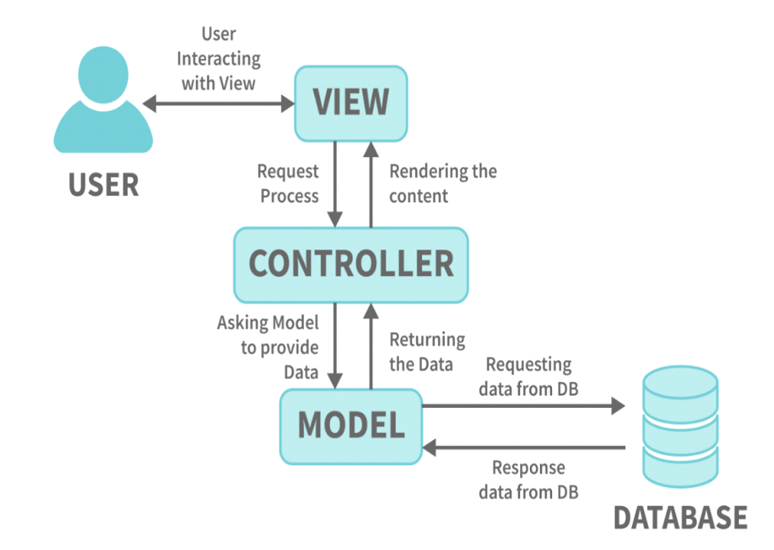

#### Hình 2.1: MVC Model

## 2.1.2 Introduction to Web Programming Model with ASP.NET MVC5

ASP.NET MVC5 allows us to create web applications using the MVC model instead of creating applications with the ASP.NET Web Forms template. The ASP.NET MVC framework is lightweight, easy to test for user interface components (compared to Web Forms applications), and integrates well with the built-in features of ASP.NET. The ASP.NET MVC framework is defined in the *System.Web.MVC* namespace and is a part of the *System.Web* namespace. MVC is a standard design pattern that many developers are familiar with. Some types of web applications are well-suited to the MVC architecture, while others are better suited to ASP.NET Web Forms and the postback mechanism. Sometimes, applications combine both architectures.

* **Separation of Application Tasks (Input Logic, Business Logic, and UI Logic)**

ASP.NET MVC makes it easy to separate application tasks such as input logic, business logic, and user interface (UI) logic, which improves testability and defaults to a Test-Driven Development (TDD) approach. All of the core features of the MVC model are implemented based on interfaces and can be tested using mock objects. Mock objects simulate the behaviors of real objects within an application. You can unit test your application without having to run the Controller within the ASP.NET process, making unit testing quick and convenient. You can use any unit-testing framework compatible with the .NET platform.

* **Extensibility & Pluggability of ASP.NET MVC**

ASP.NET MVC is an extensible and pluggable platform. The components of ASP.NET MVC are designed to be easily replaced or customized. You can add additional view engines, URL routing mechanisms, action-method parameter rendering, and other components. ASP.NET MVC also supports Dependency Injection (DI) and Inversion of Control (IoC). DI allows you to inject objects into a class for that class to use, instead of forcing the class to create the objects itself. IoC ensures that if an object requires another object, the first object gets it from an external source, such as a configuration file. The use of DI and IoC makes testing easier.

* **URL Mapping in ASP.NET MVC**

ASP.NET MVC has a powerful URL mapping feature that allows you to build applications with concise and SEO-friendly URLs. URLs do not need to include file extensions and are designed to support naming conventions suitable for search engine optimization (SEO) and RESTful URL design.

* **Support for ASP.NET Features**

ASP.NET MVC supports various ASP.NET features such as ASPX page specifications (tags), user controls (.ascx), and master pages. You can use built-in ASP.NET features like master page nesting, inline expressions (<%= %>), server controls, templates, data-binding, localization, and more.

* **Built-in Features of ASP.NET MVC**

ASP.NET MVC supports many of the built-in features of ASP.NET, such as user authentication, membership management, role-based authorization, output caching, data caching, session management, profile management, application state management, and configuration systems.

* **Razor View Engine in ASP.NET MVC**

ASP.NET MVC introduces a new view engine called Razor View Engine, which allows you to set up views quickly and easily with less effort compared to using the Web Forms view engine.

## 2.1.3 Operation of Main Components in ASP.NET MVC

* When a request originates from a web browser and reaches the IIS Web Server, it is routed to an MVC Handler.
* The MVC Handler’s job is to select the correct Controller to handle the request. The Controller is created by a component called the Controller Factory.
* Once created, the Controller determines which specific Action Method will handle the request and then executes that Action Method. The Action Method may interact with Model Classes to retrieve data or execute some business logic.
* After processing, the Action Method returns an Action Result. ASP.NET MVC provides several types of Action Results, one of which is the View Result. The View Result works with a specific View to generate HTML code, which is sent back to the web browser, allowing the user to receive the processed result.
* The View Engine is the component responsible for rendering a View. Along with ASP.NET MVC, the Webform View Engine is included, meaning you can write Views using ASPX.

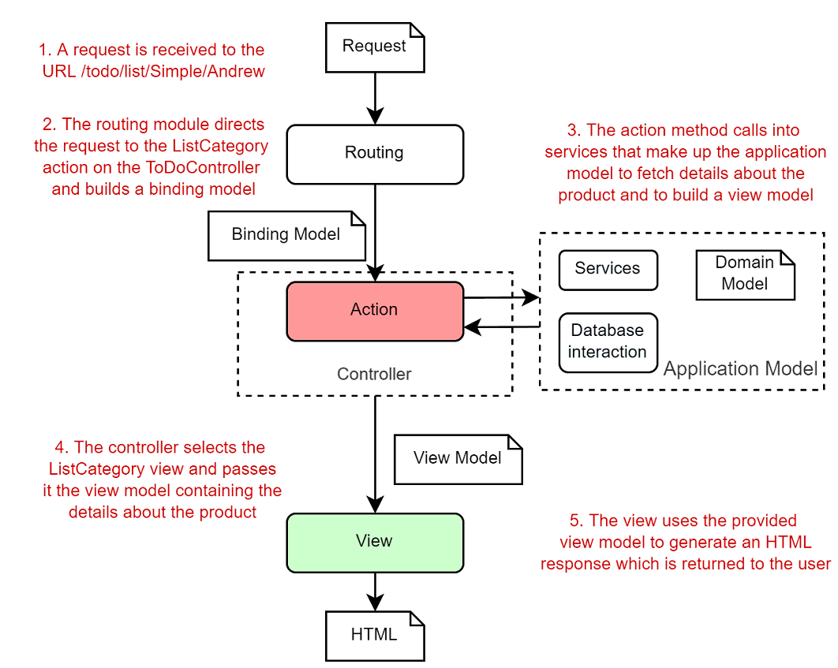

#### 

#### Hình 2.2: Describe a activity of MVC in APS.NET

## 2.1.4 Why Use ASP.NET?

The demand for building e-commerce applications is continually growing and improving. At this point, ASP no longer meets the requirements. ASP was specifically designed to sit above the Windows operating system and Internet Information Services, meaning its functionalities are very fragmented and limited. ASP.NET introduces a completely new development approach, different from the old ASP, and meets the required demands.

## 2.1.5 Advantages and Disadvantages of ASP.NET:

**Advantages:**

* ASP only used VBScript and JavaScript, limiting it from using other powerful languages like Visual Basic, C++, etc. ASP.NET, on the other hand, allows multiple languages: VBScript, JavaScript, C#, Visual Basic.Net, etc.
* ASP.NET uses a new programming style: Code-behind. Code and UI are separated, making it easier to read, manage, and maintain.
* In ASP pages, we have to write code to validate user input, while ASP.NET supports validation controls that automatically check the inputs without needing extra coding.
* ASP.NET supports developing websites that can be accessed on mobile devices like PocketPC, Smartphones, etc.
* ASP.NET supports many web server controls.
* ASP.NET allows for the design and construction of nested MasterPages.
* ASP.NET supports JavaScript debugging.
* Users can customize their web page layout according to their personal preferences using Themes, Profiles, and WebParts.
* Enhanced security features.
* It supports new data access technology, LINQ.
* It supports the development of multimedia applications using SilverLight.
* It supports asynchronous programming using ASP.NET Ajax.
* ASP.NET has strong support for the rich and diverse .NET Framework libraries, working with XML, Web Services, ADO.NET, and more.
* ASPX and ASP can work together in a single application.
* The programming architecture is similar to that of Windows applications.
* ASP.NET manages the state of controls.
* It automatically generates HTML code for server controls based on the browser type.
* ASP.NET supports various caching mechanisms.
* Deployment does not require locking or registering DLLs and allows for multiple configuration methods.
* ASP.NET allows for global application management: Global.aspx includes more events, supports session management across multiple servers without cookies.
* ASP.NET pages are precompiled. Rather than interpreting pages on every request, ASP.NET compiles dynamic web pages into DLL files that the server can execute quickly, improving performance compared to the interpreted ASP method.

**Disadvantages:**

* For small projects, using the MVC model can be cumbersome and time-consuming during development.
* Data transfer time between components can be high.

## 2.1.6 Differences Between ASP.NET MVC and ASP.NET WebForm:

|  |  |  |
| --- | --- | --- |
| **Feature** | **ASP.NET WebForm** | **ASP.NET MVC** |
| Program architecture | WebForm -> Business -> Database | Model, View, Controller |
| Syntax | WebForm syntax with events and controls managed by the server | Events controlled by controllers, no server control over UI components |
| Data access | Uses most data access technologies | Mostly uses LINQ and SQL class for object access models |
| Debugging | Debug all, including data access layers | Unit testing can be used to test controller methods |
| Load speed | Slower when there are too many controls due to large ViewState | Faster, no need to manage ViewState for controls |
| Interaction with JavaScript | Difficult, as controls are server-managed | Easier, as controls are not managed by the server |
| URL structure | <filename>.aspx?<parameters> | Clean, readable URLs: Controllers/Action/ID |

#### Bảng 2.1 Differences Between ASP.NET MVC and ASP.NET WebForm

# 2.2 AJAX:

## 2.2.1 What is Ajax?

Ajax stands for Asynchronous JavaScript and XML. It's a technique used to create dynamic websites that don't require reloading the entire page, which makes the user experience smoother and faster. In modern web technologies, Ajax is indispensable as it helps to make websites interactive. However, in SEO, Ajax is not ideal because search engine bots can't index dynamic content. This issue can be addressed, and we’ll cover that in another article.

Ajax is written in JavaScript, running on the client side, meaning each machine (user) runs independently without affecting each other. Popular JavaScript libraries like jQuery and Angular support Ajax to simplify development.

## 2.2.2 How Does Ajax Work?

Previously, applications were expected to run entirely on the web instead of being confined to local storage. However, traditional web applications operate via HTTP, which causes delays as the server processes requests and sends back complete HTML pages. To overcome this, Ajax introduces a middle layer between the client and server to reduce the data transfer and response time. Instead of reloading an entire page, only updated content is loaded, creating a smoother user experience.

Ajax is used in many popular websites like Flickr (owned by Yahoo) and Amazon’s A9 search engine. Yahoo’s upcoming release of Yahoo Mail Beta will use Ajax for improved user experience.

## 2.2.3 Disadvantages of Ajax ?

While Ajax can enhance web applications, it poses challenges such as breaking the browser’s "Back" button functionality and making it difficult to bookmark specific pages. Ajax applications don't have fixed URLs for each content change, which can confuse users.

Supported browsers for Ajax include Microsoft Internet Explorer 5.0+, Mozilla Firefox, Safari, and others.

# 2.3 HTML:

## 2.3.1 What is HTML?

HTML stands for HyperText Markup Language, which is used to create web pages. A website consists of many HTML documents. HTML elements are defined using tags, typically in pairs (open and close tags), to structure the content. For example, the text *<strong>This is bold text</strong>* makes the text bold.

## 2.3.2 How is HTML Processed?

A web browser processes an HTML file by reading the tags and converting them into readable content that can be viewed by users or understood by bots.

## 2.3.3 Programs Used to Create HTML Files:

HTML files can be created with simple text editors like Notepad or TextEdit, but it’s advisable to use a more advanced editor to avoid formatting errors, especially with non-English characters.

# 2.4 CSS:

## 2.4.1 What is CSS?

CSS stands for Cascading Style Sheets and is used to define the appearance of HTML elements. It allows web designers to style pages with colors, fonts, layouts, etc., using selectors and properties to apply to various elements.

# 2.5 Bootstrap:

## 2.5.1 What is Bootstrap?

Bootstrap is a CSS framework developed by Twitter to streamline web design. It provides a set of pre-built classes and components to avoid repetition in coding and supports responsive design through its Grid System.

## 2.5.2 Why Use Bootstrap?

Bootstrap ensures compatibility across browsers and devices, saving time and money. It’s mobile-first, responsive, and easy to use, even for beginners who are familiar with HTML, CSS, and JavaScript.

# 2.6 jQuery:

## 2.6.1 What is jQuery?

jQuery is a JavaScript library designed to simplify JavaScript code and enhance the interaction between web pages and users. It allows for easier implementation of Ajax and simplifies JavaScript syntax.

## 2.6.2 Why Use jQuery?

jQuery helps developers save time by simplifying common tasks like DOM manipulation, event handling, and Ajax calls. It also resolves cross-browser compatibility issues.

# 2.7 HTML5:

## 2.7.1 What is HTML5?

HTML5 is a new standard and the next generation of the HyperText Markup Language (HTML). Previous versions of HTML, such as HTML 4.01, were introduced in 1999. Since then, websites have undergone many changes. HTML5 is still in the development and refinement stage. However, many modern browser versions now support the new elements, tags, and APIs in HTML5.

HTML5 is the result of collaboration between the W3C organization and the WHATWG group. WHATWG worked on web forms and applications, while W3C worked on XHTML 2.0. In 2006, they decided to collaborate and create a new version of HTML, which became HTML5.

## 2.7.2 Is HTML5 important to us?

As a web user, you will benefit from HTML5 because it fixes the most obvious flaws in HTML4. Websites will have better web standards, leading to more efficient content and improved performance. Once HTML5 is widely adopted, websites will start running faster, bandwidth usage will decrease, and battery life on mobile devices will be extended.

Another benefit is that you won’t need to keep so many plugins like Flash and Java due to updates. This issue remains a nuisance for many users today, as they have to constantly update numerous add-ons and plugins for each browser. And what happens when one of them has the wrong version? Of course, websites stop working until you fix it with the correct update. All these issues will be resolved once HTML5 becomes the main standard.

If you are just a regular web user and have no intention of coding or maintaining your own website, you don’t need to do anything to enjoy the great features of HTML5. All modern browsers support HTML5 to a large extent, and you are already benefiting from it without even realizing it. Just keep your browser updated, and you’ll get the best features.

And if you are a web developer, HTML5 will make everything simpler and easier for you. If all goes well, you won’t have to deal with bugs, glitches, or design issues because all browsers will need to comply with the same standards.

Here is the translation of the text into English:

# 2.8 CSS3:

CSS3 is an upgraded version of CSS. Although it is not yet widely adopted, what it can do is certainly promising. In principle, the introduction of CSS3 has somewhat encroached on the domain of Javascript. This is because it is said that HTML is used to display content, CSS is used to present the structure, and Javascript interacts with the user. However, new features in CSS3, such as transitions and animations, have somewhat altered this principle.

Currently, when using Javascript, developers always have to consider the possibility that the user's browser might have Javascript disabled. However, in the future (hopefully soon), if we can create simple dynamic effects without needing Javascript support, it would be very convenient.

CSS3 was developed to improve compatibility with HTML5 in terms of layout and content presentation. Now, HTML documents have a very clear and understandable layout, and CSS properties and HTML tags are no longer overlapping but are separated by "class" and "id" rows.

In addition to supporting the interface, CSS3 also helps eliminate unnecessary code in HTML when using attribute tags in HTML is no longer necessary.

The new Media Queries in CSS3 support compatibility with different screen sizes without needing to modify the display content, making applications more flexible.

CSS3 is supported by most browsers worldwide. It also displays a website quite consistently across different browsers. However, web designers still need to identify which browsers are most commonly used by their audience to make the best adjustments for those browsers, or they can use certain fix functions to support CSS3.

# CHAPTER III: SYSTEM ANALYSIS AND DESIGN

# 3.1 Application Functions Analysis and Design

## 3.1.1 Application Function Specifications

The goal of this project is to develop web-based software that facilitates convenient and efficient sales management. This system will help managers easily control products, monitor customer shopping activities, and generate store revenue reports. Customers will benefit from the convenience of online shopping without needing to visit the store, saving time and effort.

### 3.1.1.1 Management Department

The system provides the following operations (users must log in with a username and password to access these functions, and the system will assign different permissions to staff members based on their roles; only the main manager has full access):

* **View Product Lists (New Products and Bestsellers)**
  + ***Description*:** The seller can manage and check the lists of new products and best-selling products.
  + ***Details:***
    - New Product List**:** Displays products in the order they were added to the system.
    - Bestseller List**:** Displays products based on sales volume.
    - UI: A product management page with filters to toggle between "New Product " and "Bestseller."
* **Check Product Availability (In Stock or Out of Stock)**
  + ***Description:*** The seller can check and update the stock status of products.
  + ***Details:***
    - Update Product Status**:** Modify the inventory quantity for products.
    - UI: A product management page that allows updating inventory quantities.
* **Update Product Prices**
  + ***Description*:** The seller can update the new price for products.
  + ***Details*:**
    - UI: A product management page that enables editing the current product price and saving changes.
* **Add Product Categories**
  + ***Description*:** The seller can add new product categories to the system.
  + ***Details*:**
    - UI: A product category management page that allows adding, editing, and deleting product categories.
* **Add Suppliers**
  + ***Description*:** The seller can add new suppliers to the system.
  + ***Details*:**
    - UI: A supplier management page that enables adding, editing, and deleting supplier information.
* **Add New Products** 
  + ***Description*:** The seller can add new products to the system.
  + ***Details*:**
    - UI A product management page that allows entering detailed information about new products, such as name, description, price, quantity, product category, and manufacturer.
* **View Contact List**
  + ***Description*:** The seller can view a list of customer contacts (e.g., customer support inquiries, information requests).
  + ***Details*:**
    - UI: A contact management page displaying a list of contacts along with detailed information such as name, email, and message content.
* **Manage Orders**
  + ***Description*:** The seller can view and manage all store orders.
  + ***Details*:**
    - UI: An order management page displaying a list of orders, allowing the seller to update order statuses (e.g., processing, confirmed, canceled) and view detailed order information.

### 3.1.1.2 Customers

* **Search Products**
  + ***Description*:** Customers can search for products by product name, category name, or supplier name.
  + ***Details*:**
    - UI: Search bar on the homepage or product catalog page.
    - Functions**:**
* Enter the manufacturer’s name in the search bar.
* Display a list of products from the specified manufacturer.
* **View Products**
  + ***Description*:** Customers can view the list of products available on the website.
  + ***Details*:**
    - UI: Product catalog page.
    - Functions**:** Displays products by category with filters and sorting options (price, name, ratings, newest, bestsellers).
* **Select and View Product Details**
  + ***Description*:** Customers can select a specific product to view its detailed information.
  + ***Details*:**
    - UI: Product detail page.
    - Functions**:** Displays detailed product information such as name, price, description, specifications, images, customer reviews, and stock status.
* **View Advertisements**
  + ***Description*:** Customers can view advertisements displayed on the website.
  + ***Details*:**
    - UI: Advertisement banners on the homepage, product catalog page, and product detail page.
    - Functions**:** Display promotional offers, featured products, or special events.
* **Place Product Orders**
  + ***Description*:** Customers can place orders for products they want to purchase.
  + ***Details*:**
    - UI: Product detail page and cart page.
    - Functions**:**
* Click "Add to Cart" on the product detail page.
* Proceed through the checkout steps from the cart.
* **Online Payment**
  + ***Description*:** Customers can make online payments for the products they have ordered.
  + ***Details*:**
    - UI: Payment page.
    - Functions**:**
* Select payment methods (credit card, debit card, e-wallet, online banking).
* Enter payment details and confirm the payment.
* **View Shopping Cart**
  + ***Description*:** Customers can view the list of products in their shopping cart.
  + ***Details*:**
    - UI: Shopping cart page.
    - Functions**:** Display products added to the cart, including product name, price, quantity, and total amount.
* **Update Shopping Cart**
  + ***Description*:** Customers can add, remove, update quantities, or clear all items in their shopping cart.
  + ***Details*:**
    - UI**:** Shopping cart page.
    - Functions**:**
* Add products: Click "Add to Cart" from the product detail page.
* Remove products: Click the "Remove" button next to the product in the cart.
* Update quantity: Change the quantity and click "Update."
* Clear all: Click "Clear All" to empty the cart.
* **Place Orders (Login Required)**
  + ***Description*:** Customers can place orders after logging into their account.
  + ***Details*:**
    - UI**:** Shopping cart page and payment page.
    - Functions**:**
* Prompt users to log in if not already logged in.
* After logging in, continue the ordering and payment process.
* **Register an Account**
  + ***Description*:** Customers can create a new account on the website.
  + ***Details*:**
    - UI**:** Registration page.
    - Functions**:**
* Enter personal information (name, email, password, phone number, address).
* Confirm and create an account.
* **Log in to Account**
  + ***Description*:** Customers can log in to their account.
  + ***Details*:**
    - UI**:** Login page.
    - Functions**:**
* Enter email and password.
* Confirm and log into the system.
* **Contact the Company via the Contact Page**
  + ***Description*:** Customers can contact the company for support or information.
  + ***Details:***
    - UI**:** Contact page.
    - Functions**:**
* Enter contact information (name, email, message content).
* Submit the contact request.

# 3.2 Main Functions of the System

### Administration (Admin)

|  |  |  |
| --- | --- | --- |
| **No.** | **Function** | **Type** |
| 1 | Log in to the system for management | Display |
| 2 | Manage products | Display |
| 3 | Add new products | Display |
| 4 | Add product categories | Display |
| 5 | Generate statistics | Display |
| 6 | Add suppliers | Display |
| 7 | Add customer categories | Display |
| 8 | View customer account list | Display |
| 9 | Manage orders | Display |

#### Bảng 3.1 Main Functions of the System of Admin

#### 

### Customers

|  |  |  |
| --- | --- | --- |
| **Rule** | **Function** | **Type** |
| 1 | View products | Display |
| 2 | Place orders | Display |
| 3 | View shopping cart | Display |
| 4 | Submit contact information | Display |
| 5 | Online payment | Display |
| 6 | Manage shopping cart (add, delete, edit, etc.) | Display |
| 8 | Register | Display |
| 9 | Log in | Display |
| 10 | View personal information | Display |
| 12 | Change password | Display |
| 13 | Place orders | Display |

#### Bảng 3.2 Main Functions of the System of Admin

# 3.3 Data Flow Diagram (DFD)

* **Account Registration (User)**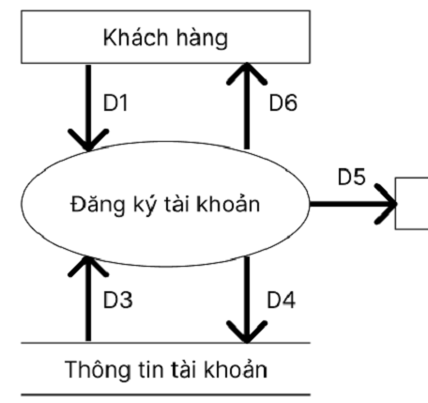
* D1: Customer information required for registration: Full Name, Email, Phone Number, Address, Password.
* D3: Account categories to be stored in the system.
* D4: Account information that has been registered.
* D5: Output device (screen).
* D6: Notification of successful account registration.
* **Account Login (User, Admin)**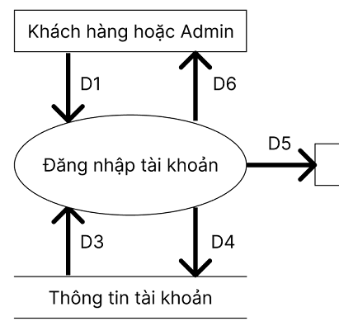
* D1: Email and Password required for login.
* D3: Account categories to be stored in the system.
* D4: Information of the logged-in account retrieved from the database.
* D5: Output device (screen).
* D6: Notification of successful account registration.
* **Search for products (User, Admin):**

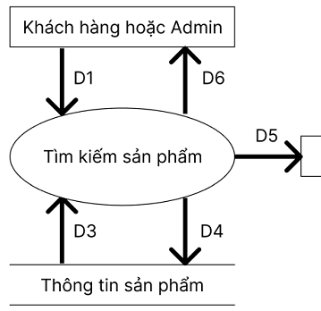

* D1: Product information to search for based on: product name, category name, supplier name
* D3: List of product information
* D4: Product information results
* D5: Output device (screen)
* D6: Return the requested product information
* **Update shopping cart(User):**

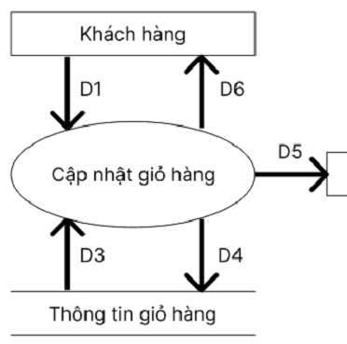

* D1: Product information and quantity of products to add, edit, or delete
* D3: Categories to be stored in the shopping cart
* D4: Updated shopping cart information
* D5: Output device (screen)
* D6: Successfully updated shopping cart information

**⦁ Place order (User):**

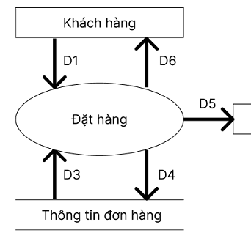

* D1: Information about the shopping cart to be processed
* D3: Data required for calculating the total amount
* D4: Total amount calculation result
* D5: Exported data (including D1, D3, D4)
* D6: Successful order information and return of D1, D3, D4

**⦁ Update account information (User):**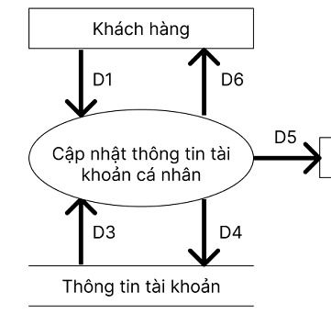

* D1: Personal account information to add, edit, or delete
* D3: Categories to be stored in the account database
* D4: Updated personal account information
* D5: Output device (screen)
* D6: Successfully updated account information displayed
* **Update product (Admin):**

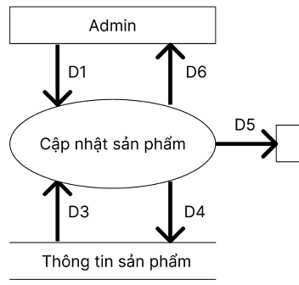

* D1: Product information to add, edit, or delete
* D3: Categories to be stored in the product inventory
* D4: Updated product information
* D5: Output device (screen)
* D6: Successfully updated product information displayed

**⦁ Update supplier (Admin):**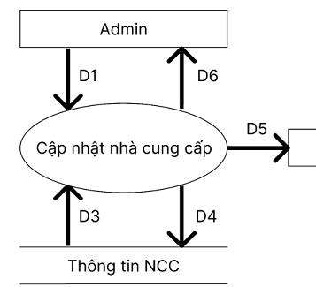

* D1: Supplier information to add, edit, or delete
* D3: Categories to be stored in the supplier database
* D4: Updated supplier information
* D5: Output device (screen)
* D6: Successfully updated supplier information displayed
* **Update product category (Admin):**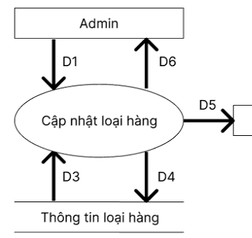
* D1: Product category information to add, edit, or delete
* D3: Categories to be stored in the product category database
* D4: Updated product category information
* D5: Output device (screen)
* D6: Successfully updated product category information displayed

**⦁ Update order (Admin):**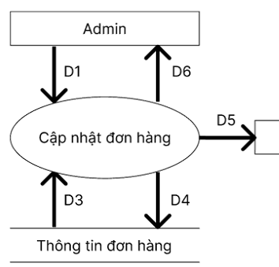

* D1: Order information to add, edit, or delete
* D3: Categories to be stored in the order database
* D4: Updated order information
* D5: Output device (screen)
* D6: Successfully updated order information displayed

**⦁ Update account (Admin):**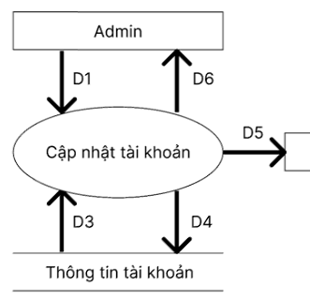

* D1: Account information to add, edit, or delete
* D3: Categories to be stored in the account database
* D4: Updated account information
* D5: Output device (screen)
* D6: Successfully updated account information displayed

**⦁ Update permissions (Admin):**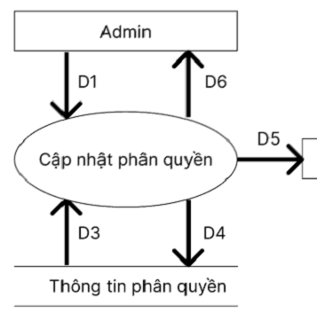

* D1: Permission information to add, edit, or delete
* D3: Categories to be stored in the permission database
* D4: Updated permission information
* D5: Output device (screen)
* D6: Successfully updated permission information displayed

**⦁ Statistics (Admin):**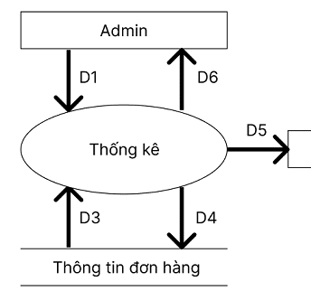

* D1: Information to be analyzed: by revenue, by the number of customers, etc.
* D3: List of orders
* D4: D1
* D5: D4
* D6: Statistical information generated

# 3.4 Data design

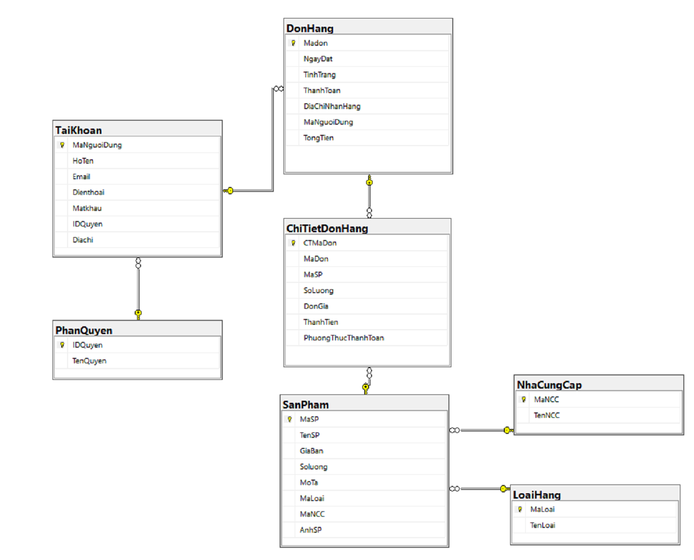

#### Hình 3.7: Database model

## 3.4.1 Detailed description of tables:

**⦁ Table NhaCungCap (Supplier):**

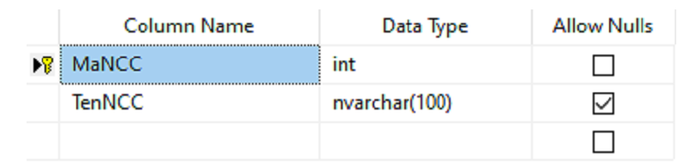

**⦁ Table LoaiHang (ProductCategory):**

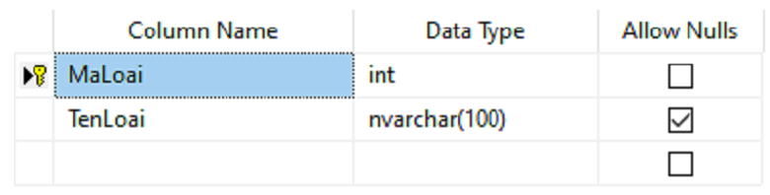

**⦁ Table SanPham (Product):**

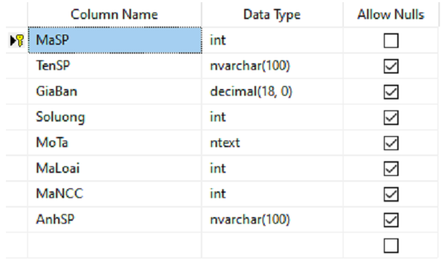

**⦁ Bảng DonHang:**

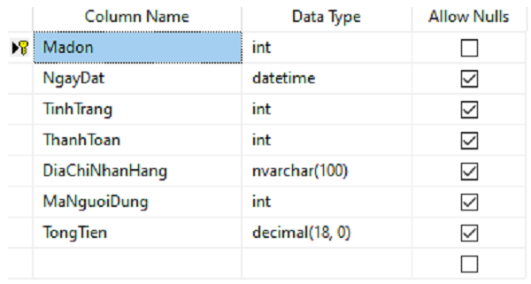

**⦁ Table ChiTietDonHang (OrderDetails):**

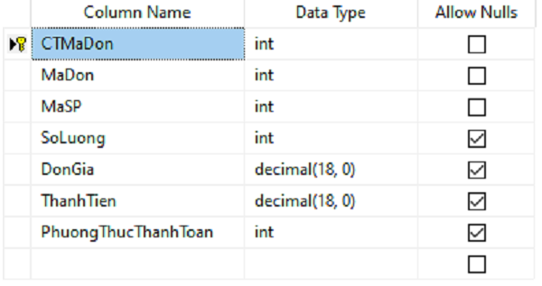

**⦁ Table TaiKhoan (Account):**

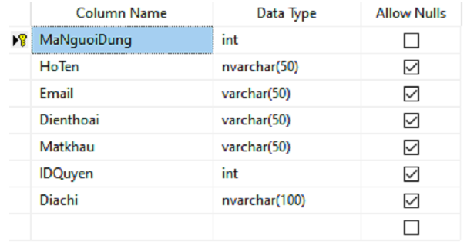

# CHAPTER 4: EXPERIMENTAL RESULTS

# CHAPTER 5: CONCLUSION

# 5.1 Results:

Expand knowledge about web applications using ASP.NET technology. At the same time, gain an understanding of how to apply the C# programming language to the web through Microsoft ASP.NET MVC5 and learning other languages and technologies such as HTML5, CSS3, jQuery, AJAX, etc.  
 Gain knowledge of LINQ (Language Integrated Query), an object-oriented query language that helps developers easily interact with various databases such as XML, relational databases, etc.  
 Based on the knowledge acquired, I have outlined a basic web application to serve educational purposes. Although this web application is still quite simple, with incomplete features, a non-optimized interface, limited algorithms, and error handling, it will serve as a foundation for developing and building more practical web applications in the future.

# 5.2 Development direction:

On the homepage for users, the layout and design need to be improved to make the website more user-friendly. Specifically, enhancing the website's compatibility to ensure it functions smoothly on both desktop and mobile browsers is crucial.  
 Additionally, current trends show that most users use Facebook or Google accounts. Therefore, integrating login functionality through these accounts will allow users to log in quickly without needing to create a new account on the website.  
 A direct feedback feature on the website is also necessary. Instead of having to contact through third-party applications like Gmail, users could send messages directly on the website to receive responses more quickly and conveniently.  
 Adding Web Service technologies to improve the website's performance and features.

# TÀI LIỆU THAM KHẢO

**Tiếng Việt**

* [1] ThS.GV Bùi Chí Thành, Slides Bài giảng Thiết kế và lập trình Web 2
* [2] ThS.GV Lê Thị Bích Hằng, ThS.GV Bùi Chí Thành, Slides Bài giảng Thiết kế và lập trình Web 2

**Internet**

* [3]https://learn.microsoft.com/vi-vn/aspnet/mvc/overview/getting-started/introduction/getting-started (13/10/2023, Getting started with ASP.NET MVC 5| Microsoft Learn), truy cập ngày 02/06/2024
* [4]https://getbootstrap.com/docs/5.3/getting-started/introduction/ (Get started with Boostrap), truy cập ngày 02/06/2024