Activity:
Diffused RGB LED – Refactored Program

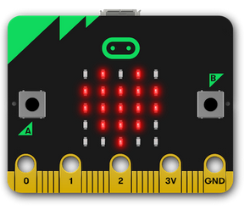
Description:
When software engineers improve code quality by changing how the code works without changing what the code does it is called refactoring the code. Code quality characteristics include properties such as code readability, understandability, performance, and efficiency. Refactoring changes the code implementation without changing the code’s functionality. Shown below, the diffused RGB LED program has been refactored to use a function to change the colors.

