Activity:
Diffused RGB LED

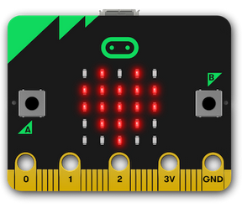
Description:
Build a program that will change the color of a RGB (red-green-blue) LED using the ‘A’ and ‘B’ buttons. The RGB LED is wired on the breadboard and connected to the micro:bit using a breakout.

Vocabulary and Concepts:
Variable: a named container for storing a value that may change while the program is running
Selection: Using a boolean condition to determine which of two parts of an algorithm is used.

Design:
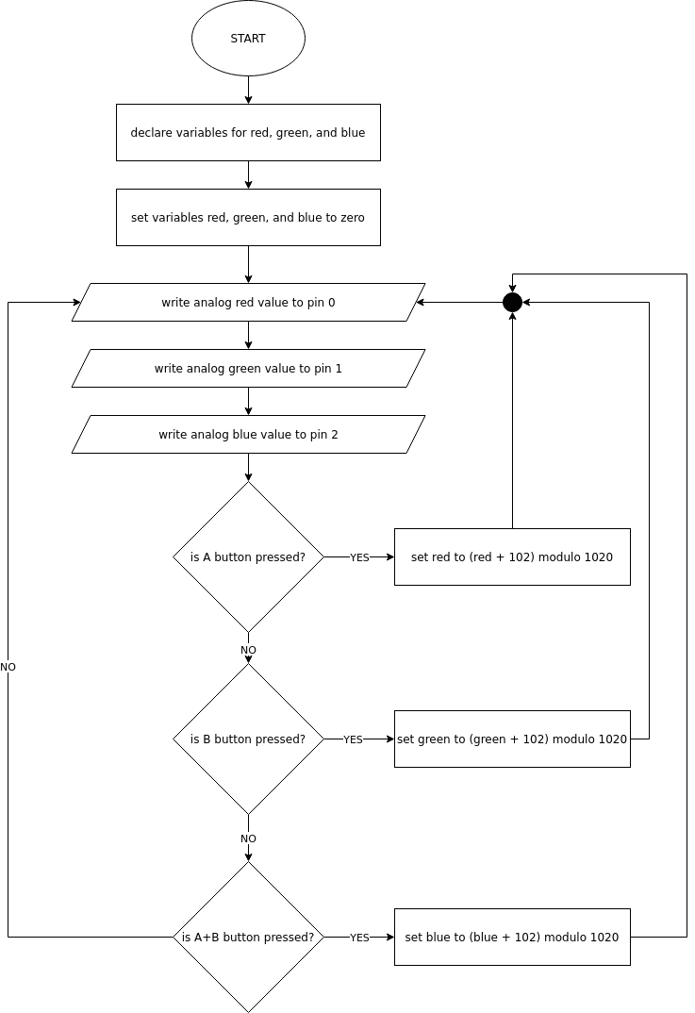

Making:
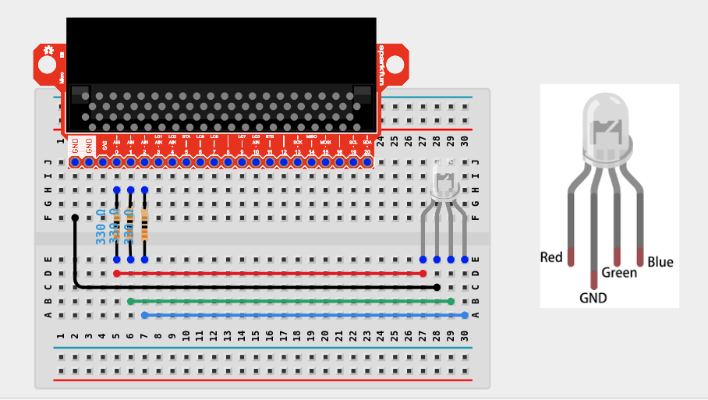
Notice the diffused RGB LED has four wires, instead of two like a regular one color LED. When you orient the LED as shown in the diagram above, the long wire (#2) is the ground (GND) wire. The other wires are the three colors as labeled in the diagram above.

Let’s Start Programming!

Step 1: Accessing the Project Editor Page
You must be connected to the Internet. You may use any modern browser such as Edge, Firefox, Chrome, or Safari.

Start the micro:bit coding tool by using a web browser to connect to makecode.microbit.org. Once the webpage is loaded, scroll down to see the MakeCode Editor Section. Click the “New Project” button. It will take a moment to load and start.

The coding tool we are using is called the Blocks Editor. Here is what it looks like when it is ready:

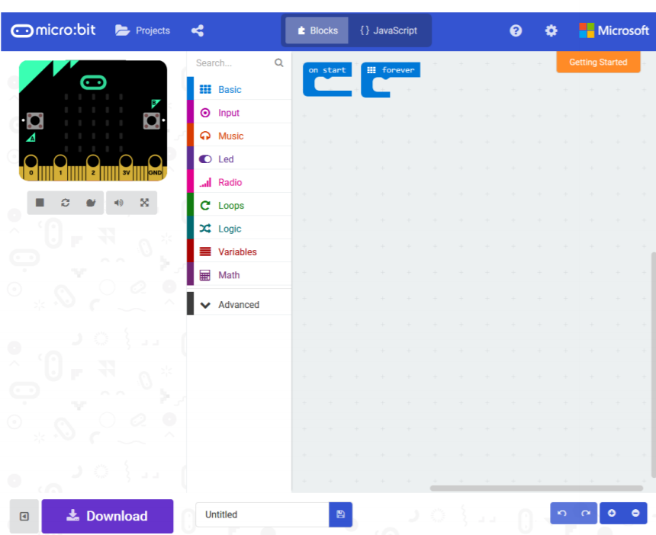

Step 2: Features of the Editing Tool
In the upper left hand corner is the micro:bit emulator. You can test your program here before you download it to the micro:bit. In the middle of the screen is the blocks chooser. The blocks are grouped into categories like Basic, Input, and Variables. The right side of the screen is where you will create your program by arranging blocks. Notice that two blocks are automatically inserted. The “on start” block contains any code that needs to happen one time only when the micro:bit is turned on. The “forever” block contains the remainder of your program. Other controls in the editor are for downloading your program, switching between blocks programming and textual programming, help, settings, and saving your projects. Let’s code!

Step 3: Getting Started
Create a variable by going to the “variables” drawer and click “new variable”. Once clicked, type a variable name such as red”. Next, create two more variables for “green” and “blue”. Drag out three “set” blocks and add them to the “on start” block. Set each one of the color variables to zero.

Next, to change the LED colors, get three “analog write pin” blocks out of the “Pins” drawer. Put them in the “forever” block and make sure the pins are “P0”, “P1”, and “P2”. Get a “red”, “green”, and “blue” variable from the variables drawer and place them in the “analog write pin” blocks. P0 is red, P1 is green, and P2 is blue.

Go to the “input” drawer and drag out an “on button A pressed” block. Go back to the variables drawer and get a “set” block and place into the “button A” block. Click the variable dropdown in the “set” block and select “red”. Next, go to the math drawer and get an “addition” block and a “remainder division” block. Place the “addition” block inside the ”remainder division” block. The “addition” block must be in the left operand slot (dividend). Get a “red” variable and place it into the “addition” block. Type the number 102 as the other operand for the addition. Type 1020 in the right hand slot of the “remainder division” block (divisor). Drag the completed “remainder division” block into the “set” block.

Duplicate the “on button A pressed” blocks and change the button dropdown to “B” and the color variables to “green”. Finally, Duplicate the “on button A pressed” blocks again and change the button dropdown to “A+B” and the color variables “blue”. An example is shown below.

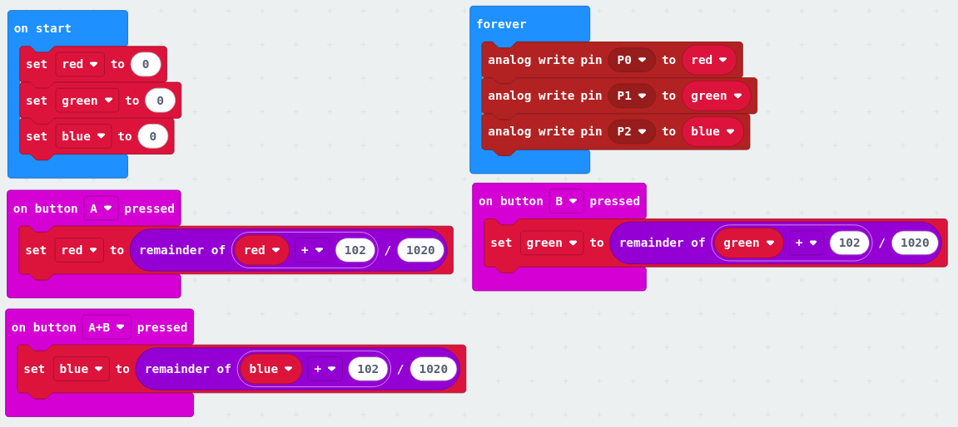

Step 4: Test your Program using the Emulator
Once you have completed assembling your blocks, click the A button and you should see the number next to Pin 0 in the emulator change. Next check the B button and verify the number next to Pin 1 changes. An “A+B” test button should be below the B button in the emulator. Click the +B button and the number next to Pin2 chould change. If your program is working correctly, then it is time to download it to the micro:bit. Before we download it, let’s give our program a name. Click on the word “Untitled” in the textbook on the bottom left side of the editor.

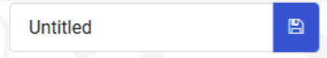

Name your program “Push button on breadboard”. You do NOT need to click the disk icon to change the name—pressing the disk icon will save your program by downloading it to your computer.

Step 5: Download the Program
Now we need to download the completed program. Click the “Download” button and save the program on your computer. Be sure to note where you have saved the program.



Step 6: Connect to your micro:bit
Next, connect your micro:bit to your computer with the USB cable. Note that the cable only goes into the micro:bit one way. If the cable is hard to insert into the micro:bit, try flipping the cable over. The following is where the USB cable needs to attach to the micro:bit.

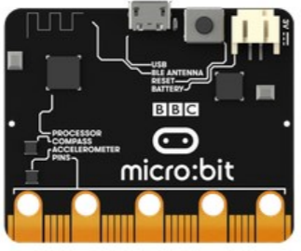

Step 7: Running the Program on the micro:bit
If you are using Windows, click the Start icon at the bottom left of your screen. Open the File Explorer (you can search for File Explorer if not displayed on your Start menu) and find your downloaded program. Right click on the program and select “Send To”. Then select “Microbit”. If you are using a Mac, drag and drop the program onto the MICROBIT device from the Finder. This will install your program on the micro:bit. The yellow LED on the back of the micro:bit will blink while your program is being installed. Your program will run automatically after the yellow LED stops blinking.

Congratulations!
You have created your Breadboard Pushbutton program!!

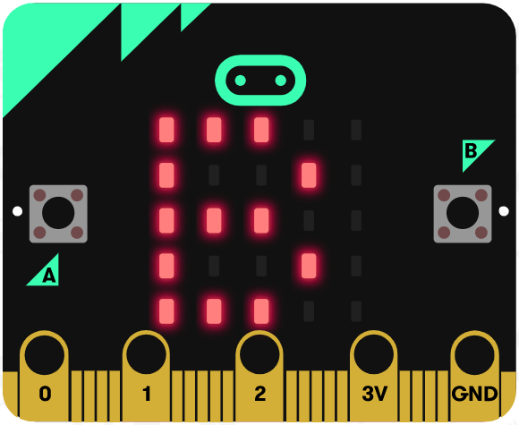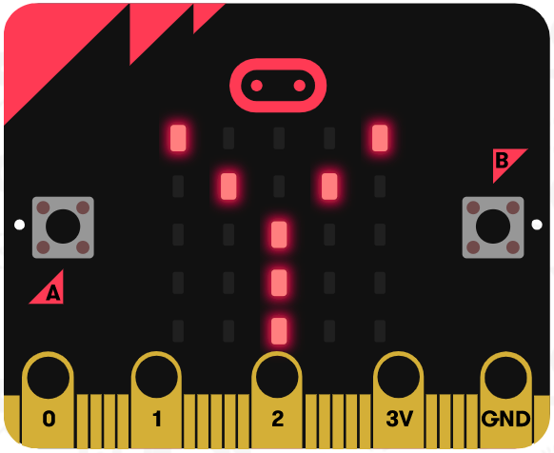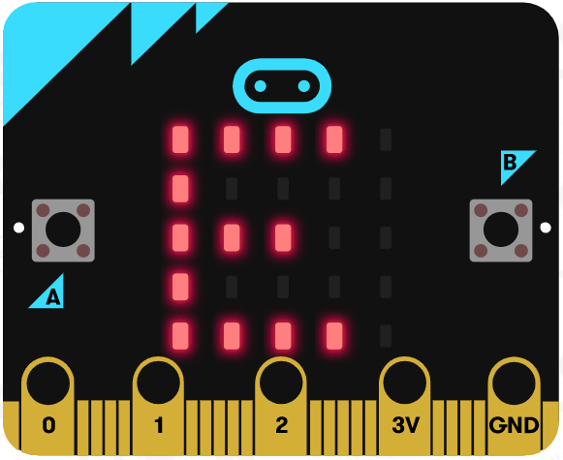
References
XXX Online Pushbutton tutorial: https://www.youtube.com/watch?v=vskNLQZp6Xg
Flowchart tool: https://www.draw.io/

