Activity:
Breadboard Pushbutton

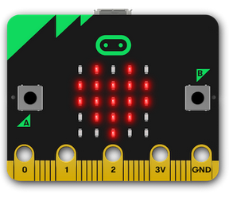
Description:
Build a program that will display a one when the button is pushed and display a zero otherwise. The pushbutton wired on the breadboard and connected to the Micro:bit.

Vocabulary and Concepts:
Variable: a named container for storing a value that may change while the program is running
Selection: Using a boolean condition to determine which of two parts of an algorithm is used.

Design:
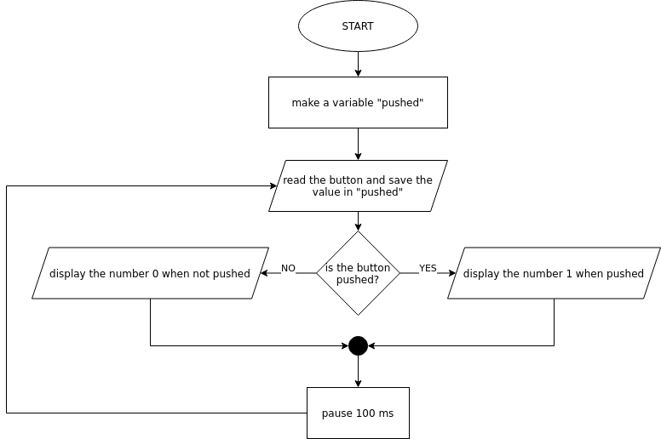
Making:
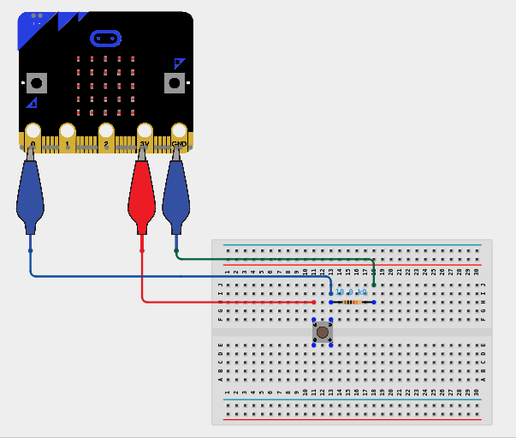
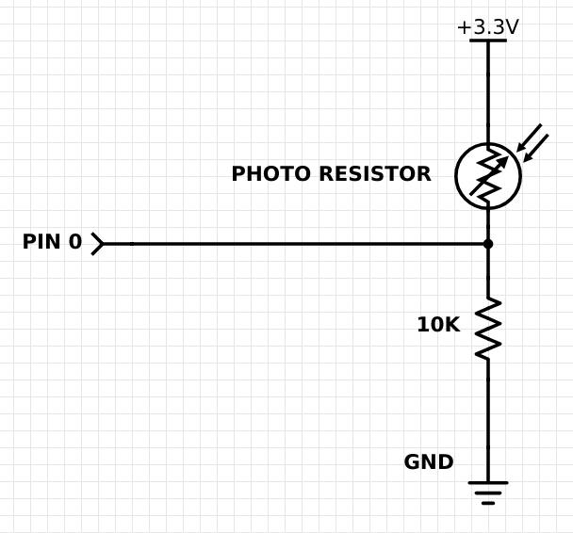
Making (alternate wiring):

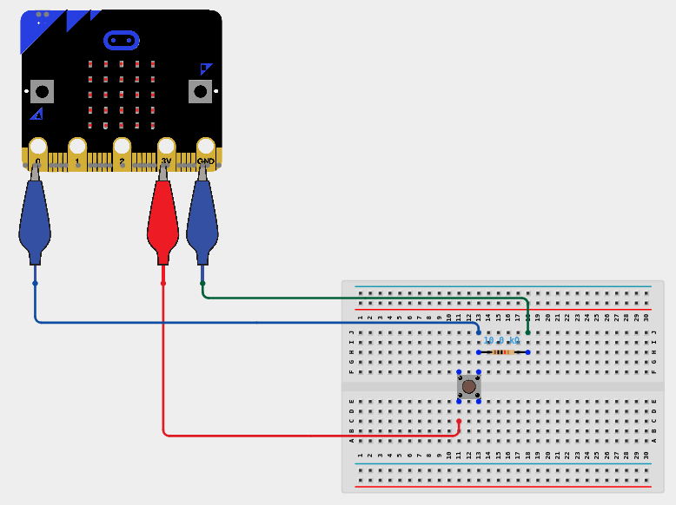

Let’s Start Programming!

Step 1: Accessing the Project Editor Page
You must be connected to the Internet. You may use any modern browser such as Edge, Firefox, Chrome, or Safari.

Start the micro:bit coding tool by using a web browser to connect to makecode.microbit.org. Once the webpage is loaded, scroll down to see the MakeCode Editor Section. Click the “New Project” button. It will take a moment to load and start.

The coding tool we are using is called the Blocks Editor. Here is what it looks like when it is ready:

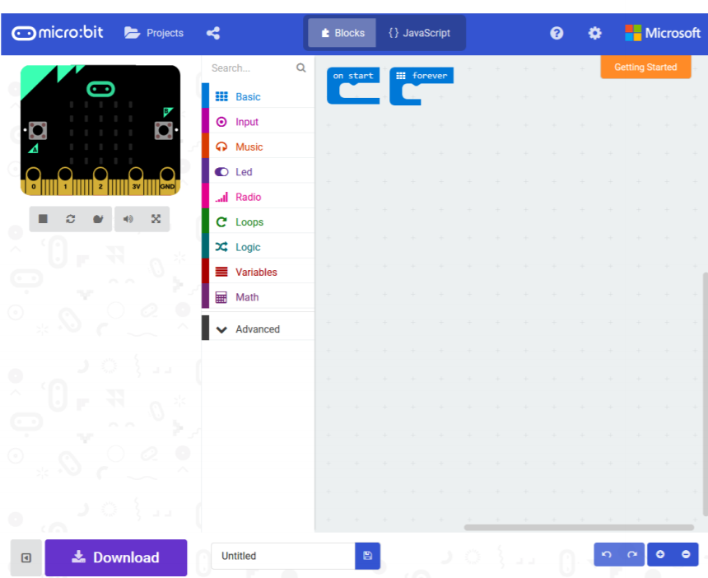

Step 2: Features of the Editing Tool
In the upper left hand corner is the micro:bit emulator. You can test your program here before you download it to the micro:bit. In the middle of the screen is the blocks chooser. The blocks are grouped into categories like Basic, Input, and Variables. The right side of the screen is where you will create your program by arranging blocks. Notice that two blocks are automatically inserted. The “on start” block contains any code that needs to happen one time only when the micro:bit is turned on. The “forever” block contains the remainder of your program. Other controls in the editor are for downloading your program, switching between blocks programming and textual programming, help, settings, and saving your projects. Let’s code!

Step 3: Getting Started
Create a variable by going to the “variables” tab and click “new variable”. Once clicked, type a variable name such as pushed”. Next, drag a “set” block out of the variables drawer and place it inside the “Forever” block. To read the pushbutton, get the “digital read pin” block out of the “Pins” drawer. Put the “digital read pin” block into the “set” block and make sure the pin is “P0”. Next, go to the logic drawer and drag out a “if” block. Add the “if” block below your “set” block. Go back to the logic drawer and get a “comparison” block. Add your “pushed” variable in the first/top slot of the “comparison”. Put a one in the second/bottom slot. Move the “comparison” block into the test of the “if” block (replace the “true”). Get a “show number” block from the basic drawer and add it to the true clause. Display the number one. Add a “show number” block to the false clause and display the number zero. Finally, go into the basic tab and grab the pause” block, place it after the “plot” block and select 100 milliseconds. An example is shown below.

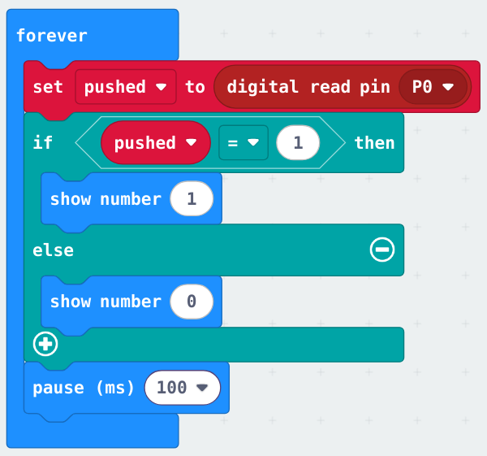
Step 4: Test your Program using the Emulator
Once you have completed assembling your blocks, click Pin 0 on the emulator. Clicking the top of Pin 0 in the emulator should change the display to one. Clicking the bottom of Pin 0 should display a zero on the emulator. If your program is working correctly, then it is time to download it to the micro:bit. Before we download it, let’s give our program a name. Click on the word “Untitled” in the textbook on the bottom left side of the editor.

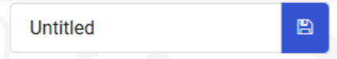

Name your program “Push button on breadboard”. You do NOT need to click the disk icon to change the name—pressing the disk icon will save your program by downloading it to your computer.

Step 5: Download the Program
Now we need to download the completed program. Click the “Download” button and save the program on your computer. Be sure to note where you have saved the program.



Step 6: Connect to your micro:bit
Next, connect your micro:bit to your computer with the USB cable. Note that the cable only goes into the micro:bit one way. If the cable is hard to insert into the micro:bit, try flipping the cable over. The following is where the USB cable needs to attach to the micro:bit.

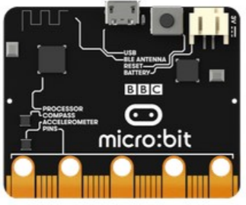

Step 7: Running the Program on the micro:bit
If you are using Windows, click the Start icon at the bottom left of your screen. Open the File Explorer (you can search for File Explorer if not displayed on your Start menu) and find your downloaded program. Right click on the program and select “Send To”. Then select “Microbit”. If you are using a Mac, drag and drop the program onto the MICROBIT device from the Finder. This will install your program on the micro:bit. The yellow LED on the back of the micro:bit will blink while your program is being installed. Your program will run automatically after the yellow LED stops blinking.

Congratulations!
You have created your Breadboard Pushbutton program!!

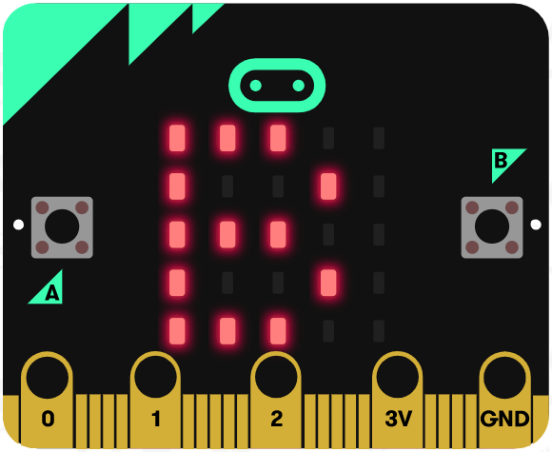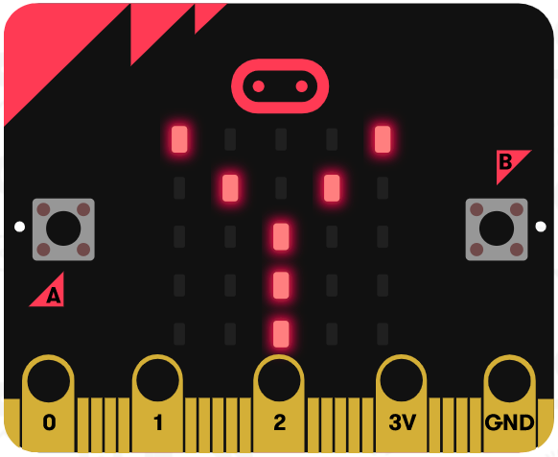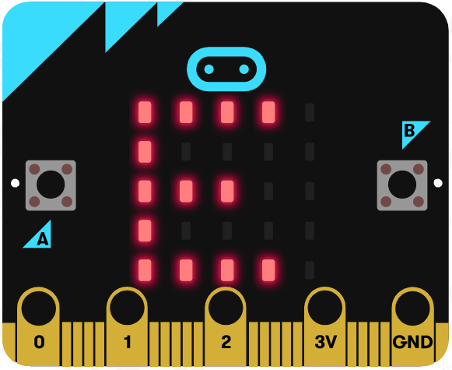
References
Online Pushbutton tutorial: https://www.youtube.com/watch?v=vskNLQZp6Xg
Flowchart tool: https://www.draw.io/

