Activity:
Light Sensor with Plot (Photoresistor)

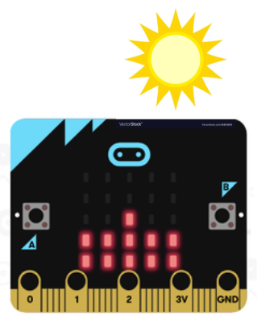
Description:
Build a program that will measure how bright the light is and display the brightness of the light as a plot. Measure the light’s brightness using a photoresistor light sensor.

Vocabulary and Concepts:
Variable: a named container for storing a value that may change while the program is running
Sensor: An input device that reads or measures a physical property and converts it to a numerical value.
Light Sensor: a “photoresistor” sensor that measures the brightness of light as resistance
Flowchart: a graphical representation of the step-by-step process of your program. The flowchart describes what the program should do. The oval shows you where the process starts. The arrows walk you through the steps. Rectangles denote steps (sequence), diamonds represent decisions (selection), parallelograms represent input/output, and arrows that point to a previous symbol represent loops (iteration). Finally, the program ends with another oval.

Design:

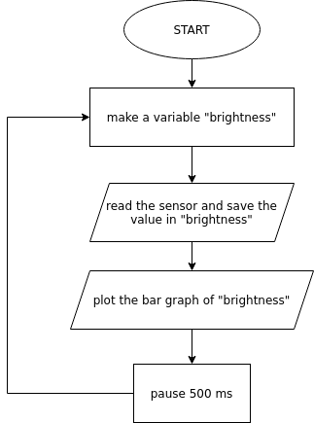

Making:
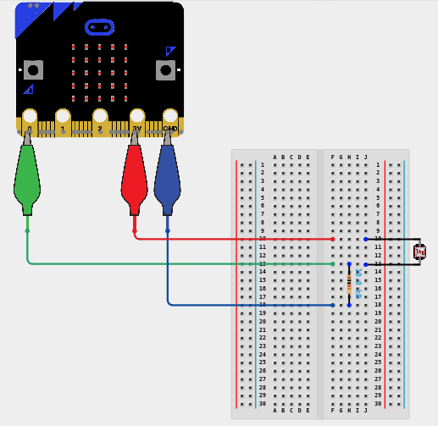
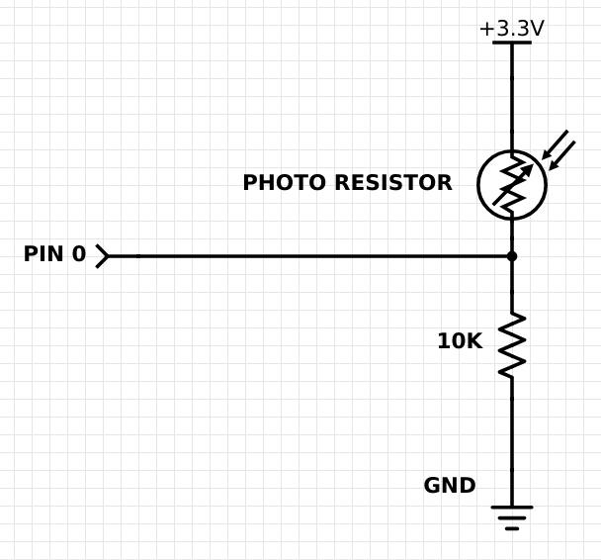
Let’s Start Programming!

Step 1: Accessing the Project Editor Page
You must be connected to the Internet. You may use any modern browser such as Edge, Firefox, Chrome, or Safari.

Start the micro:bit coding tool by using a web browser to connect to makecode.microbit.org. Once the webpage is loaded, scroll down to see the MakeCode Editor Section. Click the “New Project” button. It will take a moment to load and start.

The coding tool we are using is called the Blocks Editor. Here is what it looks like when it is ready:

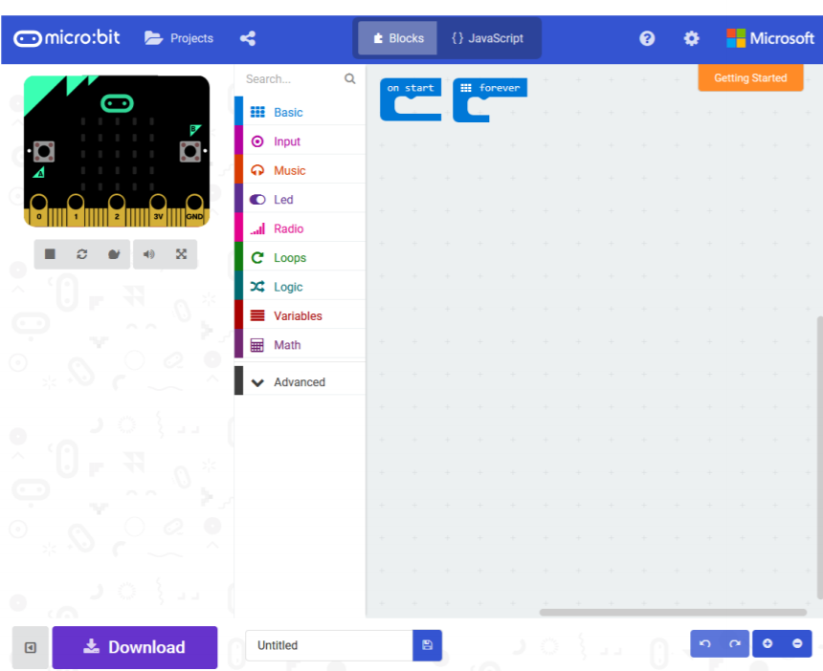

Step 2: Features of the Editing Tool
In the upper left hand corner is the micro:bit emulator. You can test your program here before you download it to the micro:bit. In the middle of the screen is the blocks chooser. The blocks are grouped into categories like Basic, Input, and Variables. The right side of the screen is where you will create your program by arranging blocks. Notice that two blocks are automatically inserted. The “on start” block contains any code that needs to happen one time only when the micro:bit is turned on. The “forever” block contains the remainder of your program. Other controls in the editor are for downloading your program, switching between blocks programming and textual programming, help, settings, and saving your projects. Let’s code!

Step 3: Getting Started
Create a variable by going to the “variables” tab and click “new variable”. Once clicked, type a variable name such as brightness” (or “lux”). Next, drag a “set” block out of the variables drawer and place it inside the “Forever” block. To read the resistance, get the “analog read pin” block out of the “Pins” drawer. Put the “analog read pin” block into the “set” block and make sure the pin is “P0”. Next, go to the LED drawer and drag out a “plot bar graph” block. Add the “plot bar graph” block below your “set” block. Add your “brightness” variable in the first/top slot. Leave a zero in the second/bottom slot. This will plot the brightness from the smallest value to the largest value (creates a bar graph that is automatically scaled). Finally, go into the basic tab and grab the pause” block, place it after the “plot” block and select 500 milliseconds. An example is shown below.

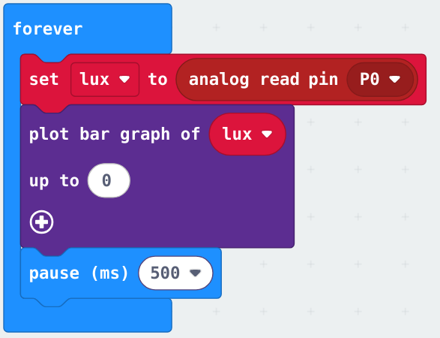

Step 4: Test your Program using the Emulator
Once you have completed assembling your blocks, click Pin 0 on the emulator. Clicking different spots on Pin 0 in the emulator should change the plot (simulates changing brightness). If your program is working correctly, then it is time to download it to the micro:bit. Before we download it, let’s give our program a name. Click on the word “Untitled” in the textbook on the bottom left side of the editor.
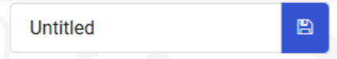

Name your program “Light brightness”. You do NOT need to click the disk icon to change the name—pressing the disk icon will save your program by downloading it to your computer.

Step 5: Download the Program
Now we need to download the completed program. Click the “Download” button and save the program on your computer. Be sure to note where you have saved the program.



Step 6: Connect to your micro:bit
Next, connect your micro:bit to your computer with the USB cable. Note that the cable only goes into the micro:bit one way. If the cable is hard to insert into the micro:bit, try flipping the cable over. The following is where the USB cable needs to attach to the micro:bit.

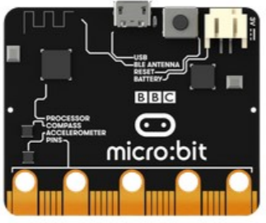

Step 7: Running the Program on the micro:bit
If you are using Windows, click the Start icon at the bottom left of your screen. Open the File Explorer (you can search for File Explorer if not displayed on your Start menu) and find your downloaded program. Right click on the program and select “Send To”. Then select “Microbit”. If you are using a Mac, drag and drop the program onto the MICROBIT device from the Finder. This will install your program on the micro:bit. The yellow LED on the back of the micro:bit will blink while your program is being installed. Your program will run automatically after the yellow LED stops blinking.

Congratulations!
You have created your Light Sensor (Photoresistor) program!!

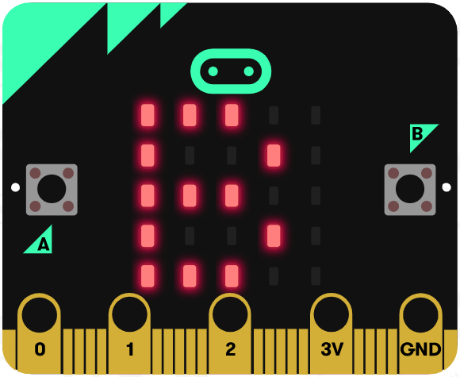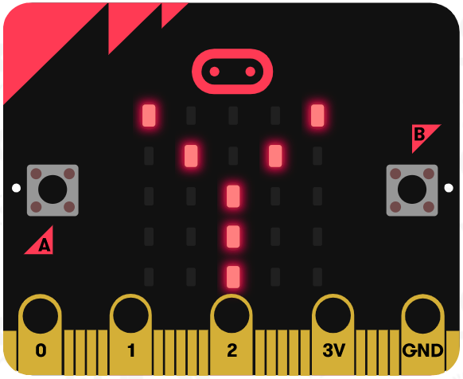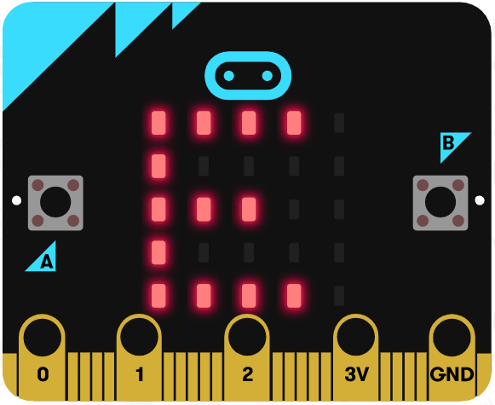
References
Online Photoresistor tutorial: https://learn.adafruit.com/micro-bit-lesson-4-sensing-light-and-temperature
Flowchart tool: https://www.draw.io/

