CS Makers – Variable Blinking LED with a Potentiometer

For this project we will build on what we learned from the “Blink a LED” circuit we built previously. We will add a variable resistor called a potentiometer. The potentiometer will control the blink rate of the LED. This document describes how to build the circuit and write the control program.

Parts required:
1 LED (any color)
1 100 Ω resistor
1 10K potentiometer
5 Jumper wires
1 Breadboard
1 Breakout
1 Micro:bit

If you don’t have a 100 Ω resistor, then any value up to 330 Ω will work. Remember it is important to use a resistor with a LED to prevent damaging either the LED or the Micro:bit.

Figure 1 is the schematic that describes how to wire the circuit. Pin 0 blinks the LED and pin 1 is used to read the potentiometer.

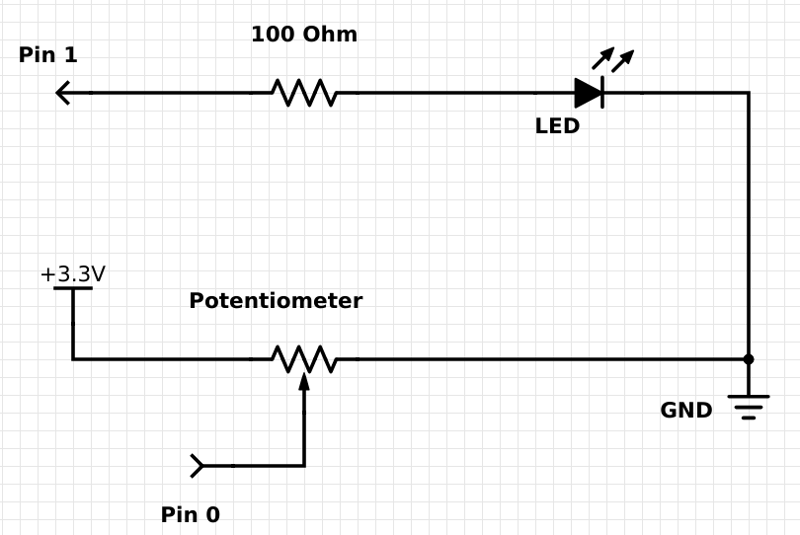
Figure 1. Schematic for the potentiometer LED blinking circuit

Remember that wires and resistors will conduct electricity in any direction. This means it does not matter which way you connect wires or resistors. However, a LED will only conduct electricity in one direction. The schematic in Figure 1 tells us which way to connect the LED once you know which wire on the LED is marked positive (+) and which one is marked negative (-). Figure 2 shows us how to determine the wires on a LED. Notice that the longer wire is the positive.
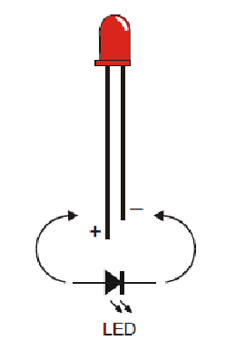
Figure 2. Light emitting diode (LED)

We will assemble the circuit on a breadboard. Recall from previous activities that the breadboard holes are connected a specific way which allows us the build the circuit without soldering, electrical tape, or other fasteners. However, not every hole is connected to every other hole on the breadboard. Figure 3 shows an example of a breadboard. You can view a refresher on how breadboards are connected on the web site https://learn.sparkfun.com/tutorials/how-to-use-a-breadboard.

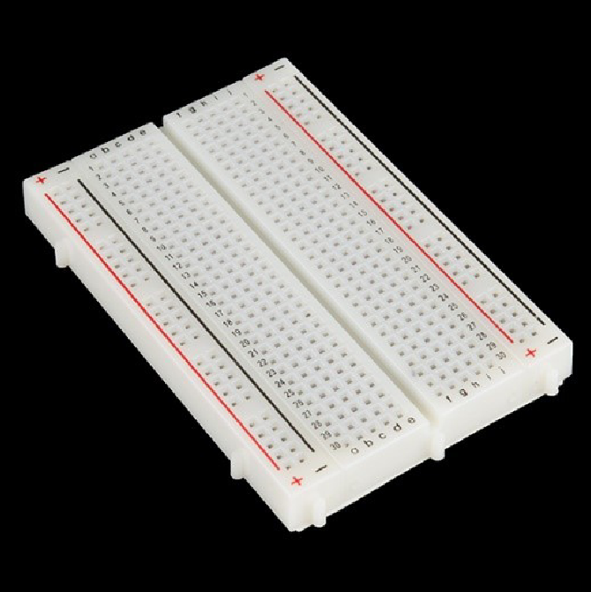
Figure 3. Breadboard

Assemble the circuit on the breadboard as shown in Figure 5. Note the potentiometer has three wires to connect and it is important that you wire it exactly as shown.

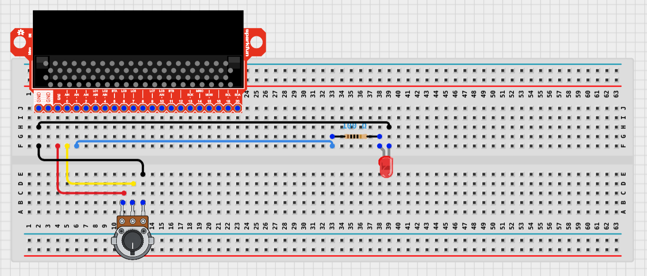

Figure 5. Wiring diagram for variable blink a LED circuit

The potentiometer is a kind of resistor that can be changed. By the turning the knob on the potentiometer, we are changing the resistance. We will connect one side of the potentiometer to power (3V3) on the breakout. The middle wire of the potentiometer is connected to pin 0. The LED part of the circuit is identical to the previous “Blink a LED” circuit.

The next step is to create the program to read the potentiometer and use the result to vary the rate the LED is blinked. Figure 6 shows the flowchart for the program.

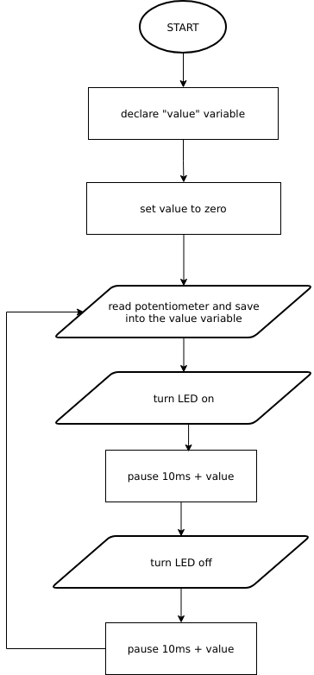

Figure 6. Program flowchart

The program needs one variable to store the value read from the potentiometer. The variable should be initialized to zero. Next, the program will repeatedly read and store the value from the potentiometer, turn the LED on, pause, turn the LED off, and pause. The time to pause should be at least 10 ms so we’ll add the value read from the potentiometer to 10 to get the time to pause. The program is shown below in Figure 7.

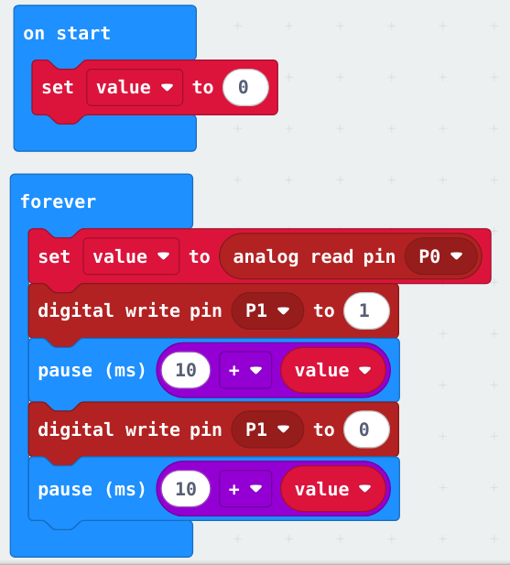

Figure 7. Program for changing the rate the LED is blinking

Instead of the breakout, you could use the alligator (crocodile) wires to make the circuit. Figure 8 shows the circuit without the breakout.
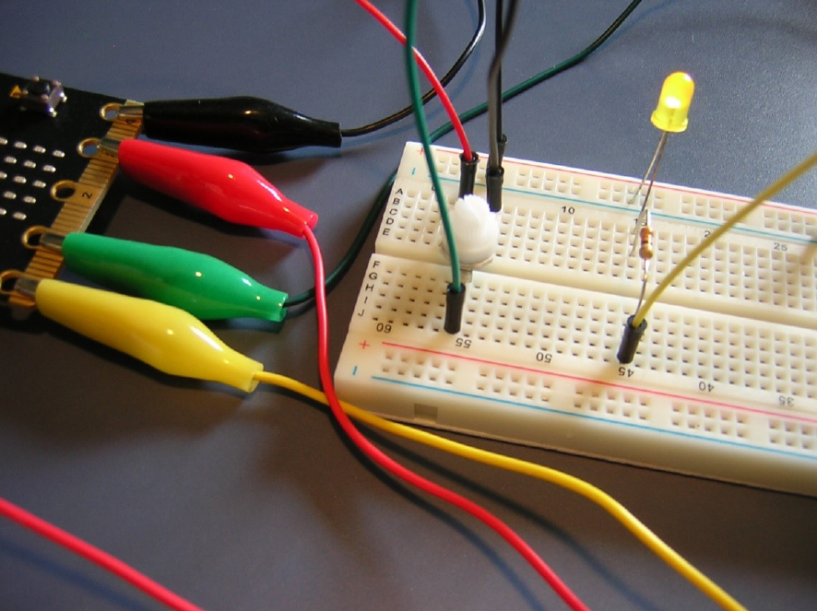
Figure 8. Circuit using alligator clips

OPTIONAL - Theory of Operation

How it works: Three volts is fed into the potentiometer from the 3V pin on the Micro:bit. As the potentiometer knob is turned the resistance changes across the potentiometer. Turn the knob all the way to one end and you have maximum resistance and nearly zero volts exiting the potentiometer. Turn the knob all the way to the other end and you have minimum resistance and nearly 3 volts exiting the potentiometer. The amount of voltage exiting the potentiometer ranges from almost zero to almost 3 volts and is used as the input to pin zero. The Micro:bit has a built-in circuit called an Analog-to-Digital converter (ADC) on pin zero. The ADC converts the analog signal (voltage) into a digital signal (an integer in the range 0...1023). The “analog read pin” block is used to access the value from the ADC. The converted value, as an integer, is added to the 10ms so the slowest the LED will blink is 10 ms and the fastest the LED will blink is 1,033 ms.

DLCS Topics:
Algorithm
Flowcharts

Figure 2 – https://learn.parallax.com/tutorials/robot/shield-bot/robotics-board-education-shield-arduino/chapter-2-shield-lights-servo-17

Figure 3 – https://www.sparkfun.com/

All other figures and text James A. Jerkins, Ph.D., CISSP

