Activity:

Introduction to the micro:bit

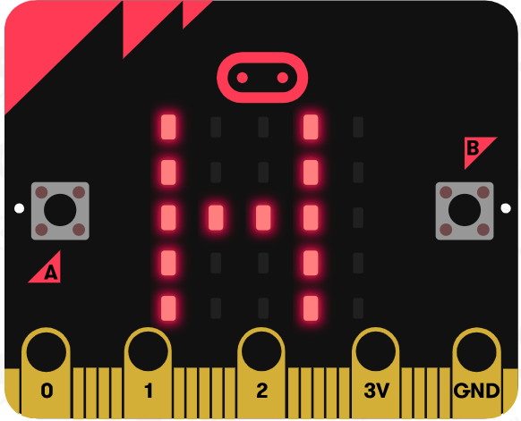 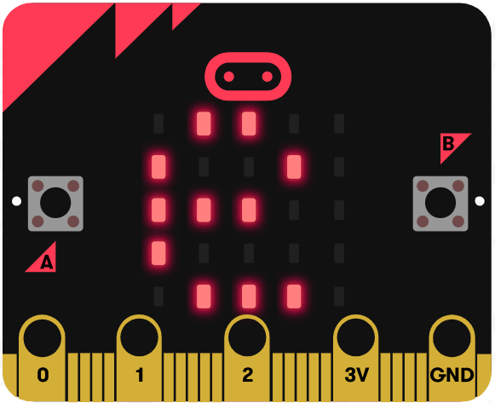 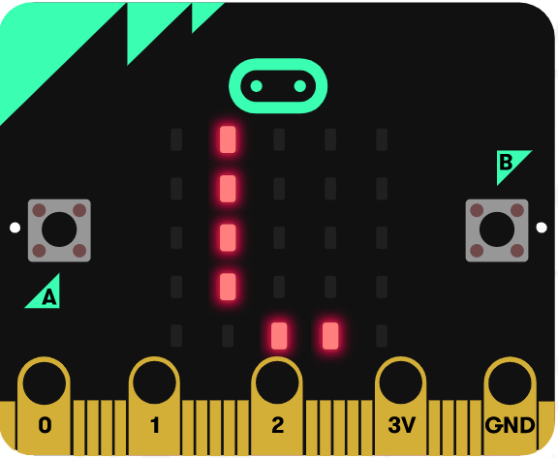  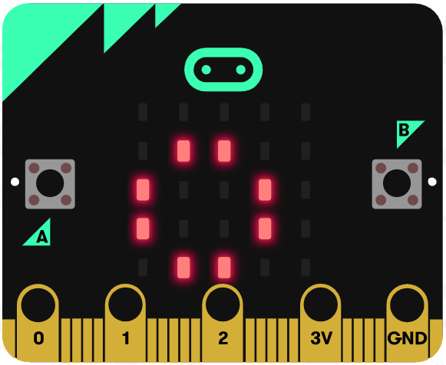

Description:

Build a program that will clear the display, output the text “Hello!”, display a square, and then display an X. After each item is displayed, the program will pause momentarily. This program runs forever displaying the message and icons over and over again.

Vocabulary and Concepts:

**Hardware**: the physical parts of a computing device—the parts you can touch

Examples: hard drive, monitor, keyboard, mouse, etc.

**Software**: the instructions that tell the hardware what to do

Examples: any programs found on a computer or phone; Google, Facebook, etc.

**Algorithm**: a step-by-step set of instructions to accomplish a task on a computer that always

works. A technique for solving a problem.

Example: the algorithm for cooking brownies

**Program**: a computer implementation of one or more algorithms—a piece of software that

performs a certain task.

**4 basic functions of a computer**: Input, Process, Output, and Storage

Input Example: entering words or numbers into a program using your keyboard or

clicking an icon with your mouse.

Process Example: the program processes your input. It is taking in the instruction you

gave it to see what it needs to do with it.

Storage Example: the input entered may need to be saved in memory so you can

access it later in time--like pulling up a Word Document saved on your Desktop

Output Example: displaying what you type on the keyboard to the screen. Also, clicking

the internet icon on your desktop will output an internet browser.

**3 essential building blocks of programs**: Sequence, Selections, Loops

**Sequence**: a series of actions completed in a specific order.

Ex: having a daily routine—wake up, get dressed, brush teeth, eat breakfast, etc.

**Selections**: asks a question to figure out which path to take next.

Ex: is it cold outside? If so, grab a jacket. If not, leave it at home.

**Loops**: asks the same question over and over until a certain task is complete.

Ex: eating breakfast--while there is still cereal in the bowl, take another bite! If there’s no more cereal, the “task” is complete. You finished your breakfast.

**Microcontroller**: a small computer on a single circuit board. It is programmed to do one thing,

simpler and smaller than a desktop computer.

**Circuit**: a set of electronic components connected by wire designed to accomplish a specific

function

**Analog circuit**: a circuit where the signal varies continuously

Example: a digital song (Stored as 1’s and 0’s) outputted directly would sound like static. An analog circuit must be used in your phone to convert those 1’s and 0’s into an audio signal that varies continuously, aka music.

**Digital circuit**: a circuit where the signal is one of two or more discrete values

Ex: A digital circuit in a cell phone may download a song as two discrete values; a bunch of 1’s and 0’s.

Flowchart:

A flowchart is a way of representing the step-by-step process (algorithm) of your program. For this program, the flowchart is:

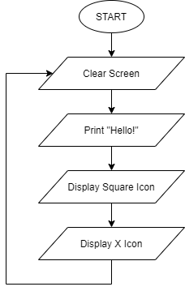

There is always a circle informing you where the algorithm starts. The arrows walk you through to the next steps. The arrow circling from “Display X Icon” to “Clear Screen” is a loop that goes on forever. If your program does NOT have an endless loop, you would end it with a circle similar to start, but label it “END”.

Let’s Start Programming!

Step 1: Accessing the Project Editor Page

You must be connected to the Internet and you may use any modern browser such as Edge, Firefox, Chrome, or Safari.

Start the micro:bit coding tool by using a web browser to connect to microbit.org/code. Once the webpage is loaded, scroll down to see the MakeCode Editor Section. Click the “Let’s Code” button. This will take us to a new page where you will click the “+ New Project” box. It will take a moment to load and start.

The coding tool we are using is called the Makecode **Blocks Editor**. Here is what it looks like when it is ready:

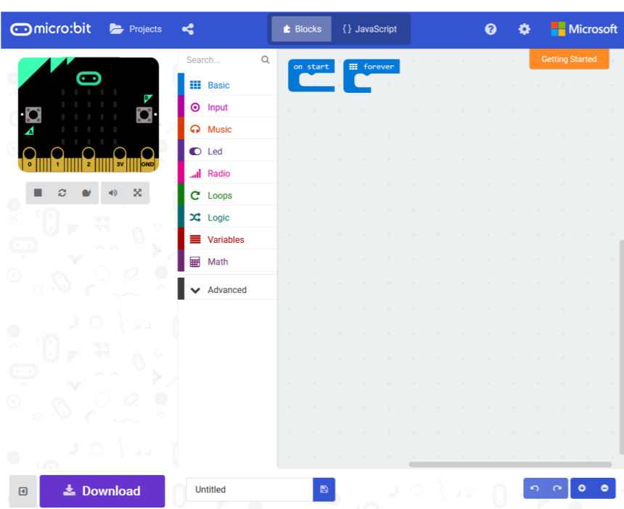

Step 2: Features of the Editing Tool

In the upper left hand corner is the micro:bit emulator. You can test your program here before you download it to the micro:bit. In the middle of the screen is the blocks chooser. The blocks are grouped into categories like Basic, Input, and Variables. The right side of the screen is where you will create your program by arranging blocks. Notice that two blocks are automatically inserted. The “on start” block contains any code that needs to happen one time only when the micro:bit is turned on. The “forever” block contains the remainder of your program. Other controls in the editor are for downloading your program, switching between blocks and Javascript, help, settings, and saving your projects. Let’s code!

Step 3: Getting Started

Click on “Basic” and insert the following blocks into the “forever” block. Blocks are added by dragging them into place. Notice the blocks resemble puzzle pieces and the must “fit” together. Some of the blocks you’ll need are shown under “…More” after you click “Basic”.

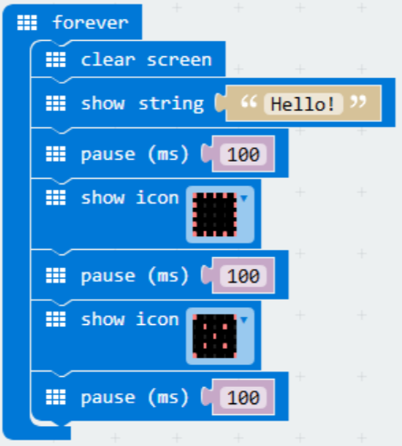

Step 4: Selection Changes

The pause times can be changed by clicking on the number 100 in the **pause** block and entering a new value. Note: the pause time is in milliseconds (ms). The message “Hello!” can be changed by clicking on the message in the **show string** block and typing a new string. Programmers call messages of text “strings”, so the **show string** block displays a message. The icons in the **show icon** block can be changed by clicking on the down arrow and selecting a new icon.

Step 5: Test your Program using the Emulator

Once you have completed assembling your blocks, the emulator will start running the program. If your program is working correctly, then it is time to download it to the micro:bit. Before we download it, let’s give our program a name. Click on the word “Untitled” in the textbook on the bottom left side of the editor.

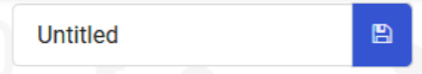

Name your program “Hello World”. You do NOT need to click the disk icon to change the name—pressing the disk icon will save your program by downloading it to your computer.

Step 6: Download the Program

Now we need to download the completed program. Click the “Download” button and save the program on your computer. Be sure to note where you have saved the program.



Step 7: Connect to your micro:bit

Next, connect your micro:bit to your computer with the USB cable. The following is where the USB cable needs to attach to the micro:bit.

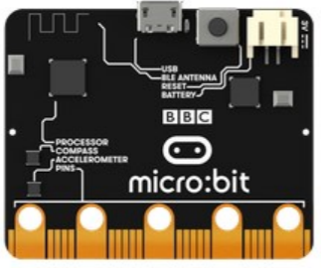

Step 8: Running the Program on the micro:bit

If you are using Windows, click the Start icon at the bottom left of your screen. Open the File Explorer (you can search for File Explorer if not displayed on your Start menu) and find your downloaded program. Right click on the program and select “Send To”. Then select “Microbit”. If you are using a Mac, drag and drop the program onto the MICROBIT device from the Finder. This will install your program on the micro:bit. The yellow LED on the back of the micro:bit will blink while your program is being installed. Your program will automatically run after the installation is complete.

Congratulations!

You have created your first micro:bit program!!

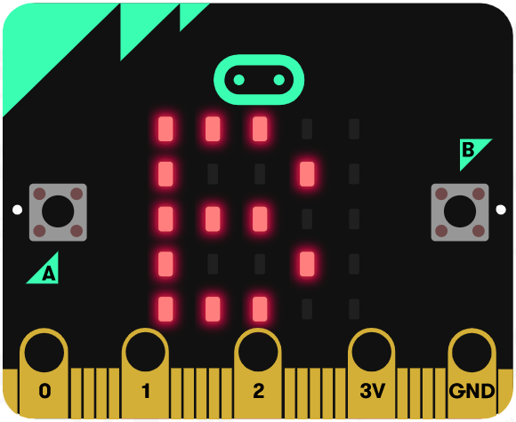 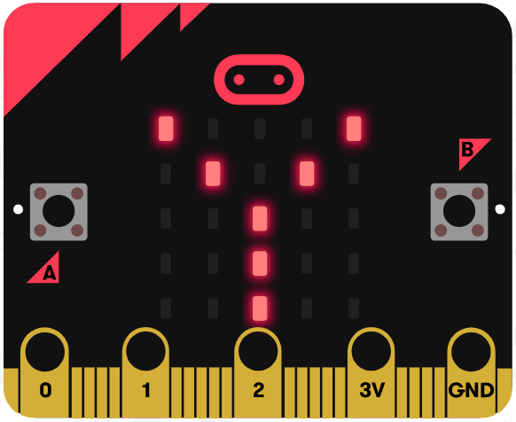 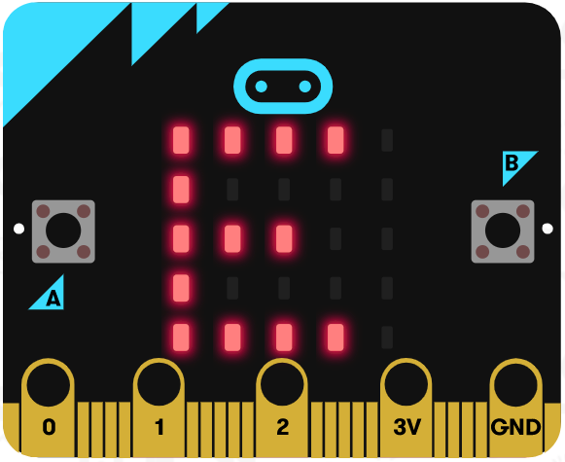

References

Online quick start tutorial: <http://microbit.org/guide/quick/>

Flowchart tool: <https://www.draw.io/>