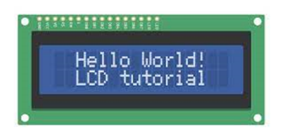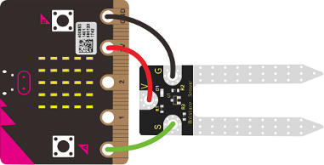

Activity:

Soil Sensor Function

Description:

Build a program that will have a function read the soil moisture value, log the reading to the SD card, and display the value onto the LCD screen using a loop. The soil moisture value will be read with a given soil moisture sensor.

Vocabulary and Concepts:

**Soil Moisture Sensor**: sensor that estimate volumetric water content

**Iteration (Loop):** A repetitive action or command typically created with programming loops. Loop action of doing something repeatedly.

**LCD (Liquid Crystal Display):** A type of flat panel display that can let light go through it or can block the light.

**Function:** A named piece of code that can be called as many times as possible, sometimes called procedures or method; a segment f code that includes the steps performed in a specified process.

Flowchart:

A flowchart is a way of representing the step-by-step process (algorithm) of your program. For this program, the flowchart is:

Build the Circuit

**Materials Required:**

* gator:soil - micro:bit Accessory Board
* gator:log -micro:bit Accessory Board
* gator:bit v2.0 – micro:bit carrier board
* MicroSD card
* MicroSD USB reader
* Twelve Crocodile Clips
* Flexible Qwiic cable
* LCD screen
* Dry and wet soil

**Hardware Hookup:**

|  |  |  |
| --- | --- | --- |
| Contact from gator:soil | Connection to gator:bit | Connector |
| PWR (power) | OUT 3.3V | Crocodile Clip |
| SIG (signal) | P0 | Crocodile Clip |
| GND (ground) | GND (ground) | Crocodile Clip |

**Instructions:**

1. **A picture containing text, electronics

   Description automatically generated** Turn on power switch located on gator:bit

|  |  |  |
| --- | --- | --- |
| Contact from gator:log | Connection to gator:bit | Connector |
| RST | P13 SCK | Crocodile Clip |
| GND (ground) | GND (ground) | Crocodile Clip |
| 3V3 | OUT 3.3V | Crocodile Clip |
| RX | P15 MOSI | Crocodile Clip |
| TX | P14 MISO | Crocodile Clip |

1. Place SD card in µSD Card Slot

|  |  |  |
| --- | --- | --- |
| Contact from LCD | Connection to gator:bit | Connector  (Qwiic Cable) |
| Connect qwiic cable in the back of LCD | OUT 3V (power) | Red wire |
| Connect qwiic cable in the back of LCD | GND (ground) | Black wire |
| Connect qwiic cable in the back of LCD | P20 (SDA) | Blue wire |
| Connect qwiic cable in the back of LCD | P19 (SCL) | Yellow wire |

1. Place gator:soil sensor in soil

Let’s Start Programming!

Step 1: Getting Started

First, copy the code from the LCD display (soil moisture) program. Next, go to functions tab and select make a function. Call the function, “soil function”. Once created, it should create a block to grab. Grab the function block and place the remaining code within the block. Finally, grab an on start block and place a call soil function within the on start block.

**Extensions:**

* GatorSoil (search “gatorsoil” in extension search bar)
* GatorLog (search <https://github.com/sparkfun/pxt-gator-log> in the extension search bar)
* LCD (search <https://github.com/evergreen22/pxt-lcd-rgb-16x2-i2c> in the extension search bar)

Step 2: Selection Changes

Step 3: Test your Program using the Emulator

Step 4: Connect to your micro:bit

Step 5: Download the Program

Step 6: Running the Program on the micro:bit

Congratulations!

You have created your Soil Moisture Function program!!

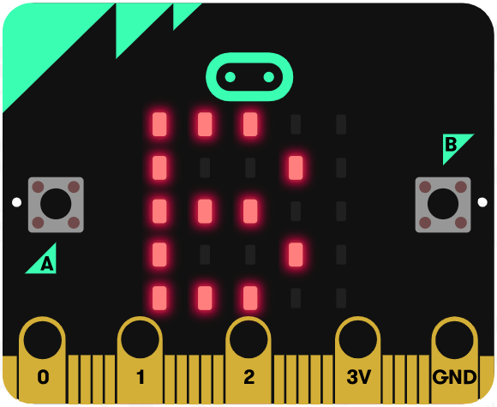 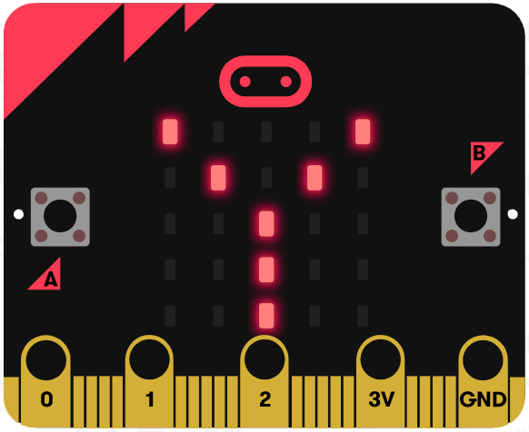 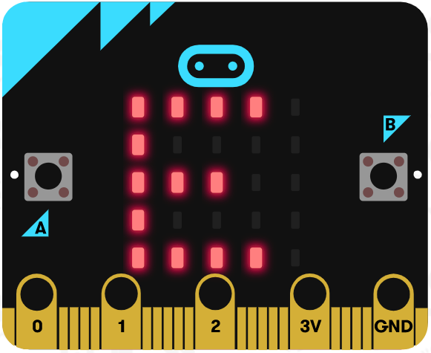

References

LCD Display tutorial: <https://www.youtube.com/watch?v=oov5Q48V844>

Flowchart tool: <https://www.draw.io/>