Activity:

Temperature Indicator #3 (Thermometer)

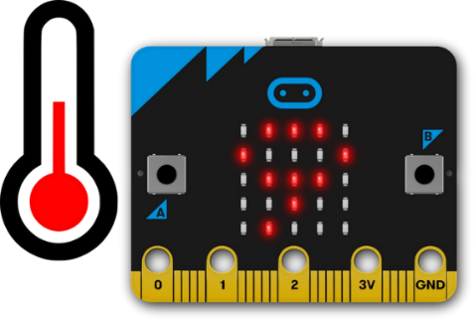

Description:

Build a program that will allow a pressed button to activate two LEDS based on temperature being above or below a fixed threshold. The red LED should light up if the temperature is above the threshold. The green LED should light up if the temperature is below the threshold.

Vocabulary and Concepts:

**Variable**: An element, feature, or factor that is liable to change; in a programming language, a symbolic representation of some state or property of the program.

**Sensor**: An input device that reads or measures a physical property and converts it to a numerical value.

**Temperature Sensor:** a sensor that measures the temperature in degrees Celsius (scientific units)

Flowchart: A flowchart is a way of representing the step-by-step process

(algorithm) of your program. For this program, the flowchart is

There is always a circle informing you where the algorithm starts.

The arrows walk you through to the next steps.

The program should take an input pressed button.

Next, output the temperature. Finally, the program should end.

Build the Circuit

**Materials Required:**

* Breadboard
* Micro:bit
* Three crocodile pin wires
* 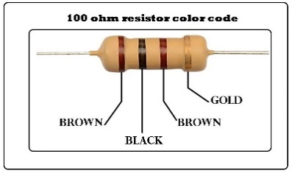Two LEDs (red and green)
* Two 100-ohm resistors (brown, black, brown, gold)

**Hardware Hookup:**

|  |  |  |
| --- | --- | --- |
| Contact from  Micro:bit | Connection to Breadboard | Connector |
| P0 | Check instruction 1 (ex: a17) | Crocodile pin wire |
| P1 | Check instruction 2 (ex: a11) | Crocodile pin wire |
| GND (ground) | GND (blue negative column) | Crocodile pin wire |
|  | Check instruction 3 (ex: 16c & 17c) | Red LED |
|  | Check instruction 4 (ex:  16c & blue negative) | Resistor |
|  | Check instruction 3 (ex: 10D &11D) | Green LED |
|  | Check instruction 4(ex:10D & blue negative) | Resistor |

**Instructions:**

1. Can be placed anywhere on breadboard from column a-e and row 1-30 or use example in chart.
2. Can be placed anywhere on breadboard except the same row as last crocodile pin wire or use example in chart.
3. The **longer leg(anode)** of LED must be on the same row as the crocodile pin wire and the **shorter leg(cathode)** of LED must be the same row as the resistor or use example in chart.
4. Must be on blue negative column and on the same as led or use example in chart.

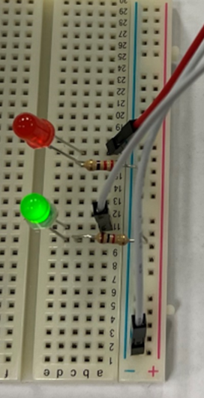

Let’s Start Programming!

Step 1: Accessing the Project Editor Page

You must be connected to the Internet and you may use any modern browser such as Edge, Firefox, Chrome, or Safari.

Start the micro:bit coding tool by using a web browser to connect to microbit.org/code. Once the webpage is loaded, scroll down to see the MakeCode Editor Section. Click the “Let’s Code” button. This will take us to a new page where you will click the “+ New Project” box. It will take a moment to load and start.

The coding tool we are using is called the **Javascript Blocks Editor**. Here is what it looks like when it is ready:

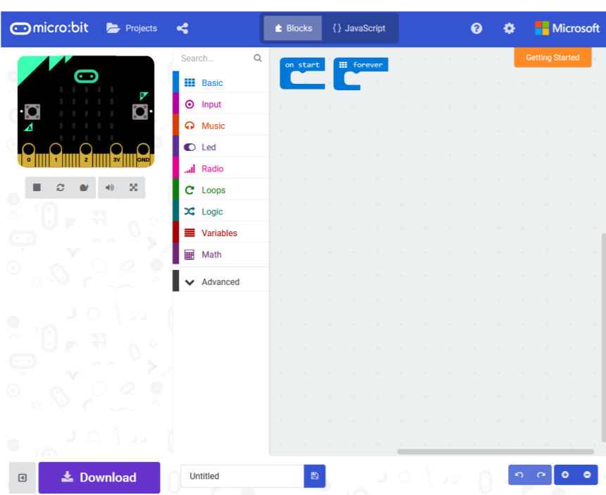

Step 2: Features of the Editing Tool

In the upper left hand corner is the micro:bit emulator. You can test your program here before you download it to the micro:bit. In the middle of the screen is the blocks chooser. The blocks are grouped into categories like Basic, Input, and Variables. The right side of the screen is where you will create your program by arranging blocks. Notice that two blocks are automatically inserted. The “on start” block contains any code that needs to happen one time only when the micro:bit is turned on. The “forever” block contains the remainder of your program. Other controls in the editor are for downloading your program, switching between blocks and Javascript, help, settings, and saving your projects. Let’s code!

Step 3: Getting Started

First, Create the program to convert the temperature from Celsius to Fahrenheit as shown in the Temperature Indicator #2 program. Next, click the logic tab and grab an if else conditional block. Then grab a comparison block and set within the logic tab and set it the variable, “Temp_in_F” less than a threshold of 72. Next, grab four digital write pin within the pin tab. Set P0 to 1 and P1 to 0 and place those two under the if statement. The other two pins should be set P0 to 0 and P1 to 1 and be place under the else statement. These blocks show if the temperature is less than 72 then turn on P0(green light) and turn off P1(red light). Else if the temperature is greater or equal to 72 then do the opposite which is turn off P0 and turn on P1. An example is shown below in the visual.

Step 4: Selection Changes

Certain changes can be made within the “on button pressed” block by choosing between A, B, or A+B which means we can determine if we would like to change the temperature when button A is pressed on the microbit, button B, or Both buttons with A+B. The threshold value can also be changed by entering a number in the text box.

Step 5: Test your Program using the Emulator

Once you have completed assembling your blocks, then press the button A on the emulator. If your program is working correctly, then it is time to download it to the micro:bit. Before we download it, let’s give our program a name. Click on the word “Untitled” in the textbook on the bottom left side of the editor.

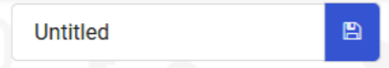

Name your program “Temperature Indicator3”. You do NOT need to click the disk icon to change the name—pressing the disk icon will save your program by downloading it to your computer.

Step 6: Download the Program

Now we need to download the completed program. Click the “Download” button and save the program on your computer. Be sure to note where you have saved the program.



Step 7: Connect to your micro:bit

Next, connect your micro:bit to your computer with the USB cable. The following is where the USB cable needs to attach to the micro:bit.

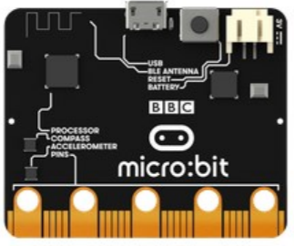

Step 9: Running the Program on the micro:bit

If you are using Windows, click the Start icon at the bottom left of your screen. Open the File Explorer (you can search for File Explorer if not displayed on your Start menu) and find your downloaded program. Right click on the program and select “Send To”. Then select “Microbit”. If you are using a Mac, drag and drop the program onto the MICROBIT device from the Finder. This will install your program on the micro:bit. The yellow LED on the back of the micro:bit will blink while your program is being installed. Your program will run once the selected button is pressed.

Congratulations!

You have created your Thermometer program!!

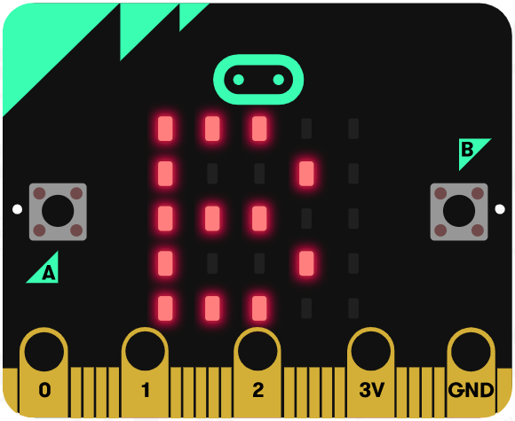 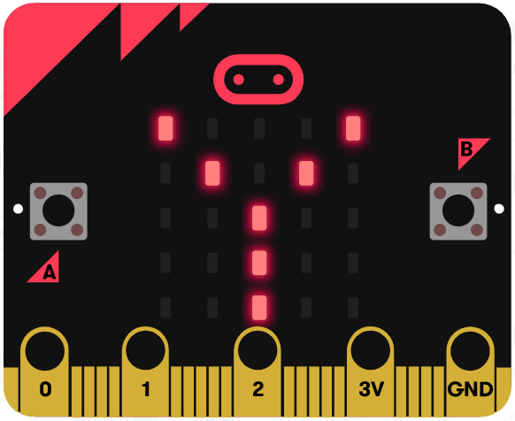 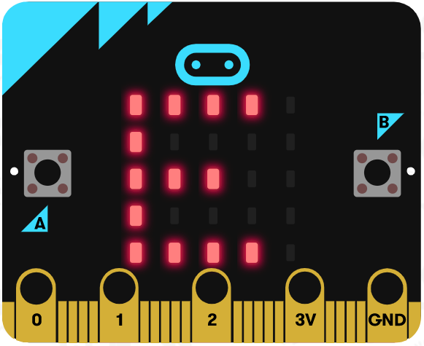

References

Flowchart tool: <https://www.draw.io/>