Activity:

Soil Moisture #4

Description:

Build a program that will read the soil moisture value, log the reading to the SD card, and display the value onto the LCD screen using a loop. The soil moisture value will be read with a given soil moisture sensor.

Vocabulary and Concepts:

**Soil Moisture Sensor**: sensor that estimate volumetric water content

**Iteration (Loop):** A repetitive action or command typically created with programming loops. Loop action of doing something repeatedly.

**LCD (Liquid Crystal Display):** A type of flat panel display that can let light go through it, or can block the light

Flowchart:

A flowchart is a way of representing the step-by-step process (algorithm) of your program. For this program, the flowchart is:

Build the Circuit

**Materials Required:**

* gator:soil - micro:bit Accessory Board
* gator:log -micro:bit Accessory Board
* gator:bit v2.0 – micro:bit carrier board
* MicroSD card
* MicroSD USB reader
* Twelve Crocodile Clips
* Flexible Qwiic cable
* LCD screen

**Hardware Hookup:**

|  |  |  |
| --- | --- | --- |
| Contact from gator:soil | Connection to gator:bit | Connector |
| PWR (power) | OUT 3.3V | Crocodile Clip |
| SIG (signal) | P0 | Crocodile Clip |
| GND (ground) | GND (ground) | Crocodile Clip |

**Instructions:**

1. **A picture containing text, electronics

   Description automatically generated** Turn on power switch located on gator:bit

|  |  |  |
| --- | --- | --- |
| Contact from gator:log | Connection to gator:bit | Connector |
| RST | P13 SCK | Crocodile Clip |
| GND (ground) | GND (ground) | Crocodile Clip |
| 3V3 | OUT 3.3V | Crocodile Clip |
| RX | P15 MOSI | Crocodile Clip |
| TX | P14 MISO | Crocodile Clip |

1. Place SD card in µSD Card Slot

|  |  |  |
| --- | --- | --- |
| Contact from LCD | Connection to gator:bit | Connector  (Qwiic Cable) |
| Connect qwiic cable in the back of LCD | OUT 3V (power) | Red wire |
| Connect qwiic cable in the back of LCD | GND (ground) | Black wire |
| Connect qwiic cable in the back of LCD | P20 (SDA) | Blue wire |
| Connect qwiic cable in the back of LCD | P19 (SCL) | Yellow wire |

1. Place gator:soil sensor in soil

Let’s Start Programming!

Step 1: Getting Started

First, confirm that your last program, Soil_Moisture#3, is working properly. Next, blocks will be added to that program. It will consist of another extension used for the LCD. This extension is received by copying and pasting the following link in the extension search bar, <https://github.com/evergreen22/pxt-lcd-rgb-16x2-i2c>. The Blocks grabbed from this LCD tab will be turn on backlight, show string and use the convert to text block found in the text tab. Finally, use the LCD cursor block.

**Extensions:**

* GatorSoil (search “gatorsoil” in extension search bar)
* GatorLog (search <https://github.com/sparkfun/pxt-gator-log> in the extension search bar)
* LCD (search <https://github.com/evergreen22/pxt-lcd-rgb-16x2-i2c> in the extension search bar)

Step 2: Selection Changes

The x and y coordinates can be changed to display on different areas of the LCD 16X2 Screen.

Step 3: Test your Program using the Emulator

Step 4: Download the Program

Step 5: Connect to your micro:bit

Step 6: Running the Program on the micro:bit

Congratulations!

You have created your LCD program!!

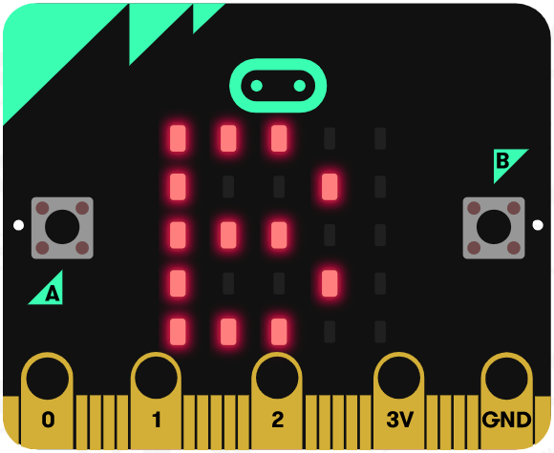 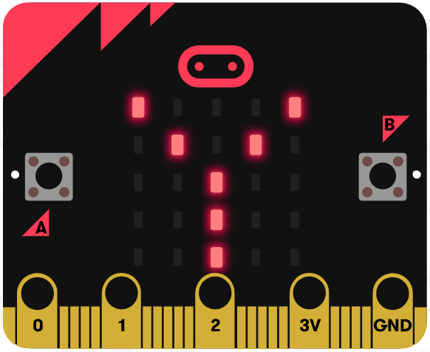 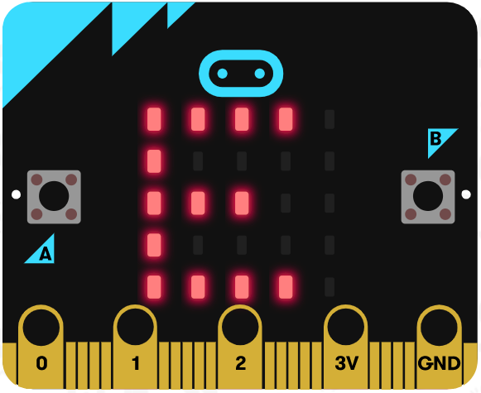

References

LCD Display tutorial: <https://www.youtube.com/watch?v=oov5Q48V844>

Flowchart tool: <https://www.draw.io/>