Activity:

LCD Hello World!

Description:

Build a program that will display hello world blinking onto the LCD screen.

Vocabulary and Concepts:

**LCD (Liquid Crystal Display):** A type of flat panel display that can let light go through it, or can block the light

Flowchart:

A flowchart is a way of representing the step-by-step process (algorithm) of your program. For this program, the flowchart is:

Build the Circuit

**Materials Required:**

* **LCD Screen**
* **Edge I/O Adapter**
* **Breadboard**
* **Flexible Qwiic cable**

**Hardware Hookup:**

|  |  |  |
| --- | --- | --- |
| Contact from LCD | Connection to gator:bit | Connector  (Qwiic Cable) |
| Connect qwiic cable in the back of LCD | OUT 3V (power) | Red wire |
| Connect qwiic cable in the back of LCD | GND (ground)  _Blue negative column) | Black wire |
| Connect qwiic cable in the back of LCD | P20 (SDA) | Blue wire |
| Connect qwiic cable in the back of LCD | P19 (SCL) | Yellow wire |

**Instructions:**

1) Place micro:bit into edge I/O adapter and connect Edge I/O adapter to breadboard with the

positive and negative matching up.

Let’s Start Programming!

Step 1: Getting Started

First, search add the LCD extension. Next, grab on start block from basic tab and grab the needed blocks within the added LCD block from extension

**Extensions:**

* LCD (search <https://github.com/evergreen22/pxt-lcd-rgb-16x2-i2c> in the extension search bar)

Step 2: Selection Changes

* Change LCD backlight block to the set LCD backlight red, green, blue. This allows to change the color of the screen.
* A picture containing text, electronics

  Description automatically generatedChange the text in the show string block

Step 3: Test your Program using the Emulator

Step 4: Download the Program

Step 5: Connect to your micro:bit

Step 6: Running the Program on the micro:bit

Congratulations!

You have created your LCD program!!

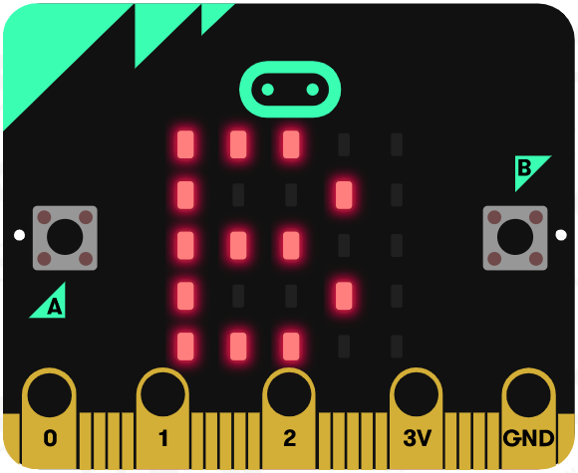 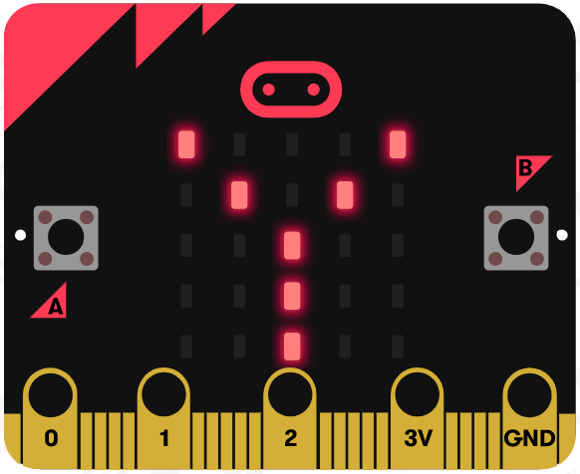 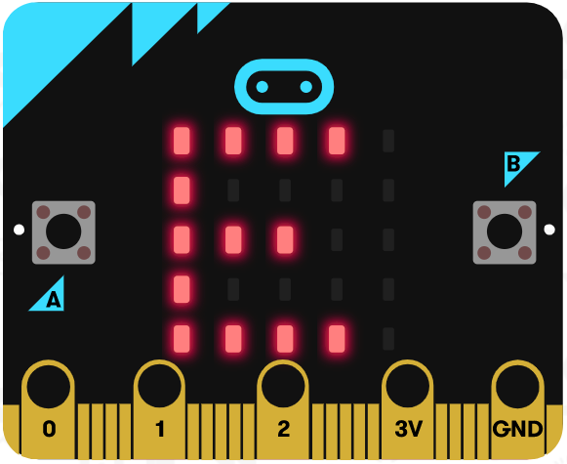

References

LCD Display tutorial: <https://www.youtube.com/watch?v=oov5Q48V844>

Flowchart tool: <https://www.draw.io/>