Activity:

Soil Moisture #1

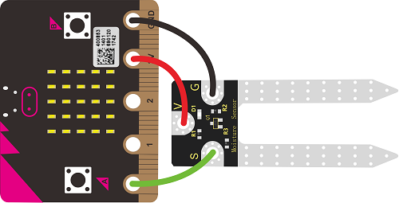

Description:

Build a program that will read the soil moisture value and display the value onto the screen. The soil moisture value will be read with a given soil moisture sensor.

Vocabulary and Concepts:

**Soil Moisture Sensor**: sensor that estimate volumetric water content

Flowchart:

A flowchart is a way of representing the step-by-step process (algorithm) of your program. For this program, the flowchart is:

Build the Circuit

**Materials Required:**

* gator:soil - micro:bit Accessory Board
* gator:bit v2.0 – micro:bit carrier board
* Three Crocodile Clips

|  |  |  |
| --- | --- | --- |
| Contact from gator:soil | Connection to gator:bit v2.0 | Connector |
| PWR (power) | P1 | Crocodile Clip |
| SIG (signal) | P0 | Crocodile Clip |
| GND (ground) | GND (ground) | Crocodile Clip |

**Hardware Hookup:**

**Instructions:**

1. Place gator:soil sensor in soil

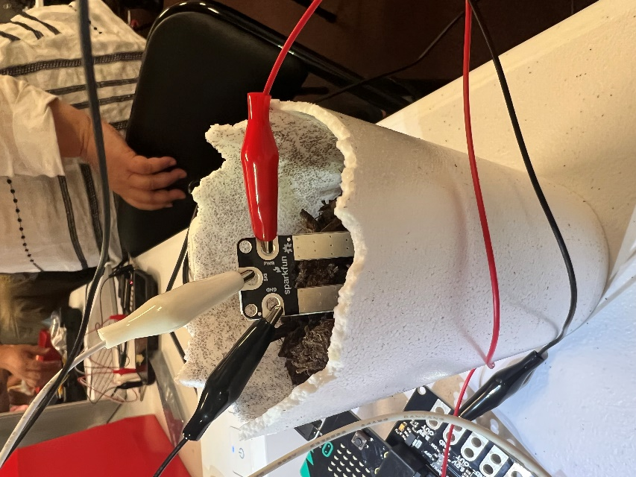

Let’s Start Programming!

Step 1: Getting Started

First, we will use the Gator Soil extension for this program. The extension can be used by clicking the “extensions” tab and typing “Gator Soil” into the extensions search bar. Next, the gator soil extension should pop up. Click the extension and the gator soil tab should now appear along with the other tabs. Click the gator soil tab to grab the get moisture block. Set pin P0 in ADCvalue using power pin P1. Finally, grab all other blocks and build your program.

**Extensions:**

* GatorSoil

Step 2: Selection Changes

Changes may consist of changing to any pin number, but P0 and P1 are good choices for now.

The ADCValue may also be changed to moisture. The ADC value is the moisture value divided by 100.

Step 3: Test your Program using the Emulator

Test your program on the emulator by clicking on button A and change the value of the soil moisture by sliding up and down on pin P0.

Step 4: Connect to your micro:bit

Step 5: Download the Program

Step 6: Run the Program on the micro:bit

Congratulations!

You have created your Soil Sensor program!!

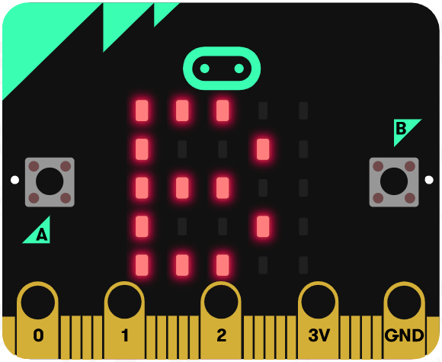 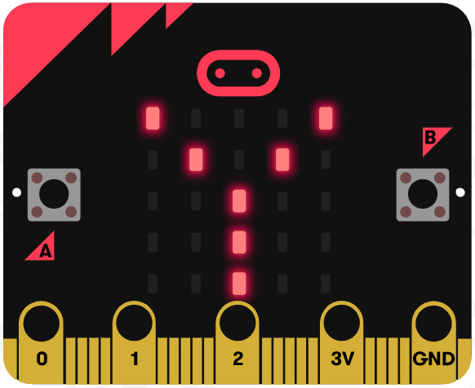 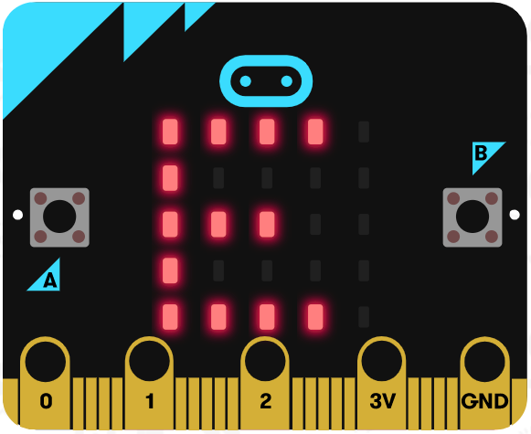

References

Online Moisture Sensor tutorial: <https://youtu.be/S8NppVT_paw>

SparkFun gator:soil Hookup Guide: <https://learn.sparkfun.com/tutorials/sparkfun-gatorsoil-hookup-guide?_ga=2.146091443.620133083.1655840734-1398352755.1654058977>

Flowchart tool: <https://www.draw.io/>