Here you will input your desired course number into the text box and press either button to open up their respective data on the inputted course:

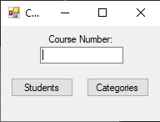

If your inputted course does not exist, this prompt will show up, for if you’d want to create said course:

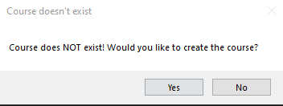

If you press the student button, this form will pop up, showing all currently enrolled students into your inputted course:

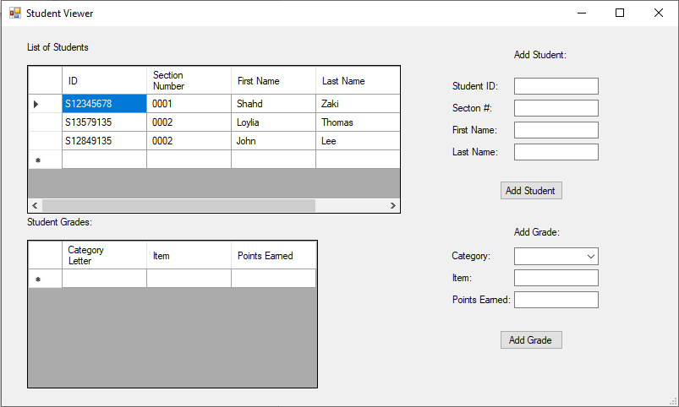

Selecting a particular student (by pressing on their respective row, showcased by the triangle on the list of students) will open their respective grades.

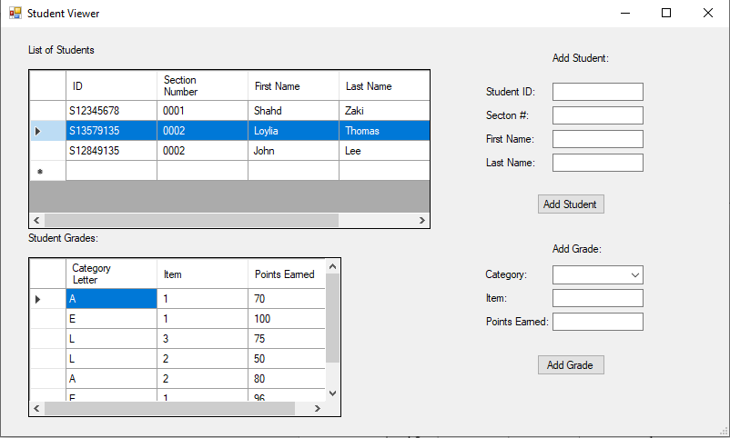

To add a student, simply include all the required parts into their respective textboxes and click Add Student.

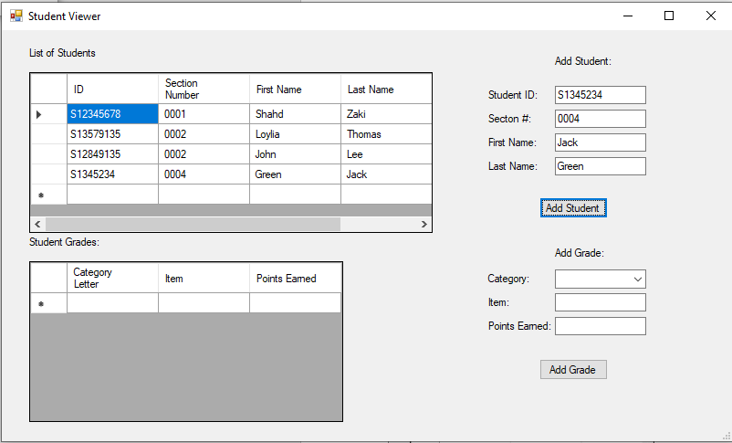

To add grades to a particular student, make sure you have that student’s grades open. Then choose out of the following available categories, add the remaining required information, and press Add Grade.

Note:

\*Item and Points Earned HAVE to be numbers

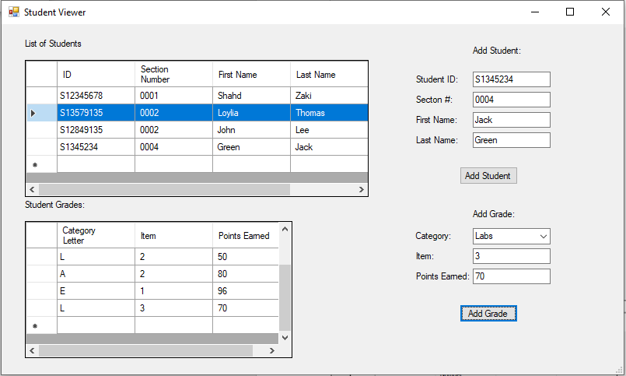

If you press the student button, this form will pop up, showing all current Categories and their overall weights to the course, and how many of each category has to be done during the course.

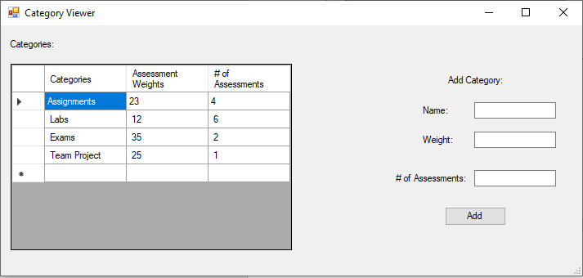

To add a new category, insert all the required information and press Add.

Note:

\*Name cannot include a first letter that is similar to any other category

\*Weight and # of Assessments HAVE to be numbers

