TensorFlow 2.13.0 Testing

one, Automatic testing:

Will 2.script 、 3.yaml 4. Copy all the data to the current path.

Execute the following command to give all script files execution permissions

|  |
| --- |
| chmod +x 2.script/* |

Execute the following command to build the test file.

|  |
| --- |
| ./2.script/build.sh |

Start the test and execute the commands one by one.

**examples**

|  |
| --- |
| ./examples.sh |

**models**

|  |
| --- |
| ./recommendation.sh  ./vision.sh  ./projects.sh |

**Benchmark**

|  |
| --- |
| ./benchmark.sh |

**others**

|  |
| --- |
| ./others.sh |

2. Manual testing:

Note: The path should be switched to your own path, and cannot be directly copied and pasted.

**examples**

The warehouse is There are in the tensorflow_examples/models/ path dcgan 、 densenet 、​

nmt _ with _ attention and There are four models in pix 2 pix , which are tested below.

First clone the repository and set the environment variables `PYTHONPATH` , as follows :

Clone the repository

|  |
| --- |
| git clone [https://github.com/tensorflow/e examples](https://github.com/tensorflow/examples) |

Bundle The examples repository is added to PYTHONPATH Environment variables

|  |
| --- |
| export PYTHONPATH="$PYTHONPATH:/home/tf-test/file /examples" |

**dcgan**

Here train .

|  |
| --- |
| python dcgan.py |

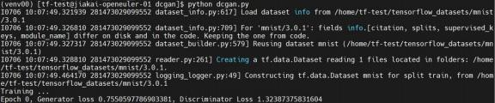

**densenet**

Here train .

|  |
| --- |
| python train.py |



**nmt_with_attention**

Here train .

|  |
| --- |
| python train.py |



**pix2pix**

Here train .

Download the dataset [facades] to tensorflow_examples/ models/pix2pix/ and unzip it facades.tar .

|  |
| --- |
| Python pix 2 pix .py - path / home / tf-​​  test/file/examples/tensorflow_examples/models/pix2pix/faca des/ |



**models**

This time we mainly tested the warehouse recommendation 、 nlp , vision and Projects The model in Clone the repository and set the environment variables:

Clone the repository

|  |
| --- |
| git clone [https://github.com/tensorfl ow/models](https://github.com/tensorflow/models) |

Bundle The models repository is added to PYTHONPATH environment variable

|  |
| --- |
| export PYTHONPATH="$PYTHONPATH:/home/tf-test/ file/models" |

**recommendation**

recommendation The model in the path Under models/official/recommendation .

***NCF***

NCF to download and preprocess the dataset and train and evaluate the model are as follows. The working path is models/official/recommendation / :

Download and preprocess the dataset, select ml- 1m dataset

|  |
| --- |
| python movielens.py --data_dir /home/tf-test/models/dataset/ncf --dataset ml- 1m |

Training and evaluating the model

|  |
| --- |
| python ncf_keras_main.py --model_dir /home/tf-test/models/model_dir/ncf --data_dir |

|  |
| --- |
| /home/tf-test/models/dataset/ncf/ --data set ml- 1m --num_gpus 0 |



***DCN v 2***

DCN v2 has the following steps for training with synthetic data:

|  |
| --- |
| python3 models/official/recommendation/ranking/train.py --mode=eval \ --model_dir=/home/tf-test/models/model_dir/dcn_v2 --pa rams_override="  runtime:  distribution_strategy: ' one_device'  task:  use_synthetic_data: true  model:  num_dense_features: 13  bottom_mlp: [512,256,2]  embedding_dim: 2  top_mlp: [1024, 1024,512,256, 1]  interaction: 'cross'  vocab_sizes: [39884406, 39043, 17289, 7420, 20263, 3, 7120, 1543, 63,  38532951, 2953546, 403346, 10, 2208, 11938, 155 , 4, 976, 14,  39979771, 25641295, 39664984, 58593 5, 12972, 108, 36]  trainer:  validation_steps: 2  " |



***DLRM***

DLRM has the following steps for training with synthetic data:

|  |
| --- |
| python3 models/official/recommendation/ranking/train.py --mode=eval \ --model_dir=/home/tf-test/models/model_dir/dlrm --para ms_override="  runtime:  distribution_strategy: ' one_device'  task:  use_synthetic_data: true  model:  num_dense_features: 13  bottom_mlp: [512,256,2]  embedding_dim: 2  top_mlp: [1024, 1024,512,256, 1]  interaction: 'dot'  vocab_sizes: [39884406, 39043, 17289, 7420, 20263, 3, 7120, 1543, 63,  38532951, 2953546, 403346, 10, 2208, 11938, 155 , 4, 976, 14,  39979771, 25641295, 39664984, 58593 5, 12972, 108, 36]  trainer:  validation_steps: 2  " |



**nlp**

nlp The model in the path Run under models/official/nlp/ .

***Transformer***

Transformer is as follows:

|  |
| --- |
| Python train.py --experiment​​​ wmt_transformer / large -- mode​​ eval --model_dir / home / tf-​​​​  test/models/model_dir/transformer --params_ove rride  task.sentencepiece_model_path='gs://tf_model_garden/nlp/transformer_wmt/ende_b pe_3 |

|  |
| --- |
| 2k.model' |

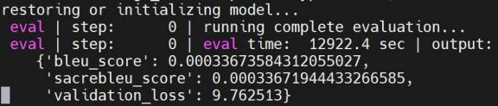

**vision**

vision The model in the path Run under models/official/vision/ .

In operation Before models , you need to download and preprocess ILSVRC2012 and co co2017 dataset, and finally Include `train*` and `val* ` The ILSVRC2012 dataset folder is renamed `imagenet-2012-

tfrecord` and put it in vision Directory; include `val*` and ` ins tances_val2017.json` coco2017 Rename the dataset folder to Coco and put it vision directory.

Then run the following model.

***vit_imagenet_finetune***

The specific test method is as follows:

|  |
| --- |
| python train.py -experiment vit_imagenet_finetune -mode eval -model_dir /home/tf- test/models/model_dir/vit_imagenet_finetune --params_overr ide="  runtime:  distribution_strategy: ' one_device'  task:  validation_data:  global_batch_size: 2  trainer:  validation_steps: 2  validation_interval: 2  " |

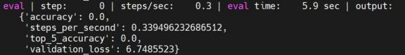

***vit_imagenet_pretrain***

The specific test method is as follows:

|  |
| --- |
| python train.py -experiment vit_imagenet_pretrain -mode eval -model_dir /home/t f- test/models/model_dir/vit_imagenet_pretrain --params_over ride="  runtime:  distribution_strategy: ' one_device'  task:  validation_data:  global_batch_size: 2  trainer:  validation_steps: 2  validation_interval: 2  " |

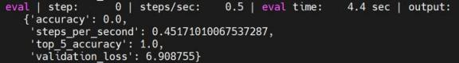

***deit_imagenet_pretrain***

The specific test method is as follows:

|  |
| --- |
| python train.py -experiment deit_imagenet_pretrain -mode eval -model_dir /home/ tf- test/models/model_dir/deit_imagenet_pretrain --params_ove rride="  runtime:  distribution_strategy: ' one_device'  task: |

|  |
| --- |
| validation_data:  global_batch_size: 2  trainer:  validation_steps: 2  validation_interval: 2  " |

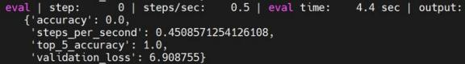

***mobilenet_imagenet​​***

The specific test method is as follows:

|  |
| --- |
| python train.py -experiment mobilenet_imagenet -mode eval -model_dir /home/tf- test/models/model_dir/mobilenet_imagenet --params_ove rride="  runtime:  distribution_strategy: ' one_device'  task:  validation_data:  global_batch_size: 2  trainer:  validation_steps: 2  validation_interval: 2  " |

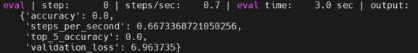

***revnet_imagenet​​***

The specific test method is as follows:

|  |
| --- |
| python train.py -experiment revnet_imagenet -mode eval -model_dir /home/tf- test/models/model_dir/revnet_imagenet --params_ove rride="  runtime:  distribution_strategy: ' one_device'  task:  validation_data:  global_batch_size: 2  trainer:  validation_steps: 2  validation_interval: 2  " |

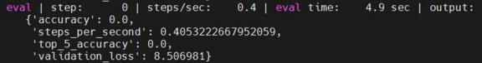

***resnet_rs_imagenet​​​​***

The specific test method is as follows:

|  |
| --- |
| python train.py -experiment resnet_rs_imagenet -mode eval -model_dir /home/tf- test/models/model_dir/resnet rs imagenet --params_override ="  runtime:  distribution_strategy: ' one_device'  task:  validation_data:  global_batch_size: 2  trainer:  validation_steps: 2  validation_interval: 2 |

|  |
| --- |
| " |

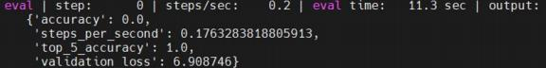

***resnet_imagenet​​***

The specific test method is as follows:

|  |
| --- |
| python train.py -experiment resnet_imagenet -mode eval -model_dir /home/ tf- test/models/model_dir/resnet_imagenet --params_over ride="  runtime:  distribution_strategy: ' one_device'  task:  validation_data:  global_batch_size: 2  trainer:  validation_steps: 2  validation_interval: 2  " |

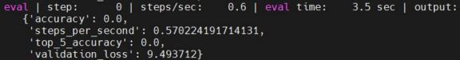

***fasterrcnn_resnetfpn_coco​​​​***

The specific test method is as follows:

|  |
| --- |
| python train.py -experiment fasterrcnn_resnetfpn_coco -mode eval -model _dir /home/tf- test/models/model_dir/fasterrcnn_resnetfpn_coco --params_ove rride="  runtime:  distribution_strategy: ' one_device'  task: |

|  |
| --- |
| validation_data:  global_batch_size: 2  trainer:  validation_steps: 2  validation_interval: 2  " |

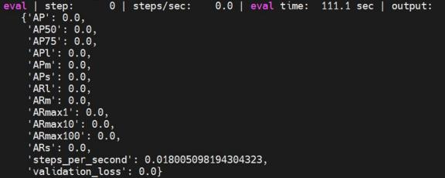

***maskrcnn_resnetfpn_coco​***

The specific test method is as follows:

|  |
| --- |
| python train.py -experiment maskrcnn_resnetfpn_coco -mode eval -model_dir /home/tf- test/models/model_dir/maskrcnn_resnetfpn_coco --params_overr ide="  runtime:  distribution_strategy: ' one_device'  task:  validation_data:  global_batch_size: 2  trainer:  validation_steps: 2  validation_interval: 2 |

|  |
| --- |
| " |

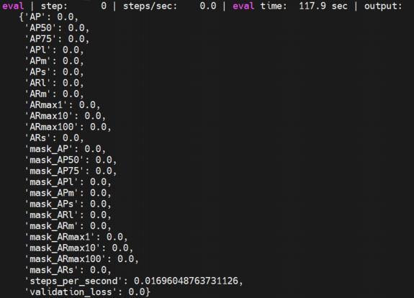

***maskrcnn_spinenet_coco***

The specific test method is as follows:

|  |
| --- |
| python train.py -experiment maskrcnn_spinenet_coco -mode eval -model_dir /home/tf- test/models/model_dir/maskrcnn_spinenet_coco --params_ov erride="  runtime:  distribution_strategy: ' one_device'  task:  validation_data:  global_batch_size: 2  trainer:  validation_steps: 2  validation_interval: 2 |

|  |
| --- |
| " |

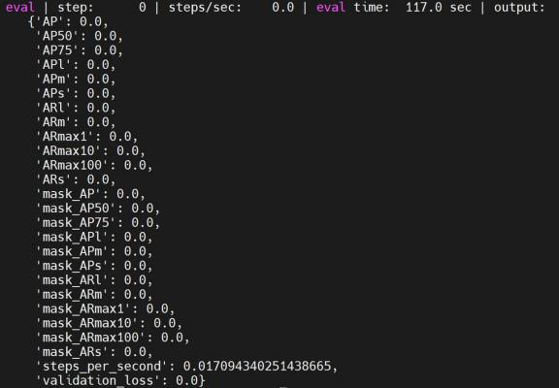

***cascadercnn_spinenet_coco***

The specific test method is as follows:

|  |
| --- |
| python train.py -experiment cascadercnn_spinenet_coco -mode eval -model_dir /home/tf- test/models/model_dir/cascadercnn_spinenet_coco --params_ove rride="  runtime:  distribution_strategy: ' one_device'  task:  validation_data:  global_batch_size: 2  trainer:  validation_steps: 2 |

|  |
| --- |
| validation_interval: 2  " |

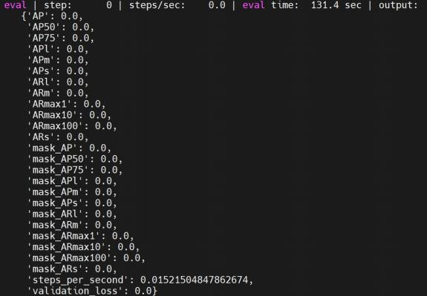

***maskrcnn_mobilenet_coco***

The specific test method is as follows:

|  |
| --- |
| python train.py -experiment maskrcnn_mobilenet_coco -mode eval -model_dir /home/tf- test/models/model_dir/maskrcnn_mobilenet_coco --params_ove rride="  runtime:  distribution_strategy: ' one_device'  task:  validation_data:  global_batch_size: 2  trainer:  validation_steps: 2 |

|  |
| --- |
| validation_interval: 2  " |

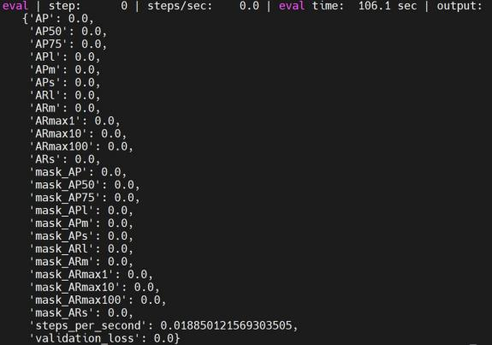

***retinanet_resnetfpn _coco***

The specific test method is as follows:

|  |
| --- |
| python train.py -experiment retinanet_resnetfpn_coco -mode eval -model_dir /home/tf- test/models/model_dir/retinanet_resnetfpn_coco --params_ove rride="  runtime:  distribution_strategy: ' one_device'  task:  validation_data:  global_batch_size: 2  trainer:  validation_steps: 2 |

|  |
| --- |
| validation_interval: 2  " |

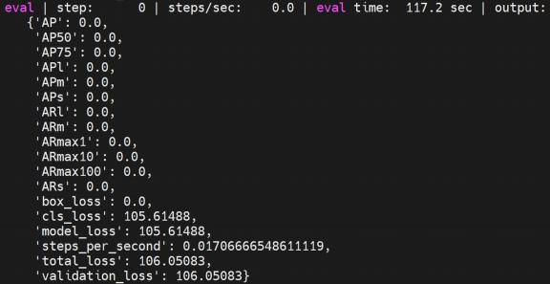

***retinanet_spinenet_coco***

The specific test method is as follows:

|  |
| --- |
| python train.py -experiment retinanet_spinenet_coco -mode eval -model_dir /home/tf- test/models/model_dir/retinanet_spinenet_coco --params_overr ide="  runtime:  distribution_strategy: ' one_device'  task:  validation_data:  global_batch_size: 2  trainer:  validation_steps: 2  validation_interval: 2  " |

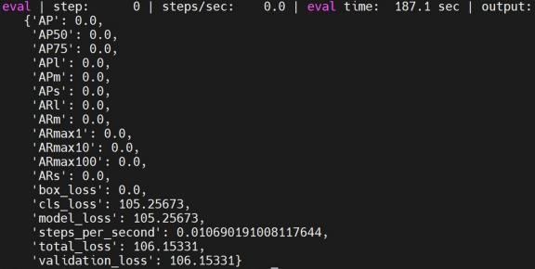

***retinanet_mobile_coco***

The specific test method is as follows:

|  |
| --- |
| python train.py -experiment retinanet_mobile_coco -mode eval -model_dir /home/tf- test/models/model_dir/retinanet_mobile_coco --params_ove rride="  runtime:  distribution_strategy: ' one_device'  task:  validation_data:  global_batch_size: 2  trainer:  validation_steps: 2  validation_interval: 2  " |

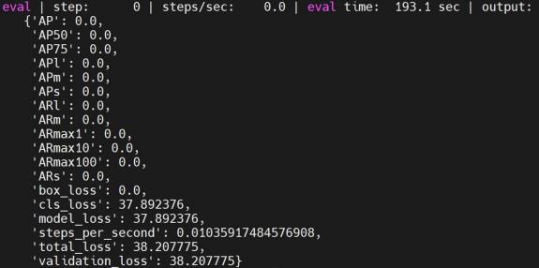

**Projects**

Projects The model in the path models/official/projects/ under.

***\*\*assemblenet\*\****

specific The eval is as follows:

|  |
| --- |
| python train_test.py |

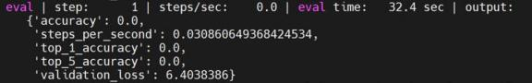

***\*\*volumetric_models \*\****

specific The eval is as follows:

|  |
| --- |
| python train_test.py |

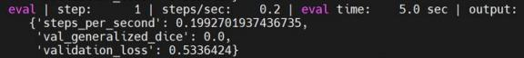

***\*\*nhnet\*\****

specific The eval is as follows:

|  |
| --- |
| python trainer_test.py |



***\*\*yt8m \*\****

specific The eval is as follows:

|  |
| --- |
| python train_test.py |

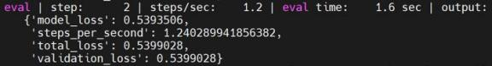

***\*\*MOVENT\*\****

specific The eval is as follows:

|  |
| --- |
| python train_test.py |

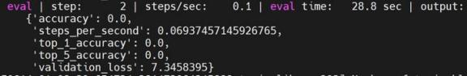

***\*\*maxvit\*\****

specific The eval is as follows:

|  |
| --- |
| python train_test.py |

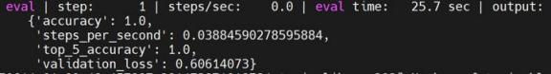

**benchmark**

The benchmark model needs to be cloned benchmark repository, and clone the above The models repository is switched to have Benchmark module v2.15.0 tags , as follows:

|  |
| --- |
| git [clone https://github.com/tensorflow/benchmarks](https://github.com/tensorflow/benchmarks)  cd models  git checkout v2.15.0 |

**resnet56**

resnet56​ In the models/official/benchmark/ keras_cifar_benchmark.py file, the combined Test with data benchmark_cpu , so you can test it directly as follows:

|  |
| --- |
| python 3 benchmarks / perfzero / lib / benchmark.py --​​  git_repos=" <https://github.com/tensorflow/models.git>;benchmark" --  gcloud_key_file_url="" --  benchmark_methods=official.benchmark.keras_cifar_benchmark.Resnet56KerasBen chm arkSynth.benchmark_cpu |

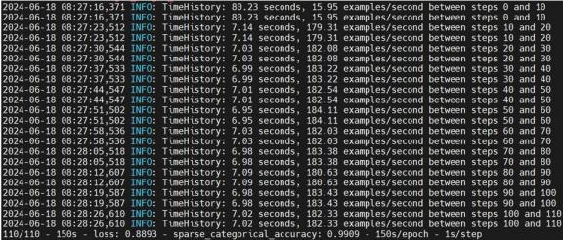

**resnet50**

resnet50​ In the models/official/benchmark/keras_imagenet_benchmark.py file , Tested with synthetic data, it comes with benchmark 1 GPU , when the program is running, it will detect whether there is a Used GPU If it does not exist, it will be used The cpu is tested, so it can be tested directly as follows:

Note: You can modify In the keras_imagenet_benchmark.py file

KerasClassifierBenchmark Base class benchmark 1 GPU method

per_replica_batch_size value to reduce batch_size To shorten the testing time.

|  |
| --- |
| python 3 benchmarks / perfzero / lib / benchmark.py --​​  git_repos=" <https://github.com/tensorflow/models.git>;benchmark" --  gcloud_key_file_url="" --  benchmark_methods=official.benchmark.keras_imagenet_benchmark.Resnet50Keras Ben chmarkSynth.benchmark 1 GPU |

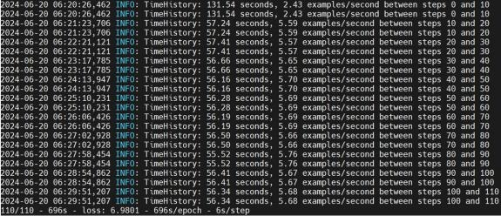

**mobilenetv1**

MobileNetV1​ In the models/official/benchmark/ keras_imagenet_benchmark.py file, In order to facilitate testing, we choose to use synthetic data here, so you need to write the corresponding

KerasPruningBenchmarkSynthBase and MobilenetV1KerasPrun ingBenchmarkSynth class, The details are as follows:

|  |
| --- |
| class KerasPruningBenchmarkSynthBase ( Resnet 50 KerasBenchmarkBase ):  """Pruning method benchmarks."""  def __init __ ( self , root _ data _ dir = None , default _ flags = None , ** kwargs ):  if default_flags​​ is None :  default_flags = {}  default_flags.update({  'skip_eval': True,  'report_accuracy_metri cs': False,  'use_synthetic_data': True,  'train_steps': 110,  'log_steps': 10,  'pruning_method': 'pol ynomial_decay', |

|  |
| --- |
| 'pruning_begin_step': 0,  'pruning_end_step': 50000,  'pruning_initial_sparsity': 0,  'pruning_final_sparsity': 0.5,  'pruning_frequency': 100,  })  super(KerasPruningBenchmarkSynthBase, self).__in it__(  default_flags=default_flags, **kwargs)  class MobilenetV 1 KerasPruningBenchmarkSynth ( KerasPruningBenchmarkSynthBase ):  """Pruning method benchmarks for MobilenetV1."""  def __init __ ( self , ** kwargs ):  default_flags = {  'model': 'mobilenet',  'optimizer': 'mobile net_default',  }  super(MobilenetV1KerasPruningBenchmarkSynth, self).__in it__(  default_flags=default_flags, **kwargs) |

It can also be adjusted batch_size to shorten the test time.

|  |
| --- |
| python 3 benchmarks / perfzero / lib / benchmark.py --​​  git_repos=" <https://github.com/tensorflow/models.git>;benchmark" --  gcloud_key_file_url="" --  benchmark_methods=official.benchmark.keras_imagenet_benchmark.MobilenetV1Ke ras PruningBenchmarkSynth.benchmark 1 GPU |

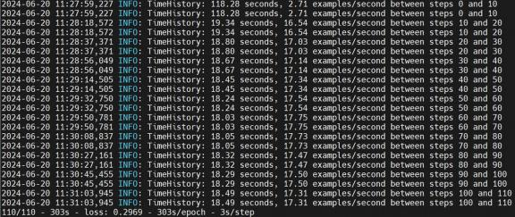

**trivial**

trivial​ In the models/official/benchmark/ keras_imagenet_benchmark.py file, for convenience

Test, here we choose to use synthetic data, so you need to write the corresponding

TrivialKerasBenchmarkSynth class is as follows:

|  |
| --- |
| class TrivialKerasBenchmarkSynth(keras_benchmark.Kera sBenchmark):  """Trivial model with synth data b enchmark tests."""  def __ init __( self , output _ dir = None , root _ data _ dir = None , ** kwargs ):  flag_methods = [resnet_imagenet_m ain.define_imagenet_keras_flags]  def_flags = {}  def_flags['use_trivial_mod el'] = True  def_flags['skip_eval'] = True  def_flags['report_accuracy_metrics '] = False  def_flags['dtype'] = 'fp16'  def_flags['use_synthetic_dat a'] = True  def_flags['train_ste ps'] = 600  def_flags['log_steps'] = 100 |

|  |
| --- |
| def_flags['distribution_strategy'] = 'mirrored'  super(TrivialKerasBenchmarkSynth, self).__in it__(  output_dir=output_dir,  flag_methods=flag_methods,  default_flags=def_flags)  @benchmark_wrappers.enable _runtime_flags  def _ run _ and _ report _ benchmark ( self ):  start_time_sec = time.time()  stats = resnet_imagenet_ main.run(FLAGS)  wall_time_sec = time.time() - start_time _sec  super(TrivialKerasBenchmarkSynth, self)._re port_benchmark(  stats,  wall_time_sec,  total_batch_size=FLAGS.batch_size ,  log_steps=FLAGS.log_steps)  def benchmark_cpu ( self ) :​  self._setup()  FLAGS.num_gpus = 0  FLAGS.enable_eager = True  FLAGS.model_dir = self._get_model_dir('benchmar k_cpu') |

|  |
| --- |
| FLAGS.batch_size = 32  FLAGS.train_steps = 10  self._run_and_report_benchmark()  def fill_report_object ( self , stats ) :​​​  super(TrivialKerasBenchmarkSynth, self).fil l_report_object(  stats,  total_batch_size=FLAGS.batch_size ,  log_steps=FLAGS.log_steps) |

|  |
| --- |
| python 3 benchmarks / perfzero / lib / benchmark.py --​​  git_repos=" <https://github.com/tensorflow/models.git>;benchmark" --  gcloud_key_file_url="" --  benchmark_methods=official.benchmark.keras_imagenet_benchmark.TrivialKerasB ench markSynth.benchmark_cpu |



**efficientnet**

efficientnet​ In the models/official/ benchmark/keras_imagenet_benchmark.py file, in order to

To facilitate testing, we choose to use synthetic data here, so you need to write the corresponding

EfficientNetKerasBenchmarkSynth class , as follows:

|  |
| --- |
| class EfficientNetKerasBenchmarkSynth ( KerasClassifierBenchmarkBase ):  """EfficientNet synth data benchmark tests."""  def __init__(self, output_dir=None, root_data_dir=None, tpu=None, **kwargs):  def_flags = {}  def_flags['log_steps'] = 10 |

|  |
| --- |
| super(EfficientNetKerasBenchmarkSynth, self).__in it__(  model='efficientnet', output_dir=output_dir, default_flags=def_ flags,  tpu=tpu, dataset_builder='synthetic', train_epochs= 1, train_steps= 110)  def benchmark_cpu ( self ) :​  self._setup()  self._run_and_repor t_benchmark(  experiment_name='ben chmark_cpu',  model_variant='efficientnet -b7',  dtype = 'bfloat16',  num_tpus=0,  distribution_strategy='o ne_device',  per_replica_batch_size=4) |

|  |
| --- |
| python 3 benchmarks / perfzero / lib / benchmark.py --​​  git_repos=" <https://github.com/tensorflow/models.git>;benchmark" --  gcloud_key_file_url="" --  benchmark_methods=official.benchmark.keras_imagenet_benchmark.EfficientNetKe ras BenchmarkSynth.bench mark_cpu |

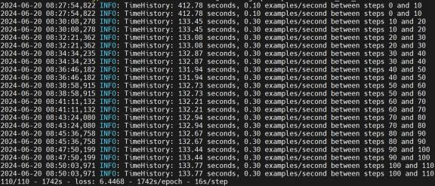

**resnet50ctl**

resnet50ctl​ In the models/official/benchmark/resnet_ctl_imagenet_benchmark.py file ,

Here we use synthetic data for testing. benchmark 1 GPU , when the program is running, it will detect whether There is available GPU If it does not exist, it will be used cpu To test, you can directly test, such as

Down:

In addition, Resnet50CtlBenchmarkBase class​ benchmark 1 GPU method batch_size Change to 32 Otherwise, it will appear The problem of insufficient RAM .

|  |
| --- |
| python 3 benchmarks / perfzero / lib / benchmark.py --​​  git_repos=" <https://github.com/tensorflow/models.git>;benchmark" --  gcloud_key_file_url="" --  benchmark_methods=official.benchmark.resnet_ctl_imagenet_benchmark.Resnet50CtlB enchmarkSynth.benchmark 1 GPU |

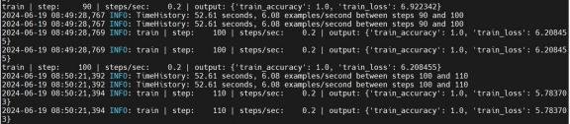

**TfScanE2E**

Testing and Evaluation Benchmark of the overall end-to-end performance of TensorFlow models.

TFScanE2E​ In the models/official/ben chamrk/tf_scan_benchmark.py file, there is a built-in benchmark_cpu , as follows:

|  |
| --- |
| python 3 benchmarks / perfzero / lib / benchmark.py --​​  git_repos=" <https://github.com/tensorflow/models.git>;benchmark" --  gcloud_key_file_url="" --  = official.benchmark.tf_scan_benchmark.TfScanE2EBenchmark.ben chmark_cpu |



**others**

Here are some small test .

**\*\*tensorflow_models\*\***

Working path: /home/tf-test/file/models/ tensorflow_models

|  |
| --- |
| python tensorflow_models_tes t.py |

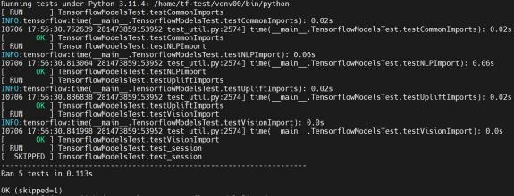

**ORBIT**

Working path: /home/tf-test/file/models/orbit/ examples/single_task

|  |
| --- |
| python single_task_trainer_test.py |

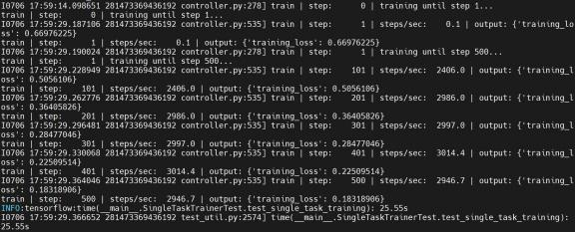

|  |
| --- |
| python single_task_evaluator_test .py |

