Everlyn Laughter
Instructor Harrison
CSC-121
7 May 2026
Alien Invasion Final Project Documentation

Project Summary
Alien Invasion is a 2D arcade-style game developed using Python and the Pygame library. The player controls a rocket ship positioned at the bottom of the screen and must defend against waves of alien invaders.
The objective of the game is to shoot down aliens while avoiding collisions. The game demonstrates core programming concepts such as object-oriented programming, event handling, game loops, and collision detection.

How to Run the Application
Requirements:
- Python 3.x installed
- Pygame library installed (pip install pygame)
Steps to Run:
- Open the project folder in VS Code or another Python editor.
- Make sure all files are in the same directory:
  - alien_invasion.py
  - alien.py
  - bullet.py
  - button.py
  - game_stats.py
  - scoreboard.py
  - settings.py
  - ship.py
  - images folder (containing ship and alien images)
- Open the terminal in the project folder.
- Run the program using the command:

python alien_invasion.py

How to Play
Controls:
- Left Arrow Key → Move ship left
- Right Arrow Key → Move ship right
- Spacebar → Fire bullets
Objective:
The goal of the game is to destroy all alien invaders using bullets while avoiding collisions. If aliens reach the ship or hit it directly, the player loses. The game continues with increasing difficulty as new alien waves appear.

Game Features
- Player-controlled rocket ship movement
- Bullet shooting system
- Alien fleet generation
- Collision detection between bullets and aliens
- Game loop for continuous gameplay
- Object-oriented structure using multiple classes

Screenshots

Screenshot 1: Game Start Screen
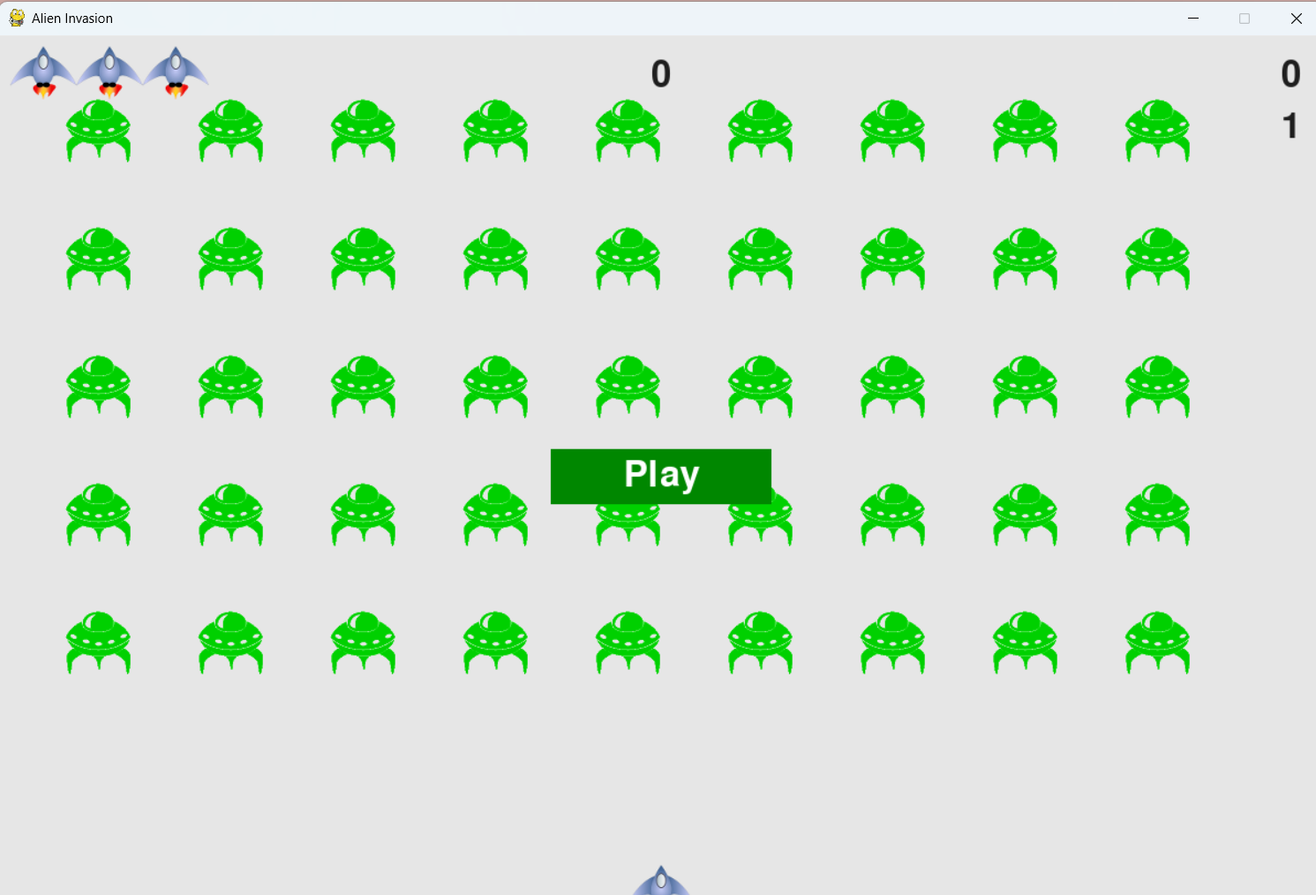
Screenshot 2: Ship Movement
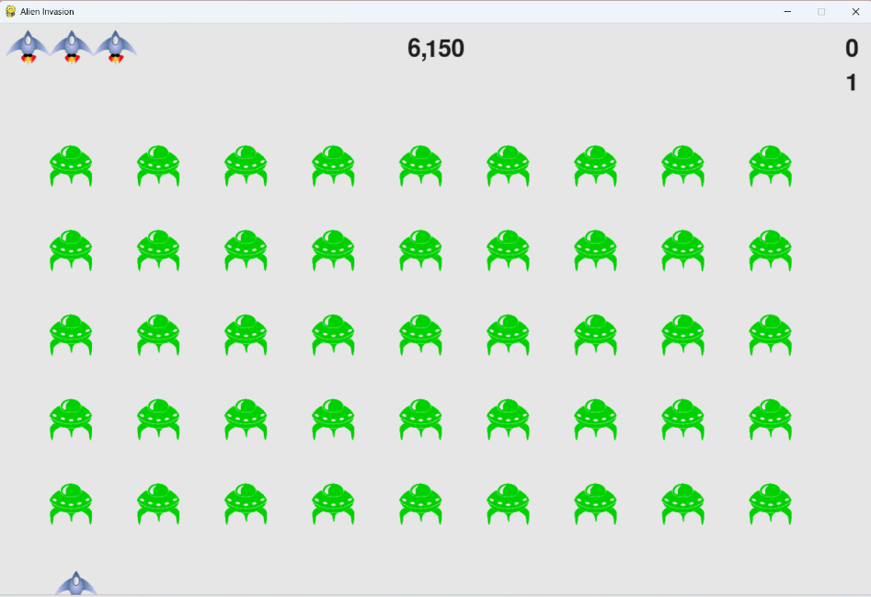

Screenshot 3: Shooting Bullets
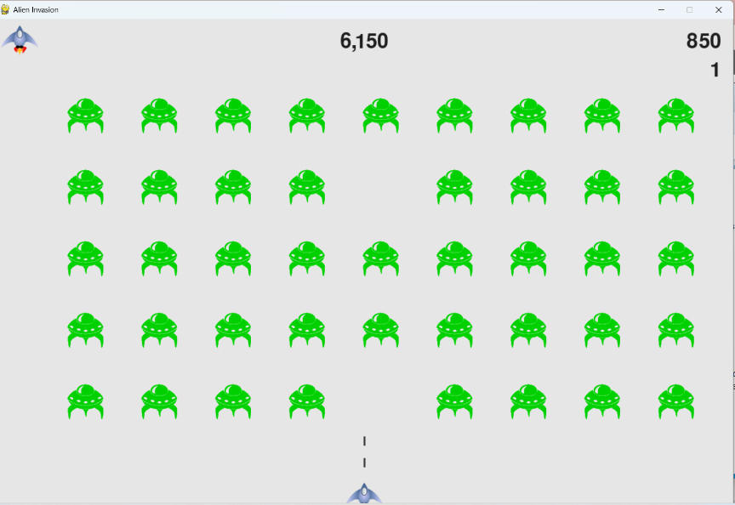
Screenshot 4: Alien Fleet
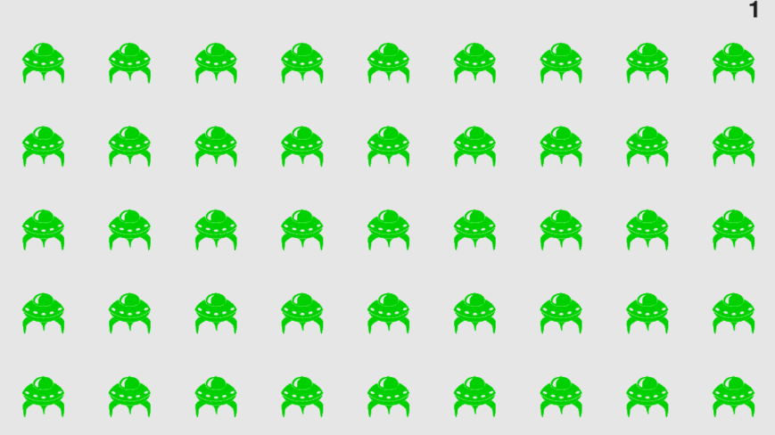
Screenshot 5: Gameplay Action
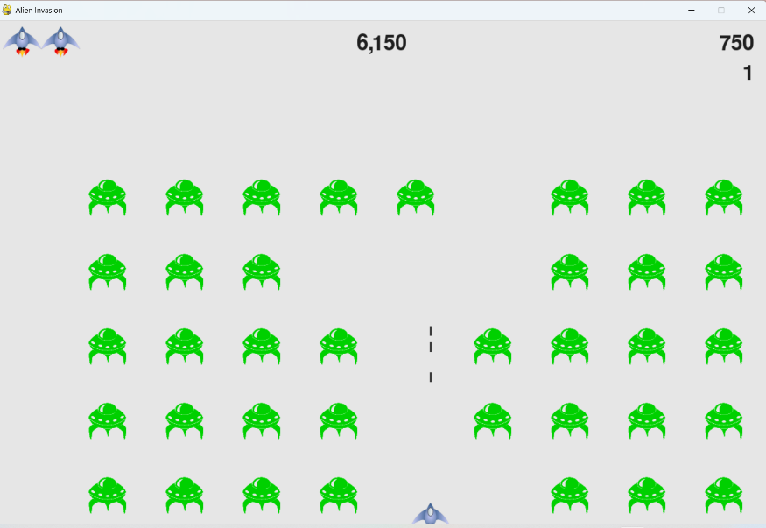

Code Overview

alien_invasion.py
import sys
from time import sleep

import pygame

from settings import Settings
from game_stats import GameStats
from scoreboard import Scoreboard
from button import Button
from ship import Ship
from bullet import Bullet
from alien import Alien

class AlienInvasion:
"""Overall class to manage game assets and behavior."""

def __init__(self):
"""Initialize the game, and create game resources."""
pygame.init()
self.clock = pygame.time.Clock()
self.settings = Settings()

self.screen = pygame.display.set_mode(
(self.settings.screen_width, self.settings.screen_height))
pygame.display.set_caption("Alien Invasion")

# Create an instance to store game statistics,
# and create a scoreboard.
self.stats = GameStats(self)
self.sb = Scoreboard(self)

self.ship = Ship(self)
self.bullets = pygame.sprite.Group()
self.aliens = pygame.sprite.Group()

self._create_fleet()

# Start Alien Invasion in an inactive state.
self.game_active = False

# Make the Play button.
self.play_button = Button(self, "Play")

def run_game(self):
"""Start the main loop for the game."""
while True:
self._check_events()

if self.game_active:
self.ship.update()
self._update_bullets()
self._update_aliens()

self._update_screen()
self.clock.tick(60)

def _check_events(self):
"""Respond to keypresses and mouse events."""
for event in pygame.event.get():
if event.type == pygame.QUIT:
sys.exit()
elif event.type == pygame.KEYDOWN:
self._check_keydown_events(event)
elif event.type == pygame.KEYUP:
self._check_keyup_events(event)
elif event.type == pygame.MOUSEBUTTONDOWN:
mouse_pos = pygame.mouse.get_pos()
self._check_play_button(mouse_pos)

def _check_play_button(self, mouse_pos):
"""Start a new game when the player clicks Play."""
button_clicked = self.play_button.rect.collidepoint(mouse_pos)
if button_clicked and not self.game_active:
# Reset the game settings.
self.settings.initialize_dynamic_settings()

# Reset the game statistics.
self.stats.reset_stats()
self.sb.prep_score()
self.sb.prep_level()
self.sb.prep_ships()
self.game_active = True

# Get rid of any remaining bullets and aliens.
self.bullets.empty()
self.aliens.empty()

# Create a new fleet and center the ship.
self._create_fleet()
self.ship.center_ship()

# Hide the mouse cursor.
pygame.mouse.set_visible(False)

def _check_keydown_events(self, event):
"""Respond to keypresses."""
if event.key == pygame.K_RIGHT:
self.ship.moving_right = True
elif event.key == pygame.K_LEFT:
self.ship.moving_left = True
elif event.key == pygame.K_q:
sys.exit()
elif event.key == pygame.K_SPACE:
self._fire_bullet()

def _check_keyup_events(self, event):
"""Respond to key releases."""
if event.key == pygame.K_RIGHT:
self.ship.moving_right = False
elif event.key == pygame.K_LEFT:
self.ship.moving_left = False

def _fire_bullet(self):
"""Create a new bullet and add it to the bullets group."""
if len(self.bullets) < self.settings.bullets_allowed:
new_bullet = Bullet(self)
self.bullets.add(new_bullet)

def _update_bullets(self):
"""Update position of bullets and get rid of old bullets."""
# Update bullet positions.
self.bullets.update()

# Get rid of bullets that have disappeared.
for bullet in self.bullets.copy():
if bullet.rect.bottom <= 0:
self.bullets.remove(bullet)

self._check_bullet_alien_collisions()

def _check_bullet_alien_collisions(self):
"""Respond to bullet-alien collisions."""
# Remove any bullets and aliens that have collided.
collisions = pygame.sprite.groupcollide(
self.bullets, self.aliens, True, True)

if collisions:
for aliens in collisions.values():
self.stats.score += self.settings.alien_points * len(aliens)
self.sb.prep_score()
self.sb.check_high_score()

if not self.aliens:
# Destroy existing bullets and create new fleet.
self.bullets.empty()
self._create_fleet()
self.settings.increase_speed()

# Increase level.
self.stats.level += 1
self.sb.prep_level()

def _ship_hit(self):
"""Respond to the ship being hit by an alien."""
if self.stats.ships_left > 0:
# Decrement ships_left, and update scoreboard.
self.stats.ships_left -= 1
self.sb.prep_ships()

# Get rid of any remaining bullets and aliens.
self.bullets.empty()
self.aliens.empty()

# Create a new fleet and center the ship.
self._create_fleet()
self.ship.center_ship()

# Pause.
sleep(0.5)
else:
self.game_active = False
pygame.mouse.set_visible(True)

def _update_aliens(self):
"""Check if the fleet is at an edge, then update positions."""
self._check_fleet_edges()
self.aliens.update()

# Look for alien-ship collisions.
if pygame.sprite.spritecollideany(self.ship, self.aliens):
self._ship_hit()

# Look for aliens hitting the bottom of the screen.
self._check_aliens_bottom()

def _check_aliens_bottom(self):
"""Check if any aliens have reached the bottom of the screen."""
for alien in self.aliens.sprites():
if alien.rect.bottom >= self.settings.screen_height:
# Treat this the same as if the ship got hit.
self._ship_hit()
break

def _create_fleet(self):
"""Create the fleet of aliens."""
# Create an alien and keep adding aliens until there's no room left.
# Spacing between aliens is one alien width and one alien height.
alien = Alien(self)
alien_width, alien_height = alien.rect.size

current_x, current_y = alien_width, alien_height
while current_y < (self.settings.screen_height - 3 * alien_height):
while current_x < (self.settings.screen_width - 2 * alien_width):
self._create_alien(current_x, current_y)
current_x += 2 * alien_width

# Finished a row; reset x value, and increment y value.
current_x = alien_width
current_y += 2 * alien_height

def _create_alien(self, x_position, y_position):
"""Create an alien and place it in the fleet."""
new_alien = Alien(self)
new_alien.x = x_position
new_alien.rect.x = x_position
new_alien.rect.y = y_position
self.aliens.add(new_alien)

def _check_fleet_edges(self):
"""Respond appropriately if any aliens have reached an edge."""
for alien in self.aliens.sprites():
if alien.check_edges():
self._change_fleet_direction()
break

def _change_fleet_direction(self):
"""Drop the entire fleet and change the fleet's direction."""
for alien in self.aliens.sprites():
alien.rect.y += self.settings.fleet_drop_speed
self.settings.fleet_direction *= -1

def _update_screen(self):
"""Update images on the screen, and flip to the new screen."""
self.screen.fill(self.settings.bg_color)
for bullet in self.bullets.sprites():
bullet.draw_bullet()
self.ship.blitme()
self.aliens.draw(self.screen)

# Draw the score information.
self.sb.show_score()

# Draw the play button if the game is inactive.
if not self.game_active:
self.play_button.draw_button()

pygame.display.flip()

if __name__ == '__main__':
# Make a game instance, and run the game.
ai = AlienInvasion()
ai.run_game()

This file controls the entire game. It handles the game loop, user input, screen updates, and coordinates all game objects, including the ship, bullets, and aliens.
ship.py
import pygame
from pygame.sprite import Sprite

class Ship(Sprite):
"""A class to manage the ship."""

def __init__(self, ai_game):
"""Initialize the ship and set its starting position."""
super().__init__()
self.screen = ai_game.screen
self.settings = ai_game.settings
self.screen_rect = ai_game.screen.get_rect()

# Load the ship image and get its rect.
self.image = pygame.image.load('images/ship.bmp')
self.rect = self.image.get_rect()

# Start each new ship at the bottom center of the screen.
self.rect.midbottom = self.screen_rect.midbottom

# Store a float for the ship's exact horizontal position.
self.x = float(self.rect.x)

# Movement flags; start with a ship that's not moving.
self.moving_right = False
self.moving_left = False

def center_ship(self):
"""Center the ship on the screen."""
self.rect.midbottom = self.screen_rect.midbottom
self.x = float(self.rect.x)

def update(self):
"""Update the ship's position based on movement flags."""
# Update the ship's x value, not the rect.
if self.moving_right and self.rect.right < self.screen_rect.right:
self.x += self.settings.ship_speed
if self.moving_left and self.rect.left > 0:
self.x -= self.settings.ship_speed

# Update rect object from self.x.
self.rect.x = self.x

def blitme(self):
"""Draw the ship at its current location."""
self.screen.blit(self.image, self.rect)

This file defines the Ship class. It manages the player’s ship, including movement, positioning, and drawing the ship on the screen.

bullet.py
import pygame
from pygame.sprite import Sprite

class Bullet(Sprite):
"""A class to manage bullets fired from the ship."""

def __init__(self, ai_game):
"""Create a bullet object at the ship's current position."""
super().__init__()
self.screen = ai_game.screen
self.settings = ai_game.settings
self.color = self.settings.bullet_color

# Create a bullet rect at (0, 0) and then set correct position.
self.rect = pygame.Rect(0, 0, self.settings.bullet_width,
self.settings.bullet_height)
self.rect.midtop = ai_game.ship.rect.midtop

# Store the bullet's position as a float.
self.y = float(self.rect.y)

def update(self):
"""Move the bullet up the screen."""
# Update the exact position of the bullet.
self.y -= self.settings.bullet_speed
# Update the rect position.
self.rect.y = self.y

def draw_bullet(self):
"""Draw the bullet to the screen."""
pygame.draw.rect(self.screen, self.color, self.rect)

This file defines the Bullet class. It controls bullet creation, movement, and removal when bullets leave the screen.

alien.py
import pygame

from pygame.sprite import Sprite

class Alien(Sprite):
"""A class to represent a single alien in the fleet."""

def __init__(self, ai_game):
"""Initialize the alien and set its starting position."""
super().__init__()
self.screen = ai_game.screen
self.settings = ai_game.settings

# Load the alien image and set its rect attribute.
self.image = pygame.image.load('images/alien.bmp')
self.rect = self.image.get_rect()

# Start each new alien near the top left of the screen.
self.rect.x = self.rect.width
self.rect.y = self.rect.height

# Store the alien's exact horizontal position.
self.x = float(self.rect.x)

def check_edges(self):
"""Return True if alien is at edge of screen."""
screen_rect = self.screen.get_rect()
return (self.rect.right >= screen_rect.right) or (self.rect.left <= 0)

def update(self):
"""Move the alien right or left."""
self.x += self.settings.alien_speed * self.settings.fleet_direction
self.rect.x = self.x

This file defines the Alien class. It handles alien creation, positioning, and movement across the screen.

button.py
import pygame

from pygame.sprite import Sprite

class Alien(Sprite):
"""A class to represent a single alien in the fleet."""

def __init__(self, ai_game):
"""Initialize the alien and set its starting position."""
super().__init__()
self.screen = ai_game.screen
self.settings = ai_game.settings

# Load the alien image and set its rect attribute.
self.image = pygame.image.load('images/alien.bmp')
self.rect = self.image.get_rect()

# Start each new alien near the top left of the screen.
self.rect.x = self.rect.width
self.rect.y = self.rect.height

# Store the alien's exact horizontal position.
self.x = float(self.rect.x)

def check_edges(self):
"""Return True if alien is at edge of screen."""
screen_rect = self.screen.get_rect()
return (self.rect.right >= screen_rect.right) or (self.rect.left <= 0)

def update(self):
"""Move the alien right or left."""
self.x += self.settings.alien_speed * self.settings.fleet_direction
self.rect.x = self.x

This file defines the Button class used throughout the game for interactive UI elements. It handles creating buttons, displaying text on them, and detecting mouse clicks. It also includes functionality to change the button’s appearance when hovered over or clicked, improving user interaction and visual feedback.

game_stats.py
class GameStats:
"""Track statistics for Alien Invasion."""

def __init__(self, ai_game):
"""Initialize statistics."""
self.settings = ai_game.settings
self.reset_stats()

# High score should never be reset.
self.high_score = 0

def reset_stats(self):
"""Initialize statistics that can change during the game."""
self.ships_left = self.settings.ship_limit
self.score = 0
self.level = 1

This file manages all game-related statistics and state tracking. It keeps track of important values such as the player’s score, level, lives, and whether the game is active. It also includes methods to reset stats at the start of a new game and to update values during gameplay.

scoreboard.py
import pygame.font
from pygame.sprite import Group

from ship import Ship

class Scoreboard:
"""A class to report scoring information."""

def __init__(self, ai_game):
"""Initialize scorekeeping attributes."""
self.ai_game = ai_game
self.screen = ai_game.screen
self.screen_rect = self.screen.get_rect()
self.settings = ai_game.settings
self.stats = ai_game.stats

# Font settings for scoring information.
self.text_color = (30, 30, 30)
self.font = pygame.font.SysFont(None, 48)

# Prepare the initial score images.
self.prep_score()
self.prep_high_score()
self.prep_level()
self.prep_ships()

def prep_score(self):
"""Turn the score into a rendered image."""
rounded_score = round(self.stats.score, -1)
score_str = f"{rounded_score:,}"
self.score_image = self.font.render(score_str, True,
self.text_color, self.settings.bg_color)

# Display the score at the top right of the screen.
self.score_rect = self.score_image.get_rect()
self.score_rect.right = self.screen_rect.right - 20
self.score_rect.top = 20

def prep_high_score(self):
"""Turn the high score into a rendered image."""
high_score = round(self.stats.high_score, -1)
high_score_str = f"{high_score:,}"
self.high_score_image = self.font.render(high_score_str, True,
self.text_color, self.settings.bg_color)

# Center the high score at the top of the screen.
self.high_score_rect = self.high_score_image.get_rect()
self.high_score_rect.centerx = self.screen_rect.centerx
self.high_score_rect.top = self.score_rect.top

def prep_level(self):
"""Turn the level into a rendered image."""
level_str = str(self.stats.level)
self.level_image = self.font.render(level_str, True,
self.text_color, self.settings.bg_color)

# Position the level below the score.
self.level_rect = self.level_image.get_rect()
self.level_rect.right = self.score_rect.right
self.level_rect.top = self.score_rect.bottom + 10

def prep_ships(self):
"""Show how many ships are left."""
self.ships = Group()
for ship_number in range(self.stats.ships_left):
ship = Ship(self.ai_game)
ship.rect.x = 10 + ship_number * ship.rect.width
ship.rect.y = 10
self.ships.add(ship)

def check_high_score(self):
"""Check to see if there's a new high score."""
if self.stats.score > self.stats.high_score:
self.stats.high_score = self.stats.score
self.prep_high_score()

def show_score(self):
"""Draw scores, level, and ships to the screen."""
self.screen.blit(self.score_image, self.score_rect)
self.screen.blit(self.high_score_image, self.high_score_rect)
self.screen.blit(self.level_image, self.level_rect)
self.ships.draw(self.screen)

This file is responsible for displaying game information on the screen, such as the current score, high score, level, and remaining lives. It formats and renders text so that it updates in real time as the game progresses. It also handles loading and saving the high score so it persists between game sessions.

settings.py
class Settings:
"""A class to store all settings for Alien Invasion."""

def __init__(self):
"""Initialize the game's static settings."""
# Screen settings
self.screen_width = 1200
self.screen_height = 800
self.bg_color = (230, 230, 230)

# Ship settings
self.ship_limit = 3

# Bullet settings
self.bullet_width = 3
self.bullet_height = 15
self.bullet_color = (60, 60, 60)
self.bullets_allowed = 3

# Alien settings
self.fleet_drop_speed = 10

# How quickly the game speeds up
self.speedup_scale = 1.1
# How quickly the alien point values increase
self.score_scale = 1.5

self.initialize_dynamic_settings()

def initialize_dynamic_settings(self):
"""Initialize settings that change throughout the game."""
self.ship_speed = 1.5
self.bullet_speed = 2.5
self.alien_speed = 1.0

# fleet_direction of 1 represents right; -1 represents left.
self.fleet_direction = 1

# Scoring settings
self.alien_points = 50

def increase_speed(self):
"""Increase speed settings and alien point values."""
self.ship_speed *= self.speedup_scale
self.bullet_speed *= self.speedup_scale
self.alien_speed *= self.speedup_scale

self.alien_points = int(self.alien_points * self.score_scale)

This file contains all configuration settings for the game. It defines values such as screen width and height, background color, game speed, bullet limits, and other gameplay constants. Centralizing these values makes it easy to adjust the game's difficulty, appearance, or behavior without modifying multiple files.

Resources
This project was developed using Python and follows standard game development practices. The following resources were used throughout development for coding support, structure, and reference:
- GitHub Repository – All project files and version control are maintained using GitHub under the username ehmatthes.
GitHub (ehmatthes)
- Textbook Reference – Python Crash Course (3rd Edition) by Eric Matthes
Python Crash Course (3rd Edition)
This textbook was used as a reference for Python programming fundamentals, object-oriented programming, and project structure.

What I Learned
- How to use Python for game development
- Object-oriented programming with multiple classes
- Handling user input with keyboard events
- Creating game loops for continuous gameplay
- Using Pygame for graphics and animation
- Collision detection between objects

Challenges Faced
- Installing and configuring Pygame correctly
- Managing file paths for images
- Debugging syntax and indentation errors in Python
- Understanding how multiple classes interact in a game loop

