P6 Variation Tutorial
- How to add Variation Assignment
This option allows variation from a single deliverable to be automatically calculated, when you click a deliverable which has variation(s) the assignment menu will show additional drop down and buttons
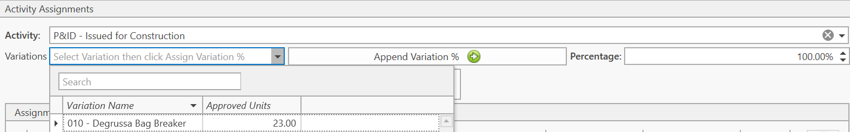
The variation drop down shows all variation for the deliverable
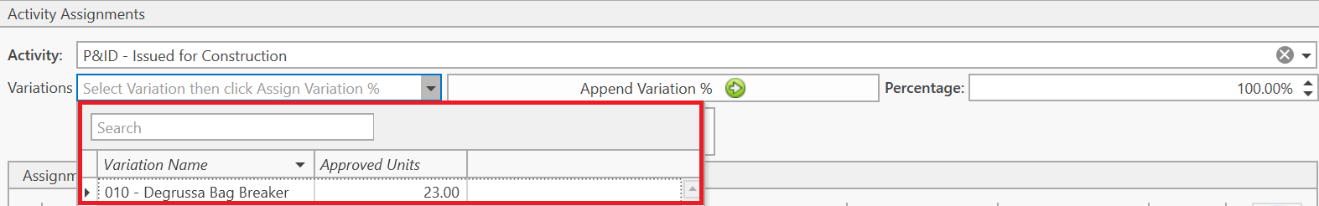
After selecting a variation click “Append Variation %” to assign the variation % on top of what has already been assigned
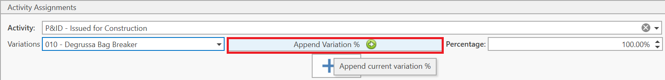
For example, when we click “Append Variation %” for this variation when nothing has been assigned to an activity yet it’ll show 18.7% (Selected variation hours divided by selected deliverable total hours)
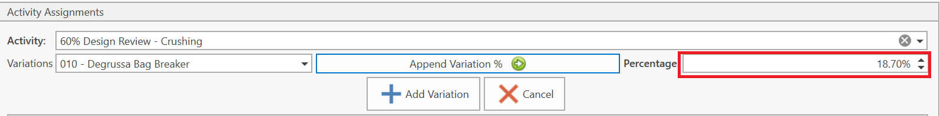
But when 0 to 20% for this deliverable has already been assigned to A1020 and we click “Append Variation %”. It’ll append 18.7% on top of what has already been assigned, in this case 20%, so we end up with 38.7% for this assignment
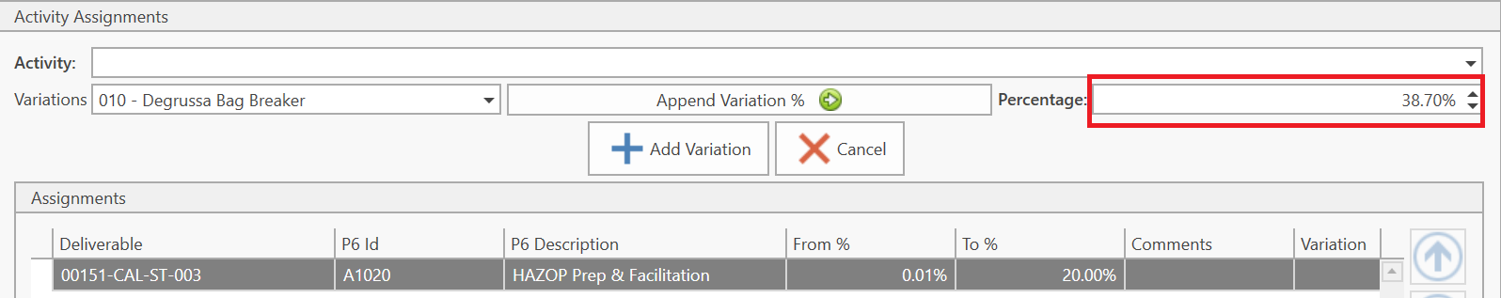
Click “Add Variation” to add this assignment as a variation assignment
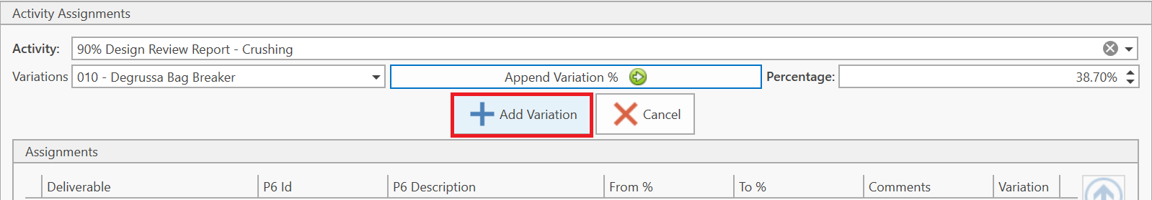
Variation assignments have additional information on the assignment
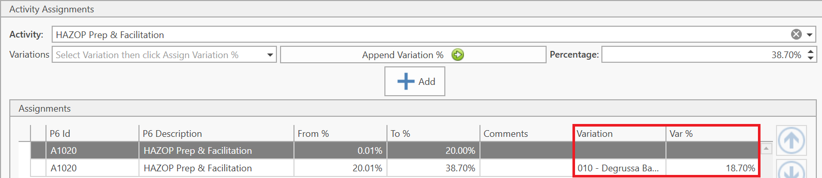
Clicking the cancel button will remove the variation assignment and allow a normal assignment to be added
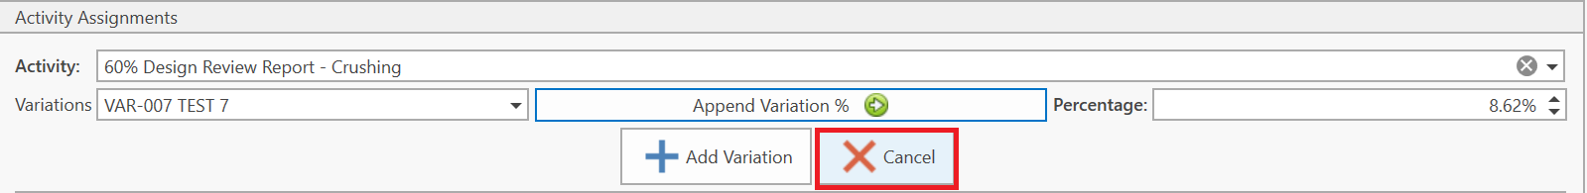

- Validation Around Variation Assignments
When a variation has already been assigned for the deliverable and “Append Variation %” is clicked it’ll show this message
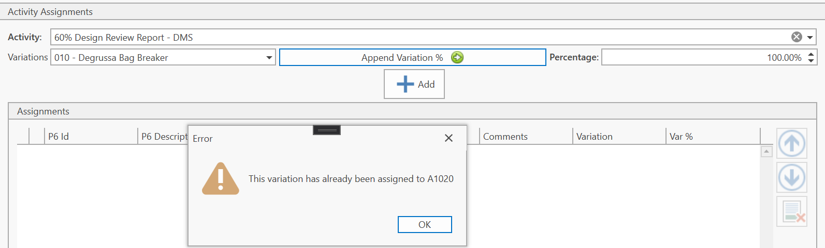
However if there’s a change in total units for the deliverable the variation % is no longer valid. This message will be shown
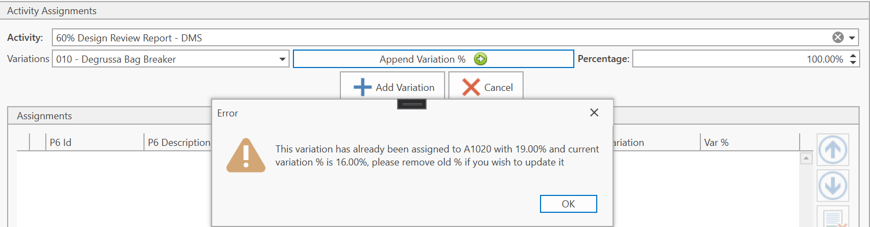
The old assignment with outdated % can be removed as follows
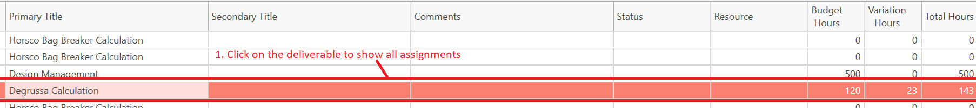
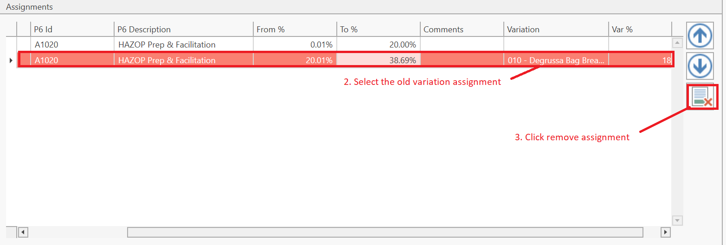
Then proceed to add the variation assignment with updated %

