

**QD. 01 CONJ. ”N” LOTE 17/19-ITAPOÃ**

**TEL.3488-1608 CEL.99174-4443**

Aluno(a):_______________________________________________________________________________

Data:__________________________ Turma:__________________________________________________

Professora:___________________________________ Turno:____________________________________

**Trabalho dirigido de matemática 3º ano**

1. Complete o quadro:

|  |  |  |  |
| --- | --- | --- | --- |
| Numeral | Centena | Dezena | unidade |
| 207 |  |  |  |
| 683 |  |  |  |
| 945 |  |  |  |
| 529 |  |  |  |
| 271 |  |  |  |
| 790 |  |  |  |
| 444 |  |  |  |

1. Decomponha os numerais:
2. 5 centena ,7 dezenas e 4 unidades:____________________________________________________
3. 7 centenas ,1 dezenas e 4 unidades:___________________________________________________
4. 9 centenas , 3 dezenas e 2 unidades:___________________________________________________
5. 2 centenas , 2 dezenas e 1 unidade:____________________________________________________
6. 1 centena ,9 dezenas e 8 unidades:_____________________________________________________
7. 3 centenas ,5 dezenas e 5 unidades:____________________________________________________
8. 8 centenas ,8 dezenas e 8 unidades:____________________________________________________
9. Escreva por extenso:

379:_________________________________________________________________________________

567:_________________________________________________________________________________

671:_________________________________________________________________________________

934:_________________________________________________________________________________

720:_________________________________________________________________________________

995:_________________________________________________________________________________

1. Observe o numeral **967542378965** responda:
2. Quantas ordem ele tem?

_______________________________________________________________________________

1. Quantas classes?

_______________________________________________________________________________

1. Escreva em algarismos romanos os números a baixo:

50:______________ 35:______________________

12 :______________ 563 :______________________

187 :________________ 99 :______________________

1. Observe a quantidade em dinheiro que Marcos e Fábio tem ?

Marcos: R$ ________________ Fábio:_______________

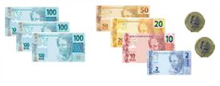 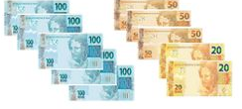

Quem tem mais dinheiro? Quanto a mais?

_____________________________________________________________________________

1. Observe o quadro e responda:

|  |  |  |  |
| --- | --- | --- | --- |
| 100 | 241 | 193 | 512 |
| 693 | 580 | 341 | 90 |
| 17 | 101 | 140 | 89 |

1. Escreva dois número que tenha o 5 na casa das centenas:

_________________________________________________________________________________

1. O número cuja decomposição seja 200 + 40 +1:

_________________________________________________________________________________

1. Um número que ,somado a 1 dezena ,seja igual a 100.

_________________________________________________________________________________

1. Dê o valor absoluto e relativo dos números em destaque:

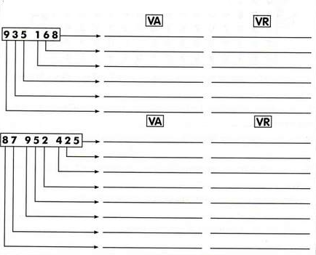

1. Observe a tabela abaixo , e pinte os numerais ímpares de amarela e os numerais pares de vermelho:

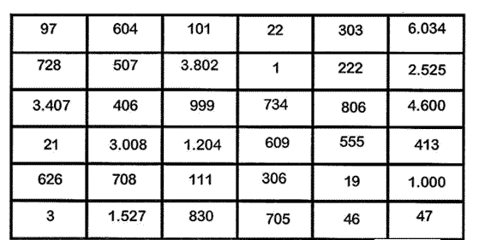

1. Ligue corretamente:

10 DXXIII

8 XCIV

523 X

94 VIII

130 XLI

41 CXXX