

**QD. 01 CONJ. ”N” LOTE 17/19-ITAPOÃ**

**TEL.3488-1608 CEL.99174-4443**

Aluno(a):_______________________________________________________________________________

Data:__________________________ Turma:__________________________________________________

Professora:___________________________________ Turno:____________________________________

**Tabalho dirigido de português do 4°ano**

1. Leia o texto e responda:

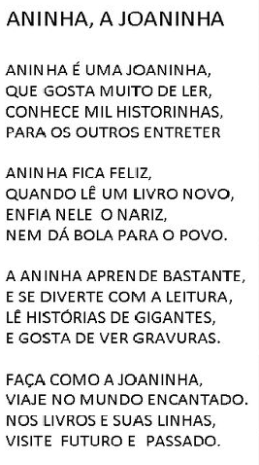

2) O que aninha gosta mais de fazer?

________________________________________________________________________________________

3) Por onde Joaninha viaja?

________________________________________________________________________________________

4) O que você achou da história de Aninha,a Joaninha?

______________________________________________________________________________________

5)Complete o quadro abaixo com atenção:

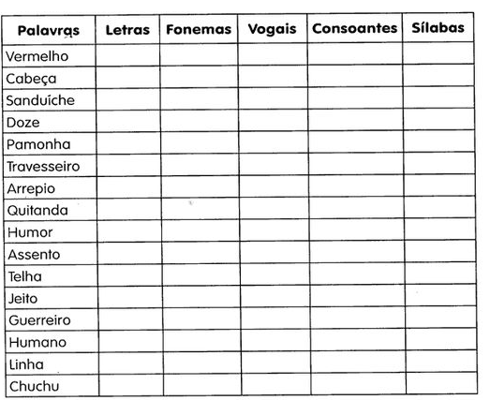

6) Complete as palavras com O ou U depois copie :

a) Marip_____sa :_____________________________________

b) M___squito:_______________________________________

c) Reb____liço:_______________________________________

d)Tab____ada :_______________________________________

e)Táb_____a :________________________________________

f) Mág____a:_________________________________________

g)Expl____dir:________________________________________

h) Rep____lho:_______________________________________

i) Gas_____lina:______________________________________

7) Retire palavras da árvore e escreva-as na coluna correta:

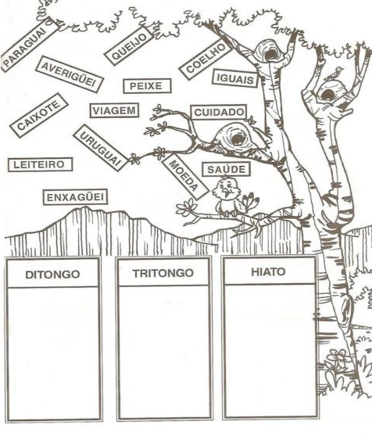

8) Complete as palavras com E ou I ,depois copie:

a) Quas______:_______________________________

b)Pát____o:_________________________________

c)Pr__vilégio :_______________________________

d) ____mpecilho:_____________________________

e) Arr___piado:______________________________

f) Cr____ar:________________________________

g) Recr___ativo:_____________________________

9) Complete as palavras com R ou RR e depois copie:

a) Ama_______ado :________________________________________

b) Pe_____uca:____________________________________________

c) _____aivoso:___________________________________________

d) Espe_____ando:________________________________________

e) Co_____eto :___________________________________________

f) Fe______o :____________________________________________

g)Cou______o :___________________________________________

h) Aqua______ela:________________________________________

i) Xíca______a :___________________________________________

10) Escreva com C ou Ç depois copie:

a) Va_____ina :_______________________________________

b) Ora________ão:____________________________________

c) _____inema:_______________________________________

d) Engra_____ado:____________________________________

e) Solu______o :_____________________________________

f) Cal_____a:________________________________________

g)_____esto:________________________________________

h)_____igarra:______________________________________

i)Tran_____a:_______________________________________