



System Verilog

Lab #
Yapp Router Exploration

Name | Usman
Instructor | Sir Sharjeel
Date | 10th November 2025

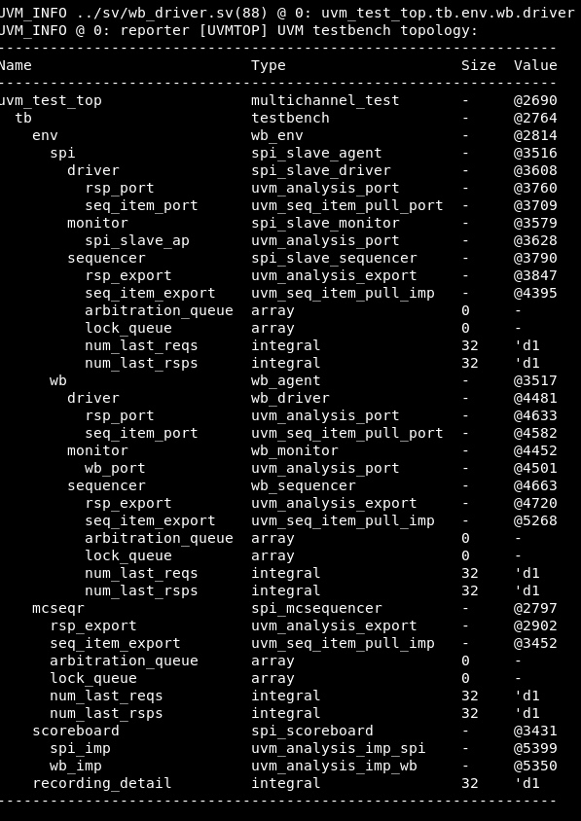

Test1:Testing reset
At active low reset dut is working wrong
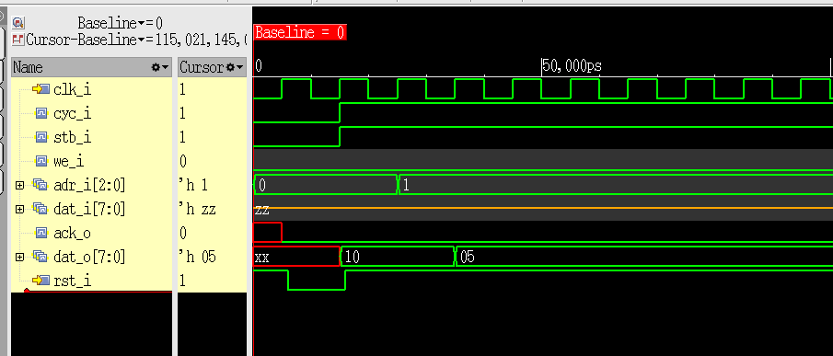
At active high reset dut is working fine
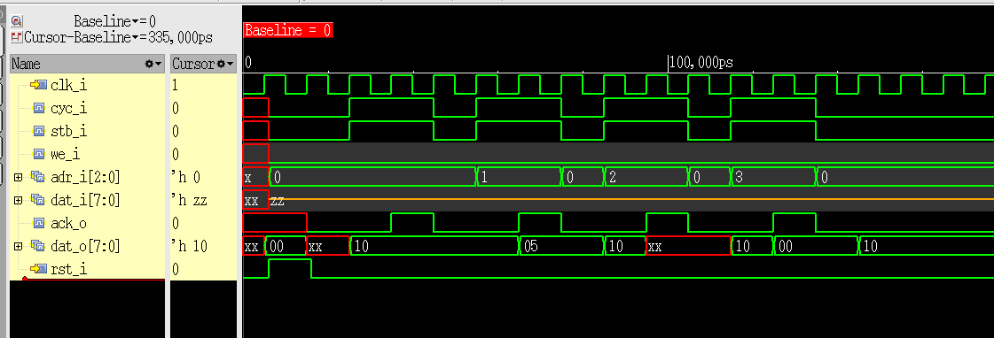

Testing wishbone uvc
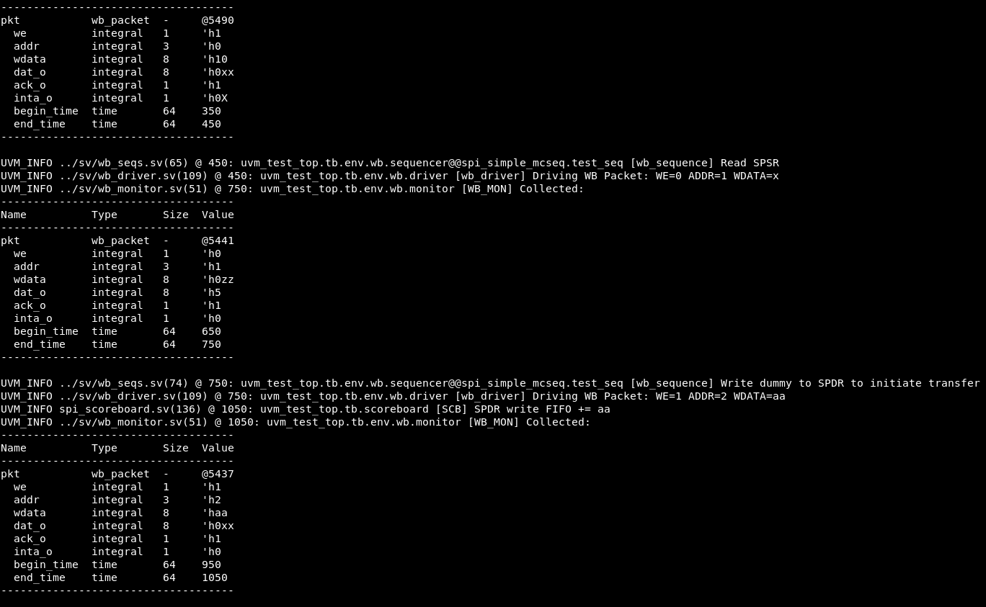
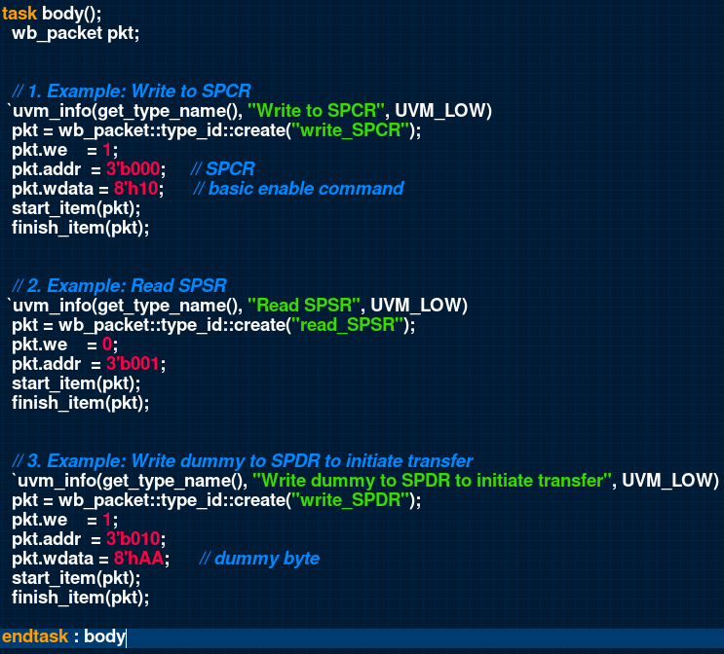

Test2:Now we have to verify that on specific address wishbone writes then spi slaves would read from that address and both should match
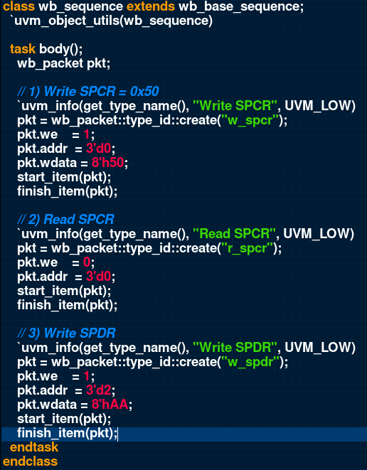

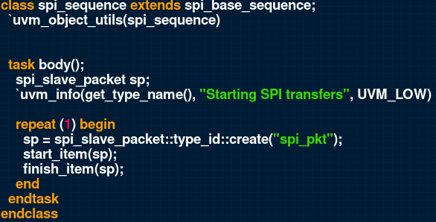

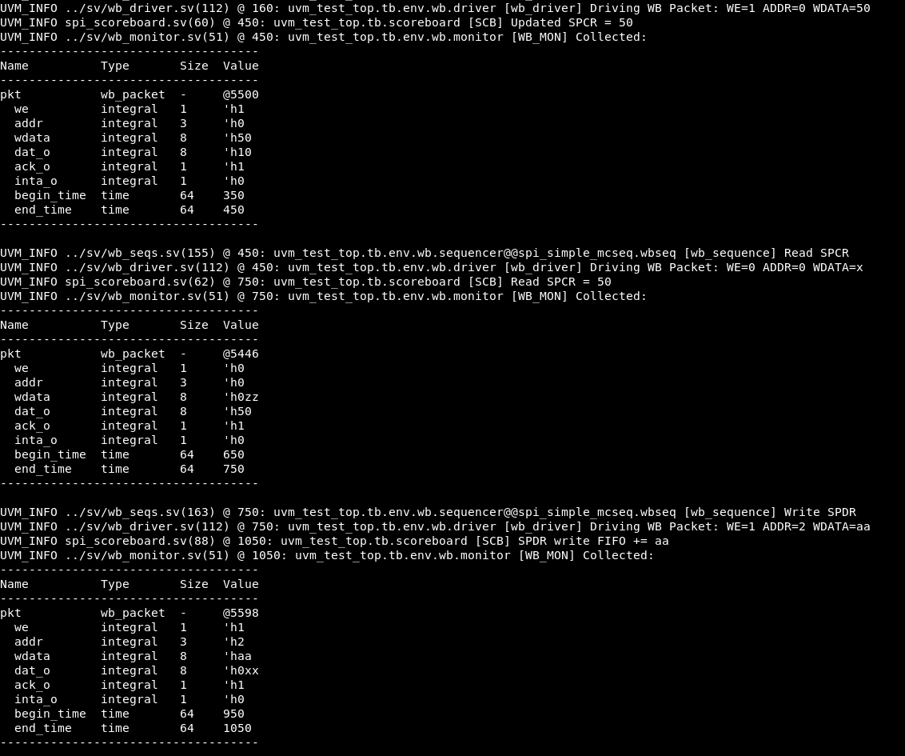

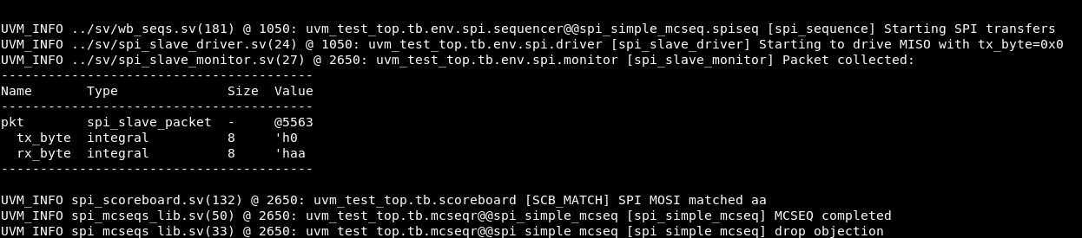

at the end we can see that scoreboard prints that value matched.

There can be another tests that can be performed for WCOL and fifo FULL and fifo empty but we have shortage of time as its 2:45 AM

