@startuml
class virtualspiSlave {
}
class virtualspiAtmel {
+void VirtualSPIAtmelInit(bool debugEnabled);
+void SPIAtmelReset(void);
+uint8_t SPIAtmelWrite(uint8_t data);
+uint8_t SPIAtmelRead(void);
+uint8_t atmelGetStatus();
+void atmelClear();
+void atmelShowText(char* text);
+void atmelShowPercent(uint8_t percent);
+void atmelShowPicture(uint16_t* picture);
+void atmelShowPercentText(uint8_t percent, char* text);
+void atmelSetHeating(bool on);
+void atmelSetMotorRPM(uint8_t rpm);
+void atmelSetSolenoidOpen(bool open);
+void atmelSetMaintenance(bool on);
+uint8_t atmelGetMotorSpeed();
+uint8_t atmelGetIGBTTemp();
+uint8_t atmelGetHeatingOutputLevel();
+bool atmelGetMotorPosSensor();
+uint8_t atmelGetMotorRPM();

-uint8_t getResult()
-uint8_t getValidResultOrReset()
-uint8_t getValidResultOrResetAdditionalValid(uint8_t validByte)

}
class virtualspi {
+VirtualSPIInit()
+void SPIReset(void)
+void SPIWrite2Bytes(uint8_t reg, uint32_t data)
+void SPIWrite(uint8_t data)
+uint8_t SPIReadByte(uint8_t reg)
+uint8_t SPIRead(void)
+uint32_t SPIRead2Bytes(uint8_t register)
+uint32_t SPIRead3Bytes(uint8_t register)
}
class virtuali2c {
+void VirtualI2CInit(void)
+void I2CWriteByte(uint8_t data)
+void I2CWriteBytes(uint8_t *data, uint8_t len)
}

class daemon {
-const uint32_t MIN_STATUS_INTERVAL
-const uint8_t ALLWAYS_STOP_BUZZING
-const uint8_t dataType
-const double SECONDS_PER_HOUR
-const uint8_t HOUR_COUNTER_VERSION
-struct ADC_Config adc_config
-struct ADC_Noise_Values adc_noise
-struct ADC_Values adc_values
-struct ADC_Calibration forceCalibration
-struct ADC_Calibration pressCalibration
-struct ADC_Calibration tempCalibration
-struct I2C_Config i2c_config
-struct I2C_Servo_Values i2c_servo_values
-struct I2C_solenoid_Values i2c_solenoid_values
-struct I2C_Motor_Values i2c_motor_values
-struct Command_Values newCommandValues
-struct Command_Values currentCommandValues
-struct Command_Values oldCommandValues
-struct Time_Values timeValues
-struct Running_Mode runningMode
-struct Settings settings
-struct State state
-struct Heater_Led_Values heaterStatus
-struct Daemon_Values daemon_values
-struct HourCounter hourCounter
-struct Button_Config buttonConfig
-struct Button_Values buttonValues
-pthread_t threadHeaterLedReader
-pthread_t threadReadADCValues
-pthread_t threadHandleButtons
-uint8_t HeaterErrorPattern[7][6]
-char* HeaterErrorCodes[]
-uint8_t HeaterErrorTimeout[7]

-int main(int argc, const char* argv[])
-int parseParams(argc, argv)
-void defineSignalHandler()
-void initOutputFile(void)
-void clearHourCounter()
-void *heaterLedEvaluation(void *ptr)
-bool checkIsHeaterState(uint32_t* leds, uint8_t errNo, bool* state, uint32_t* lastTime, uint32_t runTime)
-void *readADCValues(void *ptr)
-void *handleButtons(void *ptr)
-void speak(char* text)
-void *speakThreadFunc(void *ptr)
-bool checkForInput()
-void doOutput()
-void updateMotorTime()
-void updateHeaterTime()

+bool readConfigLine(char* keyString, char* valueString, FILE *fp)
+void ReadConfigurationFile(void)
+void ReadCalibrationFile(void)
+void resetValues()
+void evaluateInput()
+void ProcessCommand(void)
+void OptionControl()
+void parseAtmelState()
+void TempControl()
+void PressControl()
+void MotorControl()
+ValveControl()
+void ScaleFunction()
+void SegmentDisplay()
+void Beep()
+void prepareState(char* TotalUpdate)
+void writeStatus(char* data)
+void writeLog()
}
class convertFunctions {
+void StringClean(char *str, uint32_t len)
}

class basic_fonctions {
+setDebugEnabled(bool value)
+void initHardware(uint32_t shieldVersion, uint8_t* buttonPins, uint8_t* buttonInverse)
+void setADCConfigReg(uint32_t newConfig[])
+void setADCModeReg(uint16_t newModeReg)
+void GPIOInit(void)
+void writeRaspberryPin(uint8_t i, uint8_t on)
+void PCA9685Init(uint32_t shieldVersion)
+void AD7794Init(void)
+uint32_t readADC(uint8_t i)
+uint32_t readButton(uint8_t i)
}
class atmel{

}
class ad7794_interface {
+int ad7794_communicate(struct adc_private *adc, int reg, int dir, int len, uint8_t *buffer)
+int ad7794_select_channel2(struct adc_private *adc, uint8_t chan, uint32_t config)
+int ad7794_check_if_ready(struct adc_private *adc)
+uint32_t ad7794_read_data(struct adc_private *adc)
+uint32_t ad7794_read_data_reg(struct adc_private *adc, uint32_t reg)
+int ad7794_init(struct adc_private *adc, int spi_bus_nr, int spi_cs_nr)
}

class hardwareFunctions {
+void SegmentDisplaySimple(char curSegmentDisplay, struct State *state, struct I2C_Config *i2c_config)
+bool HeatOff(struct Daemon_Values *dv)
+void blink7Segment(struct I2C_Config *i2c_config)
+void setMotorRPM(uint16_t rpm, struct Daemon_Values *dv)
}
class middlewareSocket {
int connectToMiddleware(char* hostname, int portno)
}
daemon-->daemon : ProcessCommand > OptionControl / speak / parseAtmelState
daemon--> daemon : *handleButtons > speak
daemon--> daemon : speak > *speakThreadFunc
daemon--> daemon : ReadConfigurationFile / ReadCalibrationFile> readConfigLine
daemon--> daemon : initOutputFile > clearHourCounter
daemon--> convertFunctions : main
daemon-->basic_fonctions : main / ReadCalibrationFile / ReadConfigurationFile / parseParams / *heaterLedEvaluation / *readADCValues / *handleButtons
daemon-->virtualspiAtmel : main
daemon-->ad7794_interface : readADCValues
daemon-->hardwareFunctions : main / *readADCValues
daemon-->hardwareFunctions : OptionControl > blink7Segment / SegmentDisplaySimple
daemon-->daemon :*heaterLedEvaluation > checkIsHeaterState
daemon--> daemon : parseParams / defineSignalHandler / ReadConfigurationFile / initOutputFile / ReadCalibrationFile / resetValues / *heaterLedEvaluation / *readADCValues / checkForInput / evaluateInput / ProcessCommand
daemon-->atmel : main
daemon--> middlewareSocket : checkForInput
basic_fonctions--> virtualspi : initHardware/ AD7794Init / readADC
basic_fonctions--> virtuali2c: initHardware / PCA9685Init
basic_fonctions-->basic_fonctions: initHardware > GPIOInit / AD7794Init / PCA9685Init
basic_fonctions-->basic_fonctions: GPIOInit > writeRaspberryPin
basic_fonctions--> ad7794_interface : AD7794Init / readADC
virtuali2c--> virtuali2c : I2CWriteBytes > I2CWriteByte
hardwareFunctions--> virtuali2c : SegmentDisplaySimple / blink7Segment
ad7794_interface--> ad7794_interface : ad7794_select_channel2 > ad7794_communicate
ad7794_interface--> ad7794_interface : ad7794_read_data > ad7794_read_data_reg
ad7794_interface--> ad7794_interface : ad7794_read_data_reg > ad7794_communicate
virtualspi --> virtualspi : SPIReadByte / SPIRead2Bytes / SPIRead3Bytes > SPIWrite / SPIRead
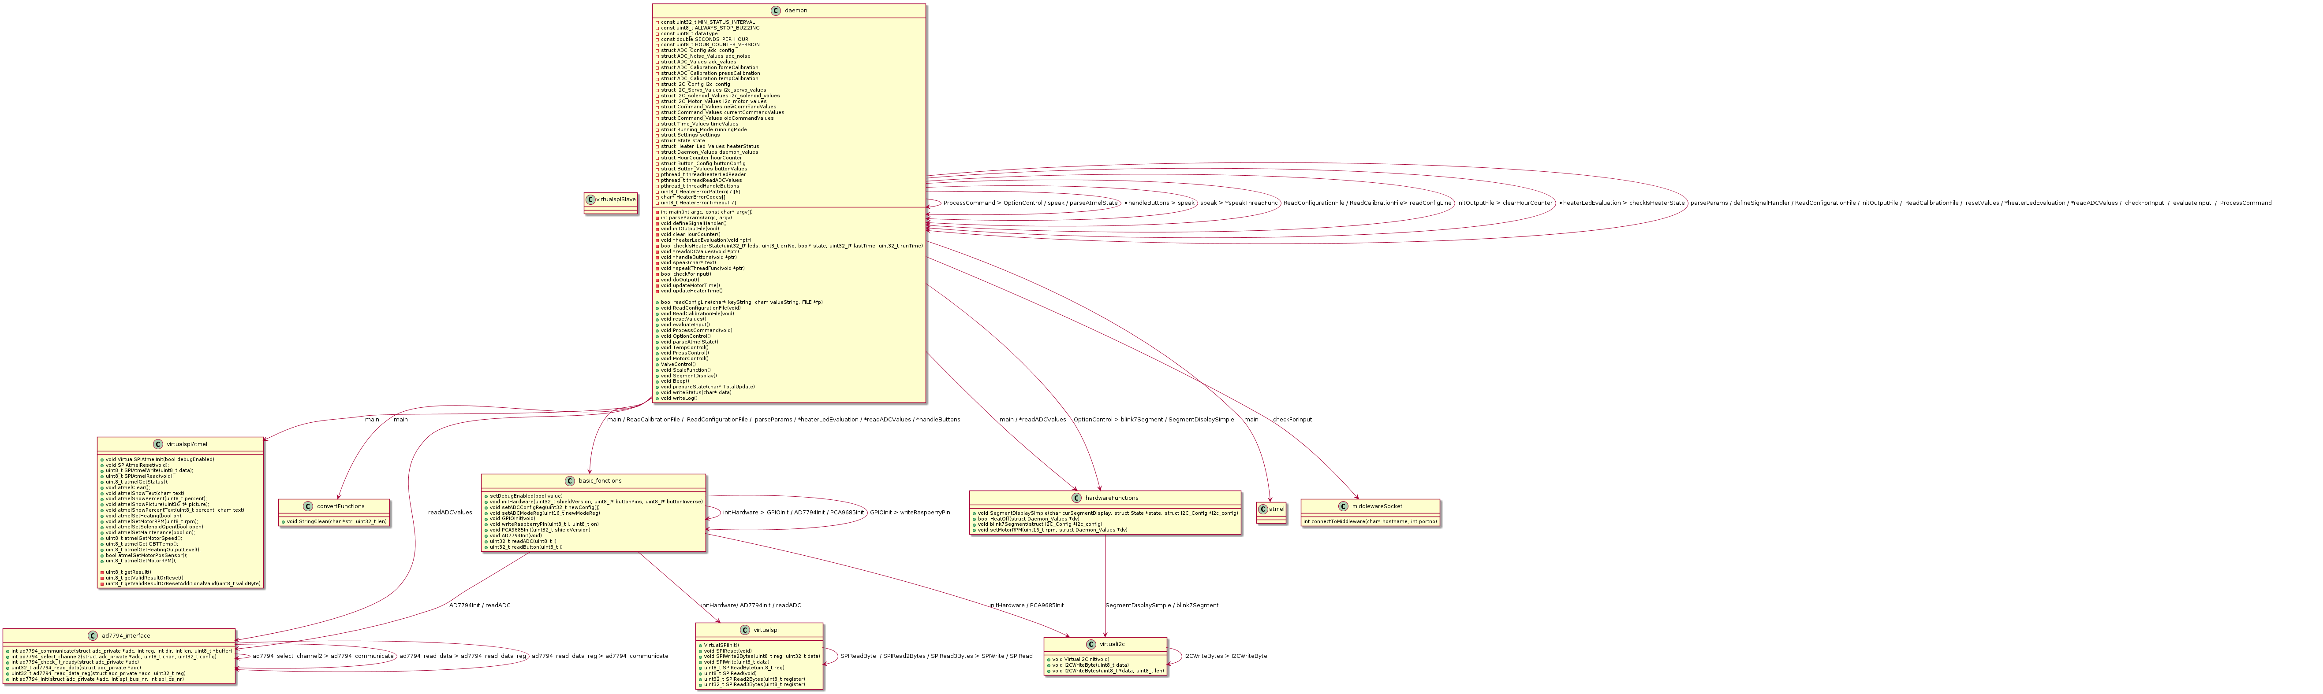
@enduml

