@startuml
class virtualspiSlave {
}
class virtualspiAtmel {
+void VirtualSPIAtmelInit(bool debugEnabled);
+void SPIAtmelReset(void);
+uint8_t SPIAtmelWrite(uint8_t data);
+uint8_t SPIAtmelRead(void);
+uint8_t atmelGetStatus();
+void atmelClear();
+void atmelShowText(char* text);
+void atmelShowPercent(uint8_t percent);
+void atmelShowPicture(uint16_t* picture);
+void atmelShowPercentText(uint8_t percent, char* text);
+void atmelSetHeating(bool on);
+void atmelSetMotorRPM(uint8_t rpm);
+void atmelSetSolenoidOpen(bool open);
+void atmelSetMaintenance(bool on);
+uint8_t atmelGetMotorSpeed();
+uint8_t atmelGetIGBTTemp();
+uint8_t atmelGetHeatingOutputLevel();
+bool atmelGetMotorPosSensor();
+uint8_t atmelGetMotorRPM();

-uint8_t getResult()
-uint8_t getValidResultOrReset()
-uint8_t getValidResultOrResetAdditionalValid(uint8_t validByte)

}
class virtualspi {
+VirtualSPIInit()
+void SPIReset(void)
+void SPIWriteByte(uint8_t reg, uint8_t data);
+void SPIWrite2Bytes(uint8_t reg, uint32_t data)
+void SPIWrite(uint8_t data)
+uint8_t SPIReadByte(uint8_t reg)
+uint8_t SPIRead(void)
+uint32_t SPIRead2Bytes(uint8_t register)
+uint32_t SPIRead3Bytes(uint8_t register)
}
class virtuali2c {
+void VirtualI2CInit(void);
+void I2CStart(void);
+void I2CStop(void);
+int CheckAck(void);
+uint8_t I2CReadByte(void);
+void I2CWriteByte(uint8_t data);
+void I2CWriteBytes(uint8_t *data, uint8_t len);
}

class daemon {
-const uint32_t MIN_STATUS_INTERVAL
-const uint8_t ALLWAYS_STOP_BUZZING
-const uint8_t dataType
-const double SECONDS_PER_HOUR
-const uint8_t HOUR_COUNTER_VERSION
-struct ADC_Config adc_config
-struct ADC_Noise_Values adc_noise
-struct ADC_Values adc_values
-struct ADC_Calibration forceCalibration
-struct ADC_Calibration pressCalibration
-struct ADC_Calibration tempCalibration
-struct I2C_Config i2c_config
-struct I2C_Servo_Values i2c_servo_values
-struct I2C_solenoid_Values i2c_solenoid_values
-struct I2C_Motor_Values i2c_motor_values
-struct Command_Values newCommandValues
-struct Command_Values currentCommandValues
-struct Command_Values oldCommandValues
-struct Time_Values timeValues
-struct Running_Mode runningMode
-struct Settings settings
-struct State state
-struct Heater_Led_Values heaterStatus
-struct Daemon_Values daemon_values
-struct HourCounter hourCounter
-struct Button_Config buttonConfig
-struct Button_Values buttonValues
-pthread_t threadHeaterLedReader
-pthread_t threadReadADCValues
-pthread_t threadHandleButtons
-uint8_t HeaterErrorPattern[7][6]
-char* HeaterErrorCodes[]
-uint8_t HeaterErrorTimeout[7]

-int main(int argc, const char* argv[])
-int parseParams(argc, argv)
-void defineSignalHandler()
-void initOutputFile(void)
-void clearHourCounter()
-void *heaterLedEvaluation(void *ptr)
-bool checkIsHeaterState(uint32_t* leds, uint8_t errNo, bool* state, uint32_t* lastTime, uint32_t runTime)
-void *readADCValues(void *ptr)
-void *handleButtons(void *ptr)
-bool checkForInput()
-void doOutput()
-void updateMotorTime()
-void updateHeaterTime()

+bool readConfigLine(char* keyString, char* valueString, FILE *fp)
+void ReadConfigurationFile(void)
+void ReadCalibrationFile(void)
+void resetValues()
+void evaluateInput()
+void ProcessCommand(void)
+void OptionControl()
+void parseAtmelState()
+void TempControl()
+void PressControl()
+void MotorControl()
+ValveControl()
+void ScaleFunction()
+void SegmentDisplay()
+void prepareState(char* TotalUpdate)
+void writeStatus(char* data)
+void writeLog()
}
class convertFunctions {
+void StringClean(char *str, uint32_t len)
+uint32_t StringConvertToNumber(const char *str);
+double StringConvertToDouble(char *str);
+int POWNTimes(uint32_t num, uint8_t n);
+char* my_itoa(int val, int base);
}

class basic_functions {
-uint32_t ConfigurationReg[]
-uint16_t ModeReg
-uint8_t* PinHeaterLeds;
-uint8_t PinHeaterLeds_v1[]
-uint8_t PinHeaterLeds_v2[]
-uint8_t PinHeaterLeds_v4[]
-uint8_t* PinHeaterControllButtons;
-uint8_t PinHeaterControllButtons_v1[]
-uint8_t PinHeaterControllButtons_v2[]
-uint8_t PinHeaterControllButtons_v4[]
-uint8_t* PinButtons;
-uint8_t PinButtons_v1[]
-uint8_t Data[10];
-uint8_t* InverseButtons;
-struct adc_private adc;
-bool debug_enabled2
-bool use_spi_dev

+setDebugEnabled(bool value)
+void initHardware(uint32_t shieldVersion, uint8_t* buttonPins, uint8_t* buttonInverse)
+void setADCConfigReg(uint32_t newConfig[])
+void setADCModeReg(uint16_t newModeReg)
+void GPIOInit(void)
+void writeRaspberryPin(uint8_t i, uint8_t on)
+void PCA9685Init(uint32_t shieldVersion)
+void AD7794Init(void)
+uint32_t readADC(uint8_t i)
+uint32_t readButton(uint8_t i)
+void buzzer(uint8_t on, uint32_t pwm);
+uint32_t readRaspberryPin(uint8_t i);
+void writeControllButtonPin(uint8_t i, uint8_t on);
+uint32_t readSignPin(uint8_t i);
+void writeI2CPin(uint8_t i, uint32_t value);
}
class atmel{
+int atmelConnenct(char* devPath);
+void atmelClose(int fd);
+void atmelClear(int fd);
+void atmelShowText(int fd, char* text);
+void atmelShowPercent(int fd, uint8_t percent);
+void atmelShowPicture(int fd, uint16_t* picture);
+void atmelShowPercentText(int fd, uint8_t percent, char* text);
}
class ad7794_interface {
+int ad7794_communicate(struct adc_private *adc, int reg, int dir, int len, uint8_t *buffer)
+int ad7794_reset(struct adc_private *adc)
+int ad7794_init(struct adc_private *adc, int spi_bus_nr, int spi_cs_nr)
+int ad7794_check_if_ready(struct adc_private *adc)
+int ad7794_select_channel(struct adc_private *adc, int chan);
+int ad7794_select_channel2(struct adc_private *adc, uint8_t chan, uint32_t config);
+uint32_t ad7794_read_data(struct adc_private *adc);
+uint32_t ad7794_read_data_reg(struct adc_private *adc, uint32_t reg);
+uint32_t ad7794_write_data(struct adc_private *adc, uint32_t reg, uint32_t data);
+int ad7794_run_conversion(struct adc_private * adc);
}

class hardwareFunctions {
-const float MOTOR_RPM_TO_PWM

+double readTemp(struct Daemon_Values *dv);
+int32_t readPress(struct Daemon_Values *dv);
+bool HeatOn(struct Daemon_Values *dv);
+bool HeatOff(struct Daemon_Values *dv);
+void setMotorRPM(uint16_t rpm, struct Daemon_Values *dv);
+void setSolenoidOpen(bool open, struct Daemon_Values *dv);
+void setServoOpen(uint8_t openPercent, uint8_t steps, uint16_t stepWait, struct Daemon_Values *dv);
+double readWeight(struct Daemon_Values *dv);
+double readWeightSeparate(double* values, struct Daemon_Values *dv)
+void SegmentDisplaySimple(char curSegmentDisplay, struct State *state, struct I2C_Config *i2c_config);
+void SegmentDisplayOptimized(char curSegmentDisplay, struct State *state, struct I2C_Config *i2c_config);
+void blink7Segment(struct I2C_Config *i2c_config);
}

class middlewareSocket {
-void middlewareEndlessTestLoop(char* hostname, int portno)

+void error(const char *msg);
+int connectToMiddleware(char* hostname, int portno);
+int connectToServer(struct hostent *server, int portno);
+bool doHandshake(int sockfd, char* application);
+bool sendToSock(int sockfd, char* buffer, uint8_t type);
+bool isSocketReady(int sockfd);
+bool recivePackageFromSock(int sockfd, char* buffer, uint8_t* type);
}
class speaker{
-void *speakThreadFunc(void *ptr)

+void speakerSpeak(char* text)
}
speaker-->bool
speaker-->daemon

class beeper{
-bool beeperdoRememberBeep;
-uint32_t beeperbeepEndTime;
-bool beeperisBuzzing;
-uint8_t beeperBeepStepEnd;

+void beeperBeepEndStep()
+void beeperBeepSeconde(uint32_t durationS)
}
beeper-->bool
beeper-->daemon
beeper-->modes

basic_functions-->bool
basic_functions-->virtualspi
basic_functions-->virtuali2c
basic_functions-->ad7794_interface
daemon_structs-->bool
hardwareFunctions-->bool
hardwareFunctions-->modes
hardwareFunctions-->basic_functions
hardwareFunctions-->daemon_structs
hardwareFunctions-->virtualspiAtmel
middlewareSocket-->bool
middlewareSocket-->convertFunctions
virtualspiAtmel-->bool
daemon-->speaker
daemon-->beeper
daemon-->bool
daemon-->modes
daemon-->basic_functions
daemon-->convertFunctions
daemon-->middlewareSocket
daemon-->virtualspi
daemon-->ad7794_interface
daemon-->daemon_structs
daemon-->hardwareFunctions
daemon-->virtualspiAtmel

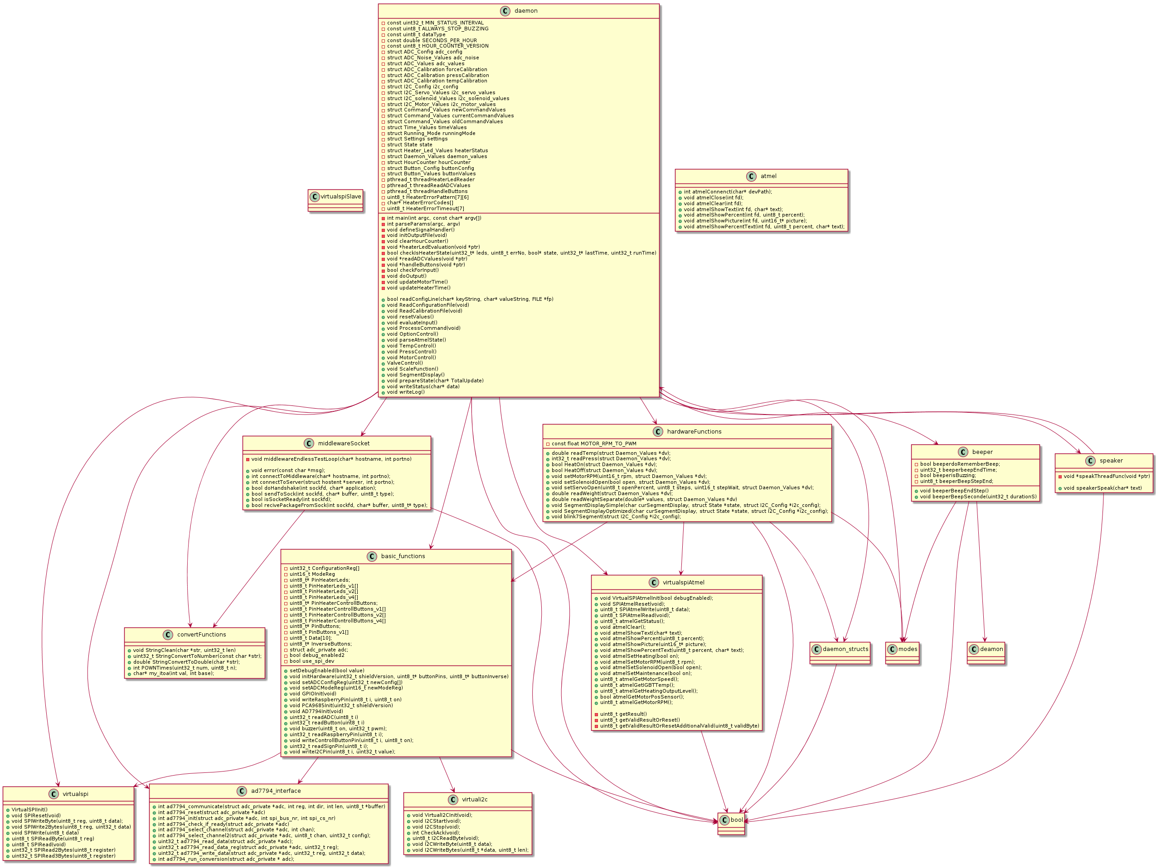
@enduml

