leve
Add-Entry Flow
Design Specification

Version | v1.0 — Post-prototype handoff
Date | June 2026
Stack | React 19 + Capacitor (iOS) + Vite 6 + TypeScript + Tailwind CSS v4
Prototype | add-entry-prototype.html (interactive HTML reference)
Status | Ready for development

1. Overview & Design Principles
The Add-Entry sheet is the primary interaction in leve. It is triggered from a floating action button (FAB) on the Day's log screen and covers adding food, activity, and weight entries. The Food tab is the core focus of this spec.

1.1 The Old Approach (Replaced)
The previous design used a speed-dial FAB with method icons (Camera, Photo, Label, Describe, Manual) that launched directly into their respective flows. This was mode-first — the user had to commit to an input method before building their meal.

1.2 The New Approach: Basket-First
The sheet opens with the basket visible from the start. Items accumulate in the basket as the user adds them, regardless of which method they used to add each one. Method selection moves to the bottom of the "Add another item" expanded tray — it becomes a secondary action, not the entry point.

Important implementation note: the existing app already contains working components for many parts of this flow (input fields, cards, overlays, camera access, segmented controls). Wherever possible, developers should reuse and extend these existing components rather than building from scratch. The goal of this redesign is a UX restructuring, not a full rewrite of the underlying component library.

Visual reference: the interactive prototype (add-entry-prototype.html) is a wireframe-quality reference intended to communicate flow and interaction logic — not pixel-perfect visual design. Treat it as a behavioural spec, not a visual spec. A Figma link with higher-fidelity visuals can be added here once available.

Core design principles:
- Basket-first: show the meal being built immediately, not a method selector
- Method-agnostic basket: Camera, Photo, Describe, Label, and Manual entries all land in the same basket
- Progressive disclosure: search + recents visible up front; input methods one tap deeper
- Simplicity over features: every UI element must earn its presence
- Native where possible: Camera and Photo use iOS system UI (AVFoundation / PHPickerViewController), not custom overlays
- Two item types only: per-100g (pantry, camera, describe) and per-serving (label scan, manual) — no other quantity paradigms

2. Design Tokens

2.1 Colours
Token | Value | Usage
--accent | #00E0AA | Primary CTA, stepper buttons, active states
--on-accent | #00352A | Text/icons on accent backgrounds
--surface | #FFFFFF | Sheet background, cards, overlays
--surface-sunken | #F3F3F3 | Add-another expanded tray, input backgrounds
--content | #1C1C1E | Primary text, headings, black labels
--content-sec | #767676 | Secondary text, subtitles, hints
--border-field | #E0E0E0 | Input borders, card borders, dividers
--danger | #FF3B30 | Delete action backgrounds

2.2 Border Radii
Token | Value | Usage
--r-pill | 9999px | Search input, tags, stepper containers
--r-sheet | 1.5rem (24px) | Bottom sheet top corners
--r-card | 1rem (16px) | Item cards, method cards, image hero
--r-field | 0.75rem (12px) | Text inputs, overlays

2.3 Shadows
Token | Value | Usage
--shadow-card | 0 1px 4px rgba(0,0,0,0.08) | Item cards, method cards
--shadow-sheet | 0 -4px 24px rgba(0,0,0,0.12) | Bottom sheet elevation
--shadow-fab | 0 4px 16px rgba(0,0,0,0.18) | FAB button

2.4 Typography
Token | Value | Usage
Item name (card) | 16px / 600 / --content | Truncated to 1 line
Item kcal (card) | 13px / 600 / --content | Right-aligned
Item meta (card) | 12px / 400 / --content-sec | Protein, unit
Section label | 13px / 600 / --content-sec uppercase | e.g. "MEAL"
CTA button | 17px / 600 / --on-accent | Full-width, 56px tall
Pantry row name | 15px / 600 / --content
Pantry row meta | 13px / 400 / --content-sec | e.g. "389 kcal · per 100g"

3. The Add Sheet

3.1 Trigger
The FAB on the Day's log screen opens the Add sheet. The sheet slides up from the bottom. Sheet height: 92dvh. Top corners: --r-sheet. Background: --surface.

3.2 Sheet Header
The header sits at the top of the sheet and contains:
- Close button (×) — left side, 44×44px tap target, dismisses the sheet without saving
- "Add" title — centred, 17px/600
- Segmented control — below the title, three tabs: Food / Activity / Weight
Note: The header is sticky and does not scroll with content.

3.3 Segmented Control
Three tabs control which pane is visible: Food (default), Activity, Weight. Switching tabs does not clear any entered data — each pane retains state for the session.

3.4 CTA Button
A full-width, sticky CTA button sits at the bottom of the sheet above the home indicator safe area.
- Food tab: disabled when basket empty; label = "Log [item name]" (1 item) or "Log meal" (2+ items)
- Activity tab: disabled when no activity entered; label = "Log activity"
- Weight tab: always enabled; label = "Log weight"
Tapping CTA commits the entry to the Day's log and dismisses the sheet.

3.5 Motion & Transitions
All transitions use standard iOS-feel easing. Do not use linear timing on any sheet or overlay motion.

Sheet open | Slides up from bottom. Spring animation: damping 0.85, initial velocity 0. Duration ~380ms.
Sheet close | Slides down. Duration ~300ms, ease-in.
Method overlays (Describe, Label) | translateX(100%) → translateX(0). Duration: 280ms, cubic-bezier(0.4, 0, 0.2, 1). Reverse on close.
Edit item overlay | Same as method overlays. translateX(100%) → translateX(0), 280ms cubic-bezier(0.4, 0, 0.2, 1).
Add-another tray expand | Height animation from 0 to content height. Duration: 220ms, ease-out.
Add-another tray collapse | Height animation to 0. Duration: 180ms, ease-in.
Analysis overlay | Fade in: opacity 0 → 1, 160ms ease-out. Fade out: opacity 1 → 0, 160ms ease-in.
Serving modal | Slides up from bottom edge of sheet. Duration: 260ms, spring.
Item card swipe-to-reveal | Follows finger (no easing while dragging). Snaps to open at -90px threshold, 180ms spring. Snaps closed on release below threshold.
Basket item added | New card fades + slides in from bottom. Duration: 200ms, ease-out.
Basket item removed | Card fades + collapses height. Duration: 180ms, ease-in.

3.6 Overlay Stack (z-index)
All overlays are positioned within the sheet component (position: absolute, inset: 0). The stacking order from back to front:

Food / Activity / Weight panes | z-index: base (1)
Edit item overlay (source overlay) | z-index: 40
Manual entry overlay | z-index: 40
Method overlays (Describe, Label) | z-index: 42 — must appear above Edit overlay
Analysis overlay | z-index: 50 — must cover everything while processing
Serving modal (bottom sheet) | z-index: 52 — appears above analysis overlay after it dismisses
Note: Method overlays (42) sit above the Edit overlay (40) because a user could theoretically open the Edit overlay then trigger a new scan — the new overlay must cover the old one. Analysis (50) and Serving modal (52) are always the topmost layers.

4. Food Pane
Visual overview — five key states of the food pane. See Appendix A1 for full-resolution Figma links.
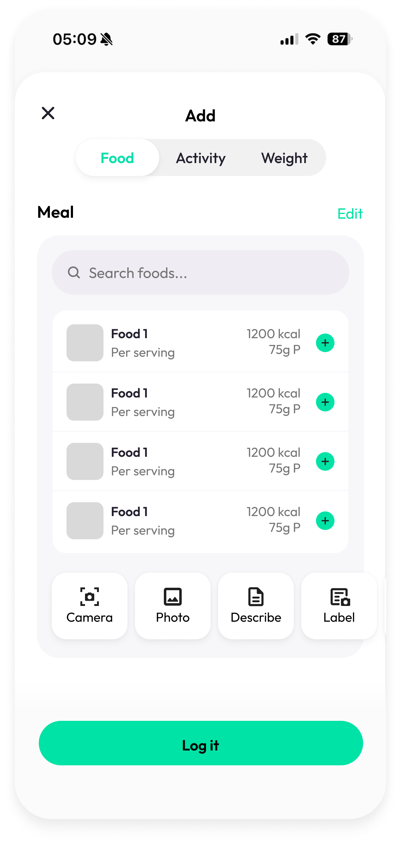  Empty state | 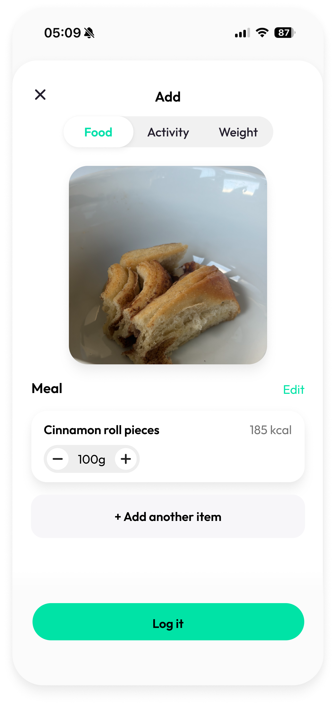  1 item added | 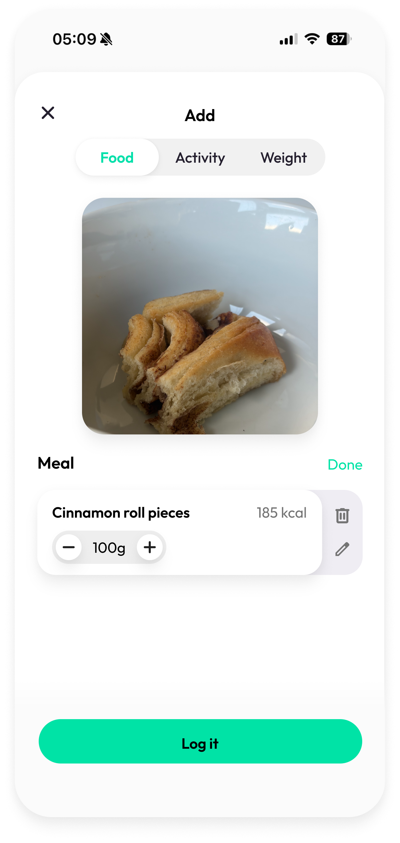  Edit mode | 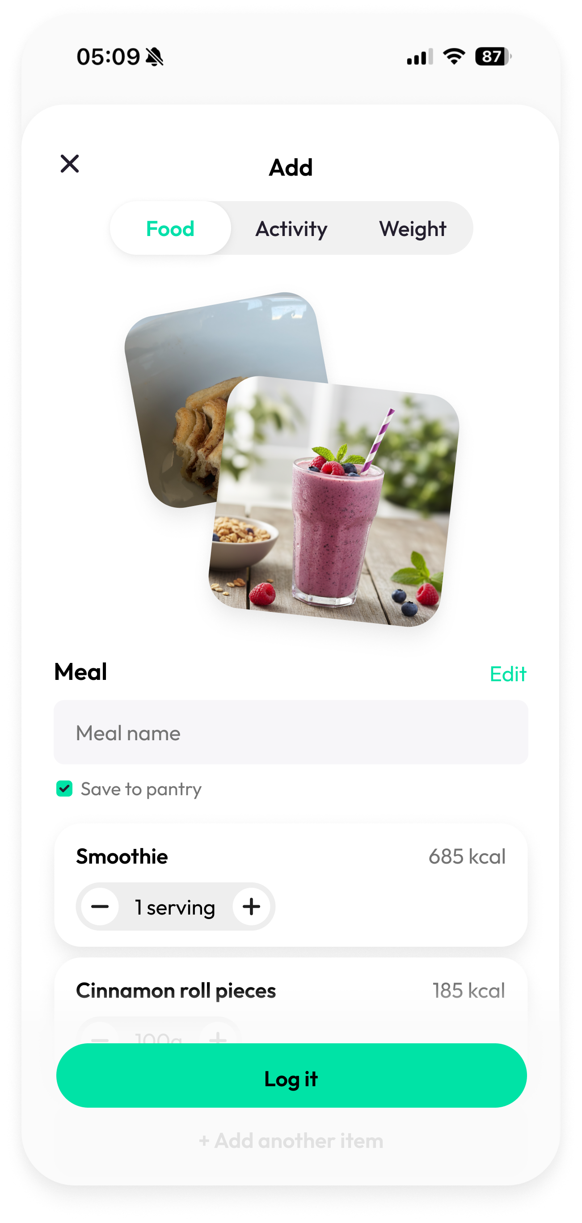  2 items (collage) | 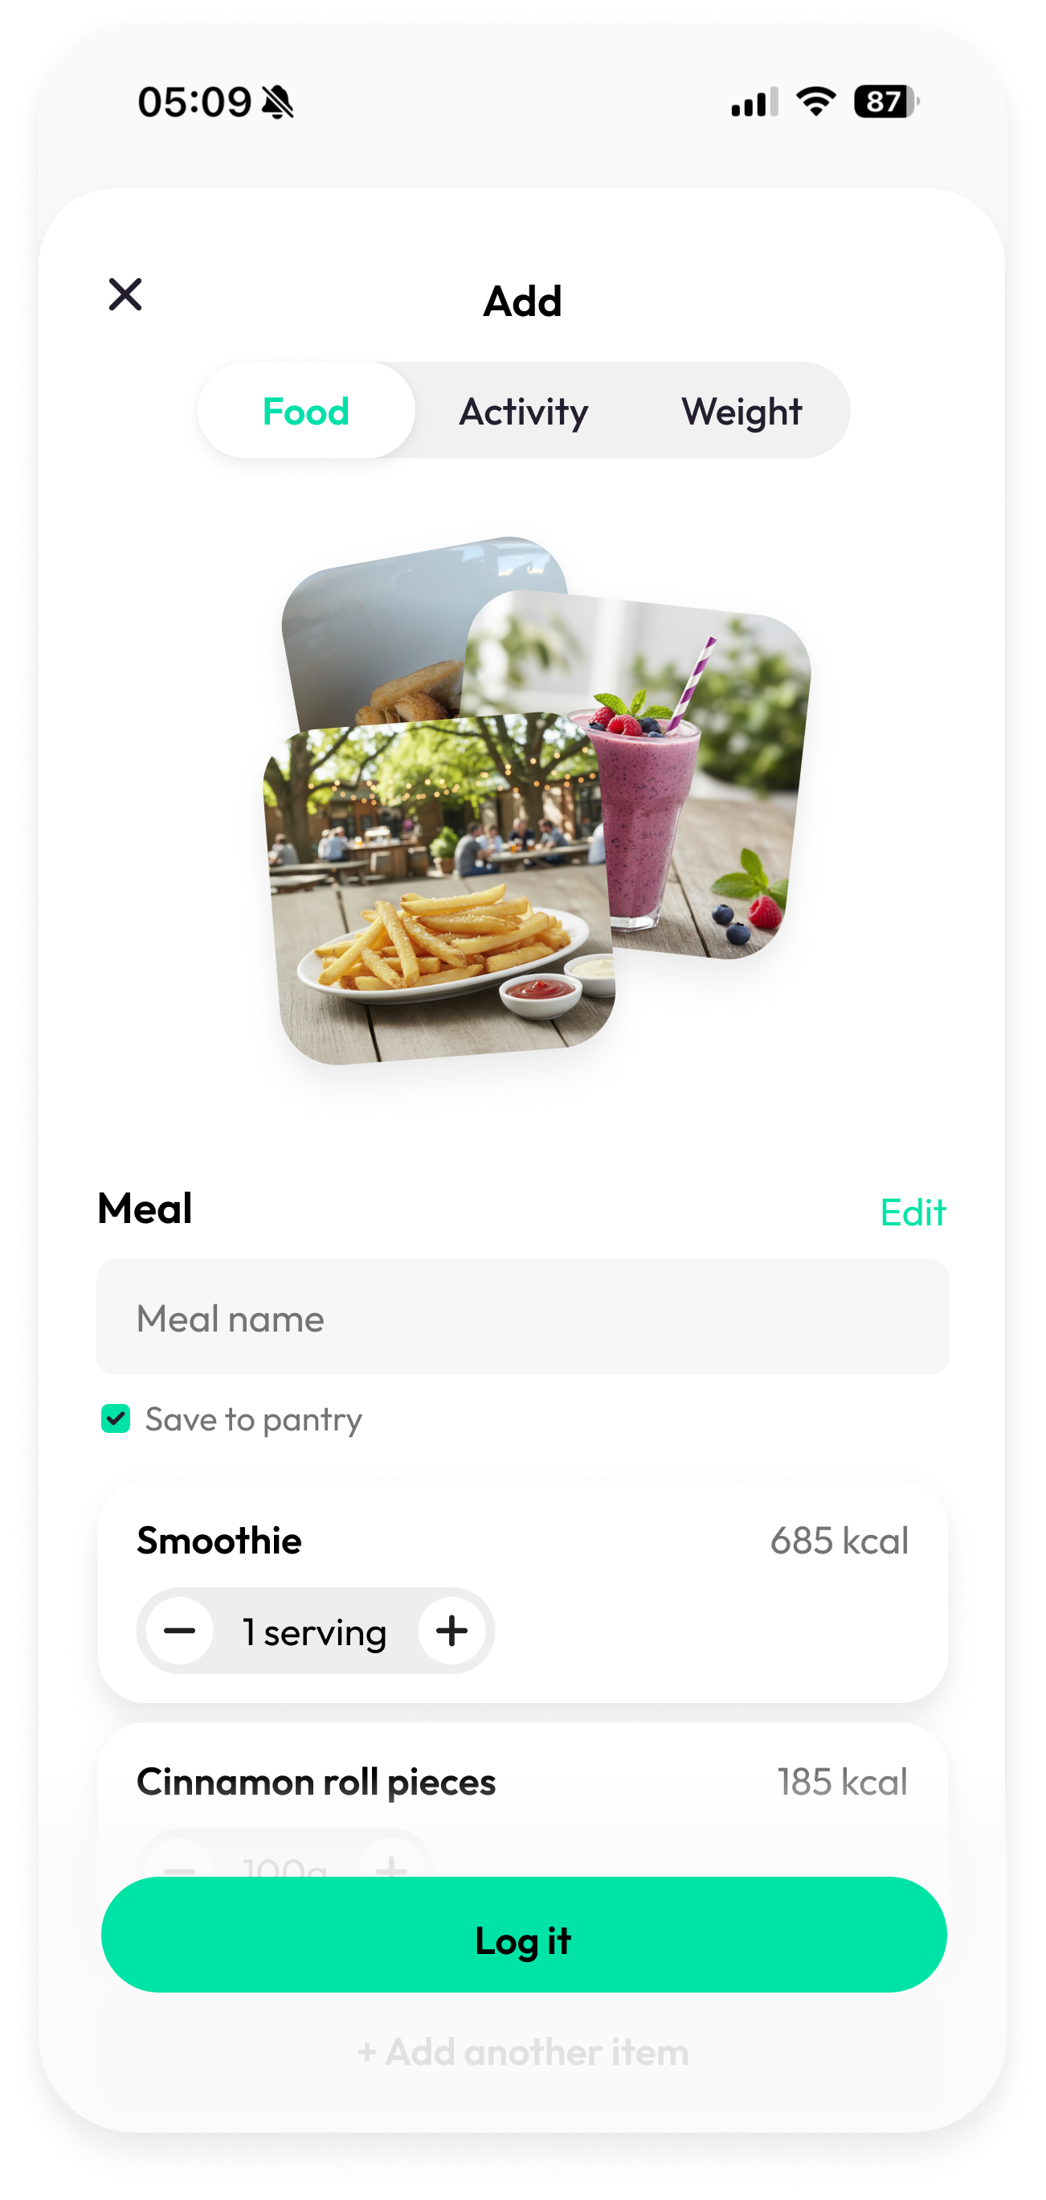  3 items (collage)

4.1 Layout
The food pane is a scrollable column. From top to bottom:
- Image hero / collage (conditional — appears only when photo sources exist)
- Meal header ("Meal" label + "Edit" button) — always visible
- Meal name input (appears when 2+ items in basket)
- Basket — logged item cards (one per item, empty when no items added yet)
- "Add another item" tray (collapsed or expanded)
Note: The entire column scrolls. The CTA button is outside the scroll area (sticky, sheet-level).

4.2 Empty State
When the basket is empty:
- "Meal" section header is visible — it is a permanent label, not conditional
- "Edit" button next to "Meal" is hidden when the basket is empty (nothing to edit)
- No image hero, no meal name input
- "Add another item" tray is expanded by default, filling the space below the Meal header — showing search, recents, and method cards
- CTA button is disabled
Note: The Meal header being always visible establishes context immediately and keeps the layout stable as items are added.

4.3 Item Cards
Each logged item renders as a card in the basket. Cards have --r-card radius, --shadow-card, and --surface background.

Default state
- Left side: item thumbnail (48×48px, --r-card radius) or colour gradient placeholder
- Centre: item name (truncated 1 line, 16px/600), kcal count (13px/600), protein (12px/--content-sec)
- Right side: qty stepper — minus (−) button, qty value, plus (+) button, unit label

Qty display rules:
- Per-100g item: display as "Xg" (e.g., "150g")
- Per-serving item: display as "X srv" (e.g., "1 srv")

Stepper behaviour:
- Per-100g: step = 10g, minimum = 10g
- Per-serving: step = 1, minimum = 1
- Tapping the qty value opens an inline number input for direct typing
- Minimum enforced on blur — cannot go below min

Swipe-to-reveal state
Swiping a card left reveals two action buttons behind the card:
- Delete (top, --danger background, white icon): removes item from basket immediately
- Edit (bottom, --surface-sunken background): opens the Edit Item overlay
The card snaps open at a -90px threshold. Tapping anywhere outside the revealed actions or swiping right dismisses back to default state.

Edit mode (basket-level)
Triggered by tapping the "Edit" button in the meal header. In edit mode:
- Each card shows a delete icon and an edit icon on the right, inline
- The stepper is hidden in edit mode
- The "Edit" button label changes to "Done"
- The "Add another item" tray is hidden entirely — not collapsed, not shown at all
- Tapping Done or removing the last item exits edit mode
Note: Hiding the tray in edit mode simplifies the UI significantly. The user is in a focused "manage what's already in the basket" state. Adding more items is a separate intent — they exit edit mode first, then add.

4.4 Meal Header
The "Meal" label is always visible — it is a permanent section header, not conditional on basket contents.
- "Meal" label — 15px/600/--content, left-aligned
- "Edit" button — right-aligned, accent colour text button, opens basket edit mode. Hidden when the basket is empty.

4.5 Meal Name & Save to Pantry
Appears below the meal header when the basket contains 2 or more items.
- Text input, placeholder = time-based suggestion: "Breakfast", "Lunch", "Dinner", or "Snack" based on current time
- "Save to pantry" checkbox below the input — unchecked by default
Note: The meal name and save-to-pantry preference are persisted with the log entry. When saving to pantry, the meal composition is stored so it can be re-added as a unit later.

4.6 Add Another Item Tray

Collapsed state
A single tappable row with:
- "+" icon (accent colour) on the left
- "Add another item" label (--content colour, not accent)
Tapping expands the tray.

Expanded state
The tray expands into a rounded container (--surface-sunken background, --r-card radius, 12px padding). From top to bottom inside the container:
- Search input — pill-shaped, left-padded search icon, placeholder "Search food…"
- Recent / suggested items list — up to 5 rows
- Method cards row — horizontally scrollable

Tray state when basket has items
When the basket contains one or more items, the tray starts collapsed. The user taps "Add another item" to expand it. After any analysis completes (Camera, Photo, Describe, or Label) or after a Manual item is saved, the tray automatically collapses back to its collapsed state. The basket is visible again with the new item(s) added.

Recent / Suggested Items List
When the search field is empty, this list shows the most recently used items (up to 5). No label or heading is shown — the list appears without explanation, relying on the user's recognition.

Each row contains:
- Thumbnail — 48×48px, --r-card radius (colour gradient for pantry items, photo for camera/photo items)
- Name — 15px/600/--content
- Meta line — "X kcal · per 100g" or "X kcal · per serving" (13px/--content-sec)
- "+" button — 32×32px, accent background, --r-pill, adds item immediately at default qty

Default qty when tapping "+":
- Per-100g item: qty = 100 (100g)
- Per-serving item: qty = 1 (1 serving)

Recency logic:
- Items are ordered by most-recently-used (most recent at top)
- On first launch, the list is seeded with a set of common items from the pantry
- When a user adds an item (from any source), that item moves to the top of the recents list
- Maximum 5 items; oldest falls off when a new one is added

Search Results
When the user types in the search field, the recent items list is replaced by search results matching the query against the pantry. Same row layout as recents. No results state shows "No items found" in --content-sec.

Method Cards Row
A horizontally scrollable row of cards at the bottom of the expanded tray. Each card is a tappable tile with an icon and label:
- Camera — triggers native iOS camera (AVFoundation / UIImagePickerController)
- Photo — triggers native iOS photo picker (PHPickerViewController)
- Describe — opens the Describe overlay
- Label — opens the Label scan overlay
- Manual — opens the Manual entry overlay

Card dimensions: min-width 68px, auto height, flex column, icon + label (12px/500/--content-sec). Border: 1.5px --border-field. Active state: accent border + light accent tint background.

5. Input Methods

5.1 Camera
Trigger | Tap Camera method card
Behaviour | Launches native iOS camera (full-screen system UI). No custom overlay.
On capture | Image sent to AI analysis. Analysis overlay shown (progress indicator + "Analysing your photo…" label).
On complete | Detected food items added to basket at default qty (100g each for per-100g items). Source image stored and shown in hero/collage.
On cancel | User dismisses system camera — nothing happens, tray returns to expanded state.
Item type produced | Per-100g items
Image hero | Yes — the captured image is associated with all items added from this session

5.2 Photo
Trigger | Tap Photo method card
Behaviour | Launches native iOS photo picker (PHPickerViewController). No custom overlay.
On selection | Selected image sent to AI analysis. Analysis overlay shown.
On complete | Same as Camera. A distinct source image is stored (multiple photos produce a collage).
On cancel | User dismisses picker — nothing happens.
Item type produced | Per-100g items
Image hero | Yes — each distinct photo selection adds a source image

5.3 Describe
Trigger | Tap Describe method card
Overlay | Full-screen overlay slides in from the right (z-index above sheet). Contains a large textarea with placeholder "Describe what you ate…" and an "Analyse" button.
"Analyse" button | Hidden until the textarea contains at least 1 character. Accent background, full-width.
On analyse | Overlay closes. Analysis overlay shown with "Analysing your description…" label.
On complete | Detected items added to basket. No image produced.
Back arrow | Dismisses overlay without analysing. Discards typed text.
Item type produced | Per-100g items
Image hero | No — describe produces no source image

5.4 Label Scan
Trigger | Tap Label method card
Overlay | Full-screen overlay slides in from the right. Contains a live camera viewfinder (WKWebView camera stream) with a wide rectangular guide frame (accent-coloured outline). A "Scan label" button sits below the viewfinder.
On scan | "Scan label" button is tapped (or auto-triggered when label is detected). Analysis overlay shown.
Serving modal timing | The analysis overlay dismisses FIRST. Once the sheet is visible again, the serving modal slides up from the bottom.
Serving modal | Modal asks: "Which values to use?" with two options: "Per 100g" and "Per serving (Xg)" where X = detected serving size in grams.
Per 100g choice | Item added with qty=100, no unit flag. Item type: per-100g.
Per serving choice | Item added with qty=1, unit='srv', servingG stored as metadata. Item type: per-serving.
Back arrow | Dismisses overlay and stops camera stream.
Image hero | No — a nutrition label is not a food photo

5.5 Manual Entry
Trigger | Tap Manual method card
Overlay | Full-screen overlay slides in from the right. Fields: Name (required, text), Calories (kcal), Protein (g), Carbs (g), Fat (g). Optional: serving size (g) — if provided, item is created as per-serving; otherwise per-100g.
Save to pantry | Checkbox below fields, unchecked by default. When checked, item is saved to user's pantry on Save.
Save button | Enabled when Name field is non-empty. Adds item to basket. Accent background, full-width.
Back / Cancel | Discards input. No item added.
Item type produced | Per-100g (no serving size) or per-serving (serving size provided)
Image hero | No

6. Image Hero & Collage
The image hero area appears above the Meal header and is driven by an array of source images (sourceImages[]). Each Camera or Photo tap appends one entry to this array. Describe, Label, and Manual taps do not contribute.

0 source images | No hero area rendered. Nothing appears above Meal header.
1 source image | Full-width hero image, aspect ratio 4:3, --r-card radius.
2 source images | Stacked collage: two images overlapping, slightly rotated (−2.5° and +3°), each ~62% width, drop shadows. Layered using absolute positioning.
3+ source images | Three-image collage: third image (0.5° rotation) on top of the first two, centred. Additional images beyond 3 are not shown in the collage but are stored.

Note: In the prototype, source images are represented by colour gradients. In the real app, they will be actual photos from the camera or photo picker, stored as local file references or base64 data.
Note: The collage height is fixed at 190px. Image frames are absolutely positioned within this container.

7. Edit Item Overlay
Tapping any item card (in default mode), or tapping the edit icon (in edit mode or swipe-to-reveal), opens the Edit Item overlay. This overlay slides in from the right, covering the full sheet surface (z-index above the basket).

7.1 Header
- Back arrow (‹) — left side. Dismisses overlay WITHOUT saving. Same behaviour as Cancel button.
- "Edit" title — centred

7.2 The Two Variants
The overlay branches into two layouts based on the item's type.

Per-100g variant
Used for: pantry items, camera results, describe results, manual items without serving size.
- Name field — full-width text input, editable
- Divider
- Calories field — full-width, labelled "Calories (kcal · per 100g)"
- 2×2 macro grid — Protein (g) / Carbs (g) / Fat (g) / Fiber (g)
- Note: "Values are per 100g. Adjust how much you ate on the card."
- Save button — full-width, accent, commits changes
- Cancel button — below Save, --content-sec text, dismisses without saving

Note: There is no serving size or gram field in this variant. The user controls quantity on the basket card (the stepper). The edit overlay only edits the food definition (nutrition per 100g).

Per-serving variant
Used for: label scan items (per serving choice), manual items with serving size provided.
- Name field — full-width text input, editable
- Divider
- Two-column row: [Serving size (g)] [Calories (kcal)] — side by side
- Note: "Values are per serving. Changing grams is for reference only."
- 2×2 macro grid — Protein (g) / Carbs (g) / Fat (g) / Fiber (g)
- Save button
- Cancel button

Note: Serving size (g) is editable metadata. It does not affect macro calculations. It exists so the user can correct "150g" to "180g" if their package differs from what was detected. The macro math always runs as: macros × qty (where qty = number of servings).

7.3 Image Upload (Edit overlay)
From the Edit overlay, the user can add or change the photo associated with a specific item. This is already implemented in the app (not in the prototype). A camera/image button in the edit overlay opens the native photo picker. The selected photo is stored with the item and displayed as its thumbnail in the basket. It also contributes to the image hero/collage.

7.4 Back Arrow Behaviour
The back arrow (‹) in the overlay header is equivalent to Cancel — it discards all edits and closes the overlay. Only the Save button commits changes.
Note: No toast notification is shown when the user cancels or taps back. A "Nutrition updated" toast should only appear after a successful Save. This is a deliberate decision — silent cancel reduces noise.

8. Data Model

8.1 Item (Food Definition)
Represents a food's nutritional profile. Shared between pantry and logged entries.

type Item = {
id: number | string;
name: string;
cal: number; // kcal (per 100g OR per serving)
pro: number; // g protein
carbs: number; // g carbohydrates
fat: number; // g fat
fiber: number; // g fiber
servingG?: number; // serving size in grams — per-serving items only
thumb?: string; // photo URL or CSS gradient string
};

8.2 LoggedItem
Represents one item in the basket (or saved log entry).

type LoggedItem = {
item: Item;
qty: number; // grams if no unit; servings if unit === "srv"
unit?: "srv"; // present ONLY for per-serving items
image?: string; // source photo URL (from camera/photo) — optional
};

8.3 Macro Calculation
A single function drives all macro display throughout the app:

function macros(item: Item, qty: number, unit?: "srv") {
const scale = unit === "srv" ? qty : qty / 100;
return {
cal: Math.round(item.cal * scale),
pro: +(item.pro * scale).toFixed(1),
carbs: +(item.carbs * scale).toFixed(1),
fat: +(item.fat * scale).toFixed(1),
fiber: +(item.fiber * scale).toFixed(1),
};
}

// Examples:
// Chicken breast 150g (per-100g): scale = 150/100 = 1.5
// Skyr Yoghurt 2 srv (per-serving): scale = 2

8.4 Source Images
Tracked as an array of source image references for the hero/collage:

type SourceImage = {
url: string; // local file URI or base64 data URL
};

let sourceImages: SourceImage[] = [];

// Appended each time Camera or Photo produces a result.
// Reset to [] when the sheet is dismissed and re-opened.

9. Analysis Overlay
A full-screen overlay (covers the entire sheet) that appears while the AI backend processes a photo or description. It is not dismissible by the user.

Background | Semi-transparent dark (rgba 0,0,0,0.6) over the sheet
Content | Centred spinner + text label
Label variants | "Analysing your photo…" (camera/photo), "Analysing your description…" (describe), "Scanning label…" (label)
Duration | Shown until backend response returns. No timeout — stays until success or error.
Error state | On failure: overlay content changes to error message + "Try again" button. Dismiss returns to the sheet (add-another expanded).

10. Activity Pane
The Activity pane is preserved from the previous implementation. No changes in this release. It is out of scope for this design iteration.

Current state: two sub-modes selectable via a toggle at the top of the pane:
- Manual: free-text name (optional) + calories burned (number input)
- Estimate: select intensity level + duration → calculated estimate of calories burned
Note: Full redesign of the Activity pane is deferred to a future sprint. The implementation in the current app should remain untouched.

11. Weight Pane
The Weight pane is preserved from the previous implementation. No changes in this release.

Current state: a number input for weight value, with a kg/lbs unit toggle.
Note: Full redesign of the Weight pane is deferred to a future sprint. The implementation in the current app should remain untouched.

12. Day's Log → Edit Meal Flow
This flow is a future implementation. The design intent is documented here so it is considered during the Add sheet's component architecture.

When a user taps a meal entry in the Day's log:
- The same Add sheet component opens, reusing all existing components.
- The basket is pre-populated with the meal's logged items (from the saved entry).
- The sheet title changes to "Edit meal" (not "Add").
- The segmented control (Food / Activity / Weight) is hidden — the sheet opens directly to the food view.
- The CTA button label is "Save" (not "Log meal").
- Method cards are available — the user can add more items to the existing meal.
- If the meal was not previously saved to pantry: "Save to pantry" checkbox appears (unchecked).
- If the meal was already saved to pantry: a "Saved to pantry ✓" indicator appears (non-interactive).
- Tapping Save commits the edited meal and dismisses the sheet.
- Tapping × (close) discards all changes.

Note: The Edit Meal sheet should be implemented as a mode/prop on the existing Add sheet component, not as a separate component. The basket, method overlays, and edit item overlay are all shared.

13. Component Inventory
Suggested React component breakdown for the Add-Entry feature. The main file is src/ui/components/AddEntrySheet.tsx (~1200 lines). Components marked with * already exist there or in src/ui/kit/ and should be extended, not rebuilt.

<AddSheet /> | Root sheet component. Controls open/close state, active tab, mode (add vs edit-meal). * Likely exists — extend to support basket-first layout and edit-meal mode.
<FoodPane /> | Hosts basket, hero, meal header, and add-another tray. Restructured from previous implementation.
<ImageHero /> | New component. Renders single hero or collage based on sourceImages array.
<BasketItem /> | Single item card with stepper, swipe-to-reveal, and edit mode states. * Likely exists — extend with swipe-to-reveal and per-serving unit display.
<AddAnotherTray /> | New component (or significant refactor). Collapsed / expanded tray with search, recents, and method cards.
<MethodCards /> | New component. Scrollable row of input method cards at the bottom of the add-another tray.
<EditItemOverlay /> | Slide-in overlay for editing food definition. Branching per-100g vs per-serving. * May exist — extend with serving size field and inline Save/Cancel.
<DescribeOverlay /> | Slide-in overlay with textarea and Analyse button. * Likely exists.
<LabelOverlay /> | Slide-in overlay with camera viewfinder and Scan button. * Likely exists.
<ManualOverlay /> | Slide-in overlay with manual entry fields. * Likely exists — add serving size field.
<AnalysisOverlay /> | Full-cover spinner overlay during AI processing. * Likely exists.
<ServingModal /> | Bottom sheet modal shown after label scan: per 100g vs per serving choice. * May exist.
<ActivityPane /> | * Existing component — no changes required.
<WeightPane /> | * Existing component — no changes required.

14. Open Items & V2 Considerations
The following are known gaps or deferred decisions. They should be addressed in a future iteration.

14.1 Error States
- Camera/Photo permission denied: show an in-overlay message with a "Go to Settings" link
- Analysis failed / no items detected: error state in analysis overlay with "Try again" button
- Network offline: queue the analysis request and retry when connectivity is restored (or show offline error)
- Manual entry validation: calories must be a positive number; name cannot be empty or whitespace-only

14.2 Haptics
- Item added to basket: light impact feedback
- Analysis complete: notification feedback
- Item deleted: medium impact feedback
- CTA tap: medium impact feedback
- Stepper tap: selection feedback

14.3 Accessibility
- All interactive elements must have VoiceOver labels
- Swipe-to-reveal must have an accessible alternative (long-press context menu or edit mode)
- Analysis overlay must announce completion to VoiceOver
- Colour contrast: --content-sec (#767676) on --surface (#FFF) = 4.48:1 — passes AA for normal text at 13px+ (16px minimum for AA Large)
Note: Re-check --content-sec contrast at 12px sizes (pantry row icons, stepper unit labels). May need to darken to #6E6E6E or use --content for those specific elements.

14.4 Pantry Management
The current pantry is a static list. V2 should include:
- User-created items (saved from manual entry or label scan)
- Full pantry browser (separate from Add flow) for managing, editing, and deleting pantry items
- Frequently used items auto-surfaced

14.5 Barcode Scanning
An alternative to OCR label scanning. Tap barcode icon → scan UPC/EAN → look up in nutrition database → skip the serving modal if the database entry already has serving size data.

14.6 Nutrition Data Sources
The backend AI analysis and pantry data source strategy is out of scope for this design spec. Decisions needed:
- Open Food Facts, USDA FoodData Central, or proprietary database for label/barcode lookups
- AI model and prompt strategy for camera/photo/describe analysis
- Confidence thresholds: when to show a "review these items" step vs. add directly to basket

14.7 Multi-photo Meal
Currently each Camera/Photo tap adds one gradient placeholder to the collage. In the real app, multiple taps from the same meal-building session should build a cohesive collage. Consider: a maximum of 3 visible collage images regardless of how many were taken, with a "+N more" indicator if needed.

14.8 Offline / Queuing
For camera and photo analysis: if the network is unavailable, queue the image locally and show a "Pending analysis" card in the basket. When connectivity restores, process automatically and update the card.

15. Codebase Reference
This section maps the design spec to the actual leve codebase. The goal is to restructure an existing component — not build from scratch. The project lives at src/ in the leve repository.

15.1 Primary File
src/ui/components/AddEntrySheet.tsx (~1200 lines)
This is the main file to restructure. It already contains:
- FoodForm with pantry search, camera, photo, describe, and label scan modes
- ScanState machine: idle → source-picking → confirming → analyzing → results
- Activity pane and Weight pane (no changes needed to these)
- Sheet header with Food/Activity/Weight tab control (SegmentedControl)
Note: The basket-first UX is a restructuring of FoodForm: instead of a single-item flow, FoodForm becomes a multi-item basket with the add-another tray and image hero.

15.2 Design Spec → Code Type Mapping
Spec: per-100g item | measurementType: 'per_100g' on FoodItem (src/domain/types.ts)
Spec: per-serving item | measurementType: 'per_serving' on FoodItem — referenceAmount is the serving size in grams
Spec: qty (basket item) | quantity: number on FoodEntry — in the item's reference unit (g for per_100g, servings for per_serving)
Spec: servingG | FoodItem.referenceAmount (number) — grams per one serving
Spec: macros(item, qty, unit) | nutritionFor(item, quantity) in src/domain/calc.ts
Spec: basket item | MealItem in src/domain/types.ts — also used in mealData
Spec: meal data (name + items) | FoodEntry.mealData: { name, photo?, items: MealItem[] }
Spec: sourceImages[] | Currently: FoodEntry.mealData.photo (single URL). Multi-image collage is V2.

15.3 Kit Components Available (src/ui/kit/)
These are already built and should be reused as-is:
- Sheet — bottom sheet with rubber-band drag and spring-back
- SegmentedControl — the Food / Activity / Weight tab switcher
- Button — standard CTA button
- LabeledInput — text input with label
- NumberField — numeric input with increment/decrement
- ServingStepper — stepper showing quantity with unit label (100g / 1 serving)
- WheelPicker — scroll wheel for quantity selection
- MeasurementTypeSelector — per 100g vs per serving toggle
- Icon — inline SVG icon set (uses currentColor)
- useSheetSetFooter — hook to set sheet-level footer from child components

15.4 Supporting Infrastructure
Camera / photo capture | src/lib/camera.ts — captureFromCamera(), captureFromLibrary(), isNativeIOS()
Food scan (AI analysis) | src/lib/foodScan.ts — scanFood(imageDataUrl) → ScannedFood[]
Image downscaling | src/lib/image.ts — downscaleImage(), MAX_SCAN_PX
Haptics | src/lib/haptics.ts — hapticLight() (no-op on web, Capacitor Haptics on iOS)
Pantry lookup | src/domain/pantry.ts — findByName()
Date utilities | src/data/ids.ts — todayISO(), newId()
Reactive queries | src/state/live.ts — useLive<T>(fn, deps)

15.5 Architecture Rules
- Layer rule: ui/ may import from all layers; never import React in domain/.
- Styling: always use semantic Tailwind tokens (bg-surface, text-content, border-border-field, text-accent) — never raw hex or neutral primitives.
- Dark mode: the .dark class remaps only neutral primitives; semantic tokens flip automatically — no dark: variants needed.
- iOS interactive elements: call hapticLight() on tap; use -webkit-tap-highlight-color: transparent (already in global CSS).
- Typecheck: always run npm run typecheck after TypeScript changes; must be clean before ios:sync.
- Build workflow: npm run build → npm run ios:sync → test on device.

Appendix: References

A1. Figma Design Files
File: https://www.figma.com/design/lTohbizQubix8C1mwRDx7J/Untitled

Key frames:
- Empty state — node-id=321-3505
- 1 item added (with image hero) — node-id=321-3923
- 1 item, edit mode active — node-id=322-1355
- 2 items added (with 2-photo collage) — node-id=321-4128
- 3 items added (with 3-photo collage) — node-id=321-4380

Direct frame links:
Empty state
1 item — with image
1 item — edit mode
2 items — with image collage
3 items — with image collage

The Figma file is the canonical visual spec — pixel-accurate layout, spacing, typography, and component states. Open each frame in Figma to zoom and inspect individual elements.

A2. Interactive Prototype
The interactive prototype (add-entry-prototype.html) is a wireframe-quality behavioural reference. It was used to validate and iterate on the UX flow, not to specify visual polish. Use it to understand interaction logic, overlay transitions, and state changes — not for exact visual measurements.

Prototype limitations (known deviations from real app behaviour):
- Camera and Photo use simulated analysis with colour gradients instead of real photos
- Label scan uses a static mock camera viewfinder (no real camera stream)
- Analysis timing is fixed at 1.6 seconds (real app will vary by network speed)
- Pantry data is seeded with static mock items
- Recents logic is seeded; not truly persisted across sessions in the prototype
- Haptics are not present in the prototype
- Image upload in Edit overlay is noted but not prototyped
- Day's log Edit Meal flow is not prototyped

End of document. Version 1.1 — leve Add-Entry Flow Design Spec

