In Pipe Inspection Robot
AN EMBEDDED PROJECT REPORT

Submitted by

AMAL MATHEW THOMAS (14)
AVINAS SUMESH (22)
GOUTHAM KRISHNA (32)
NABIL N (46)
V SIVASANKAR (66)
to

SAINTGITS COLLEGE OF ENGINEERING (AUTONOMOUS)
(Affiliated to the APJ Abdul Kalam Technological University, Thiruvananthapuram)
In partial fulfilment of the requirements for the award of the Degree of

BACHELOR OF TECHNOLOGY IN
ELECTRICAL AND ELECTRONICS ENGINEERING


DEPARTMENT OF ELECTRICAL AND ELECTRONICS ENGINEERING
SAINTGITS COLLEGE OF ENGINEERING (AUTONOMOUS) KOTTUKULAM HILLS, PATHAMUTTOM KERALA 686532

DECLARATION

The Embedded Project Report titled “IN Pipe Inspection Robot” is submitted by us to Saintgits College of Engineering (Autonomous), in partial fulfillment of the requirements for the award of the Degree of Bachelor of Technology, and is a bona fide record of the project work carried out by us under the supervision of SREERAM K , Assistant Professor , Department of Electrical and Electronics Engineering.
This submission is a record of our own investigations. Wherever the ideas or words of others have been included, we have adequately and accurately cited and referenced the original sources. We also declare that we have adhered to the principles of academic honesty and integrity and have not misrepresented or fabricated any data, idea, fact, or source in this submission.
We understand that any violation of the above will be a cause for disciplinary action by the College and may also evoke penal action from the sources that have not been properly cited or from whom proper permission has not been obtained. The contents of this report, in full or in parts, have not been submitted to any other institute or university for the award of any degree or diploma.

PLACE : KOTTAYAM | SIGNATURE
DATE : 21/10/2026

DEPARTMENT OF ELECTRICAL AND ELECTRONICS ENGINEERING SAINTGITS COLLEGE OF ENGINEERING (AUTONOMOUS), KOTTAYAM


CERTIFICATE
This is to certify that the embedded project report titled “IN Pipe Inspection Robot” submitted by AMAL MATHEW THOMAS (14), AVINAS SUMESH (22), GOUTHAM KRISHNA (32), NABIL N (46), V SIVASANKAR (66) to SAINTGITS COLLEGE OF ENGINEERING (Autonomous) affiliated to the APJ Abdul Kalam Technological University, Thiruvananthapuram, in partial fulfilment of the requirements for the award of the Degree of Bachelor of Technology in ELECTRICAL AND ELECTRONICS ENGINEERING, is a bonafide record of the work presented by them under our guidance and supervision. This Report in any form has not been submitted to any other Institute or University for the award of any Degree or Diploma.

Course Coordinator:
Dr. Sreeram K
Assistant Professor

UG Coordinator: Head of the Department:
Er. Jancy Varghese Dr. Fossy Mary Chacko
Assistant Professor Associate Professor
Chapter No. | Title | Page Number
 | DECLARATION | 2
 | CERTIFICATE | 3
 | ACKNOWLEDGEMENTS | 4
 | ABSTRACT | 6
Chapter 1 | INTRODUCTION | 7
1.1 | Background and Motivation | 7
1.2 | Project Objectives | 7
Chapter 2 | LITERATURE SURVEY | 9
2.1 | In-Pipe Inspection Systems & Kinematics | 9
2.2 | Wireless Microcontrollers & Video Streaming | 9
2.3 | Solid-State Motor Drivers & Power Distribution | 9
Chapter 3 | SYSTEM DESIGN & METHODOLOGY | 10
3.1 | Block Diagrams and System Architecture | 10
3.2 | Operating Principle (Methodology) | 11
3.3 | Hardware Description and Pin Mapping | 12
3.4 | Software Architecture & Smartphone UI | 12
Chapter 4 | IMPLEMENTATION & RESULTS | 13
4.1 | Hardware Setup and Mechanical Chassis | 13
4.2 | Experimental Setup and Test Matrix | 14
4.3 | Performance Metrics and Results Analysis | 14
Chapter 5 | CONCLUSION & FUTURE WORK | 15
5.1 | Conclusion | 15
5.2 | Future Work (Scalability) | 15
Chapter 6 | REFERENCES | 16

Abstract

Inspecting the inside of industrial pipelines or municipal drains is critical for catching leaks and structural damage early. However, sending workers into these dark, tight spaces is extremely risky. To solve this issue, our team developed a compact, low-cost IN Pipe Inspection Robot that can be controlled wirelessly using a custom Android app built with MIT App Inventor.
The robot rides on a six-wheel chassis driven by four DC gear motors. An ESP32 microcontroller acts as the central brain, while a separate ESP32-CAM module streams real-time video of the pipe's interior directly to the operator's smartphone. To help navigate safely, the robot carries an HC-SR04 ultrasonic sensor for measuring distance, an IR proximity sensor to spot sudden obstacles, and a high-brightness 12V LED light switched by a MOSFET to illuminate pitch-black pipes. The entire setup runs off an onboard 3S lithium-ion battery pack, regulated down to 5V through a buck converter, making it completely untethered and independent of laptops or wall power.
During field testing inside test pipes, every feature worked smoothly. The smartphone interface responded instantly to drive commands, the video stream stayed clear, and the ultrasonic sensor measured distances with an impressive accuracy of within 1 to 2 cm. Overall, this project demonstrates an affordable, practical solution that keeps human inspectors safe out of harm's way while getting clear eyes inside hidden pipes.

CHAPTER 1

INTRODUTION

1.1 Background and Motivation
Pipes are the silent workhorses of modern infrastructure, carrying everything from water and sewage to industrial chemicals and cables. Over time, friction, corrosion, and physical strain cause cracks, blockages, and severe leaks. Catching these problems early prevents catastrophic failures, but finding them isn't easy.
Historically, pipe inspection meant either digging up infrastructure or forcing technicians into toxic, cramped underground networks. Both approaches are expensive, slow, and dangerous. While commercial robotic crawlers exist, they are often bulky, extremely expensive, and tied down by trailing tether wires that snag inside long pipe runs.
Our motivation was to build a simple, budget-friendly alternative. By combining accessible off-the-shelf electronics like the ESP32 microcontroller with a custom smartphone app, we created an untethered, highly maneuverable robot. It allows technicians to stand safely outside while steering the device through pipes and viewing a live camera feed right from their phone screens.

1.2 Project Objectives
To make this vision a reality, we set clear goals for our project:
Design a Compact Crawler Chassis: Build a flexible six-wheel robot that can grip and travel smoothly inside round pipe walls.
Implement Wireless Smartphone Control: Build a user-friendly Android app in MIT App Inventor that connects over Wi-Fi to control the robot without needing laptops or cumbersome cables.
Ensure Reliable Drive Logic: Use an L298N motor driver to command four DC gear motors for smooth forward, backward, and quick stopping actions.
Stream Live Video: Integrate an independent ESP32-CAM module to broadcast continuous, low-latency video from inside dark pipes.
Provide Accurate Telemetry: Combine an ultrasonic sensor (HC-SR04) for distance measurement (targeting sub-2cm accuracy) with an IR proximity sensor for immediate obstacle detection.
Include Auxiliary Lighting: Add a bright 12V LED light controlled directly via an N-channel MOSFET logic switch.
Ensure Self-Powered Independence: Integrate a 3S Lithium-ion battery pack, complete with a protection circuit (BMS) and step-down buck converter, allowing hours of untethered operation.

CHAPTER 2

LITERATURE SURVEY

2.1 In-Pipe Inspection Systems & Kinematics
Over the years, engineers have experimented with different mobile mechanisms for pipe navigation, including inchworm crawlers, wall-press mechanisms, and traditional wheeled rovers. While wall-pressing crawlers provide excellent grip, their mechanical complexity makes them prone to jam when encountering irregular debris or sudden pipe bends. Research shows that multi-wheel layout systems offer the ideal balance: they provide plenty of surface traction, remain lightweight, and keep control algorithms simple while bridging small gaps or bumps along the pipe floor.

2.2 Wireless Microcontrollers & Visual Streaming
Traditionally, inspection robots depended on thick, heavy tether cables to feed video and control signals back to a operator station. However, tether friction drastically limits how far a robot can travel inside a pipe. Modern low-cost microcontrollers like the ESP32 (powered by a Tensilica 32-bit dual-core chip) changed this. Hosting a localized web server directly on the board allows both movement control and live video streaming (via Motion JPEG) over standard 802.11 Wi-Fi, completely freeing the robot from heavy wires.

2.3 Power Regulation and Motor Driving
Inductive components like DC motors create electrical noise, voltage dips, and current spikes when starting or changing direction. In an embedded system, these voltage drops can cause microcontrollers to brown out and reset continuously. Literature highlights the importance of splitting the power network into two paths: high-current power dedicated to motor drivers like the L298N H-Bridge, and clean, regulated power provided by buck converters and protective Battery Management Systems (BMS) for delicate digital components.

CHAPTER 3

METHODOLOGY
System Design & Methodology

3.1 System Architecture
The robot's design is divided into four main layers: the User Interface, Wireless Network, Control Processing, and Physical Hardware. The smartphone handles user interaction, transmitting commands and receiving live data over a local Wi-Fi hotspot. The main ESP32 acts as the system brain, managing motor drivers, sensors, and lighting switches.

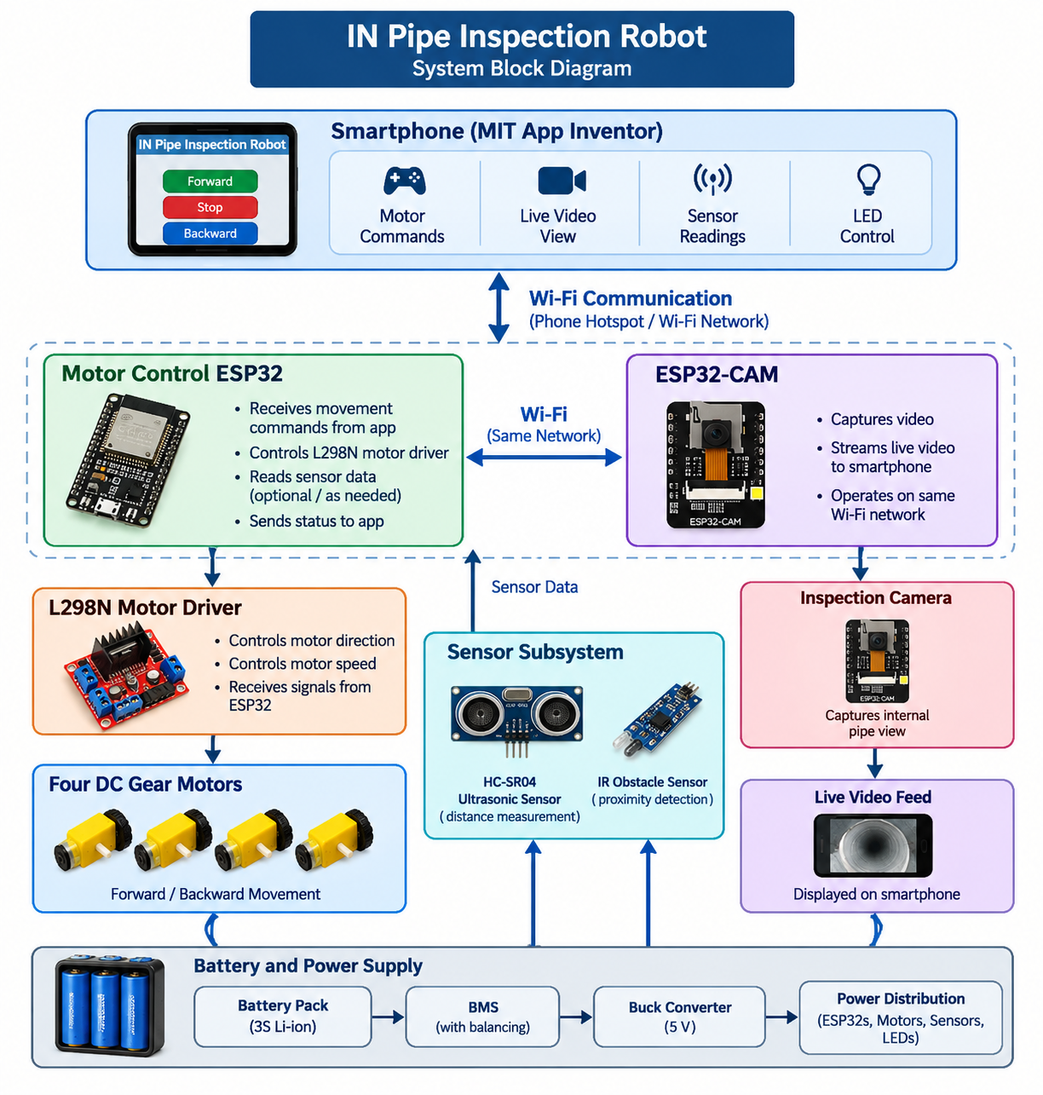

3.2 Operating Principle (Methodology)

Connecting to the Network: When powered on, both the main ESP32 controller and the ESP32-CAM auto-connect to the smartphone's Wi-Fi hotspot and take on local IP addresses.
Sending Drive Commands: As the operator presses directional buttons on the app screen, the app sends quick HTTP GET requests (such as /forward, /backward, or /stop) to the main ESP32's web server.
Driving the Wheels: The main ESP32 receives these commands and updates its output pins. These control logic signals (IN1–IN4) and speed signals (ENA, ENB) on the L298N driver, driving the four motors forward or in reverse.
Streaming Video: The onboard ESP32-CAM streams continuous video directly into a WebViewer window built into the smartphone app.
Reading Sensors: The app regularly asks the controller for updated sensor data. The ESP32 triggers the ultrasonic distance sensor, checks the state of the IR sensor, and sends back real-time readings.
Smart Power Distribution: The 3S Lithium-ion battery pack feeds raw 12V power straight to the motors and high-intensity LED light. Simultaneously, a step-down buck converter regulates that voltage down to a steady 5V to power the ESP32 microcontrollers and sensors without interruption.

3.3 Hardware Description and Pin Mapping
Below is the hardware pin connection table mapping out how components link to the central ESP32 board:
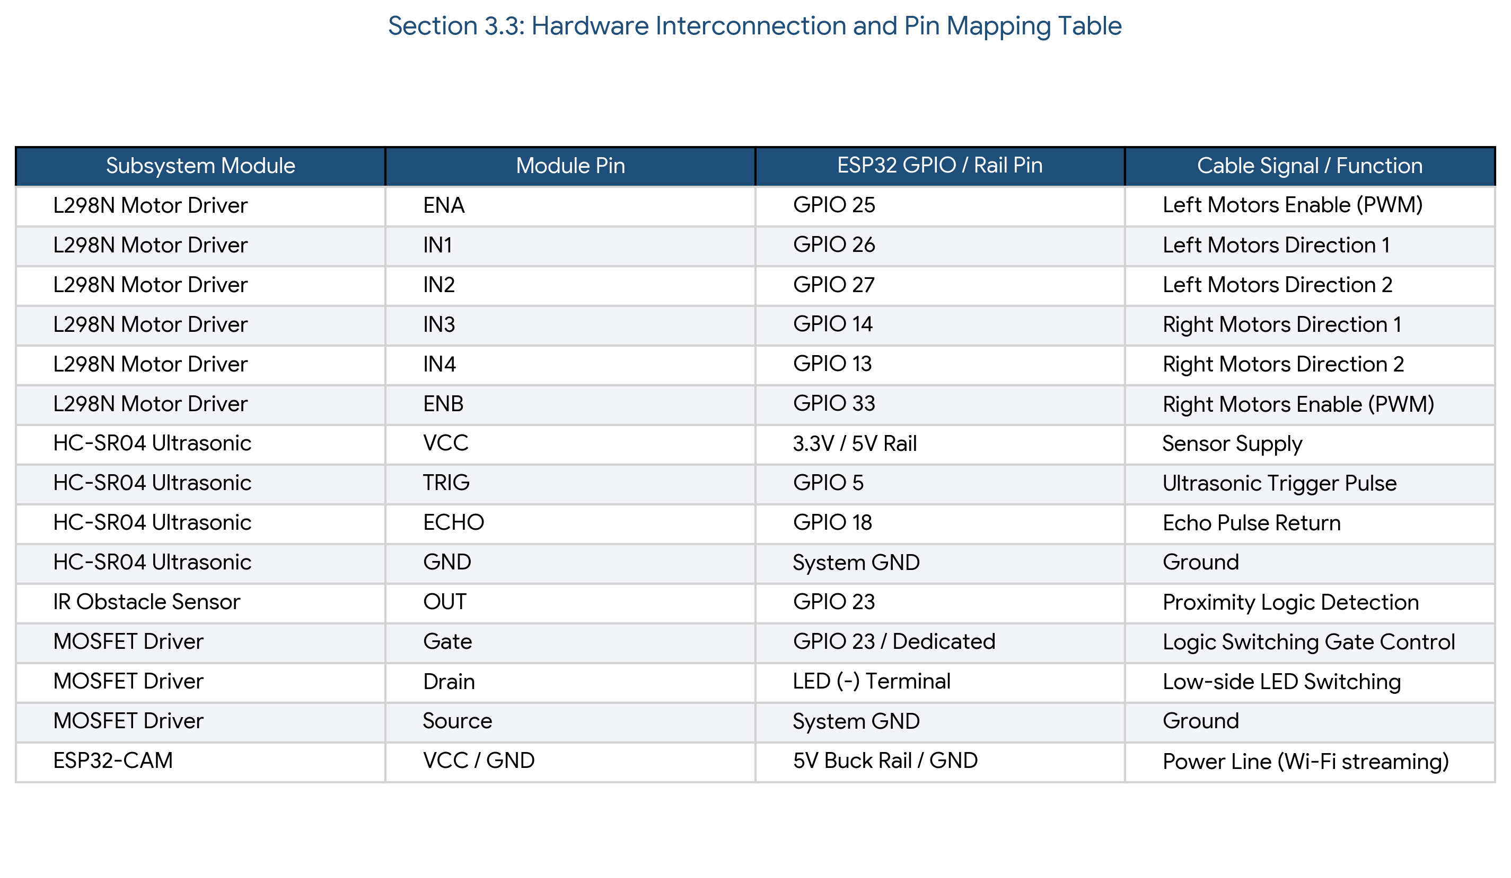

3.4 Software Layout and Smartphone Interface

We designed the smartphone app using MIT App Inventor to keep control intuitive for the user:

Live Camera View: A dedicated web window displays the video stream from the pipe interior in real time.
Telemetry Dashboard: Displays numerical distance readings (e.g., Distance: 157 cm), IR obstacle warnings (Clear or Obstacle Detected), operational status, and connection health.
Touch Controls: Large, responsive buttons for driving (FORWARD, STOP, BACKWARD), toggling the inspection lighting (LED ON, LED OFF), and reconnecting the video stream if interrupted.

CHAPTER 4

Implementation & Results

4.1 Hardware Assembly and Mechanical Structure
We constructed the chassis around a central cylindrical body made from durable PVC tubing. To keep the robot stable inside curved pipe bottoms, we added radially extended leg mounts supporting six wheels in total: four powered main drive wheels connected to TT DC gear motors, and two passive helper wheels for balance. All internal circuitry, power conversion modules, and battery management components sit securely inside the protected central frame.
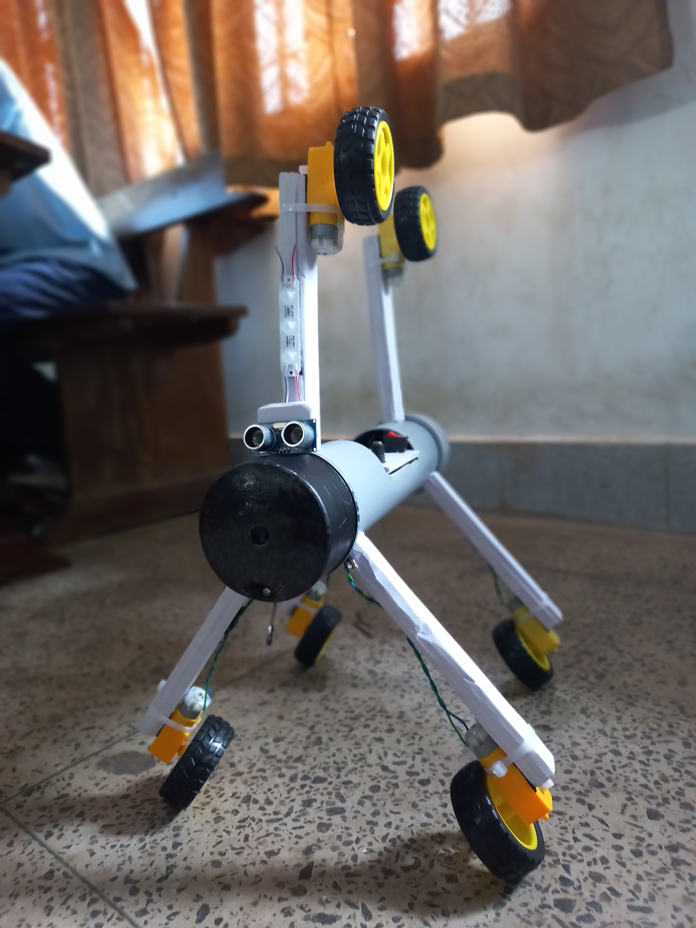

4.2 Field Testing and Results Matrix
We evaluated the fully assembled robot through bench-top validation and live operational runs inside test pipes. The evaluation verified that every control, sensor, and streaming module performed reliably:

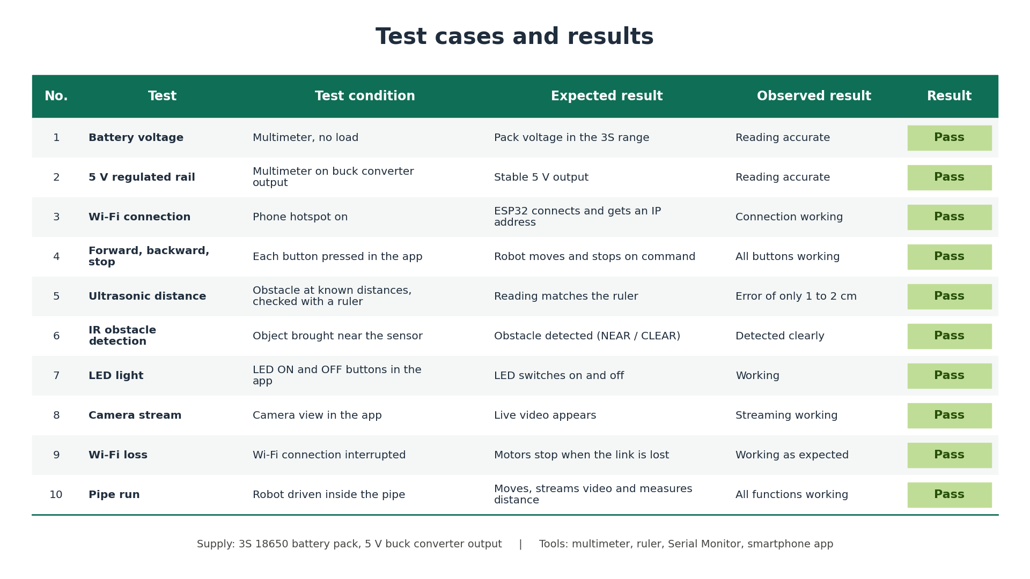

4.3 Performance Breakdown
Telemetry Accuracy: The HC-SR04 ultrasonic sensor provided precise distance readings inside cylindrical pipes. Across multiple trials up to 200 cm, errors remained remarkably low—consistently within ±1 to 2 cm.
Control Latency: HTTP command requests over the local hotspot network logged minimal response times (<100 ms execution delay), giving the operator crisp, immediate stopping control around obstacles.
Electrical Stability: Isolating the 5V logic supply with a step-down buck converter prevented motor voltage dips from causing micro-controller resets, even under full motor acceleration.

CHAPTER 5

CONCLUSION & FUTURE WORK

5.1 Conclusion
The IN Pipe Inspection Robot successfully meets all its key design goals. It offers a practical, highly capable solution for remote inspection that avoids the high price tags and bulky cables of commercial alternatives. Controlled entirely through an intuitive smartphone application, the robot travels inside pipes, streams clear live video, measures distances accurately, detects obstacles, and lights up dark spaces. By operating independently on an onboard lithium battery system, it eliminates the need for bulky equipment, helping keep human operators safely out of hazardous confined spaces.

5.2 Future Work (Scalability)
While our prototype successfully proves the core concepts, several improvements can adapt this platform for commercial and industrial field deployment:
Hardware & Mechanical Upgrades:
Self-Adjusting Scissor Chassis: Replace fixed legs with spring-loaded or motorized scissor linkages so the robot can expand or contract to fit different pipe diameters on the fly.
Extended Range Communication: Add high-gain directional antennas or a lightweight fiber-optic tether option for deep underground inspections beyond standard Wi-Fi range.
Onboard Data Archiving: Add local micro-SD recording to back up high-resolution video logs and sensor data for later review.
Industrial and Environmental Features:
Rugged Waterproof Housing: Upgrade the body to IP67/IP68 sealed enclosures to protect electronics when navigating wet or active sewer lines.
Environmental Gas Detection: Add compact gas sensors (such as Methane MQ-4, Air Quality MQ-135, or Hydrogen Sulfide modules) to warn operators of toxic gas buildup before workers enter an area.
Automated Obstacle Braking: Add automatic safety overrides that stop the robot instantly if an obstacle gets closer than 10 cm, preventing accidental collisions.
AI Defect Detection: Implement machine learning algorithms (like YOLO or OpenCV) on the video feed to automatically point out, tag, and categorize pipe cracks, rust spots, and structural damage in real time.

CHAPTER 6

REFRENCES

'Design and Development of In-Pipe Inspection Robot for Crack Detection'

-IEEE Sensors Journal

'Autonomous Pipeline Inspection and Defect Detection Robot'

- Elsevier Microelectronics Journal

'Sensor-Based In-Pipe Crawler System for Leakage Monitoring'

- Springer Robotics and Autonomous System

