|  |  |
| --- | --- |
|  | Pimpri Chinchwad Education Trust’s  Pimpri Chinchwad College of Engineering |
|
|

Department: AS&H Academic Year: 2020 - 2021 Sem – II

Subject : CPPS – II

**Mini Project Report**

**Project Title : HOSPITAL MANAGEMENT SYSTEM**

**Team Members**

Division: J

Name of the Student:

1. Sumit Tekam (FY20J1045)
2. Shyam Tiwari (FY20J1049)
3. Shrikant Gobre (FY20J1074)
4. Mayur Tambe (FY20J1042)

**Index**

|  |  |  |
| --- | --- | --- |
| **Sr.no.** | **Title** | **Page No** |
| **1** | **Introduction** | **03-06** |
| **2** | **Problem Recognition/ Problem Statement** | **07-08** |
| **3** | **Modeling** | **09** |
| **4** | **Outputs** | **10-23** |
|  | **References** | **24** |

HOSPITAL MANAGEMENT SYSTEM

## INTRODUCTION:

I have undertaken the project of HOSPITAL MANAGEMENT for hospital. The main aim of developing hospital management is to eliminate errors in the present manual system. Hospital Management is a new theory in management faculty. Hospital management encompasses all facts of a hospital, as well as the coordination of all of its components. This could include everything from patient care to record . To ensure that their company runs successfully, all hospital healthcare managers collaborate with clinicians, make policy choices, oversee patient care, budgeting and accounting, and lead marketing activities .Earlier a senior doctor used to perform the role of a hospital manager. However, nowadays everything demands a specialist. Almost all the things related to hospital have changed. Many categories concerning medical sciences and hospital have altered totally. There are various types of hospitals today, including ordinary hospitals, specialty hospitals and super specialty hospitals. The categories are regarding to the types of facilities they offer to the people. Eligible professionals are needed for the smooth operating of a hospital. Various courses and training programs have been developed to find out eligible hospital managers. Such professionals are well trained to solve the rising challenges and specific necessities of modern day hospitals. The Hospital Management courses are open to non-medical background graduates also.

In recent times, health care concept of the people have undergone a tremendous change which has lead to higher expectations and an increased demand for high quality medical care and facilities. Here comes the importance of Health/ Hospital Management. It is the latest concept in the field of management and one of the most lucrative and important careers in the health sector. According to a recent US survey, Hospital management is one among the top ten millennium professions which provides a direct link between 8 healthcare facilities and those supplying the services they need. A career in Hospital Management involves ensuring effective utilization of physical and financial resources of the hospital as well as creating an organizational climate beneficial to the growth and development of the personnel. It is a difficult, challenging, responsible and moreover, a demanding job.

A hospital manager is in a way responsible for administrative dealings of the hospital. He accepts the charge of various aspects of hospital management and health administration reverencing to the patients and healthcare. Professional services of trained manpower namely Hospital administrators/ managers have now become essential to manage hospitals and medical facilities. It is the hospital administrators/ managers who manage hospitals, outpatient clinics, hospices, drug abuse treatment centers etc. They would be responsible for overall patient care, education, research and community health care associated with the organization, and make sure that they conform to the rules of the Hospital. These people with the help of a team of assistants look after the administrative affairs i.e. plan coordinate and direct the delivery of health services within a hospital. In early days, senior doctors used to perform the role of a hospital manager. But now things have changed and the services of these qualified professionals are required for the smooth functioning of hospitals. The services of these professionals go a long way in making the hospital more productive, profitable and comfortable for the patients.

## About Hospital Management System C Project:

Hospital Management System C Project

This mini project, like any other, is built without graphics and comes with simple file handling operations. The key features in hospital management system are:

1. Add new patient record:

In this feature, user can add a new patient record choosing between O.P.D. service and Emergency service. In O.P.D. service (shown in output screen below), name, address, age, sex, disease description and specialist room number to be referred are available. Thus given information is stored in file. The information to be given are same in Emergency service.

2. Search or edit patient record:

In this mini project, two features – searching and editing patient records are placed under a single feature. User can search or edit via. record number of the patient or his/her full name.

All the information corresponding to the respective patient are displayed. These include the ones provided while adding a new patient record. If wrong information about record number or patient full name is provided, the program displays a message saying that no records were available.

Also, user can view the list of expenditures of the particular patient whose record is sought. In the program, the financial information include total charge, total deposited and total money to return.

3. List record of patients:

In hospital management system c project, users can list patient records by choosing any one of the four options listed below:

Records of patients in alphabetical order

Records of Emergency patients

Records of O.P.D. patients

Records of patients in a particular date

As in the two features mentioned above, user can view financial records corresponding to any particular patient listed according to any one of the four options mentioned above. Pressing ‘Enter’ user can view the records of next patients.

4. Delete patient records:

This features allows user to delete added record of any patient. For this the patient number to be removed is to be provided. Upon ‘Enter’, user can view the patient record and the financial records of the patient. To delete the record, press ‘Enter’ and the respective patient record will be deleted from the file.

# PROBLEM STATEMENT:

Hospital is associated with the lives of common people and their day-to-day routines so We decided to work on this project .The manual handling of the record is time consuming and highly prone to error. The purpose of this project is to automate or make online, the process of day-to-day activities like Room activities, Admission of New Patient, Discharge of Patient etc. We have tried to kept the information of the patient up to date and their records for history purpose. We have tried our best to make the complicated process Hospital Management System as simple as possible using Structure & Modular techniques &Menu oriented interface.

We have tried to design the program in such a way that user may not have any difficulty in using this program & further expansion is possible without much effort. Even though we cannot claim that this work to be entirely exhaustive, the main purpose of our exercise is to perform Hospital’s activity in programed way rather than manually which is time consuming.

The aim of our project is to provide a paper-less hospital upto 90%. It also provide low-cost reliable automation of the existing system.

# 

# Objective:

Hospital are the essential part of our lives, providing best medical facilities to people suffering from various ailments, which may be due to change in climatic conditions, increased work-load, emotional trauma stress etc. It is necessary for the hospitals to keep track of its day-to-day activities & records of its patients, doctors, nurses, ward boys and other staff personals that keep the hospital running smoothly & successfully.

But keeping track of all the activities and their records on paper is very cumbersome and error prone. It also is very inefficient and a time-consuming process Observing the continuous increase in population and number of people visiting the hospital. Recording and maintaining all these records is highly unreliable, inefficient and error-prone. It is also not economically & technically feasible to maintain these records on paper.

Thus keeping the working of the manual system as the basis of our project.

The main aim of our project is to provide a paper-less hospital up to 90%. It also aims at providing low-cost reliable automation of the existing systems. The system also provides excellent security of data at every level of user-system interaction and also provides robust & reliable storage and backup facilities.

**FLOWCHART:**

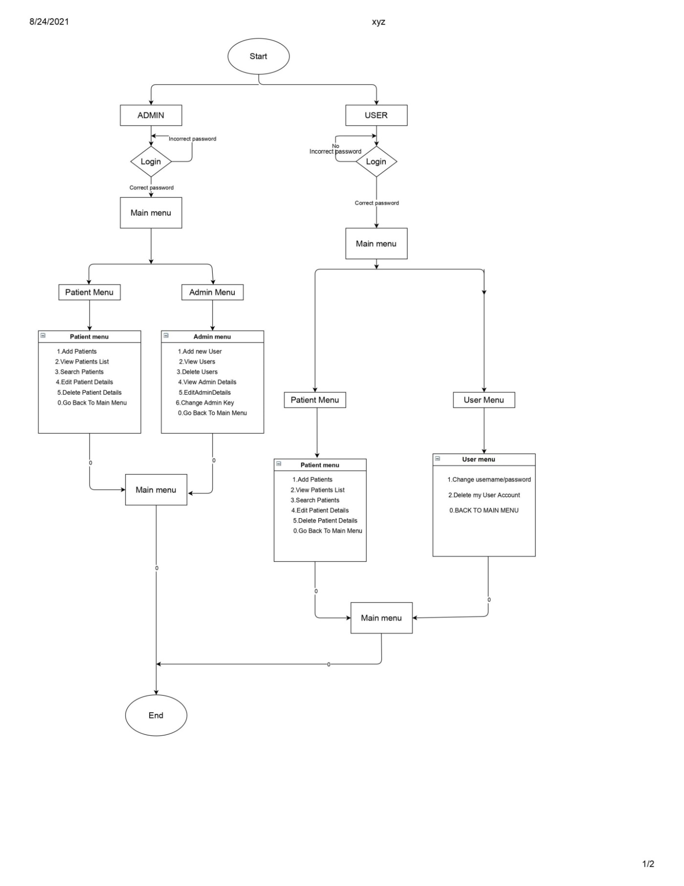

# OUTPUT:

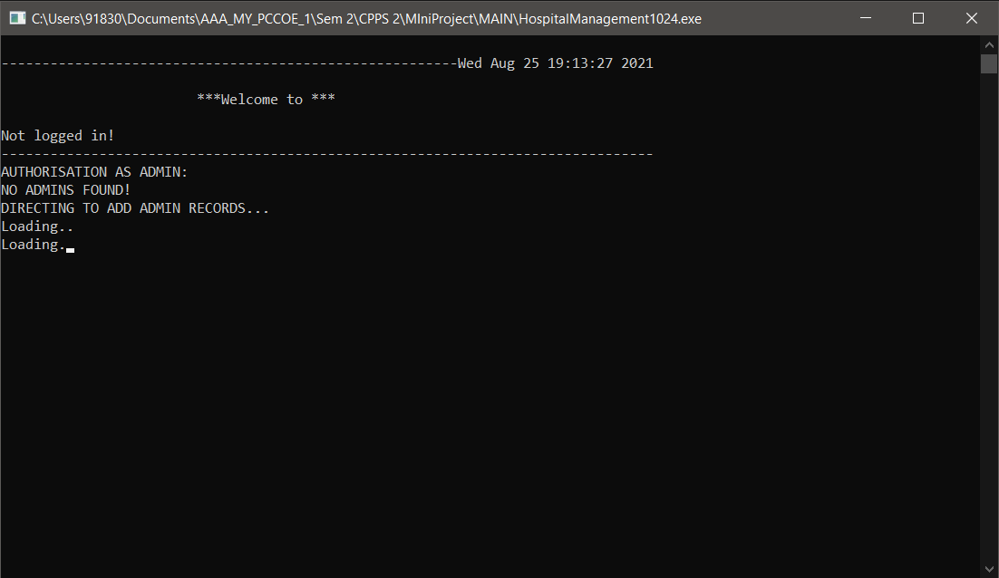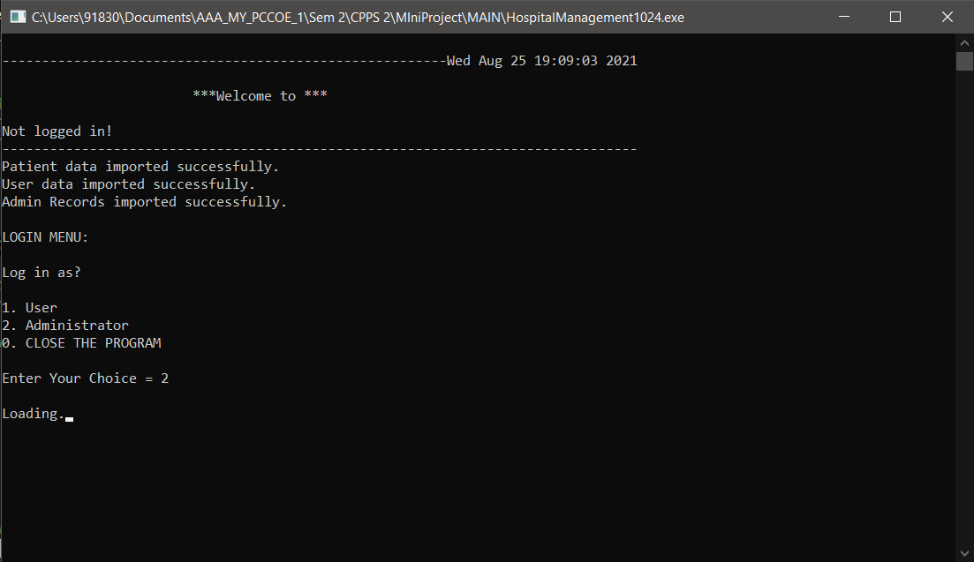

# C:\Users\DELL\Downloads\Screenshot 2021-08-25 191844.png

# C:\Users\DELL\Downloads\Screenshot 2021-08-25 191919.png

# C:\Users\DELL\Downloads\Screenshot 2021-08-25 192002.png

# C:\Users\DELL\Downloads\Screenshot 2021-08-25 193525.png

# C:\Users\DELL\Downloads\Screenshot 2021-08-25 193827.png

# C:\Users\DELL\Downloads\Screenshot 2021-08-25 194005.png

# C:\Users\DELL\Downloads\Screenshot 2021-08-25 194239.png

# C:\Users\DELL\Downloads\Screenshot 2021-08-25 194722.png

# C:\Users\DELL\Downloads\Screenshot 2021-08-25 195205.png

# C:\Users\DELL\Downloads\Screenshot 2021-08-25 195342.png

# C:\Users\DELL\Downloads\Screenshot 2021-08-25 195459.png

# C:\Users\DELL\Downloads\Screenshot 2021-08-25 195906.png

# C:\Users\DELL\Downloads\Screenshot 2021-08-25 201817.png

# C:\Users\DELL\Downloads\Screenshot 2021-08-25 205045.png

# C:\Users\DELL\Videos\a1c065af-fa52-4458-a70f-4e8b85ece811.jfif

# C:\Users\DELL\Videos\49ee7c5c-207e-4cbc-9df3-f93eb36592c3.jfif

# C:\Users\DELL\Videos\91622442-bcb4-4250-b7be-954408e5c128.jfif

# C:\Users\DELL\Videos\a50bdb80-2ad0-4095-8894-7e833e58d4d1.jfif

# C:\Users\DELL\Videos\7ff06779-2dca-47d5-a1c6-e85990111508.jfif

# C:\Users\DELL\Videos\efa326c3-4391-46e2-b513-6cd6e1f88e8b.jfif

# C:\Users\DELL\Videos\efa326c3-4391-46e2-b513-6cd6e1f88e8b.jfif

# C:\Users\DELL\Videos\6d95dd95-0750-4ddd-a390-d900f3df58f9.jfif

# C:\Users\DELL\Videos\4875df40-5fa6-49b7-abeb-4da3b424cd95.jfif

# C:\Users\DELL\Videos\cbcd49cf-01dc-49df-b4bd-8283830217a9.jfif

# C:\Users\DELL\Videos\cbcd49cf-01dc-49df-b4bd-8283830217a9.jfif

# C:\Users\DELL\Videos\aa5c290c-c628-4575-bf04-b0ef681fba12.jfif

# REFERENCES:

1. <https://youtu.be/Gge76h47kx4>
2. <https://youtu.be/qg69AXmHhx8>
3. <https://1drv.ms/x/s!AgsG_DAQ3DUSgQ6ntZ32LI1nw8YD?e=hl573W>
4. <https://itsourcecode.com/free-projects/c-projects/simple-hospital-management-system-in-c-with-source-code>

## THANK YOU