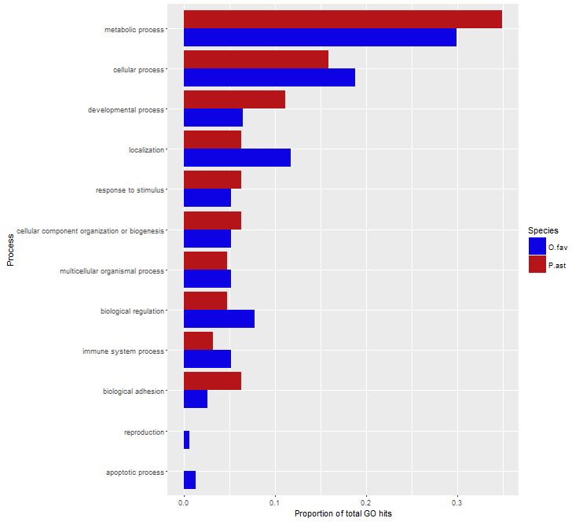

**Supplementary Figure 1**: Tier 1 Biological Process Gene Ontology term breakdown of differentially expressed genes for *Orbicella faveolata* (O.fav) and *Porites asteroides* (P.ast). Data shown as ratio of terms in a category out of the total number of GO terms for that species.

**Supplementary Figure 2**: Log2fold change per species of a) death receptor signaling b) TWEAK apoptosis. Black fill indicates gene was not present in the species in question. Log2fold values for annotation with multiple gene copies were averaged and the averaged values used to create the heat maps. Genes found in only one of four species not listed.

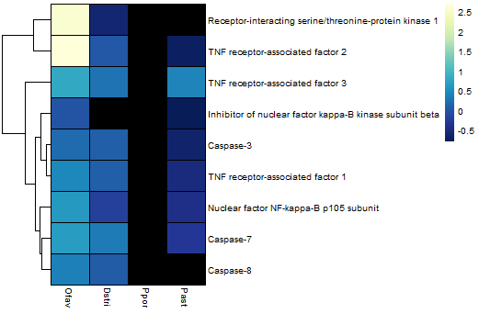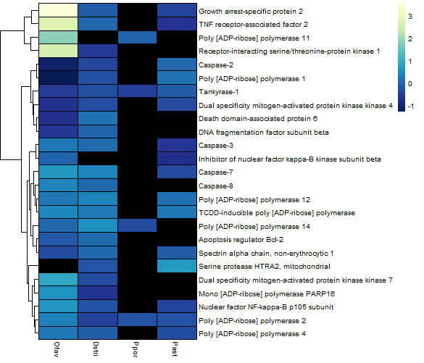

**a.**

**b.**

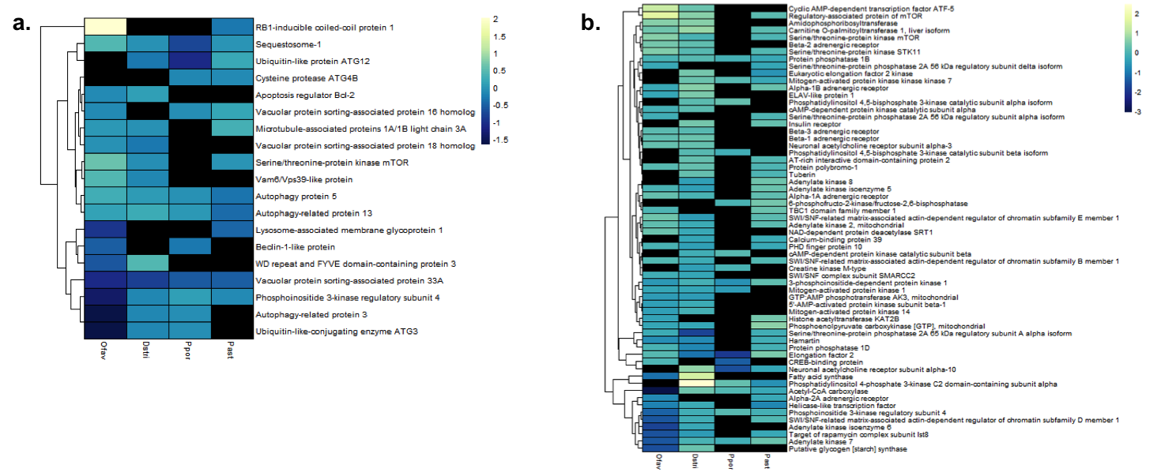

**Supplementary Figure 3**: Log2fold change per species of a) autophagy and b) AMPK. Black fill indicates gene was not present in the species in question. Log2fold values for annotation with multiple gene copies were averaged and the averaged values used to create the heat maps. Genes found in only one of four species not listed.

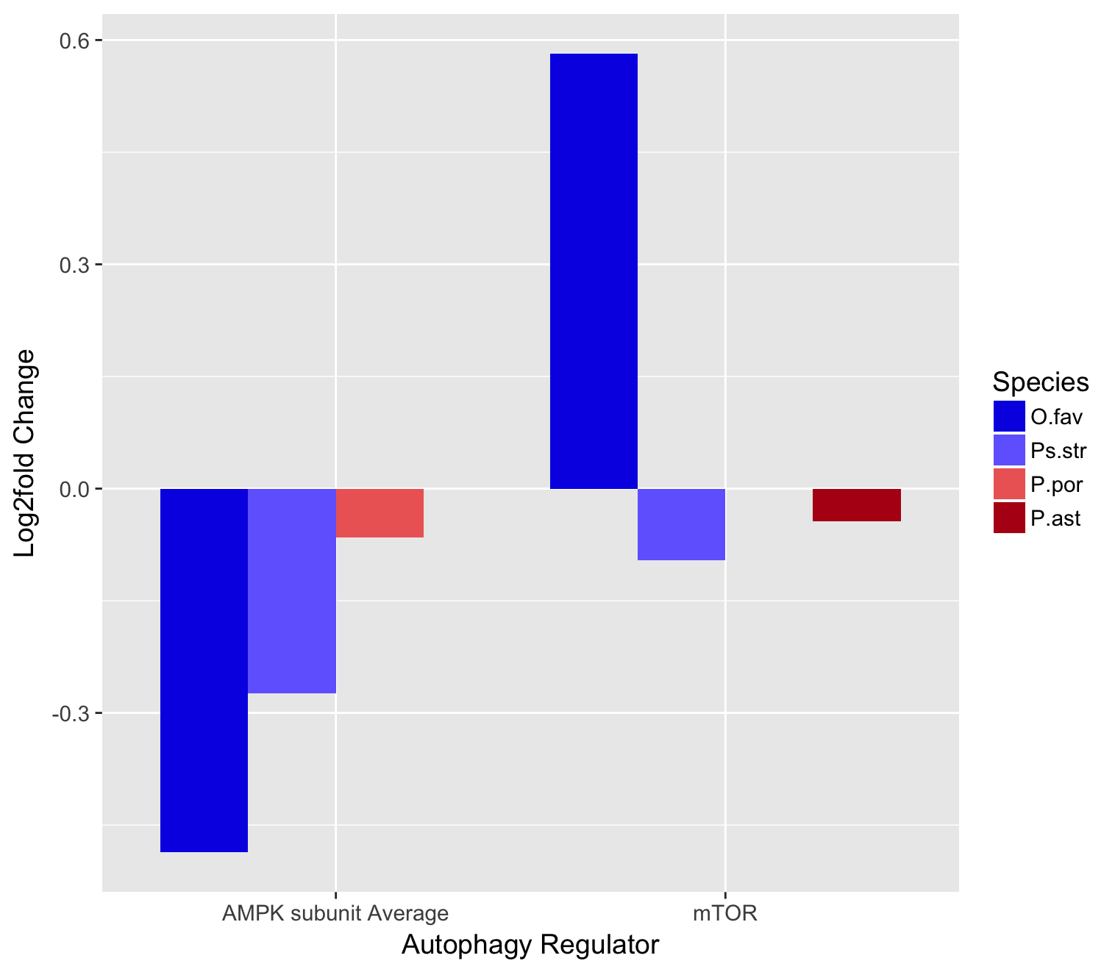

**Supplementary Figure 4**: Log2fold-change of autophagy regulations AMPK (promoter) and mTOR (inhibitor) by species.