

**<<Mini-store application>>**

**Software Design Specification**

– HCM, July 2023 –

Group 1 – Mini Store Application

* Hứa Thượng Hảo
* Đổ Duy Khanh
* Phạm Quang Khải
* Bùi Minh Quang
* Nguyễn Quốc Thái

# I. Overview

## 1. Code Packages

***Package descriptions***

|  |  |  |
| --- | --- | --- |
| **No** | **Package** | **Description** |
| *01* | *App* | *this package contain  classes for app UI and business layer and main class* |
| *02* | *Data access layer* | *this package contain package and class to access data in database* |
| *03* | *Model* | *this package contain class entity* |
| *04* | *Service* | *this package contain class query data* |
| *05* | *Business logic layer* | *this package contain class and method logic* |
| *06* | *Presentation layer* | *this package contain UI class* |
| *07* | *Form* | *this package contain form UI and controls* |
| *08* | *Dependencies* | *this package contain frameworks, project* |
| *09* | *Package* | *this package contain library* |
| *10* | *Resource* | *this package contain image and icon* |

## 2. Database Design

### a. Database Schema

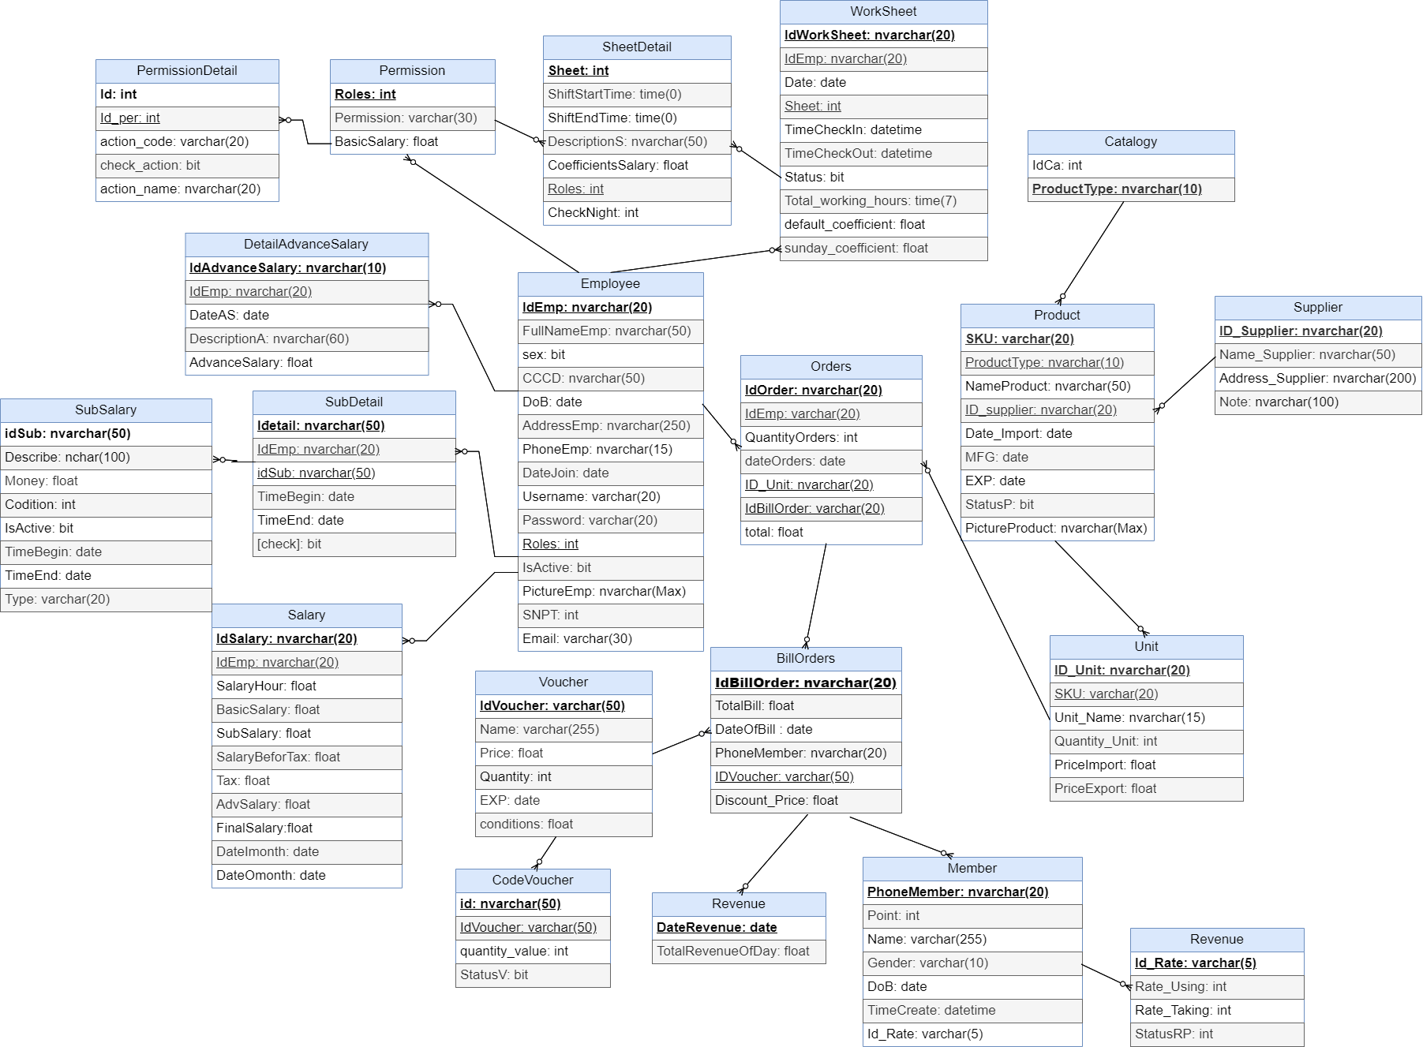

### b. Table Description

|  |  |  |
| --- | --- | --- |
| No | **Table** | Description |
| 1 | Employee | store employee information |
| 2 | SheetDetail | Summary of shifts in mini store |
| 3 | WorkSheet | the employees corresponding to each shift in the store |
| 4 | DetailAdvanceSalary | list of employees who advance salary |
| 5 | SubSalary | employees receive support salary |
| 6 | DetailSubSalary | the categories of salary support |
| 7 | Permission | employee roles such as: admin, employee, guardian, super admin |
| 8 | Salary | salary information of each employee |
| 9 | PermissionDetail | to assign permissions to each employee |
| 10 | Orders | Customer's invoice when buying the product |
| 11 | Member | Customer's member information to reduce the price when buying |
| 12 | Voucher | information of each type of voucher |
| 13 | CodeVoucher | Describe the use code of each voucher when used |
| 14 | BillOrders | all invoices and the price of each bill |
| 15 | Revenue | Describe the store's sales |
| 16 | Product | All product information |
| 17 | Catalogy | distinguish the type of product |
|  |  |  |

# II. Code Designs

1. ***Function Create Employee***

### Class Diagram (file ClassDiagram.mdj)

### b. Class Specifications

#### frmCreateEmployee.cs

|  |  |  |
| --- | --- | --- |
| **No** | **Method** | **Description** |
| *01* | *Void btAddNew()* | *To get information of employee, after check all validation, add all of it to database* |
| *02* | *Void btImport()* | *To open window dialog and get image* |
| *03* | *Void CreateEmployee_FormLoad()* | *Decide what form will load in the first-time user attractive* |
| *04* | *Void btClose()* | *Close form* |
| *05* | *Void btNext_Clickt()* | *Next to order part of form for user to enter others information* |

#### frmModels.cs

|  |  |  |
| --- | --- | --- |
| **No** | **Method** | **Description** |
| *01* |  |  |

#### frmServiceMiniStore.cs

|  |  |  |
| --- | --- | --- |
| **No** | **Method** | **Description** |
| *01* | *+ServiceMiniStore* | *constructor* |
| *02* | *+List<T> GetAll()* | *Get all employee in database* |
| *03* | *+Create (T entity)* | *Use to create new employee* |

***frmEmployeeService.cs***

|  |  |  |
| --- | --- | --- |
| **No** | **Method** | **Description** |
| *01* |  |  |

### 

### c. Sequence Diagram(s)

Add Employee Functions

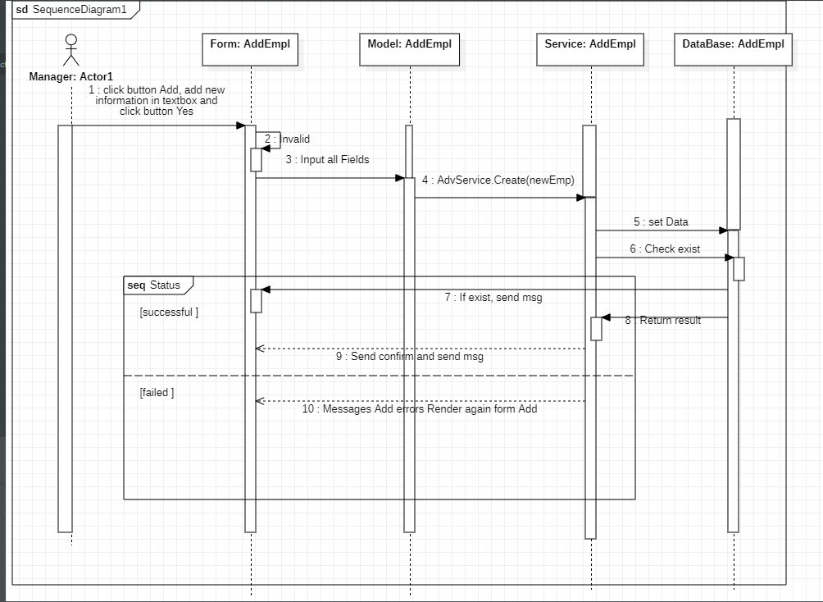

### d. Database Queries

Add Employee: insert into Employee values (‘IdEmp’, ‘FullNameEmp’, ‘sex’, ‘CCCD’, ‘DoB’, ‘AddressEmp’, ‘PhoneEmp’, ‘DateJoin’, ‘Uername’, ‘Password’, ‘Roles’, ‘IsActive’, ‘PictureEmp’)

# e. Flow chart

