RESEARCH PORTFOLIO
Evey Huang, PhD.  Research Assistant Professor  Kellogg School of Management  Northwestern University | 
Design human-AI Collaboration in Teams & Organizations

Teams and organizations turn individual knowledge and contributions into coordinated action, innovation, and decisions. AI is expanding what individuals can produce, but improvements in individual productivity and output quality do not establish whether AI improves the collective processes through which people accomplish work together.
My research examines how AI changes collective work and how we can design systems to support collaboration across science, entrepreneurship, and knowledge work domains. I contribute empirical models of collaboration, AI systems that scaffold interaction, methods for measuring behavior at scale, and evidence on how AI changes the diversity of scientific ideas and judgments.
I use AI in three complementary ways in my research: as a phenomenon whose organizational consequences I examine, as an intervention for supporting collaboration, and as an instrument for measuring collective work. My work takes a mixed-methods, interdisciplinary approach and leverages in-depth qualitative investigations, computational social science, design research, and AI-enabled measurement.
The three research streams that follow explain how distributed expertise becomes useful, what makes teams effective, and how AI could change scientific knowledge production.

jiaxinh.evey@gmail.com / eveyhuang.com

RESEARCH OVERVIEW
How AI changes collective work
Three connected questions organize the research: how people learn, what organizations can observe, and how they make judgments.
01 | How people learn  Coaching model → AI coaching system / p. 3  Collaboration skills and learning environments / p. 4
02 | What organizations can observe  Multimodal measurement across science, pitching, and sport / p. 5  Full entrepreneurship pipeline figure / p. 9
03 | How organizations make judgments  Diversity in scientific ideas and reviews / p. 6  AI as a participant in generation and evaluation
OTHER PROJECTS
Literary style · Online harassment · Emoji recommendations
Related work on judgment, influence, and context / p. 7
RESEARCH AND APPLIED EXPERIENCE
Northwestern · Novohaven · Education and field partnerships / p. 8
Across these projects, AI is a phenomenon to study, an intervention to design, and an instrument for measuring collective work.

01 / HOW PEOPLE LEARN
From coaching expertise to AI support
Learning from distributed expertise requires people to recognize what they need, interpret others’ experiences, and ask for useful help. This research traces how coaches perform that work and translates their practices into AI that prepares mentors and novices to learn from one another.
Understanding coaching expertise [1]
We analyzed 24 coaching sessions involving three coaches and 30 novice entrepreneurs, supplemented by interviews and communication observations, to examine how coaching makes distributed expertise useful. Coaches connected novices to relevant people, translated project-specific experiences into transferable lessons, questioned assumptions, and scaffolded requests for assistance. The study contributes a cognitive model of one-to-many coaching that specifies the interactional work required for collective learning.
From the coaching model to an AI system [2]
We used this model to design a proactive AI system that helps novices articulate assumptions, identify risks, and prepare a meeting agenda. Mentors receive project context and suggested strategies and can inspect and revise the expert knowledge guiding the system. After iterative prototyping, an exploratory deployment with one mentor and 11 novices found that novices surfaced overlooked risks and reconsidered priorities; participants described subsequent conversations as more focused and intentional. Incomplete context sometimes required additional verification. The contribution is an approach to grounding AI assistance in revisable expert knowledge and situated evidence about preparing people to collaborate.
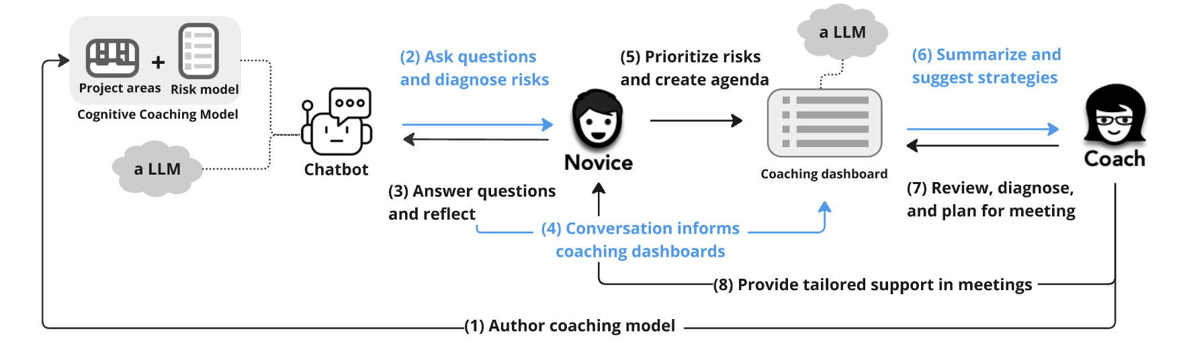
The system connects novice reflection, mentor preparation, and revision of the expert model. [2]
The doctoral dissertation connects the empirical coaching model to the design of proactive, adaptive, and differentiated support for mentors and novices, establishing the trajectory developed in these two studies. [16]
REFERENCES
[1] Huang, E. J., Rees Lewis, D., Gaudani, S., Easterday, M., & Gerber, E. (2023). Intelligent Coaching Systems: Understanding One-to-Many Coaching for Ill-Defined Problem Solving. Proceedings of the ACM on Human-Computer Interaction, 7(CSCW1), 138:1-138:24. doi:10.1145/3579614.
[2] Huang, E. J., Easterday, M., & Gerber, E. (2025). AI That Helps Us Help Each Other: A Proactive System for Scaffolding Mentor-Novice Collaboration in Entrepreneurship Coaching. Proceedings of the ACM on Human-Computer Interaction, 9(7), 1-30. doi:10.1145/3757549. Open-access paper / System code.
[16] Huang, E. (2024). Human-AI Collaboration For Entrepreneurship Coaching: Leveraging a Cognitive Model and an LLM to Provide Proactive, Adaptive, and Differentiated Support. Doctoral dissertation, Northwestern University. Dissertation.

01 / HOW PEOPLE LEARN
Learning to collaborate
Collaboration depends on capabilities people develop through work, including seeking help, deliberating, and coordinating expertise. These projects examine how learning environments and organizational routines support those capabilities, extending the coaching research beyond preparation for an individual meeting.
Learning collaboration skills through work [8]
Our CSCW workshop proposal examines how organizational routines, relationships, and technologies can help workers articulate needs, seek assistance, and coordinate expertise during complex tasks. It contributes an interdisciplinary agenda that treats collaboration as a capability developed through practice, rather than assuming that access to colleagues and communication tools is sufficient.
Deliberation-based learning [11]
We designed and evaluated a learning environment in a university design course to study how students scope open-ended political projects through deliberation. Students formed teams and developed proposals by iterating through ideas, questions, information seeking, and revision. The study contributes an empirical model linking deliberation to the development of shared projects.
Equitable engagement in making [13]
This workshop paper examines why access to makerspaces does not ensure equitable engagement. Preliminary research identified novice makers’ challenges and coaches’ support strategies, producing a task model that informed a proposed intelligent coaching system. The contribution is a design foundation for extending coaching support, rather than an evaluated intervention.
Disagreement and collective intelligence [14]
This workshop paper considers how disagreement can help groups integrate diverse perspectives into collective work. It frames disagreement as a design concern for collective intelligence, connecting the range of views people contribute to the interaction through which a group considers them.
REFERENCES
[8] Huang, E., Garg, K., Gómez-Zará, D., Hui, J., Kulkarni, C., Massimi, M., Churchill, E. F., & Gerber, E. (2023). Supporting Workers in Developing Effective Collaboration Skills for Complex Work. CSCW Companion, 486-489. Workshop proposal. doi:10.1145/3584931.3611290.
[11] Carlson, S., Lu, K., Huang, E., Gerber, E., & Easterday, M. (2020). Designing a Model for Deliberation-Based Learning. ICLS, 1553-1556. Paper and abstract.
[13] Huang, E., Easterday, M., & Gerber, E. (2022). Designing Intelligent Coaching Systems to Support Equitable Engagement in Making. CHI workshop on Learning Hands-on Creative and Maker Skills. Workshop abstract.
[14] Huang, E., Easterday, M., & Gerber, E. (2020). Encouraging Disagreements to Integrate Diversity in Collective Intelligence. CHI workshop on Effective Activism for Change.

02 / WHAT ORGANIZATIONS CAN OBSERVE
Measuring interaction with multimodal AI
Coordination, knowledge integration, and recovery after setbacks are difficult to observe systematically. We develop theory-grounded codebooks and multimodal AI pipelines that annotate recorded interaction, compare annotations with human judgments, and relate behavioral patterns to outcomes. This work examines what organizations can learn when previously difficult-to-observe processes become measurable.
Measuring what matters in teams [3]
Our perspective article organizes the measurement opportunity around scale, resolution, and temporal continuity: comparing settings, connecting constructs to enacted behavior, and tracing sequences of coordination and repair. It contributes a methodological framework while distinguishing a general AI capability from the evidence needed to validate a particular behavioral measure.
Knowledge integration in science teams [4, 15]
Across 400 hours of recorded science-team interaction, we examine how members build on, connect, evaluate, and extend one another’s contributions. Current analyses suggest that effective collaboration depends on what teams do with members’ ideas, alongside the ideas initially contributed. The manuscript develops an empirical account of integration; the associated IC2S2 presentation addresses the evaluation of multimodal models for annotating team behavior.
Entrepreneur–investor interaction [5]
We analyze 100 pitching episodes to examine how questions and responses reveal preparedness and relate to investment judgments beyond a prepared presentation. Codebook-guided annotations preserve who speaks, which question an answer addresses, and how the exchange develops; a concept bottleneck model relates named behaviors to offer decisions. The preliminary analysis illustrated on page 9 suggests that answer characteristics add information beyond the prepared pitch. These observational relationships remain bounded by the recorded setting and measurement choices.
Regrouping in professional volleyball [6]
We study team huddles to examine how cohesion and coordination are enacted under time pressure. Current results associate consistency in regrouping after setbacks with overall performance. The study contributes behavioral evidence about repeated recovery episodes, while distinguishing an observed association from the effect of a particular regrouping intervention.
REFERENCES
[3] Huang, E. J., Uzzi, B., & Groh, M. Measuring What Matters in Teams with Multimodal AI. Journal of Organization Design.
[4] Huang, E. J., Chalekson, M., Groh, M., Abrams, D., & Uzzi, B. Multimodal AI for Large-Scale Scientific Team Behavior Analysis. Manuscript in preparation.
[15] Huang, E., Groh, M., Abrams, D., & Uzzi, B. (2025). Evaluating Multimodal Language Models for Annotating Team Behaviors in Videos. IC2S2 conference presentation.
[5] Huang, E. J., Grey, A., Uzzi, B., & Groh, M. Measuring Catch and Toss and Its Impact in Entrepreneurial Pitching. Submitted to Organization Science, Special Issue: AI-Enabled Frontiers in Organizational Science.
[6] Grey, A., Huang, E. J., Uzzi, B., & Groh, M. How Teams Regroup in the Seconds After a Setback. Submitted to Organization Science, Special Issue: AI-Enabled Frontiers in Organizational Science.

03 / HOW ORGANIZATIONS MAKE JUDGMENTS
AI and scientific knowledge production
Organizations influence which possibilities people consider and which receive support. This theme examines how AI changes that process by comparing the diversity of scientific ideas and evaluative judgments, making collective consequences visible beyond the quality of individual outputs.
Double compression in scientific knowledge production [7]
We compare 23 proposals and 85 expert reviews from a biomedical grant competition with outputs from Claude, Gemini, and GPT under the same call and review criteria. Computational experiments use embeddings, diversity and coverage measures, topic analysis, and style-normalized comparisons to examine collections of ideas and judgments. Preliminary findings identify double compression: AI-generated proposals concentrate around common ideas, leaving distinctive human proposals underrepresented, while AI-generated reviews produce more homogeneous judgments. The contribution is evidence that AI can narrow diversity at both generation and evaluation, motivating evaluation at the collective level. The study compares independently produced human and AI work; it does not test scientists using AI assistance or measure realized innovation.
REFERENCES
[7] Huang, E. J., Groh, M., & Uzzi, B. Double Compression: How AI Narrows Both the Generation and the Gatekeeping of Scientific Ideas. Manuscript in preparation.

RELATED RESEARCH
Other projects
These projects examine how computational systems represent human judgment, preserve conversational context, and distribute influence. They provide related foundations for studying what becomes visible to a system and how that representation shapes people’s options.
Interacting with literary style [9]
Through interviews, crowdsourced comparisons, and a neural model of stylistic similarity, we studied how tools can represent judgments that people recognize but struggle to articulate. Explorer and Editor interfaces helped six study participants inspect patterns and reflect on their interpretations, although model errors could cause confusion. The contribution is a method and interfaces for making aspects of tacit judgment inspectable while preserving human interpretation.
Computational responses to online harassment [10]
A scoping review and qualitative analysis of 17 papers examined whether tools reflected intended beneficiaries’ identities, definitions of harm, and preferred responses. We found gaps between those needs and documented implementations: people could supply information while platforms retained authority over classification and action. The review distinguishes participation from influence and identifies design questions about who shapes computational judgments. The paper received a DIS 2024 Honorable Mention.
Context in emoji recommendations [12]
We developed Reeboc to examine whether conversational context improves emoji recommendations beyond the current message. In a controlled group-chat study, participants preferred conversation-based suggestions and selected emojis more quickly. The system preserves topics and emotions available in the preceding exchange, including for emoji-only messages, contributing a contextual recommendation method and evidence of its use in communication.
REFERENCES
[9] Sterman, S., Huang, E., Liu, V., & Paulos, E. (2020). Interacting with Literary Style through Computational Tools. CHI. doi:10.1145/3313831.3376730.
[10] Huang, E., Sarma, A., Hwang, S., Chandrasekharan, E., & Chancellor, S. (2024). Opportunities, Tensions, and Challenges in Computational Approaches to Addressing Online Harassment. DIS. Honorable Mention. doi:10.1145/3643834.3661623.
[12] Kim, J.-G., Gong, T., Kim, B., Park, J., Kim, W., Huang, E., Han, K., Kim, J., Ko, J., & Lee, S.-J. (2020). No More One Liners: Bringing Context into Emoji Recommendations. ACM Transactions on Social Computing, 3(2), Article 9. doi:10.1145/3373146.

RESEARCH AND APPLIED EXPERIENCE
Research, design, and practice
Field partnerships and applied system development connect this research to the settings in which people work and learn. They provide opportunities to translate empirical models into systems while examining how organizational knowledge is represented and revised.
Research at Northwestern
I am a Research Assistant Professor at Northwestern University’s Kellogg School of Management (July 2026–present), following postdoctoral work with Brian Uzzi and Matthew Groh (February 2025–June 2026). I independently wrote the proposal for Building Behavioral Process Models from Real Teams with Multimodal AI, which received $75,000 from Microsoft’s AI and the New Future of Work program, with Brian Uzzi as PI. The related TeamLens proposal was a finalist in the Stanford HAI and Google DeepMind AI for Organizations Grand Challenge.
Shared AI workflows at Novohaven
Since October 2025, I have worked with Novohaven as an AI Advisor and Forward Deployment Engineer. I designed and developed an agentic platform that makes company expertise available through shared workflows, specifying task steps, information requirements, and output standards. Domain experts can revise workflows, users can inspect execution histories, and proposed updates require human review. The project extends my research on revisable expert knowledge into organizational practice; its effects on learning and work quality have not been empirically established.
Education and other applied work
My PhD in Technology and Social Behavior at Northwestern (2024) bridged computer science and communication studies; I also earned an MS in the program (2023) and a BA in Economics from UC Berkeley (2017). My doctoral work involved a sustained incubator partnership, and I coached engineering students in human-centered design. At Spark AI (December 2024–December 2025), I advised teams on AI features and deployment for K–12 learning products. At Northwestern Memorial Hospital (summer 2022), I studied older adults’ medication and scheduling workflows and translated usability findings into design recommendations.
Outside work, I play guitar and tennis, take film and digital photographs, read, doodle, and cook spicy food.
jiaxinh.evey@gmail.com / eveyhuang.com

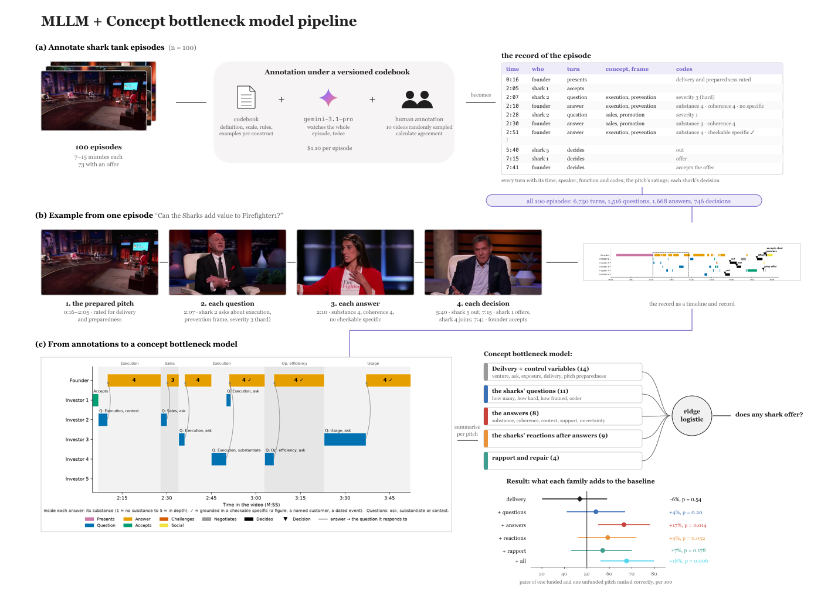
Entrepreneurship pitching [5]: annotation, interaction records, and concept bottleneck analysis. Project summary on page 5.

