PERSONAL DATA

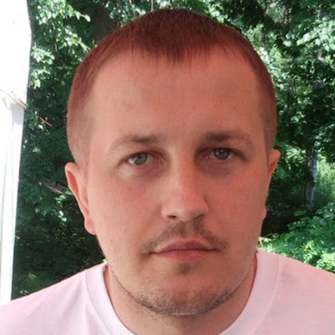

|  |  |
| --- | --- |
| **Name:** | Yevhen Khaliman |
| **Location:** | Ukraine, Kiev |
| **Telegram:** | @eugene9000 |
| **E-mail:** | Eugen.haliman@gmail.com |
| **Skype:** | live:khalimaneugene |
| **LinkedIn:** | [**Evgeny Haliman**](http://linkedin.com/in/yevhen-khaliman/) |

OBJECTIVE

|  |  |
| --- | --- |
| **Desired Position:** | **Software Engineer / Test Automation** |

SUMMARY OF QUALIFICATION

|  |
| --- |
| I have almost 4 years in the IT industry as a **Software Engineer** and **Test Automation**. During my work as a Software Engineer, I was engaged in the development of web applications including the back-end(JakartaEE, Spring) and front-end sides(Backbone.js). Also, I am setting up automation on a remote server and creating desktop applications for project needs. During my work as a Test Automation Engineer, I was engaged in testing automation for mobile applications, desktop applications for Windows, and web applications. I have been involved in the maintenance and creation of API tests and load testing in the **Java language**. I am open-minded, result-oriented, and self-motivated. |

TECHNICAL SKILLS

* Java 21, C#, JavaFX, Python, TypeScript, HTML/XML/CSS, BackBone.js, Kotlin
* Spring (core, security, data, boot), Hibernate, Jakarta EE, Tomcat, Kafka
* Rest-Assured, Playwright, Cypress, Gatling, Selenium, Appium, Web browser’s tools, TestRail, Jira, Postman, Curl
* PostgreSQL, MySQL, H2, SOQL, Kafka
* Docker, BASH, Jenkins, Maven, Gradle, Git, Log4j, TinyLog, Allure
* TestNG, Junit, Cucumber
* React, Angular, Vue.js
* Intellij IDEA, Visual Studio code
* Linux, Mac, Windows
* Azure, GCP, AWS, Kubernetes

EDUCATION

* 2002 – 2008 / **National Technical University of Ukraine** "*Igor Sikorsky Kyiv Polytechnic Institute*" Master degree at “Telecommunication Systems and Networks”

EXPERIENCE

|  |  |
| --- | --- |
| **Company** | “SoftServe” |
| **Duration** | **08/2020 – Nowadays** |
| **Project Description Global Business and data analytics web application**  **Customer USA company**  **Involvement Duration 4 months**  **Project Role Software Engineer(10 team members)**  **Responsibilities**   • Java Programming (**JakartaEE, Spring, JavaFX, jdbc**)  • Web Development (**Backbone.js**)  • Database Integration (**Docker**)  • Version Control and Collaboration (**GitLab**)  • Documentation and Communication (**Jira**)  • Fixing defects  • Testing and Quality Assurance  • Continuous Integration and Deployment (**Jenkins)**  • Problem Solving and Troubleshooting | |
| **Project Description B2B healthcare applicatoin(**RESTful API application**)**  **Customer EU company**  **Involvement Duration 2 years 4 months**  **Project Role Senior TA Engineer (10 team members)**  **Responsibilities**   • Test script automation(**Java 21, Rest-Assured, javaFX, TestNG, Jira, Docker, maven, GitHub, SonarQube**)  • Automation of test processes(**Jenkins**)  • Setting up a remote server environment (**Linux**)  • Analyzing test conditions  • Editing test cases  • Reporting defects  • Creating and publishing a test report(**Allure**)  • Analyzing test results  • Running tests on Jenkins  • Framework creation and update  • Fixing failed test scripts if possible  • Writing test scripts based on existing automation framework (**java, Rest-Assured**) | |
| **Project Description Security products for mobile devices and PC**  **Customer CA company**  **Involvement Duration 11 months**  **Project Role TA Engineer(30-35 team members)**  **Responsibilities**   • Test script automation(J**ava11, Selenium, Junit, Appium, Jira, TestRail, Jenkins, Docker, Gradle, GitLab**)  • Analyzing test conditions  • Editing test cases  • Reporting defects  • Analyzing mobile logs  • Analyzing test results, Running tests on Jenkins | |

|  |  |
| --- | --- |
| **Company** | “Volia” |
| **Duration** | 01/2008 – 07/2018 |
| **Description** | Technician inspector in a company providing access to cable television and broadband internet |
| **Responsibilities** | Сonnecting customers to the company network; Trouble-shooting ; Looking for new clients; |

CODE EXAMPLES

|  |  |
| --- | --- |
| **Github link** | [**/Password-Keeper**](https://github.com/evgeny-haliman/Password-Keeper) |
| **Description** | JavaFX desktop application that allows you to store credentials in an encrypted form on your local PC |

|  |  |
| --- | --- |
| **Github link** | [**/Word-shelf**](https://github.com/evgeny-haliman/word-shelf) |
| **Description** | A web application that allows you to save words, transcriptions, translations, and related sentences. (**Spring boot, oauth2 with JWT and Stateless, postgreSQL, spring jdbc template, JS, rest, single page app**) |