PERSONAL DATA
Name: | Yevhen Khaliman
Location: | Ukraine, Kiev
Telegram: | @eugene9000
E-mail: | Eugen.haliman@gmail.com
Skype: | live:khalimaneugene
LinkedIn: | Evgeny Haliman

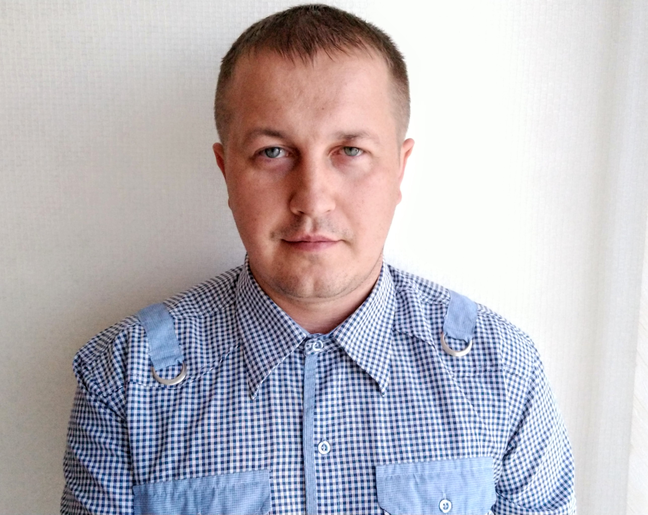

OBJECTIVE
Desired Position: | Java Software Engineer

SUMMARY OF QUALIFICATION
I have almost 4 years in the IT industry as a Software Engineer and Test Automation. During my work as a Software Engineer, I was engaged in the development of web applications including the back-end(JakartaEE, Spring) and front-end sides(Backbone.js). Also, I am setting up automation on a remote server and creating desktop applications for project needs. During my work as a Test Automation Engineer, I was engaged in testing automation for mobile applications, desktop applications for Windows, and web applications. I have been involved in the maintenance and creation of API tests and load testing in the Java language. I am open-minded, result-oriented, and self-motivated.

TECHNICAL SKILLS
- Java 21, javaScript, JavaFX, Python, TypeScript, HTML/XML/CSS, BackBone.js,
- Spring (core, security, data, boot), Hibernate, Jakarta EE, Tomcat
- Rest-Assured, Playwright, Cypress, Gatling, Selenium, Appium, Web browser’s tools, TestRail, Jira, Postman, Curl
- PostgreSQL, MySQL, H2, SOQL
- Docker, BASH, Jenkins, Maven, Gradle, Git, Log4j, TinyLog, Allure
- TestNG, Junit, Cucumber
- Agile, Scrum, Behavior Driven Development
- Intellij IDEA, Visual Studio code
- Linux, Mac, Windows
- Azure, GCP, AWS

EDUCATION
- 2002 – 2008 / National Technical University of Ukraine "Igor Sikorsky Kyiv Polytechnic Institute" Master degree at “Telecommunication Systems and Networks”

EXPERIENCE
Company | “SoftServe”
Duration | 08/2020 – Nowadays
Description | Global Business and data analytics web application
Responsibilities | Java Software Engineer.  • Development WEB applications  • Support  • Fixing defects  Test Automation Engineer.  • Automation of test scripts  • Setting up remote server environment(Linux)  • Continuous integration  • Reporting
Company | “Foxminded Software”
Duration | 02/2020– 03/2020
Description | Joint development of the project
Company | Freelance
Duration | 09/2018– 11/2019
Description | Manual QA Engineer. Doing Test cases; writing bug reports.  Designed and developed multiple different web applications with java
Company | “Volia”
Duration | 01/2008 – 07/2018
Description | Technician inspector in a company providing access to cable television and broadband internet
Responsibilities | Сonnecting customers to the company network;  Trouble-shooting ; Looking for new clients;

